

Department of Computer Science and Engineering Notes of Lesson

Academic Year: 2025- 2026

SUBJECT TITLE AND CODE : DESIGN AND ANALYSIS OF
ALGORITHMS (BCS401) SEMESTER : IV



INSTITUTIONAL MISSION AND VISION
Objectives
- To provide quality education and groom top-notch professionals, entrepreneurs and leaders for different fields of engineering, technology and management.
- To open a Training-R & D-Design-Consultancy cell in each department, gradually introduce doctoral and postdoctoral programs, encourage basic & applied research in areas of social relevance, and develop the institute as a center of excellence.
- To develop academic, professional and financial alliances with the industry as well as the academia at national and transnational levels.
- To develop academic, professional and financial alliances with the industry as well as the academia at national and transnational levels.
- To cultivate strong community relationships and involve the students and the staff in local community service.
- To constantly enhance the value of the educational inputs with the participation of students, faculty, parents and industry.

Vision
- Development of academically excellent, culturally vibrant, socially responsible and globally competent human resources.

Mission
- To keep pace with advancements in knowledge and make the students competitive and capable at the global level.
- To create an environment for the students to acquire the right physical, intellectual, emotional and moral foundations and shine as torch bearers of tomorrow's society.
- To strive to attain ever-higher benchmarks of educational excellence.

Department of Computer Science And Engineering
Vision of the Department

To develop highly talented individuals in computer science and engineering to deal with real world challenges in industry, education, research and society.
Mission of the Department

- To inculcate professional behavior, strong ethical values, innovative research capabilities and leadership abilities in the young minds & to provide a teaching environment that emphasizes depth, originality and critical thinking.
- Motivate students to put their thoughts and ideas adoptable by industry or to pursue higher studies leading to research.
Program Educational Objectives (PEO'S):
  - Empower students with a strong basis in the mathematical, scientific and engineering fundamentals to solve computational problems and to prepare them for employment, higher learning and R&D.
  - Gain technical knowledge, skills and awareness of current technologies of computer science engineering and to develop an ability to design and provide novel engineering solutions for software/hardware problems through entrepreneurial skills.
  - Exposure to emerging technologies and work in teams on interdisciplinary projects with effective communication skills and leadership qualities.
  - Ability to function ethically and responsibly in a rapidly changing environment by applying innovative ideas in the latest technology, to become effective professionals in Computer Science to bear a life-long career in related areas.
Program Specific Outcomes (PSOs)
PSO1: Ability to apply skills in the field of algorithms, database design, web design, cloud computing and data analytics.
PSO2: Apply knowledge in the field of computer networks for building network and internet based applications.

Analysis & Design of Algorithms |  | Semester | 4
Course Code | BCS401 | CIE Marks | 50
Teaching Hours/Week (L: T:P: S) | 3:0:0:0 | SEE Marks | 50
Total Hours of Pedagogy | 40 | Total Marks | 100
Credits | 03 | Exam Hours | 03
Examination type (SEE) | Theory
Course objectives:
- To learn the methods for analyzing algorithms and evaluating their performance.
- To demonstrate the efficiency of algorithms using asymptotic notations.
- To solve problems using various algorithm design methods, including brute force, greedy, divide and conquer, decrease and conquer, transform and conquer, dynamic programming, backtracking, and branch and bound.
- To learn the concepts of P and NP complexity classes.
Teaching-Learning Process (General Instructions)
These are sample Strategies, which teachers can use to accelerate the attainment of the various course outcomes.
- Lecturer method (L) does not mean only the traditional lecture method, but different types of teaching methods may be adopted to achieve the outcomes.
- Utilize video/animation films to illustrate the functioning of various concepts.
- Promote collaborative learning (Group Learning) in the class.
- Pose at least three HOT (Higher Order Thinking) questions in the class to stimulate critical thinking.
- Incorporate Problem-Based Learning (PBL) to foster students' analytical skills and develop their ability to evaluate, generalize, and analyze information rather than merely recalling it.
- Introduce topics through multiple representations.
- Demonstrate various ways to solve the same problem and encourage students to devise their own creative solutions.
- Discuss the real-world applications of every concept to enhance students' comprehension.
Module-1
INTRODUCTION: What is an Algorithm?, Fundamentals of Algorithmic Problem Solving.
FUNDAMENTALS OF THE ANALYSIS OF ALGORITHM EFFICIENCY: Analysis Framework,
Asymptotic Notations and Basic Efficiency Classes, Mathematical Analysis of Non recursive Algorithms, Mathematical Analysis of Recursive Algorithms.
BRUTE FORCE APPROACHES: Selection Sort and Bubble Sort, Sequential Search and Brute Force String Matching.
Chapter 1 (Sections 1.1,1.2), Chapter 2(Sections 2.1,2.2,2.3,2.4), Chapter 3(Section
3.1,3.2)
Module-2
BRUTE FORCE APPROACHES (contd..): Exhaustive Search (Travelling Salesman probem and Knapsack Problem).
DECREASE-AND-CONQUER: Insertion Sort, Topological Sorting.
DIVIDE AND CONQUER: Merge Sort, Quick Sort, Binary Tree Traversals, Multiplication of Large Integers and Strassen’s Matrix Multiplication.

Chapter 3(Section 3.4), Chapter 4 (Sections 4.1,4.2), Chapter 5 (Section 5.1,5.2,5.3, 5.4)
Module-3
TRANSFORM-AND-CONQUER: Balanced Search Trees, Heaps and Heapsort.
SPACE-TIME TRADEOFFS: Sorting by Counting: Comparison counting sort, Input Enhancement in String Matching: Horspool’s Algorithm.
Chapter 6 (Sections 6.3,6.4), Chapter 7 (Sections 7.1,7.2)
Module-4
DYNAMIC PROGRAMMING: Three basic examples, The Knapsack Problem and Memory Functions, Warshall’s and Floyd’s Algorithms.
THE GREEDY METHOD: Prim’s Algorithm, Kruskal’s Algorithm, Dijkstra’s Algorithm, Huffman Trees and Codes.
Chapter 8 (Sections 8.1,8.2,8.4), Chapter 9 (Sections 9.1,9.2,9.3,9.4)
Module-5
LIMITATIONS OF ALGORITHMIC POWER: Decision Trees, P, NP, and NP-Complete Problems. COPING WITH LIMITATIONS OF ALGORITHMIC POWER: Backtracking (n-Queens problem, Subset-sum problem), Branch-and-Bound (Knapsack problem), Approximation algorithms for NP-Hard problems (Knapsack problem).
Chapter 11 (Section 11.2, 11.3), Chapter 12 (Sections 12.1,12.2,12.3)
Course outcome (Course Skill Set)

At the end of the course, the student will be able to:
- Apply asymptotic notational method to analyze the performance of the algorithms in terms of time complexity.
- Demonstrate divide & conquer approaches and decrease & conquer approaches to solve computational problems.
- Make use of transform & conquer and dynamic programming design approaches to solve the given real world or complex computational problems.
- Apply greedy and input enhancement methods to solve graph & string based computational problems.
- Analyse various classes (P,NP and NP Complete) of problems
- Illustrate backtracking, branch & bound and approximation methods.

Assessment Details (both CIE and SEE)
The weightage of Continuous Internal Evaluation (CIE) is 50% and for Semester End Exam (SEE) is 50%. The minimum passing mark for the CIE is 40% of the maximum marks (20 marks out of 50) and for the SEE minimum passing mark is 35% of the maximum marks (18 out of 50 marks). A student shall be deemed to have satisfied the academic requirements and earned the credits allotted to each subject/ course if the student secures a minimum of 40% (40 marks out of 100) in the sum total of the CIE (Continuous Internal Evaluation) and SEE (Semester End Examination) taken together.

Continuous Internal Evaluation:
- For the Assignment component of the CIE, there are 25 marks and for the Internal Assessment Test component, there are 25 marks.
- The first test will be administered after 40-50% of the syllabus has been covered, and the second test will be administered after 85-90% of the syllabus has been covered
- Any two assignment methods mentioned in the 22OB2.4, if an assignment is project-based then only one assignment for the course shall be planned. The teacher should not conduct two assignments at the end of the semester if two assignments are planned.
- For the course, CIE marks will be based on a scaled-down sum of two tests and other methods of assessment.
Internal Assessment Test question paper is designed to attain the different levels of Bloom’s taxonomy as per the outcome defined for the course.

Semester-End Examination:
Theory SEE will be conducted by the University as per the scheduled timetable, with common question papers for the course (duration 03 hours).
- The question paper will have ten questions. Each question is set for 20 marks.
- There will be 2 questions from each module. Each of the two questions under a module (with a maximum of 3 sub-questions), should have a mix of topics under that module.
- The students have to answer 5 full questions, selecting one full question from each module.
- Marks scored shall be proportionally reduced to 50 marks
Suggested Learning Resources:
Textbooks
- Introduction to the Design and Analysis of Algorithms, By Anany Levitin, 3rd Edition (Indian), 2017, Pearson.
Reference books
- Computer Algorithms/C++, Ellis Horowitz, SatrajSahni and Rajasekaran, 2nd Edition, 2014, Universities Press.
- Introduction to Algorithms, Thomas H. Cormen, Charles E. Leiserson, Ronal L. Rivest, Clifford Stein, 3rd Edition, PHI.
- Design and Analysis of Algorithms, S. Sridhar, Oxford (Higher Education)
Web links and Video Lectures (e-Resources):
- Design and Analysis of Algorithms: https://nptel.ac.in/courses/106/101/106101060/

Analysis and Design of Algorithms (BCS401)

Contents

Module No. | Module Name | Page Number
1 | Introduction, Performance Analysis, Asymptotic Notations, Important Problem  Types, Fundamental Data Structures | 1 - 21
2 | BRUTE FORCE APPROACHES Decrease-And-  Conquer, Divide And Conquer | 22-46
3 | TRANSFORM-AND-CONQUER: Balanced  Search Trees, Heaps Space-Time Tradeoffs: Sorting by Counting continued. | 47-65
4 | Dynamic Programming, Transitive Closure, All Pairs Shortest Paths, The Greedy Method: Kruskal’s Algorithm, Prim’s Algorithm. Dijkstra’s Algorithm. | 66-81
5 | Backtracking, Programme and Bound,0/1 Knapsack problem, NP-Complete and NP- Hard problems | 82-109
Question Bank |  | 110-116

Lecture Notes on Analysis and Design of algorithms
BCS401

Module-1:Introduction to Algorithm
Contents

- Introduction
  - What is an Algorithm?
  - Algorithm Specification
  - Analysis Framework
- Performance Analysis
  - Space complexity
  - Time complexity
- Asymptotic Notations
  - Big-Oh notation
  - Omega notation
  - Theta notation
  - Little-oh notation
  - Mathematical analysis
- Important Problem Types
  - Sorting
  - Searching
  - String processing
  - Graph Problems
  - Combinatorial Problems
- Fundamental Data Structures
  - Linear Data Structures
  - Graphs
  - Trees
  - Sets and Dictionaries.

Module-1: Introduction
  - Introduction
    - What is an Algorithm?
Algorithm: An algorithm is a finite sequence of unambiguous instructions to solve a particular problem.
      - Input. Zero or more quantities are externally supplied.
      - Output. At least one quantity is produced.
      - Definiteness. Each instruction is clear and unambiguous. It must be perfectly clear what should be done.
      - Finiteness. If we trace out the instruction of an algorithm, then for all cases, the algorithm terminates after a finite number of steps.
      - Effectiveness. Every instruction must be very basic so that it can be carried out, in principle, by a person using only pencil and paper. It is not enough that each operation be definite as in criterion c; it also must be feasible.
    - Algorithm Specification
An algorithm can be specified in
      - Simple English
      - Graphical representation like flow chart
      - Programming language like c++/java
      - Combination of above methods.
Example: Combination of simple English and C++, the algorithm for selection sort is specified as follows.
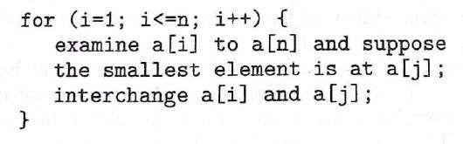
Example: In C++ the same algorithm can be specified as follows. Here Type is a basic or user defined data type.
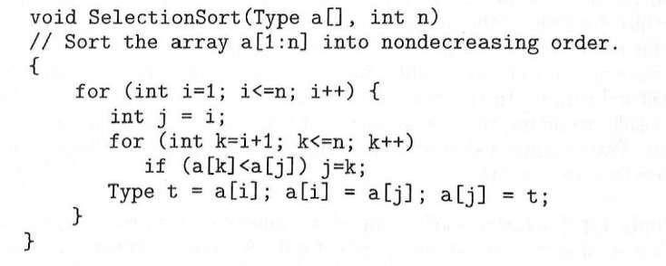

    - Analysis Framework
Measuring an Input’s Size
It is observed that almost all algorithms run longeron larger inputs. For example, it takes longer to sort larger arrays, multiply largermatrices, and so on. Therefore, it is logical to investigate an algorithm's efficiency as a function of some parameter n indicating the algorithm's input size.
There are situations, where the choice of a parameter indicating an input size does matter. The choice of an appropriate size metric can be influenced by operations of the algorithm in question. For example, how should we measure an input's size for a spell-checking algorithm? If the algorithm examines individual characters of its input, then we should
measure the size by the number of characters; if it works by processing words, we should count their number in the input.
We should make a special note about measuring the size of inputs for algorithms involving properties of numbers (e.g., checking whether a given integer n is prime). For such algorithms, computer scientists prefer measuring size by the number b of bits in the n's binary
representation: b = ⌊log2 n ⌋ + 1. This metric usually gives a better idea about the efficiency of algorithms in question.

Units for Measuring Running lime
To measure an algorithm's efficiency, we would like to have a metric that does not depend on these extraneous factors. One possible approach is to count the number of times each of the algorithm's operations is xecuted. This approach is both excessively difficult and, as we shall see, usually unnecessary. The thing to do is to identify the most important operation of the algorithm, called the basic operation, the operation contributing the most to the total running time, and compute the number of times the basic operation is executed.
For example, most sorting algorithms work by comparing elements (keys) of a list being sorted with each other; for such algorithms, the basic operation is a key comparison.
As another example, algorithms for matrix multiplication and polynomial evaluation
require two arithmetic operations: multiplication and addition.
Let cop be the execution time of an algorithm's basic operation on a particular computer, and let C(n) be the number of times this operation needs to be executed for this algorithm. Then we can estimate the running time T(n) of a program implementing this algorithm on that computer by the formula:

T(n) = copC(n)
Unless n is extremely large or very small, the formula can give a reasonable estimate of the algorithm's running time.
It is for these reasons that the efficiency analysis framework ignores multiplicative constants and concentrates on the count's order of growth to within a constant multiple for large-size inputs.

Orders of Growth
Why this emphasis on the count's order of growth for large input sizes? Because for large values of n, it is the function's order of growth that counts: just look at table which contains values of a few functions particularly important for analysis of algorithms.
Table: Values of several functions important for analysis of algorithms
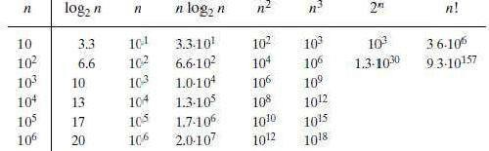

Algorithms that require an exponential number of operations are practical for solving only problems of very small sizes.
  - Performance Analysis
There are two kinds of efficiency: time efficiency and space efficiency.
- Time efficiency indicates how fast an algorithm in question runs;
- Space efficiency deals with the extra space the algorithm requires.
In the early days of electronic computing, both resources time and space were at a premium. The research experience has shown that for most problems, we can achieve much more spectacular progress in speed than in space. Therefore, we primarily concentrate on time efficiency.
    - Space complexity
Total amount of computer memory required by an algorithm to complete its execution is called as space complexity of that algorithm. The Space required by an algorithm is the sum of following components
      - A fixed part that is independent of the input and output. This includes memory space for codes, variables, constants and so on.
      - A variable part that depends on the input, output and recursion stack. ( We call these parameters as instance characteristics)
Space requirement S(P) of an algorithm P, S(P) = c + Sp where c is a constant depends on the fixed part, Sp is the instance characteristics\
Example-1: Consider following algorithm abc()
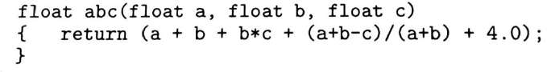
Here fixed component depends on the size of a, b and c. Also instance characteristics Sp=0

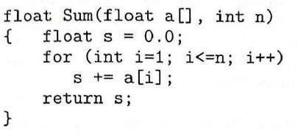
Example-2: Let us consider the algorithm to find sum of array. For the algorithm given here the problem instances are characterized by n, the number of elements to be summed. The space needed by a[ ]depends on n.So the space complexity can be written as;Ssum(n) ≥ (n+3); n for a[ ], One each for n, i and s.

    - Time complexity
Usually, the execution time or run-time of the program is refereed as its time complexity denoted by tp(instance characteristics). This is the sum of the time taken to execute all instructions in the program. Exact estimation runtime is a complex task, as the number of instructions executed is dependent on the input data. Also different instructions will take different time to execute. So for the estimation of the time complexity we count only the number of program steps. We can determine the steps needed by a program to solve a particular problem instance in two ways.
Method-1: We introduce a new variable count to the program which is initialized to zero. We also introduce statements to increment count by an appropriate amount into the program. So when each time original program executes, the count also incremented by the step count.
Example: Consider the algorithm sum(). After the introduction of the count the program will be as follows. We can estimate that invocation of sum() executes total number of 2n+3 steps.
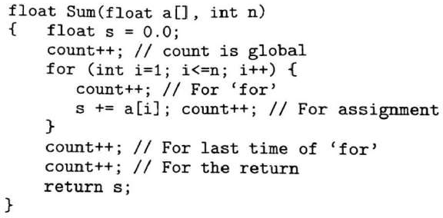
Method-2: Determine the step count of an algorithm by building a table in which we list the total number of steps contributed by each statement. An example is shown below. The code will find the sum of n numbers
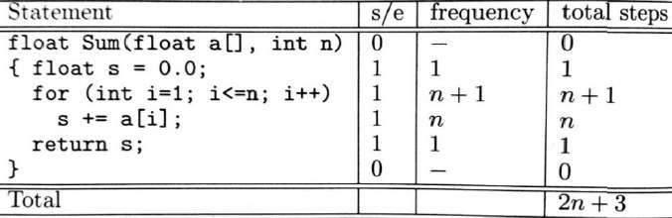

Example: Matrix addition
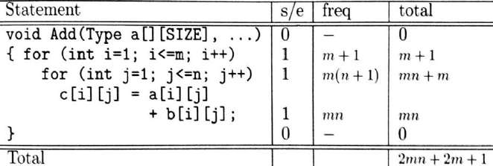
The above method is both excessively difficult and, usually unnecessary. The thing to do is to identify the most important of the algorithm, called the basic operation, the operation contributing the most to the total running time, and compute the number of times the basic operation is executed.
Trade-off
There is often a time-space-tradeoff involved in a problem, that is, it cannot be solved with few computing time and low memory consumption. One has to make a compromise and to exchange computing time for memory consumption or vice versa, depending on which algorithm one chooses and how one parameterizes it.

  - Asymptotic Notations
The efficiency analysis framework concentrates on the order of growth of an algorithm’s basic operation count as the principal indicator of the algorithm’s efficiency. To compare and rank such orders of growth, computer scientists use three notations: O(big oh), Ω(big omega), Θ (big theta) and o(little oh)
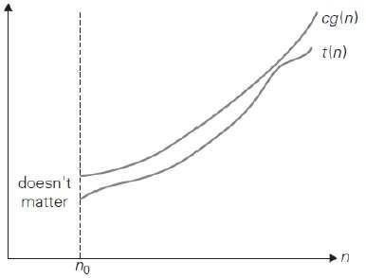
    - Big-Oh notation
Definition: A function t(n) is said to be in O(g(n)), denoted t(n)∈O(g(n)), if t (n) is bounded above by some constant multiple of g(n) for all large n, i.e., if there exist some positive constant c and some nonnegative integer n0 such that
t(n) ≤ cg(n) for all n ≥ n0.
Informally, O(g(n)) is the set of all functions with a lower or same order of growth as g(n).
Note that the definition gives us a lot of freedom in choosing specific values for constants c and n0.
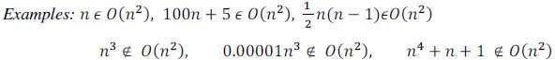

Strategies to prove Big-O: Sometimes the easiest way to prove that f (n) = O(g(n)) is to take c to be the sum of the positive coefficients off(n). We can usually ignore the negative coefficients.
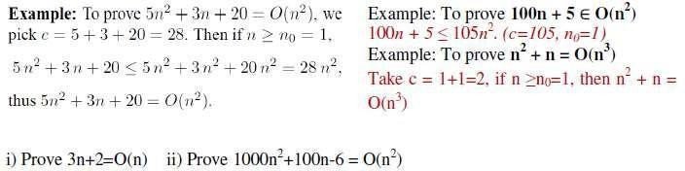
    - Omega notation
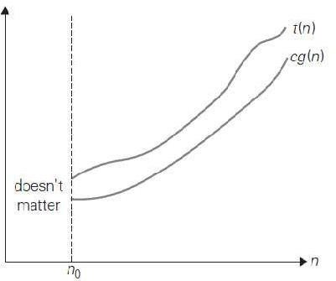
Definition: A function t(n) is said to be in Ω(g(n)), denoted t(n)∈Ω(g(n)), if t(n) is bounded below by some positive constant multiple of g(n) for all large n,i.e., if there exist some positive constant c and some nonnegative integer n0 suchthatt(n) ≥ c g(n) for all n ≥ n0.

Here is an example of the formal proof that n³ ∈Ω(n²):n³ ≥ n² for all n ≥ 0, i.e., we can select c = 1 and n0 = 0.

Example:

Example: To prove n³ + 4n² = Ω(n²)
We see that, if n≥0, n³+4n²≥ n³≥ n^{2;} Therefore n³+4n² ≥ 1n²for alln≥0 Thus, we have shown that n³+4n² =Ω(n²) where c = 1 & n0=0

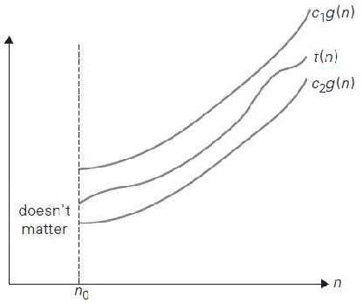
    - Theta notation
A function t(n) is said to be in Θ(g(n)), denoted t(n) ∈ Θ(g(n)),if t (n) is bounded both above and below by some positive constant multiples ofg(n)
for all large n, i.e., if there exist some positive constants c1 and c2 and somenonnegative integer n0 such that
c2g(n) ≤ t(n) ≤c1g(n) for all n ≥ n0.

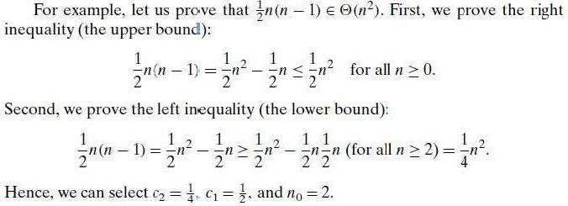
Example: n² + 5n + 7 = Θ(n²)
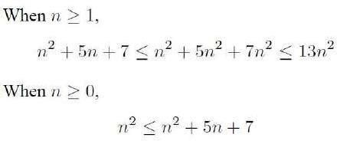
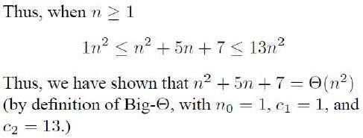

Strategies for Ω and Θ
      - Proving that a f(n) = Ω(g(n)) often requires more thought.
        - Quite often, we have to pick c < 1.
        - A good strategy is to pick a value of c which you think will work, and determine which value of n0 is needed.
        - Being able to do a little algebra helps.

        - We can sometimes simplify by ignoring terms of f(n) coefficients.
With the positive

      - The following theorem shows us that proving f(n) = Θ(g(n)) is nothing new: Theorem: f(n) = Θ(g(n)) if and only iff(n) = O(g(n)) and f(n) =Ω(g(n)).
Thus, we just apply the previous two strategies.
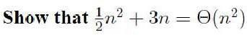
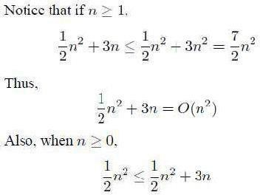
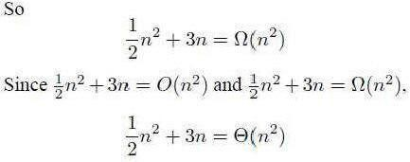

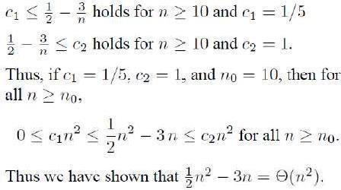
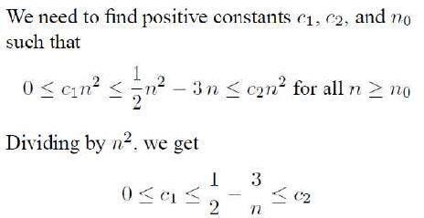
Theorem: If t1(n) ∈ O(g1(n)) and t2(n) ∈ O(g2(n)), then t1(n) + t2(n) ∈ O(max{g1(n), g2(n)}). (The analogous assertions are true for the Ω and Ө notations as well.)
Proof: The proof extends to orders of growth the following simple fact aboutfour arbitrary real numbers a1, b1, a2, b2: if a1 ≤ b1 and a2 ≤ b2, then a1 + a2 ≤ 2 max{b1, b2}.
Since t1(n) ∈ O(g1(n)), there exist some positive constant c1 and some nonnegative integer n1 such that t1(n) ≤ c1g1(n) for all n ≥ n1.

Similarly, since t2(n) ∈ O(g2(n)), t2(n) ≤ c2g2(n) for all n ≥ n2.
Let us denote c3 = max{c1, c2} and consider n ≥ max{n1, n2} so that we can use both inequalities. Adding them yields the following:
t1(n) + t2(n) ≤ c1g1(n) + c2g2(n)
≤ c3 g1(n) + c3g2(n) = c3[g1(n) + g2(n)]
≤ c32 max{g1(n), g2(n)}.
Hence, t1(n) + t2(n) ∈ O(max{g1(n), g2(n)}), with the constants c and n0 required by the O definition being 2c3 = 2 max{c1, c2} and max{n1, n2}, respectively.

3.4. Little Oh The function f(n)= o(g(n)) [ i.e f of n is a little oh of g of n ] if and only if
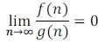
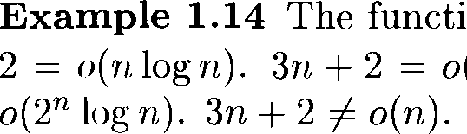
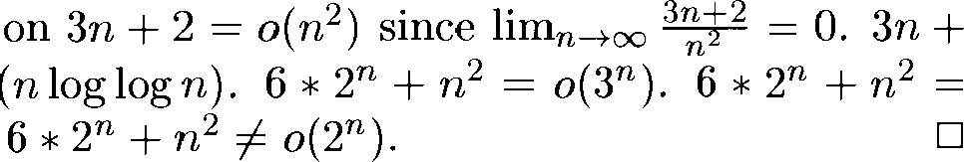
Example:

For comparing the order of growth limit is used
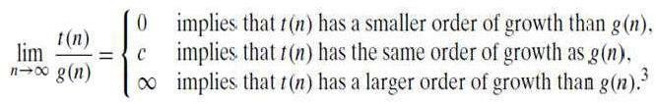
If the case-1 holds good in the above limit, we represent it by little-oh.

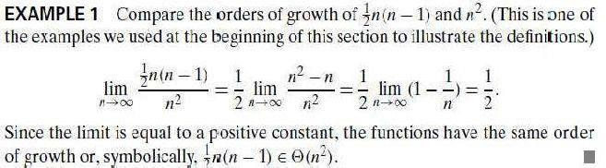
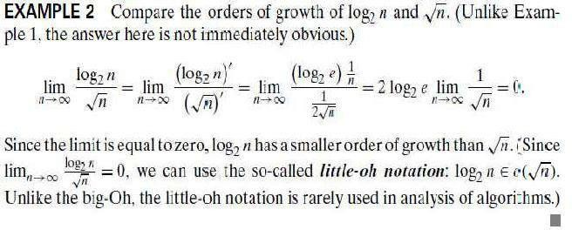
    - Basic asymptotic efficiency Classes
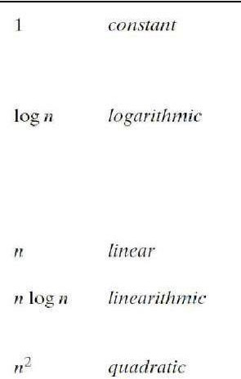
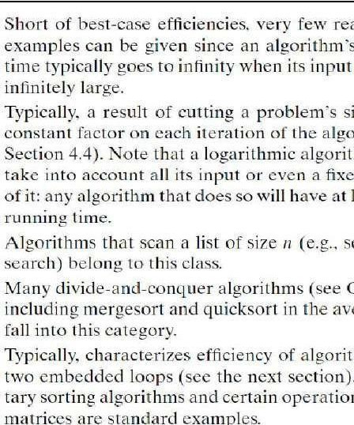
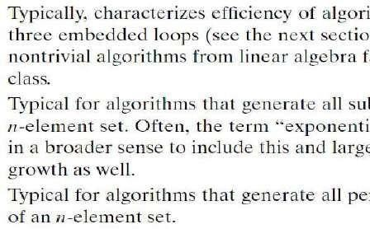
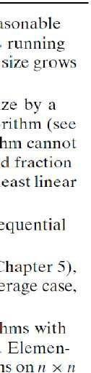
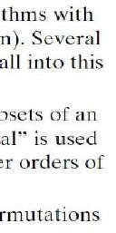
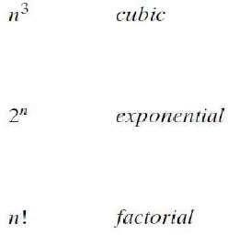
Class Name Comments

    - Mathematical Analysis of Non-recursive & Recursive Algorithms
Analysis of Non-recursive Algorithms
General Plan for Analyzing the Time Efficiency of Nonrecursive Algorithms
      - Decide on a parameter (or parameters) indicating an input’s size.
      - Identify the algorithm’s basic operation. (As a rule, it is located in innermost loop.)
      - Check whether the number of times the basic operation is execut d depends only on the size of an input. If it also depends on some additional property, the worst-case,

average-case, and, if separately.
necessary, best-case efficiencies have to be investigated

      - Set up a sum expressing the number of times the algorithm’s executed.
      - Using standard formulas and rules of sum manipulation, either
basic operation is

find a closedform

formula for the count or, at the very least, establish its order of growth.

Example-1: To find maximum element in the given array
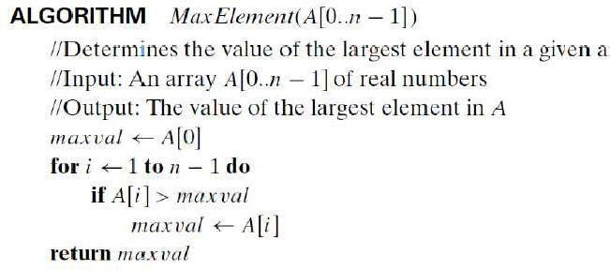
Here comparison is the basic operation. Note that number of comparisions will be same for all arrays of size n. Therefore, no need to distinguish worst, best and average cases. Total

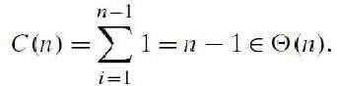
number of basic operations are,
(comparison)

Example-2: To check whether all the elements in the given array are distinct
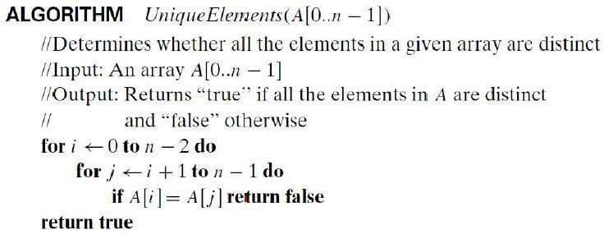
Here basic operation is comparison. The maximum no. of comparisons happen in the worst case. (i.e. all the elements in the array are distinct and algorithms return true).
Total number of basic operations (comparison) in the worst case are,

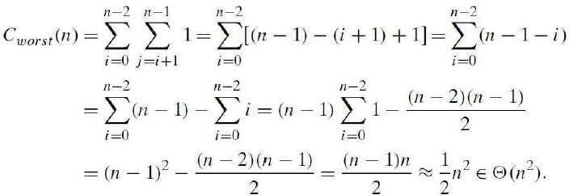
Other than the worst case, the total comparisons areless than ¹ n². For example if the first
2
two elements of the array are equal, only one comparison is computed. So in general C(n) =O(n²)

Example-3: To perform matrix multiplication
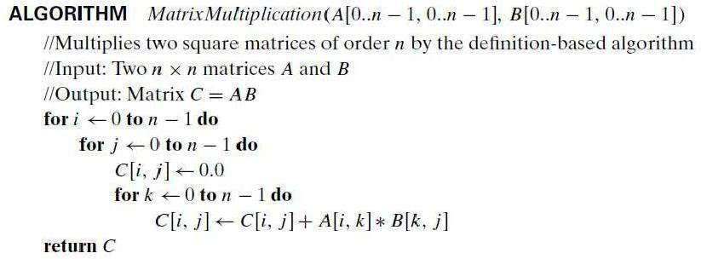
Number of basic operations (multiplications) is

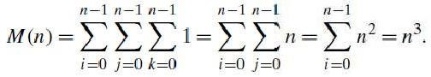
Total running time:
Suppose if we take into account of addition; Algoritham also have same number of additions
A(n) = n³
Total running time:

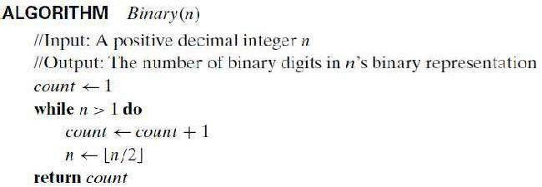
Example-4: To count the bits in the binary representation

The basic operation is count=count + 1 repeats no. of times
Analysis of Recursive Algorithms
General plan for analyzing the time efficiency of recursive algorithms
- Decide on a parameter (or parameters) indicating an input’s size.
- Identify the algorithm’s basic operation.
- Check whether the number of times the basic operation is executed can vary on different inputs of the same size; if it can, the worst-case, average-case, and best- case efficiencies must be investigated separately. Set up a recurrence relation, with an appropriate initial condition, for the number of times the basic operation is executed.
- Solve the recurrence or, at least, ascertain the order of growth of its solution.
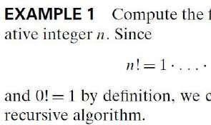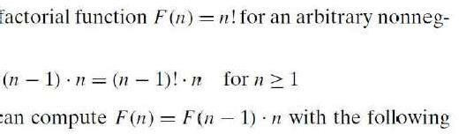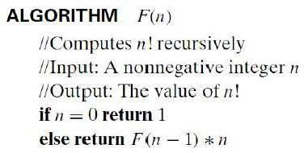
Example-1
Since the function F(n) is computed according to the formula
The number of multiplicationsM(n) needed to compute it must satisfy the equality
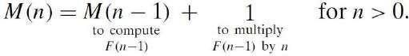
Such equations are called recurrence relations
Condition that makes the algorithm stopif n = 0 return 1. Thus recurrence relation and initial conditionfor the algorithm’s number of multiplications M(n) can be stated as
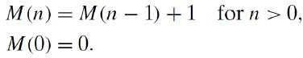
We can use backward substitutions method to solve this
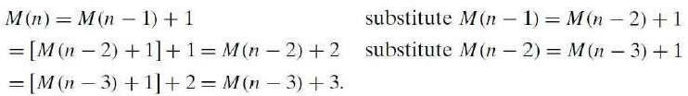
….

Example-2: Tower of Hanoi puzzle. In this puzzle, There are n disks of different sizes that canslide onto any of three pegs. Initially, all the disks are on the first peg in order ofsize, the largest on the bottom and the smallest on top. The goal is to move all thedisks to the third peg, using the second one as an auxiliary, if necessary. We canmove only one disk at a time, and it is forbidden to place a larger disk on top of asmaller one.The problem has an elegant recursive solution, which is illustrated in Figure.
- If n = 1, we move the single disk directly from the source peg to the destination peg.
- To move n>1 disks from peg 1 to peg 3 (with peg 2 as auxiliary),
  - we first move recursively n-1 disks from peg 1 to peg 2 (with peg 3 as auxiliary),
  - then move the largest disk directly from peg 1 to peg 3, and,
  - finally, move recursively n-1 disks from peg 2 to peg 3 (using peg 1 as auxiliary).
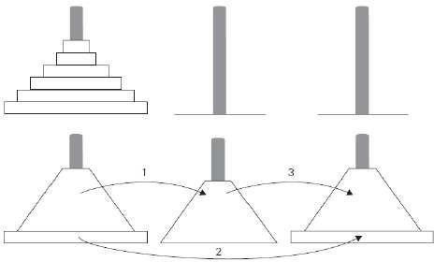
Figure: Recursive solution to the Tower of Hanoi puzzle
Algorithm: TowerOfHanoi(n, source, dest, aux)
If n == 1, THEN
move disk from source to dest else
TowerOfHanoi (n - 1, source, aux, dest) move disk from source to dest TowerOfHanoi (n - 1, aux, dest, source)
End if
Computation of Number of Moves
The number of moves M(n) depends only on n. The recurrence equation is
We have the following recurrence relation for the number of moves M(n):
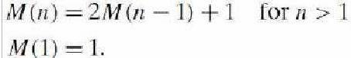
We solve this recurrence by t e same method of backward substitutions:
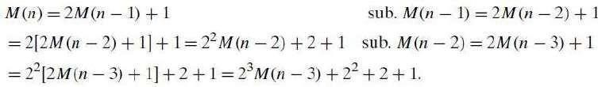

The pattern of the first three sums on the left suggests that the next one will be 2⁴M(n − 4) + 2³ + 2² + 2 + 1, and generally, after i substitutions, we get
Since the initial condition is specified for n = 1, which is achieved for i = n-1, weget the following formula for the solution to recurrence,
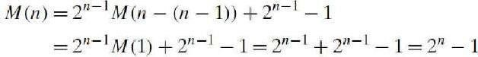

Example-3: To count bits of a decimal number in its binary representation
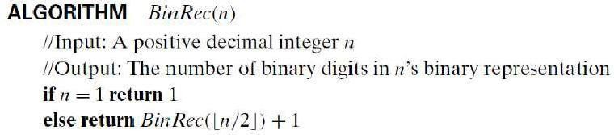

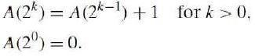
The recurrence relation can b Also note that A(1) = 0.
written as
.

The standard approach to solving such a recurrence is to solve it only for n = 2^{k} and then take advantage of the theorem called the smoothness rule which claims that under very broad assumptions the order of growth observed for n = 2^{k} gives a correct answer about the order of growth for all values of n.
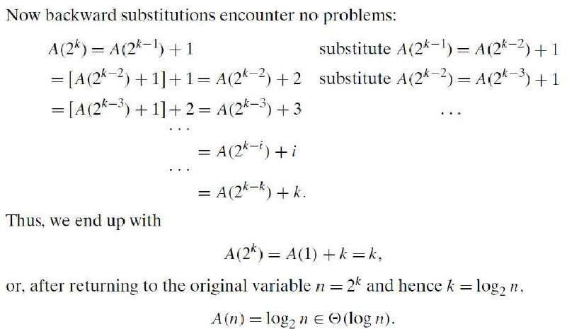

  - Important Problem Types
In this section, we are going to introduce the most important problem types: Sorting, Searching, String processing, Graph problems, Combinatorial problems.
    - Sorting
The sorting problem is to rearrange the items of a given list in non-decreasing order. As a practical matter, we usually need to sort lists of numbers, characters from an alphabet or character strings. Although some algorithms are indeed better than others, there is noalgorithm that would be the best solution in all situations. Some of the algorithms are simple but relatively slow, while others are faster but more complex; some work better on randomly ordered inputs, while others do better on almost-sorted lists; so e are suitable only for lists residing in the fast memory, while others can be adapted for sorting large files stored on a disk; and so on.
Two properties of sorting algorithms deserve special mention. A sorting algorithm is called stable if it preserves the relative order of any two equal elements in its input. The second notable feature of a sorting algorithm is the amount of extra memory the algorithm requires. An algorithm is said to be in-place if it does not require extra memory, except, possibly, for a few memory units.
    - Searching
The searching problem deals with finding a given value, called a search key, in a given set. (or a multiset, which permits several elements to have the same value).There are plenty of searching algorithms to choose from. They range from the straight forward sequential search to a spectacularly efficient but limited binary search and algorithms based on representing the underlying set in a different form more conducive to searching. The latter algorithms are of particular importance for real-world applications because they are indispensable for storing and retrieving information from large databases.
    - String Processing
In recent decades, the rapid proliferation of applications dealing with non-numerical data has

intensified the interest of algorithms. A string is a
researchers and computing practitioners sequence of characters from an alphabet.
in string-handling String-processing

algorithms have been important for computer science in conjunction with computer languages and compiling issues.
    - Graph Problems
One of the oldest and most interesting areas in algorithmics is graph algorithms. Informally, a graph can be thought of as a collection of points called vertices, some of which are connected by line segments called edges. Graphs can be used for modeling a wide variety of applications, including transportation, communication, social and economic networks, project scheduling, and games. Studying different technical and social aspects of the Internet in particular is one of the active areas of current research involving computer scientists, economists, and social scientists.

    - Combinatorial Problems
Generally speaking, combinatorial problems are the most difficult problems in computing, from both a theoretical and practical standpoint. Their difficulty stems from the following facts. First, the number of combinatorial objects typically grows extremely fast with a problem’s size, reaching unimaginable magnitudes even for moderate-sized instances.
Second, there are no known algorithms for solving most such problems exactly in an acceptable amount of time.
  - Fundamental Data Structures
Since the vast majority of algorithms of interest operate on data, particular ways of organizing data play a critical role in the design and analysis of algorithms. A data structure can be defined as a particular scheme of organizing related data items.
    - Linear Data Structures
The two most important elementary data structures are the array and the linked list.
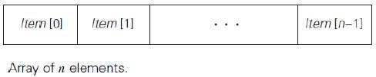
A(one-dimensional) array is a sequence of n items of the same data type that are stored contiguously in computer memory and made accessible by specifying a value of the array’s index.

A linked list is a sequence of zero or more elements called nodes, each containing two kinds of information: some data and one or more links called pointers to other nodes of the linked list. In a singly linked list, each node except the last one contains a single pointer to the next element. Another extensions the structure called the doubly linked list, in which every node, except the first and the last, contains pointers to both its successor and its predecessor.
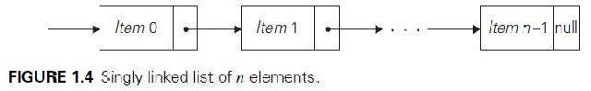
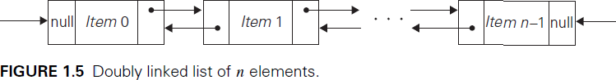

A list is a finite sequence of data items, i.e., a collection of data items arranged in a certain linear order. The basic operations performed on this data structure are searching for, inserting, and deleting an element. Two special types of lists, stacks and queues, are particularly important.
A stack is a list in which insertions and deletions can be done only at the end. This end is called the top because a stack is usually visualized not horizontally but vertically—akin to a stack of plates whose ―operations‖ it mimics very closely.

A queue, on the other hand, is a list from which elements are deleted from one end of the structure, called the front (this operation is called dequeue), and new elements are added to the other end, called the rear (this operation is called enqueue). Consequently, a queue operates in a ―first-in–first-out‖ (FIFO) fashion—akin to a queue of customers served by a single teller in a bank. Queues also have many important applications, including several algorithms for graph problems.
Many important applications require selection of an item of the highest priority among a dynamically changing set of candidates. A data structure that seeks to satisfy the needs of such applications is called a priority queue. A priority queue is a collection of data items from a totally ordered universe (most often, integer or real numbers). The principal operations on a priority queue are finding its largest element, deleting its largest element, and adding a new element.
    - Graphs
A graph is informally thought of as a collection of points in the plane called ―vertices‖ or nodes,‖ some of them connected by line segments called ―edges‖ or ―arcs.‖A graph G is called undirected if every edge in it is undirected. A graph whose every edge is directed is called directed. Directed graphs are also called digraphs.
The graph depicted in Figure (a) has six vertices and seven undirected edges:
V = {a, b, c, d, e, f }, E = {(a, c), (a, d), (b, c), (b, f ), (c, e), (d, e), (e, f )}.
The digraph depicted in Figure 1.6b has six vertices and eight directed edges:
V = {a, b, c, d, e, f }, E = {(a, c), (b, c), (b, f ), (c, e), (d, a), (d, e), ( , c), (e, f )}.
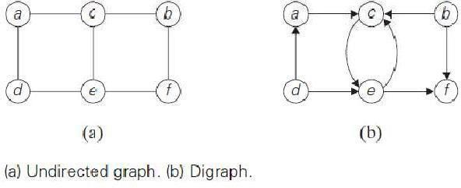
Graph Representations- Graphs for computer algorithms are usually represented in one of two ways: the adjacency matrix and adjacency lists.
The adjacency matrix of a graph with n vertices is an n x n boolean matrix with one row and one column for each of the graph’s vertices, in which the element in the i^{th} row and the j^{th} column is equal to 1 if there is an edge from the i^{th} vertex to the j^{th} vertex, and equal to 0 if there is no such edge.
The adjacency lists of a graph or a digraph is a collection of linked lists, one for each vertex, that contain all the vertices adjacent to the list’s vertex (i.e., all the vertices connected to it by an edge).

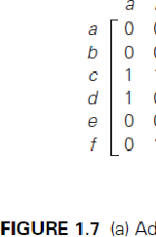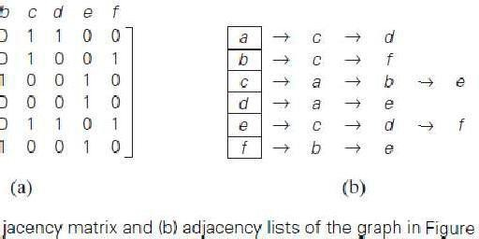
Weighted Graphs: A weighted graph (or weighted digraph) is a graph (or digraph) with numbers assigned to its edges. These numbers are called weights or costs.
Among the many properties of graphs, two are important for a great number of applications: connectivity and acyclicity. Both are based on the notion of a path. A path from vertex u to vertex v of a graph G can e defined as a sequence of adjacent (connected by an edge) vertices that starts with u and ends with v.
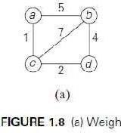
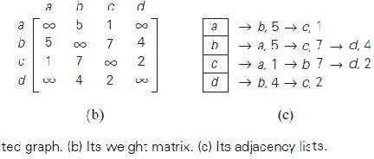
A graph is said to be connected if for every pair of its vertices u and v there is a path from u to v. Graphs with several connected components do happen in real-world applications. It is important to know for many applications whether or not a graph under consideration has cycles. A cycle is a path of a positive length that starts and ends at the same vertex and does not traverse the same edge more than once.
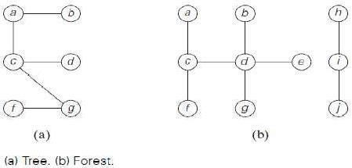
    - Trees
A tree (more accurately, a free tree) is a connected acyclic graph. A graph that has no cycles but is not necessarily connected is called a forest: each of its connected components is a tree. Trees have several
important properties other graphs do not have. In particular, the number of edges in a tree is always one less than the number of its vertices:|E| = |V|-1
Rooted Trees: Another very important property of trees is the fact that for every two vertices in a tree, there always exists exactly one simple path from one of these vertices to the other. This property makes it possible to select an arbitrary vertex in a free tree and consider it as the root of the so-called rooted tree. A rooted tree is usually depicted by placing its root on the top (level 0 of the tree), the vertices adjacent to the root below it (level 1), the vertices two edges apart from the roots till below (level 2), and so on.

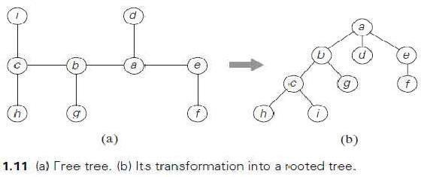
The depth of a vertex v is the length of the simple path from the root to v. The height of a tree is the length of the longest simple path from the root to a leaf.

Ordered Trees- An ordered tree
is a rooted tree in which all the children of each vertex are ordered. It is convenient to assume that in a tree’s diagram; all the children are ordered left to right. A binary tree can be defined as an ordered tree in which every vertex has no more than two children and each child is designated as either a left child or a right child of its parent; a binary tree may also be empty.
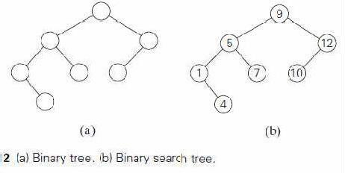
If a number assigned to each parental vertex is larger than all the numbers in its left subtree and smaller than all the numbers in its right subtree. Such trees are called binary search trees. Binary trees and binary search trees have a wide variety of applications in computer science.
    - Sets and Dictionaries
A set can be described as an unordered collection (possibly empty) of distinct items called elements of the set. A specific set is defined either by an explicit listing of its elements (e.g., S = {2,3, 5, 7}) or by specifying a property that all the set’s elements and only they must satisfy (e.g., S = {n: n is a prime number smaller than 10}).
The most important set operations are: checking membership of a given item in a given set; finding the union of two sets, which comprises all the elements in either or both of them; and finding the intersection of two sets, which comprises all the common elements inthe sets.
Sets can be implemented in computer applications in two ways. The first considers only sets that are subsets of some large set U, called the universal set. If set U has n elements, then any subset S of U can be represented by a bitstring of size n, called a bit vector, in which the i^{th} element is 1 if and only if the i^{th} element of U is included in set S.
The second and more common way to represent a set for computing purposes is to use the list structure to indicate the set’s elements. This is feasible only for finite sets. The requirement for uniqueness is sometimes circumvented by the introduction of a multiset, or bag, an unordered collection of items that are not necessarily distinct. Note that if a set is represented by a list, depending on the application at hand, it might be worth maintaining the list in a sorted order.
Dictionary: In computing, the operations we need to perform for a set or a multiset most often are searching for a given item, adding a new item, and deleting an item from the collection. A data structure that implements these three operations is called the dictionary.
An efficient implementationof a dictionary has to strike a compromise between the efficiency

of searching and the efficiencies of the other two operations. They range from an unsophisticated use of arrays (sorted or not) to much more sophisticated techniques such as hashing and balanced search trees.
A number of applications in computing require a dynamic partition of so men-element set into a collection of disjoint subsets. After being initialized as a collection of n one-element subsets, the collection is subjected to a sequence of intermixed union and search operations. This problem is called the set union problem.

Design
Lecture Notes on



and Analysis ofAlgorithms

Module-2 :Divide and Conquer

      - General method
      - Recurrence equation
      - Algorithm: Binary search
Contents

      - Algorithm: Finding the maximum and minimum
      - Algorithm: Merge sort
      - Algorithm: Quick sort
      - Algorithm: Strassen’s matrix multiplication
      - Advantages and Disadvantages
      - Decrease and Conquer Approach
      - Algorithm: Topological Sort

- Generalmethod
Divide and Conquer is one of the best-known general algorithm design according to the following general plan:

Technique. It works

- Given a function to compute on ‘n’ inputs the divide-and-conquer strategy suggests splitting the inputs into ‘k’ distinct subsets, 1<k<=n, yielding ‘k’ sub problems.
  - These sub problems must be solved, and then a method must be found to combine sub solutions into a solution of the whole.
  - If the sub problems are still relatively large, then the divide-and-conquer strategy can possibly be reapplied.
  - Often the sub problems resulting from a divide-and-conquer design are of the same type as the original problem.For those cases the reapplication of the divide-and- conquer principle is naturally expressed by a recursive algorithm.

A typical case with k=2is diagrammatically shown below.
Problem of size n
Sub Problem of size n/2
Sub Problem of size n/2
Solutiontosubproblem2
Solution to subproblem 1
Solution to the original problem

Control Abstraction for divide and conquer:
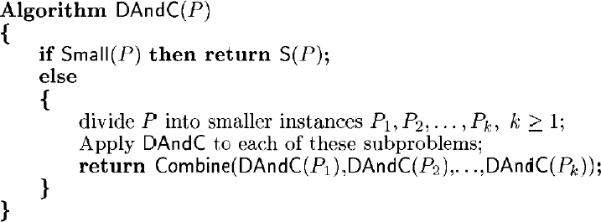
In the above specification,
  - Initially DAndC(P) is invoked, where ‘P’ is the problem to be solved.
  - Small (P) is a Boolean-valued function that determines whether the input size is small enough that the answer can be computed without splitting. If this so, the function ‘S’ is invoked. Otherwise, the problem P is divided into smaller sub problems. These sub problems P1, P2 …Pk are solved by recursive application of DAndC.
  - Combine is a function that determines the solution to P using the solutions to the ‘k’ sub problems.

- Recurrence equation for Divide and Conquer
If the size of problem ‘p’ is n and the sizes of the ‘k’ sub problems are n1, n2….nk, respectively, then the computing time of divide and conquer is described by the recurrence relation

Where,
  - T(n) is the time for divide and conquer method on any input of size n and
  - g(n) is the time to compute answer directly for small inputs.
  - The function f(n) is the time for dividing the problem ‘p’ and combining the solutions to sub problems.
For divide and conquer based algorithms that produce sub problems of the same type as the original problem, it is very natural to first describe them by using recursion.
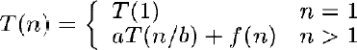
More generally, an instance of size n can be divided into b instances of size n/b, with a of them needing to be solved. (Here, a and b are constants; a>=1 and b > 1.). Assuming that size n is a power of b(i.e. n=b^{k}), to simplify our analysis, we get the following recurrence for the running time T(n):
. (1)
where f(n) is a function that accounts for the time spent on dividing the problem into smaller ones and on combining their solutions.

The recurrence relation can theorem.
be solved by i) substitution method or by using ii) master

- Substitution Method - This method repeatedly makes substitution for each

occurrence of the function T in the right-hand side until all disappear.
such occurrences

- Master Theorem - The efficiency analysis of many divide-and-conquer algorithms is greatly simplified by the master theorem. It states that, in recurrence equation T(n) =

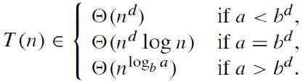
aT(n/b) + f (n), If f (n)∈ Θ (n^{d}) where d ≥ 0 then

Analogous results hold for the Ο and Ω notations, too.
For example, the recurrence for the number of additions A(n) made by thedivide-and- conquer sum-computation algorithm (see above) on inputs of sizen = 2^{k} is
Thus, for this example, a = 2, b = 2, and d = 0; hence, since a >b^{d},

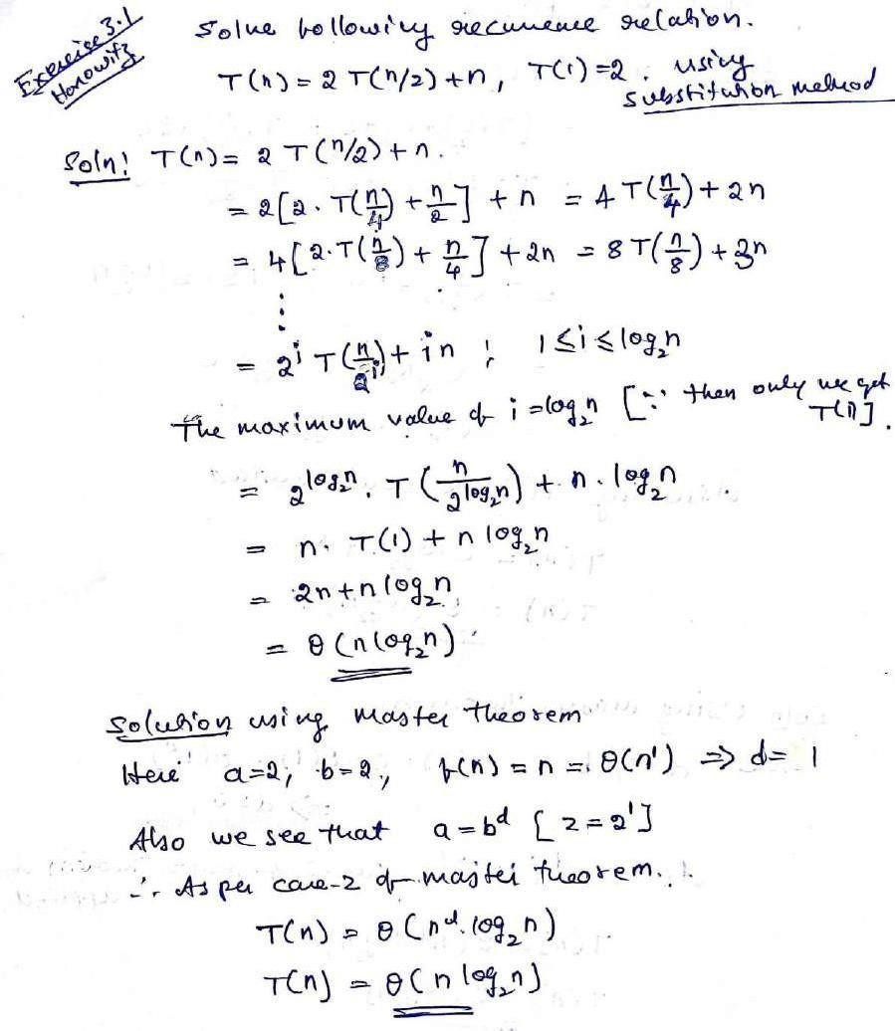
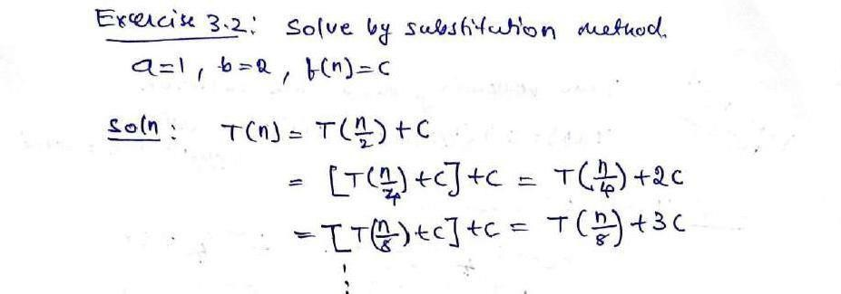
Problems on Substitution method & Master theorem to solve the recurrence relation

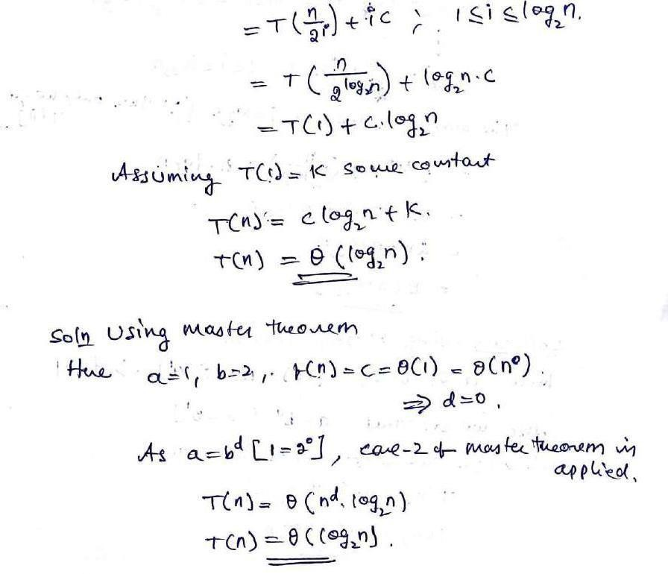
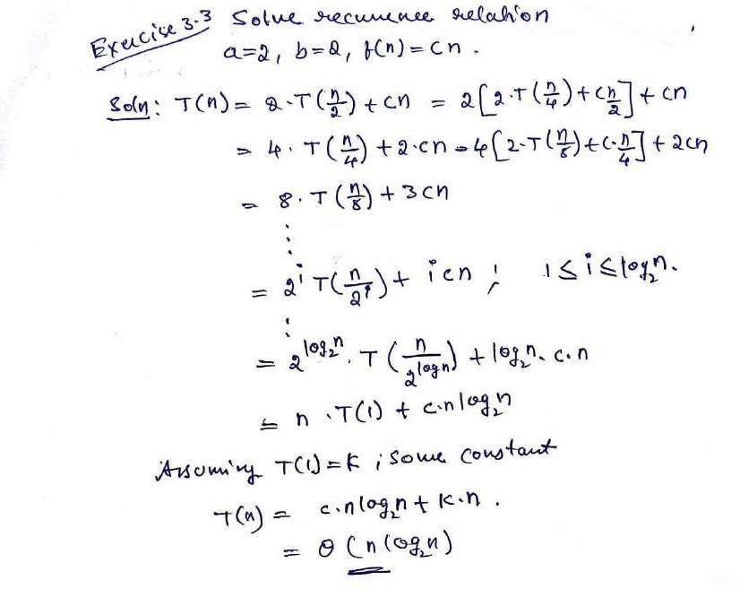

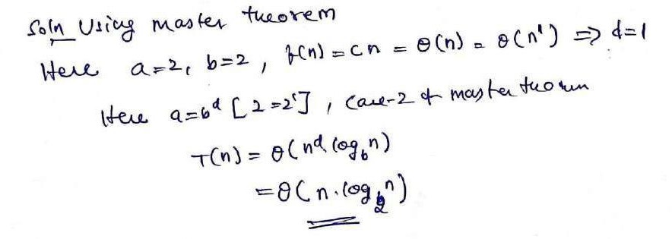
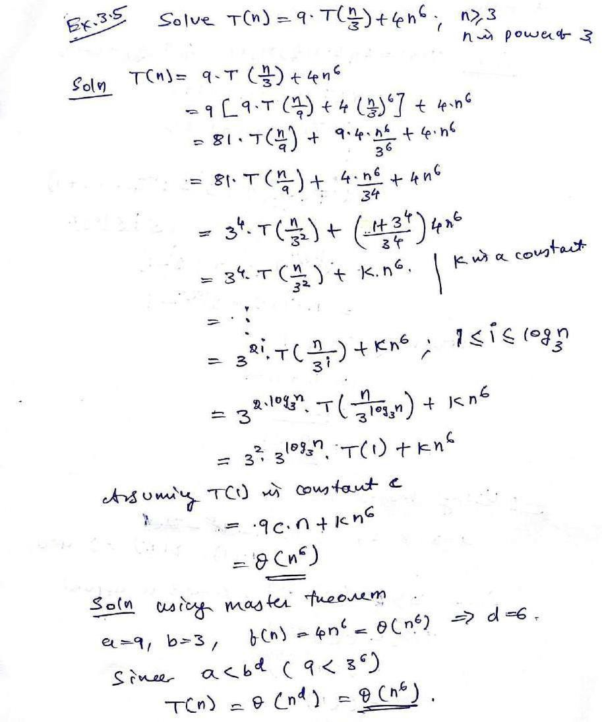

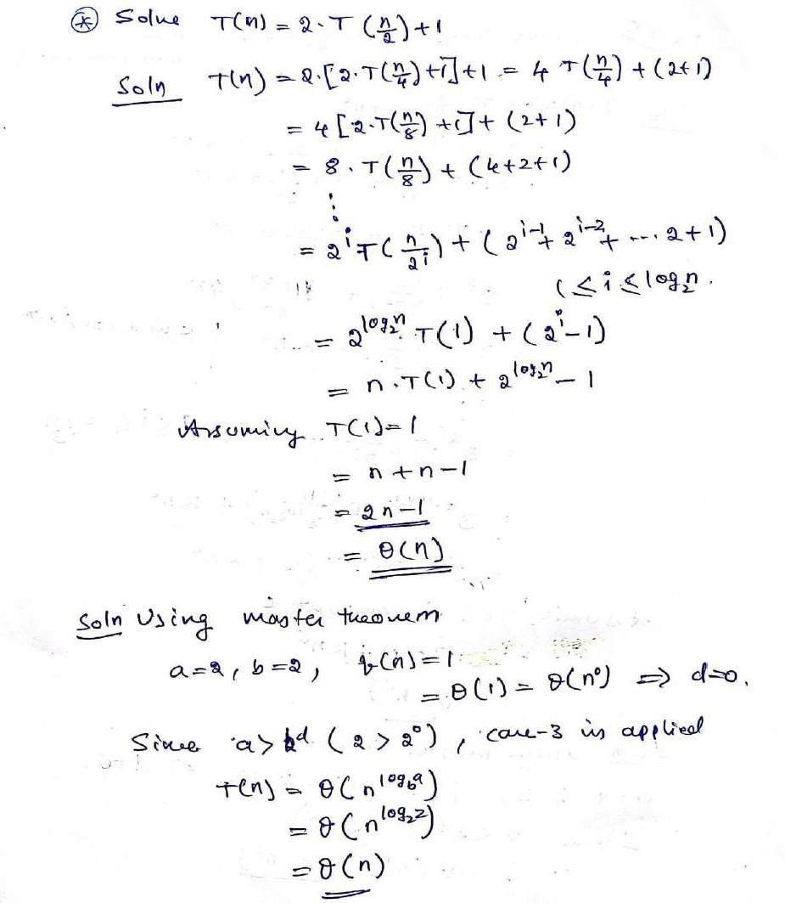
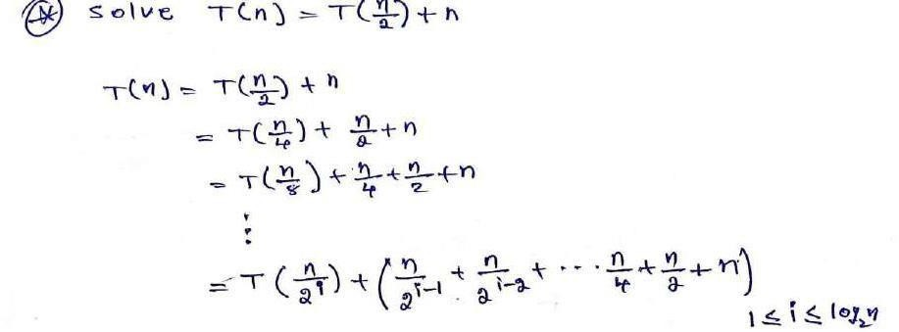

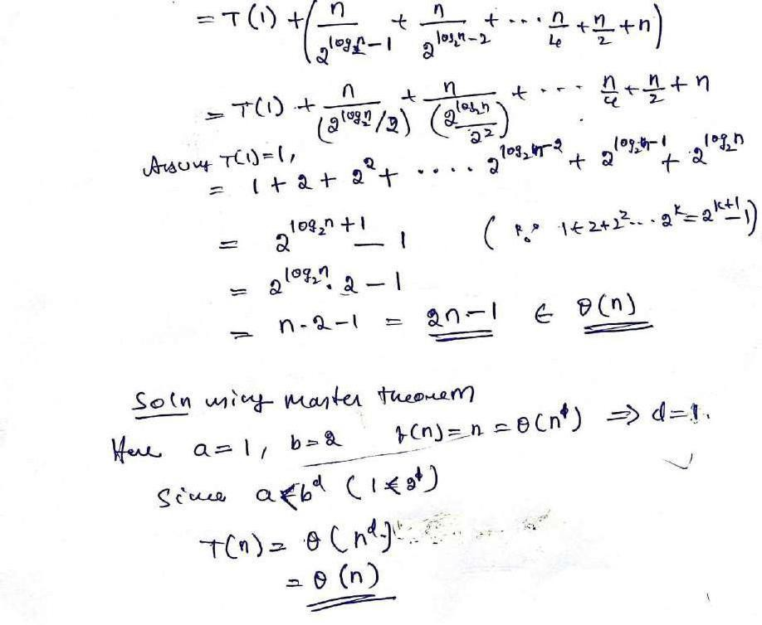

Binary Search
Problem definition:Let ai, 1 ≤ i ≤ n be a list of elements that are sorted in non-decreasing order. The problem is tofind whether a given element x is present in the list or not. If x is present we have to determine a value j (element’s position) such that aj=x. If x is not in the list, then j is set to zero.
Solution:Let P = (n, ai…al , x) denote an arbitrary instance of search problem where n is the number of elements in the list, ai…alis the list of elements andx is the key element to be searched for in the given list.Binary search on the list is done as follows:

Step1: Pick an index q in the middle range [i, l] i.e. q=(n + 1)/2] and compare x with aq. Step 2: if x = aqi.e key element is equal to mid element, the problem is immediatelysolved.
Step 3: if x <aqin this case x has to be searched for only in the sub-list ai, ai+1, ……, aq- Therefore, problem reduces to (q-i, ai…aq-1, x).
Step 4: if x >aq,x has to be searched for only in the sub-list aq+1, ...,., al . Therefore problem reduces to (l-i, aq+1…al, x).
For the above solution procedure, the Algorithm can be implemented as recursive or non- recursive algorithm.

Recursive binary search algorithm
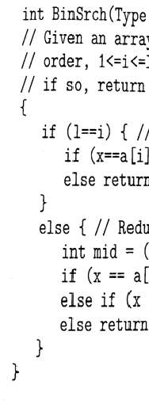
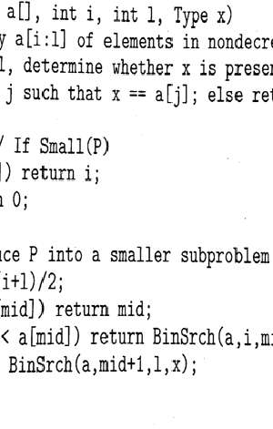
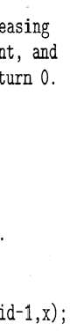
Iterative binary search:
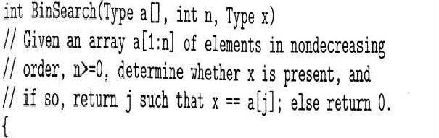
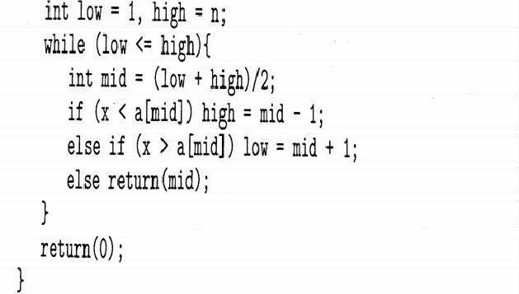
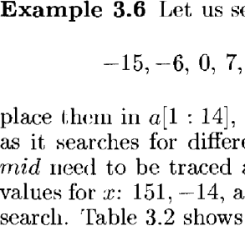
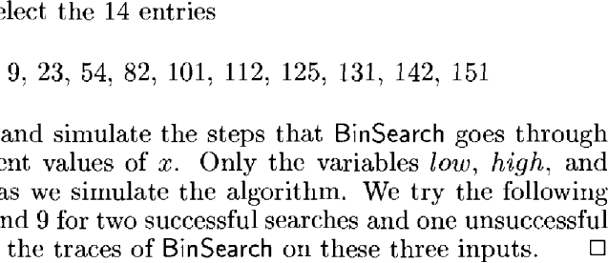

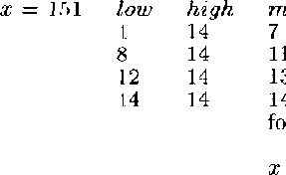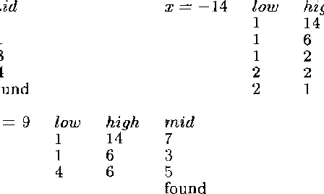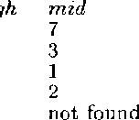
Analysis
In binary search the basic operation is key comparison. Binary Search can be analyzed with the best, worst, and average case number of comparisons. The numbers of comparisons for the recursive and iterative versions of Binary Search are the same, if comparison counting is relaxed slightly. For Recursive Binary Search, count each pass through the if-then-else block as one comparison. For Iterative Binary Search, count each pass through the while block as one comparison. Let us find out how many such key comparison does the algorithm make on an array of n elements.
Best case –Θ(1) In the best case, the key is the middle in the array. A constant number of comparisons (actually just 1) are required.
Worst case - Θ(log2 n) In the worst case, the key does not exist in the array at all. Through each recursion or iteration of Binary Search, the size of the admissible range is halved. This halving can be done ceiling (log2n ) times. Thus, [ log2 n ] comparisons are required.
Sometimes, in case of the successful search, it may take maximum number of comparisons.
[ log2 n ]. So worst case complexity of successful binary search is Θ (log2 n).
Average case - Θ (log2n) To find the average case, take the sum of the product of number of comparisons required to find each element and the probability of searching for that element. To simplify the analysis, assume that no item which is not in array will be searched for, and that the probabilities of searching for each element are uniform.
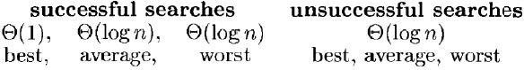
Space Complexity - The space requirements for the recursive and iterative versions of binary search are different. Iterative Binary Search requires only a constant amount of space, while

Recursive Binary Search requires space proportional to the number maintain the recursion stack.
of comparisons to

Advantages: Efficient on very big list, Can be implemented iteratively/recursively.

Limitations:
- Interacts poorly with the memory hierarchy
- Requires sorted list as an input
- Due to random access of list element, needs arrays instead of linked list.

Finding the maximum and minimum
Problem statement:Given a list of n elements, the problem is to find minimum items.

the maximum and

StraightMaxMin: A simple and straight forward algorithm to achieve this is given below.
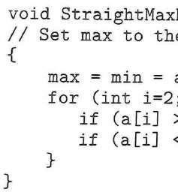
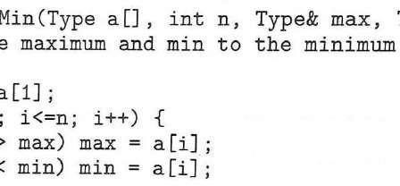
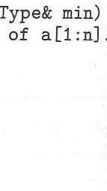

Explanation:
- StraightMaxMin requires 2(n-1) comparisons in the best, average & worst cases.
- By realizing the comparison of a[i]>max is false, improvement in a algorithm can be done. Hence we can replace the contents of the for loop by,
If(a[i]>Max) then Max = a[i]; Else if (a[i]<min) min=a[i]
- On the average a[i] is > max half the time.So, the avg. no. of comparison is 3n/2-1.

Algorithm based on Divide and Conquer strategy
Let P = (n, a [i],……,a [j]) denote an arbitrary instance of the problem. Here ‘n’ is the no. of elements in the list (a[i],….,a[j]) and we are interested in finding the maximum and minimum of the list.If the list has more than 2 elements, P has to be divided into smaller instances.
For example, we might divide ‘P’ into the 2 instances, P1=( [n/2],a[1], a[n/2])
P2= ( n-[n/2], a[[n/2]+1], , a[n])
After having divided ‘P’ into 2 smaller sub problems, we can solve them by recursively invoking the same divide-and-conquer algorithm.
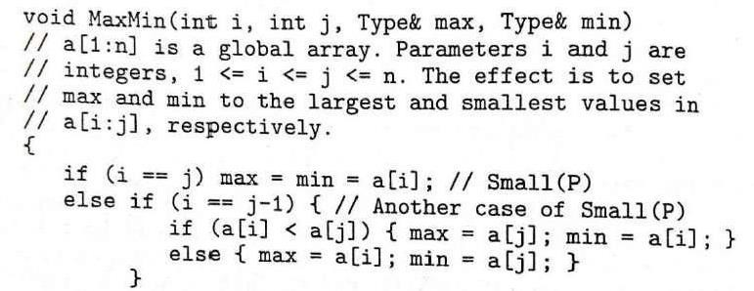
Algorithm:

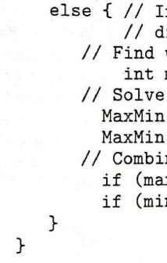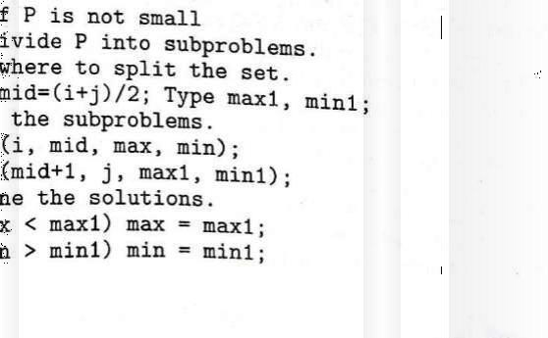

Example:
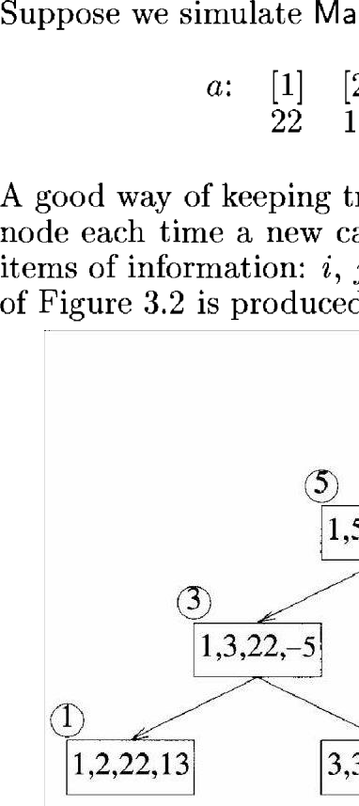
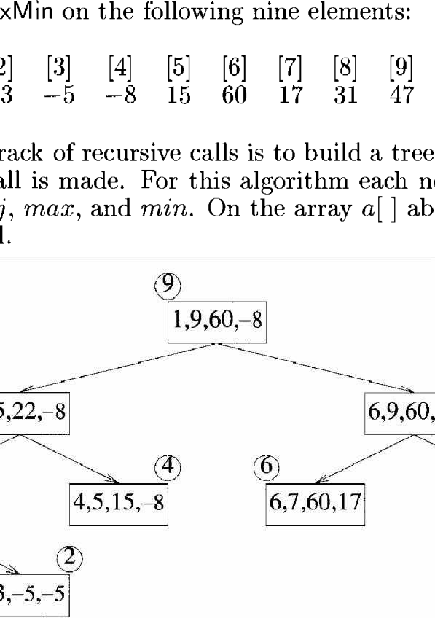
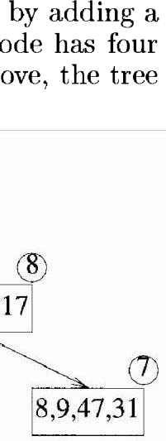
of recursive calls of MaxMin is as follows

Analysis - Time Complexity
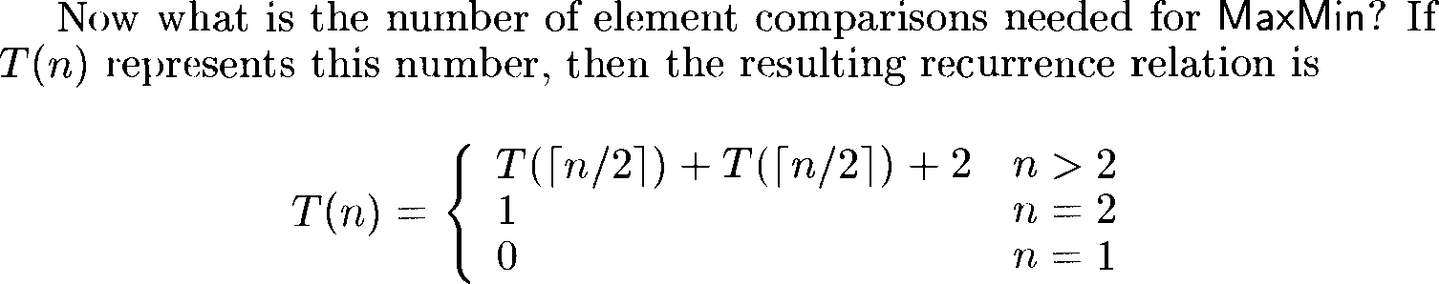

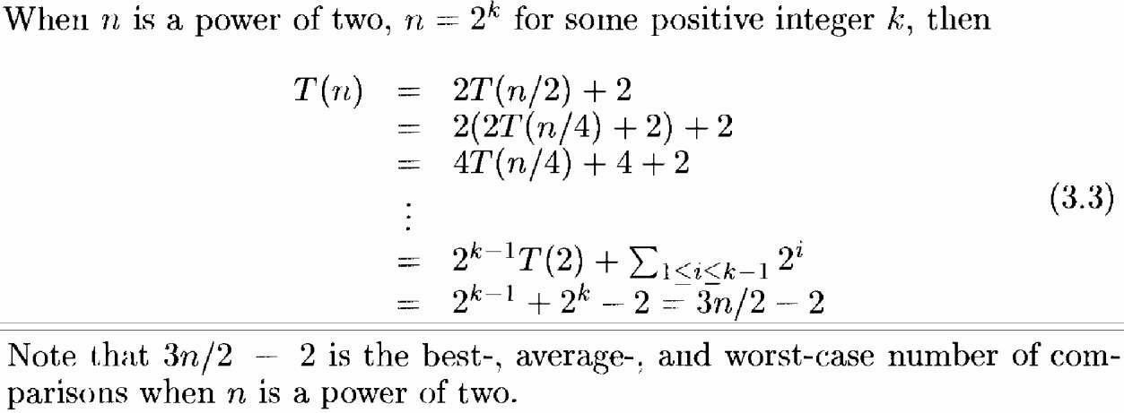
Compared with the straight forward method (2n-2) this method saves 25% in comparisons.

Space Complexity
Compared to the straight forward method, the MaxMin method requires extra stack space for i, j, max, min, max1 and min1. Given n elements there will be 𝗁log2n] + 1 levels ofrecursion and we need to save seven values for each recursive call. (6 + 1 for return address).

Merge Sort
Merge sort is a perfect example of a successful application of the divide-and conquer
taencdhnAiq[uen./I2t ]so.r.tsn-a1g],ivseonrtianrgrayeaAch[Oof..t.hnem- 1r]ecbuyrsdiivveildyi,nganidt itnhteontwmoerhgailnvges tAhe[0tw..o 𝗁snm/a2l]le-1r ] sorted arrays into a single sorted one.
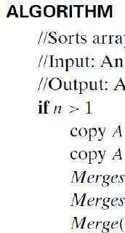
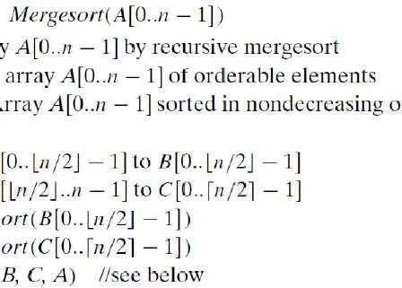
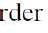
The merging of two sorted arrays can be done as follows.
- Two pointers (array indices) are initialized to point to the first elements of the arrays being merged.
- The elements pointed to are compared, and the smaller of them is added to a new array being constructed

- After that, the index of the smaller element is incremented to point to its immediate successor in the array it was copied from. This operation is repeated until one of the two given arrays is exhausted, and then the remaining elements of the other array are copied to the end of the new array.
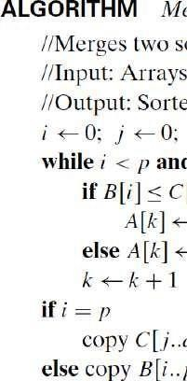
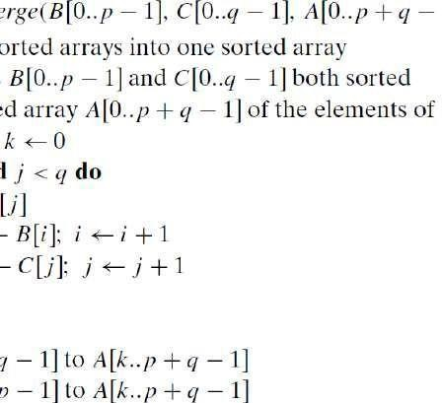
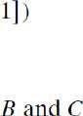

Example:
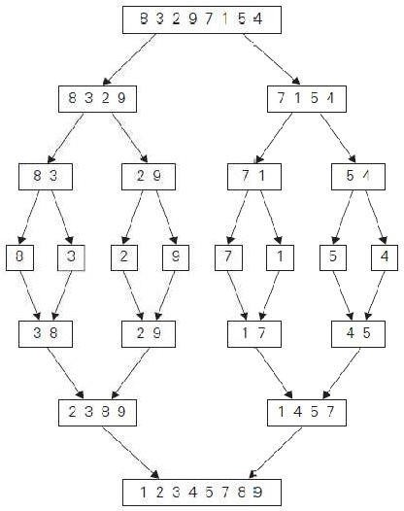
The operation of the algorithm on the list 8, 3, 2, 9, 7, 1, 5, 4 is illustrated in the figure

Analysis
Here the basic operationis key comparison. As merge sort execution does not depend on the order of the data, best case and average case runtime are the same as worst case runtime.
Worst case:During key comparison, neither of the two arrays becomes empty before the other one contains just one element leads to the worst case of merge sort. Assuming for

simplicity that total number of elements n is a power of 2, the recurrence relation for the number of key comparisons C(n) is
where, Cmerge(n) is the number of key comparisons made during the merging stage.
Let us analyze Cmerge(n), the number of key comparisons performed during the merging stage. At each step, exactly one comparison is made, after which the total number of elements in the two arrays still needing to be processed is reduced by 1. In the worst case, neither of the two arrays becomes empty before the other one contains just one element (e.g., smaller elements may come from the alternating arrays).Therefore, for the worst case, Cmerge(n) = n –1.
Now,
Solving the recurrence equation using master theorem:
Here a = 2, b = 2, f (n) = n, d = 1. Therefore 2 = 2¹, case 2 holds in the master theorem
Cworst(n) = Θ (n^{d} log n) = Θ (n¹ log n) = Θ (n log n)Therefore Cworst(n) = Θ (n log n)

Advantages:
- Number of comparisons performed is nearly optimal.
- For large n, the num er of comparisons made by this algorithm in the average case turns out to be about 0.25n less and hence is also in Θ(n log n).
- Merge sort will never degrade to O (n²)
- Another advantage of mergesort over quicksort and heap sort is its stability. (A sorting algorithm is said to be stable if two objects with equal keys appear in the same order in sorted output as they appear in the input array to be sorted. )

Limitations:
- The principal shortcoming of mergesort is the linear amount [O(n) ] of extra storage the algorithm requires. Though merging can be done in-place, the resulting algorithm is quite complicated and of theoretical interest only.

Variations of merge sort
- The algorithm can be implemented bottom up by merging pairs of the array’s elements, then merging the sorted pairs, and so on. (If n is not a power of 2, only slight book keeping complications arise.) This avoids the time and space overhead of using a stack to handle recursive calls.
- We can divide a list to be sorted in more than two parts, sort each recursively, and then merge them tog ther. Thisscheme, which is particularly useful for sorting files residing on secondary memorydevices, is called multiway mergesort.

Quick sort
Quicksort is the other important sorting algorithm that is based on the divide-and-conquer approach. Unlike mergesort, which divides its input elements according to their position in the array, quicksort divides ( or partitions) them according to their value.
A partition is an arrangement of the array’s elements so that all the elements to the left of some element A[s] are less than or equal to A[s], and all the elements to the right of A[s] are greater than or equal to it:
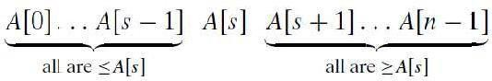
Obviously, after a partition is achieved, A[s] will be in its final position in thesorted array,

and we can continue sorting the two subarrays to the left and to independently (e.g., by the same method).
theright of A[s]

In quick sort, the entire workhappens in the division stage, with no work required to combine the solutions tothe subproblems.
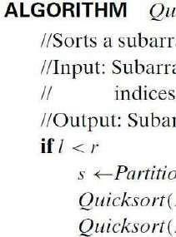
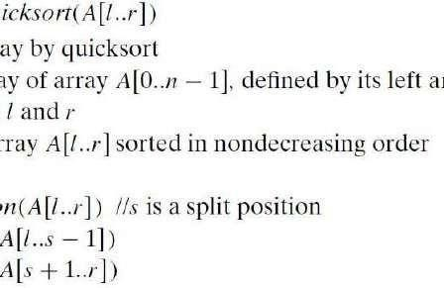
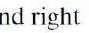

Partitioning
We start by selecting a pivot—an element with respect to whose value we are going to divide the sub array. There are several different strategies for selecting a pivot. We use the sophisticated method suggested by C.A.R. Hoare, the prominent British computer scientist who invented quicksort.
Select the sub array’s first element: p = A[l].Now scan the sub array from both ends, comparing the sub array’s elements to the pivot.
- The left-to-right scan, denoted below by index pointer i, starts with the second element. Since we want elements smaller than the pivot to be in the left part of the sub array, this scan skips over elements that are smaller than the pivot and stops upon encountering the first element greater than or equal to the pivot.
- The right-to-left scan, denoted below by index pointer j, starts with the last element of the sub array. Since we want elements larger than the pivot to be in the right part of the

subarray, this scan skips over elements that are larger than the pivot and stops on encountering the first element smaller than or equal to the pivot.
After both scans stop, three situations may arise, depending on whether or not the scanning indices have crossed.
- If scanning indices i and j have not crossed, i.e., i< j, we simply exchange A[i] and A[j ] and resume the scans by incrementing I and decrementing j, respectively:
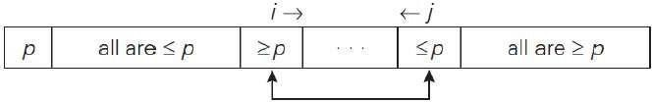
- If the scanning indices have crossed over, i.e., i> j, we will have partitioned the subarray after exchanging the pivot with A[j]:
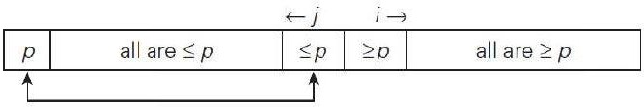
- If the scanning indices stop while pointing to the same element, i.e., i = j, the value they are pointing to must be equal to p. Thus, we have the subarray partitioned, with the split position s = i = j :
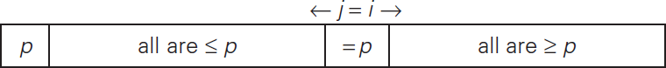
We can combine this with the case-2 byexchanging the pivot with A[j] whenever i≥j
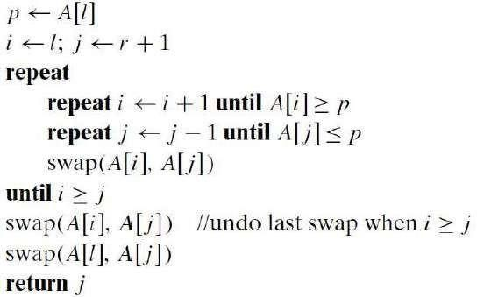
ALGORITHM HoarePartition(A[l..r])
//Partitions a subarray by Hoare’s algorithm, using the first element as a pivot
//Input: Subarray of array A[0..n − 1], defined by its left and right indices l and r (l<r)
//Output: Partition of A[l..r], with the split position returned as this function’s value
Note that index i can go out of the subarray’s bounds in this pseudo code.

Example: Example of quicksort operation. (a) Array’s transformations with pivot sshown in bold. (b) Tree of recursive calls to Quicksort with input values land r of subarray bounds and split position s of a partition obtained.
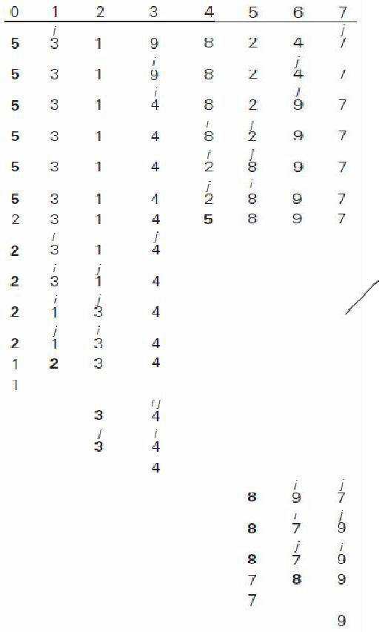
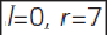

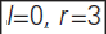
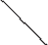
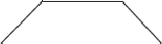
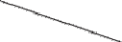
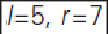
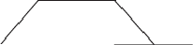
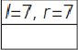

Analysis
Best Case -Here the basic operation is key comparison. Number of key comparisons made before a partition is achieved is n + 1 if the scanning indices cross over and n if they coincide. If all the splits happen in the middle of corresponding subarrays, we will have the best case. The number of key comparisons in the best case satisfies the recurrence,
According to the Master Theorem, Cbest(n) ∈Θ(n log2 n); solving it exactly for n = 2^{k} yields
Cbest(n) = n log2 n.
Worst Case – In the worst case, all the splits will be skewed to the extreme: one of the two subarrays will be empty, and the size of the other will be just 1 less than the size of the subarray being partitioned. This unfortunate situation will happen, inparticular, for increasing arrays. Indeed, if A[0..n − 1] is a strictly increasing array and we use A[0] as the pivot, the

left-to-right scan will stop on A[1] while the right-to-left scan will go all the way to reach A[0], indicating the split at position 0:So, after making n + 1 comparisons to get to this partition and exchanging the pivot A[0] with itself, the algorithm will be left with the strictly increasing array A[1..n − 1] to sort. This sorting of strictly increasing arrays of diminishing sizes will continue until the last one A[n−2.. n−1] has been processed. The total number of key comparisons made will be equal to
Average Case - Let Cavg(n) be the average number of key comparisons made by quicksort on a randomly ordered array of size n. A partition can happen in any position s (0 ≤ s ≤n−1) after n+1comparisons are made to achieve the partition. After the partition, the left and right subarrays will have s and n − 1−s elements, respectively. Assuming that the partition split can happen in each position s with the same probability 1/n, we get the following recurrence relation:

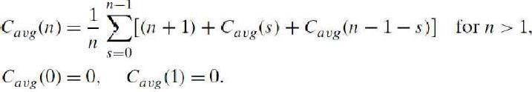
Its solution, which is much trickier than the worst- and best-case analyses, turns out to be
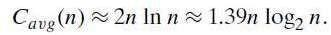
Thus, on the average, quicksort makes only 39% more comparisons than in the best case. Moreover, its innermost loop is so efficient that it usually runs faster than merge sort on
randomly ordered arrays of Non trivial sizes. This certainly justifies the name given to the algorithm by its inventor.
Variations: Because of quicksort’s importance, there have been persistent efforts over the years to refine the basic algorithm. Among several improvements discovered by researchers are:
- Better pivot selection methods such as randomized quicksort that uses a random element or the median-of-three method that uses the median of the leftmost, rightmost, and the middle element of the array
- Switching to insertion sort on very small subarrays (between 5 and 15 elements for most computer systems) or not sorting small subarrays at all and finishing the algorithm with insertion sort applied to the entire nearly sorted array
- Modifications of the partitioning algorithm such as the three-way partition into segments smaller than, equal to, and larger than the pivot
Limitations: 1. It is not stable. 2. It requires a stack to store parameters of subarrays that are yet to be sorted. 3. While Performance on randomly ordered arrays is known to be sensitive not only to the implementation details of the algorithm but also to both computer architecture and data type.

Stassen’s Matrixmultiplication
Direct Method: Suppose we want to multiply two n x n matrices, A and B. Their product, C=AB, will be an n by n matrix and will therefore have n² elements. The number of multiplications involved in producing the product in this way is Θ(n³)
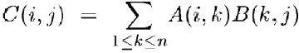

Divide and Conquermethod: Using the divide and conquer matrix achieved through multiplying the submatrices recursively.
multiplication is

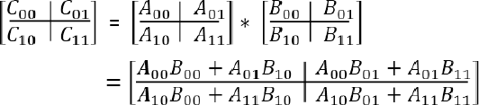
In the above method, we do multiplications for matrices of size n/2 x /2 and 4 additions. Addition of two matrices takes O(n²) time. So the time complexity can be written asT(n) = 8T(n/2) + O(n²) which happe to be O(n³); same as the direct method
8 n
n
Divide and Conquer through Strassen’s Method: By using divide-and-conquer approach proposed by Strassen in 1969, we can reduce the number of multiplications.
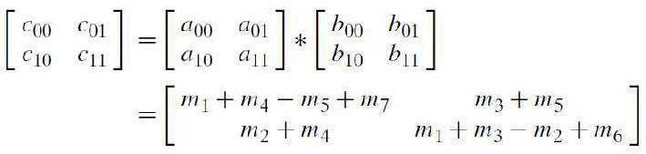
Multiplication of 2×2 matrices: The principal insight of the algorithm lies in the discovery that we can find the product C of two 2 × 2 matrices A and B with just 7 multiplications as opposed to the eight required by the brute-force algorithm. This is accomplished by using the following formulas:
where
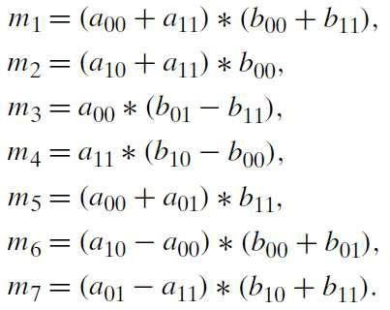
Thus, to multiply two 2×2 matrices, Strassen’s algorithm makes seven multiplications and 18 additions/subtractions, whereas the brute-force algorithm requires eight multiplications and four additions.

Multiplication of n×n matrices: Let A and B be two n × n matrices where n is a power of
2. (If n is not a power of 2, matrices can be padded with rows and columns of zeros.) We can divide A,B, and their product C into four n/2 ×n/2 sub matrices each as follows:
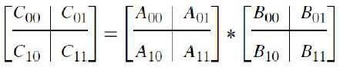
It is not difficult to verify that one can treat these submatrices as numbers to get the correct product. For example, C00 can be computed as M1 + M4– M5 + M7 where M1, M4, M5, and M7

are found by Strassen’s formulas, with the numbers replaced by submatrices. If the seven products of n/2 × n/2 matrices are computed same method, we have Strassen’s algorithm for matrix multiplication.

Analysis ( fromtext book T1: Levtin et al )
the corresponding recursively by the

Here the basic operation is multiplication. If M(n) is the number of multiplications made by Strassen’s algorithm in multiplying two n × n matrices (where n is a power of 2), we get the following recurrence relation for it:
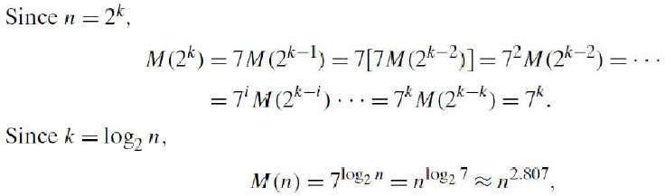

This implies M(n) = Θ(n^{2.807})which is smaller than n³ required by the brute-force algorithm.

Analysis ( From T2: Horowitz et al )
Suppose if we consider both multiplication and addition. The resulting recurrence ration T(n) is
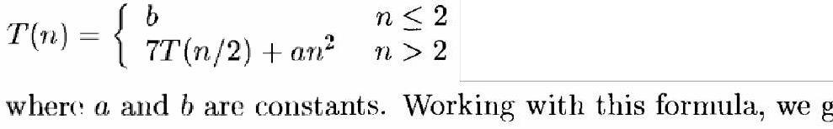
Note: No. of addition/ subtraction Operations18(n/2)²= an²

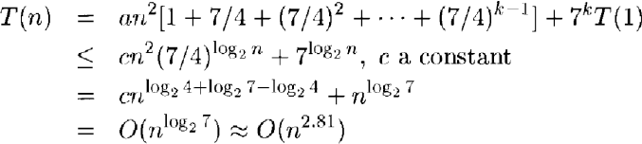

Advantages and Disadvantages of Divide & Conquer

Advantages
- Parallelism: Divide and conquer algorithms tend to have a lot of inherent parallelism. Once the division phase is complete, the sub-problems are usually independent and can therefore be solved in parallel. This approach typically generates more enough

concurrency to keep the machine busy and can be adapted for processor machines.
execution in multi-

- Cache Performance: divide and conquer algorithms also tend to have good cache performance. Once a sub-problem fits in the cache, the standard recursive solution reuses the cached data until the sub-problem has been completely solved.
- It allows solving difficult and often impossible looking problems like the Tower of Hanoi. It reduces the degree of difficulty since it divides the problem into sub problems that are easily solvable, and usually runs faster than other algorithms would.
- Another advantage to this paradigm is that it often plays a part in finding other efficient algorithms, and in fact it was the central role in finding the quick sort and merge sort algorithms.

Disadvantages
- One of the most common issues with this sort of algorithm is the fact that the recursion is slow, which in some cases outweighs any advantages of this divide and conquer process.
- Another concern with it is the fact that sometimes it can become more complicated than a basic iterative approach, especially in cases with a large n. In other words, if someone wanted to add a large amount of numbers together, if they just create a simple loop to add them together, it would turn out to be a much simpler approach than it would be to divide the numbers up into two groups, add these groups recursively, and then add the sums of the two groups together.
- Another downfall is that sometimes once the problem is broken down into sub problems, the same sub problem can occur many times. It is solved again. In cases like these, it can often be easier to identify and save the solution to the repeated sub problem, which is commonly referred to as memorization.

Decrease and Conquer Approach
Decrease-and-conquer is a general algorithm design technique, based on exploiting a relationship between a solution to a given instance of a problem and a solution to a smaller instance of the same problem. Once such a relationship is established, it can be exploited either top down (usually recursively) or bottom up. There are three major variations of decrease-and-conquer:
- decrease-by-a-constant, most often by one (e.g., insertion sort)
- decrease-by-a-constant-factor, most often by the factor of two (e.g., binary search)
- variable-size-decrease (e.g., Euclid’s algorithm)

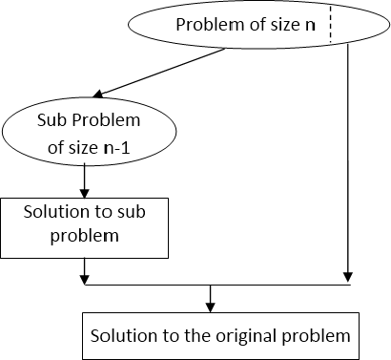
In the decrease-by-a-constant variation, the size of an instance is reduced by the same constant on each iteration of the algorithm. Typically, this constant is equal to one although other constant size reductions do happen occasionally.

Figure: Decrease-(by one)-and-conquer technique
Example: a^{n} = a^{n-1}×a

The decrease-by-a-constant-factor technique suggests reducing a problem instance by the

same constant factor on each factor is equal to two.
Iteration of the algorithm. In most applications, this constant

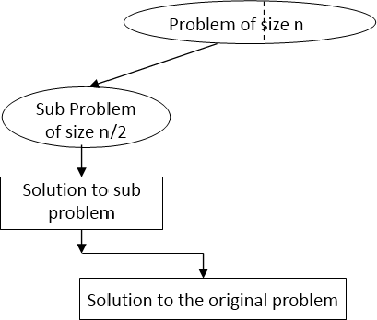
Figure: Decrease-(byhalf)-and-conquer technique.

Example:
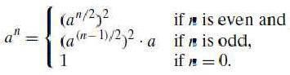

Finally, in the variable-size-decrease variety of decrease-and-conquer, the size-reduction pattern varies from one iteration of an algorithm to another.
Example: Euclid’salgorithm for computing the greatest common divisor. It is based on the formula. gcd(m, n) = gcd(n, m mod n).
Though the value of the second argument is always smaller on the right-hand side than on the left-hand side, it decreases neither by a constant nor by a constant factor.

Topological Sort
Background: A directed graph, or digraph for short, is a graph with directions specified for all its edges. The adjacency matrix and adjacency lists are the two principal means of representing a digraph. Ther are only two notable differences between undirected and directed graphs in representing them: (1) the adjacency matrix of a directed graph does not

have to be symmetric; (2) an edge in a directed graph has just one (not nodes in the digraph’s adjacency lists.
wo) corresponding

Depth-first search and breadth-first search are principal traversal algorithms for traversing digraphs as well, but the structure of corresponding forests can be more complex than for undirected graphs. Thus, even for the simple example of Figure, the depth-first search forest (Figure b) exhibits all four types of edges possible in a DFS forest of a directed graph:
- tree edges (ab, bc, de),
- back edges (ba) from vertices to their ancestors,
- forward edges (ac) from vertices to their descendants in the tree other than their children, and
- cross edges (dc), whichare none of the aforementioned types.
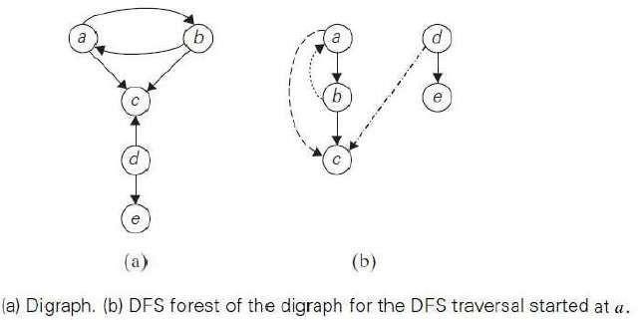

Note that a back edge in a DFS forest of a directed graph can connect a vertex to its parent. Whether or not it is the case, the presence of a back edge indicates that the digraph has a directed cycle. A directed cycle in a digraph is a sequence of three or more of its vertices that starts and ends with the same vertex and in which every vertex is connected to its immediate predecessor by an edge directed from the predecessor to the successor. For example, a, b, a is a directed cycle in the digraph in Figure given above. Conversely, if a DFS forest of a digraph has no backedges, the digraph is a dag, an acronym for directed acyclic graph.

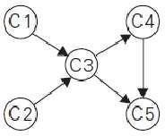
Motivation for topological sorting: Consider a set of five required courses {C1, C2, C3, C4,C5} a part-time student has to take in some degree program. The courses can betaken in any order as long as the following course prerequisites are met: C1 andC2 have no prerequisites,
C3 requires C1 and C2, C4 requires C3, and C5 requiresC3 and C4. The
student can take only one course per term. In which order shouldthe student take the

courses?The situation can be modeled by a digraph in which vertices represent courses and directed edges indicate prerequisite requirements.
In terms of this digraph, the uestion is whether we can list its vertices in such an order that for every edge in the graph, the vertex where the edge starts is listed before the vertex where the edge ends. In other words, can you find such an ordering of this digraph’s vertices? This problem is called topological sorting.
Topological Sort: For topological sorting to be possible, a digraph in question must be a DAG. i.e., if a digraph has no directed cycles, the topological sorting problem for it has a solution.
There are two efficient algorithms that both verify whether a digraph is a dag and, if it is, produce an ordering of vertices that solves the topological sorting problem. The first one is based on depth-first search; the second is based on a direct application of the decrease-by-one technique.

Topological Sorting based on DFS Method
- Perform a DFS traversal and note the order in which vertices become dead-ends
- Reversing this order yields a solution to the topological sorting problem, provided, of course, no back edge has been encountered during the traversal. If a back edge has been encountered, the digraph is not a DAG, and topological sorting of its vertices is impossible.

Illustration
  - Digraph for which the topological sorting problem needs to be solved.
  - DFS traversal stack w th the subscript numbers indicating the popping off order.
  - Solution to the problem. Here we have drawn the edges of the digraph, and they all point from left to right as the problem’s statement requires. It is a convenient way to check visually the correctness of a solution to an instance of the topological sorting problem.
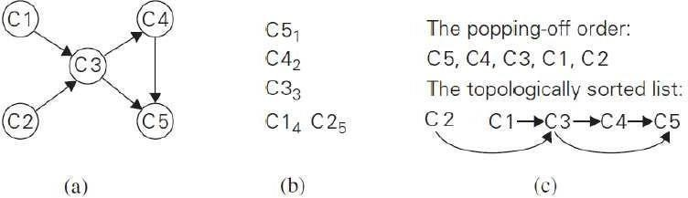
Topological Sorting using decrease-and-conquer technique
Method: The algorithm is based on a direct implementation of the decrease-(byone)-and- conquer technique:

- Repeatedly, identify in a remaining digraph a source, which is a vertex with no incoming edges, and delete it along with all the edges outgoing from it. (If there are several sources, break the tie arbitrarily. If there are none, stop because the problem cannot be solved.)
- The order in which the vertices are deleted yields a solution to the topological sorting problem.
Illustration - Illustration of the source-removal algorithm for the topological sorting problem is given here. On each iteration, a vertex with no incoming edges is deleted from the digraph.
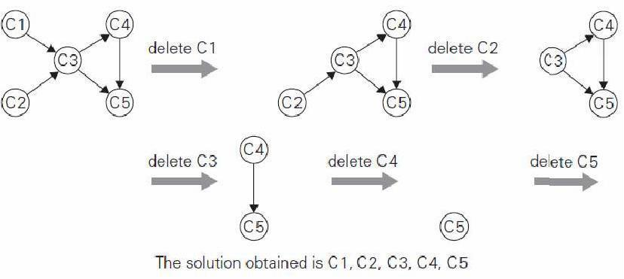
Note: The solution obtained by the source-removal algorithm is different from the one obtained by the DFS-based algorithm. Both of them are correct, of course; the topological sorting problem may have several alternative solutions.

Applications of Topological Sorting
  - Instruction scheduling in program compilation
  - Cell evaluation ordering in spreadsheet formulas,
  - Resolving symbol dependencies in linkers.

***

  - The General Method Definition:

Module-3
THE GREEDY METHOD

Greedy technique is a general algorithm design strategy, built on following elements:
    - configurations: different choices, values to find
    - objective function: some configurations to be either maximized or minimized

The method:
    - Applicable to optimization problems ONLY
    - Constructs a solution through a sequence of steps
    - Each step expands a partially constructed solution so far, until a complete solution to the problem is reached.

On each step, the choice made must be
    - Feasible: it has to satisfy the problem‘s constraints
    - Locally optimal: it has to be the best local choice among all feasible choices available on that step
    - Irrevocable: Once made, it cannot be changed on subsequent steps of the algorithm

NOTE:
    - Greedy method works best when applied to problems with the greedy-choice
property
    - A globally-optimal solution can always be found by a series of local improvements from a starting configuration.

Greedy method vs. Dynamic programming method:
    - LIKE dynamic programming, greedy method solves optimization problems.
    - LIKE dynamic programming, greedy method problems exhibit optimal substructure
    - UNLIKE dynamic programming, greedy method problems exhibit the
greedy choice property -avoids back-tracing.

Applications of the Greedy Strategy:

Optimal solutions:
Change making
Minimum Spanning Tree (MST) Single-source shortest paths Huffman codes

Approximations:
Traveling Salesman Problem (TSP) Fractional Knapsack problem

Knapsack problem
- One wants to pack n items in a luggage
  - The ith item is worth vi dollars and weighs wi pounds
  - Maximize the value but cannot exceed W pounds
  - vi , wi, W are integers
- 0-1 knapsack → each item is taken or not taken
- Fractional knapsack → fractions of items can be taken
- Both exhibit the optimal-substructure property
  - 0-1: If item j is removed from an optimal packing, the remaining packing is an optimal packing with weight at most W-wj
  - Fractional: If w pounds of item j is removed from an optimal packing, the remaining
packing is an optimal packing with weight at most W-w that can be taken from other n-1 items plus wj – w of item j
Greedy Algorithm for Fractional Knapsack problem
- Fractional knapsack can be solvable by the greedy strategy
  - Compute the value per pound vi/wi for each item
  - Obeying a greedy strategy, take as much as possible of the item with the greatest value per pound.
  - If the supply of that item is exhausted and there is still more room, take as much as possible of the item with the next value per pound, and so forth until there is no more room
  - O(n lg n) (we need to sort the items by value per pound) O-1 knapsack is harder
- knapsack cannot be solved by the greedy strategy
  - Unable to fill the knapsack to capacity, and the empty space lowers the effective value per pound of the packing
  - We must compare the solution to the sub-problem in which the item is included with the solution to the sub-problem in which the item is excluded before we can make the choice

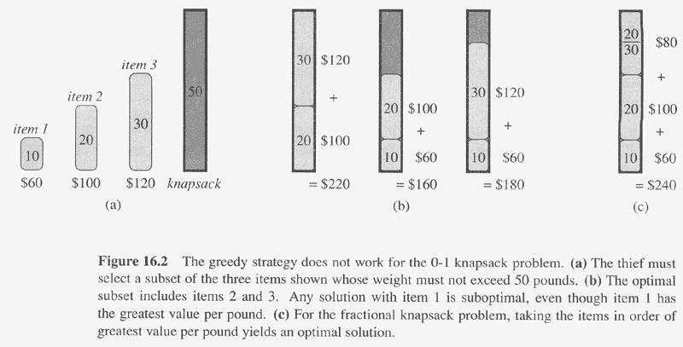

Job sequencing with deadlines
The problem is stated as below.
    - There are n jobs to be processed on a machine.
    - Each job i has a deadline di≥ 0 and profit pi≥0.
    - Pi is earned iff the job is completed by its deadline.
    - The job is completed if it is processed on a machine for unit time.
    - Only one machine is available for processing jobs.
    - Only one job is processed at a time on the machine
    - A feasible solution is a subset of jobs J such that each job is completed by its deadline.
    - An optimal solution is a feasible solution with maximum profit value.
Example : Let n = 4, (p1,p2,p3,p4) = (100,10,15,27), (d1,d2,d3,d4) = (2,1,2,1)

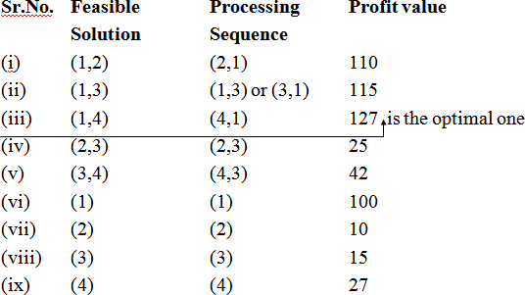

    - Consider the jobs in the non increasing order of profits subject to the constraint that the resulting job sequence J is a feasible solution.
    - In the example considered before, the non-increasing profit vector is (100 27 15 10) (2 1 2 1)
p1 p4 p3 p2 d1 d d3 d2 J = { 1} is a feasible one
J = { 1, 4} is a feasible one with processing sequence ( 4,1) J = { 1, 3, 4} is not feasible
J = { 1, 2, 4} is not feasible J = { 1, 4} is optimal

Theorem: Let J be a set of K jobs and
σ = (i1,i2,….ik) be a permutation of jobs in J such that di1 ≤ di2 ≤…≤ dik.
    - J is a feasible solution iff the jobs in J can be processed in the order σ without violating any deadly.

Proof:
    - By definition of the feasible solution if the jobs in J can be processed in the order without violating any deadline then J is a feasible solution.

    - So, we have only to prove that if J is a feasible one, then σ represents a possible order in which the jobs may be processed.
    - Suppose J is a feasible solution. Then there exists σ¹ = (r1,r2,…,rk) such that drj ≥ j, 1 ≤ j <k
i.e. dr1 ≥1, dr2 ≥ 2, …, drk
≥ k. each job requiring an unit time.

    - σ = (i1,i2,…,ik) and σ¹ = (r1,r2,…,rk)
    - Assume σ ¹ ≠ σ. Then let a be the least index in which σ ¹ and σ differ. i.e. a is such that ra ≠ ia.
    - Let rb = ia, so b > a (because for all indices j less than a rj = ij).
    - In σ ¹ interchange ra and rb.
    - σ = (i1,i2,… ia ib ik ) [rb occurs before ra
    - in i1,i2,…,ik]
    - σ ¹ = (r1,r2,… ra rb … rk )
    - i1=r1, i2=r2,…ia-1= ra-1, ia ≠ rb but ia = rb
    - We know di1 ≤ di2 ≤ … dia ≤ dib ≤… ≤ dik.
    - Since ia = rb, drb ≤ dra or dra ≥ drb.
    - In the feasible solution dra ≥ a drb ≥ b
    - So if we interchange ra and rb, the resulting permutation σ¹¹= (s1, … sk) represents an order with the least index in which σ¹¹ and σ differ is incremented byone.
    - Also the jobs in σ¹¹ may be processed without violating a deadline.
    - Continuing in this way, σ¹ can be transformed into σ without violating anydeadline.
    - Hence the theorem is proved

GREEDY ALGORITHM FOR JOB SEQUENSING WITH DEADLINE

Procedure greedy job (D, J, n) J may be represented by

// J is the set of n jobs to
// by their deadlines //
be completed // one dimensional array J (1: K)
The deadlines are

J ←{1} D (J(1)) ≤ D(J(2)) ≤ .. ≤ D(J(K))
for I ← 2 to n do To test if JU {i} is feasible,

If all jobs in JU{i} can be completed we insert i into J and verify by their deadlines D(J®) ≤ r 1 ≤ r ≤ k+1 then J ← JU{I}
end if
repeat
end greedy-job Procedure JS(D,J,n,k)
// D(i) ≥ 1, 1≤ i ≤ n are the deadlines //
// the jobs are ordered such that //
// p1 ≥ p2 ≥……. ≥ pn //
// in the optimal solution ,D(J(i) ≥ D(J(i+1)) //
// 1 ≤ i ≤
k // integer D(o:n), J(o:n), i, k, n, r D(0) ←J(0) ← 0
// J(0) is a fictious job with D(0) = 0 // K←1; J(1) ←1 // job one is inserted into J //
for i ←2 to do // consider jobs in non increasing order of pi //
// find the position of i and check feasibility of insertion // r← k // r and k are indices for existing job in J //
// find r such that i can be inserted after r // while D(J(r)) > D(i) and D(i) ≠ r do
// job r can be processed after i and //
// deadline of job r is not exactly r //
r← r-1 // consider whether job r-1 can be processed after i // repeat
if D(J(r)) ≥ d(i) and D(i) > r then
// the new job i can come after existing job r; insert i into J at position r+1
// for I ← k to r+1 by –1 do
J(I+1)← J(l) // shift jobs( r+1) to k right by//
//one position //

repeat

if D(J(r)) ≥ d(i) and D(i) > r then
// the new job i can come after existing job r; insert i into J at position r+1
// for I ← k to r+1 by –1 do
J(I+1)← J(l) // shift jobs( r+1) to k right by//
//one position // Repeat

COMPLEXITY ANALYSIS OF JS ALGORITHM
- Let n be the number of jobs and s be the number of jobs included in the solution.
- The loop between lines 4-15 (the for-loop) is iterated (n-1)times.
- Each iteration takes O(k) where k is the number of existing jobs.
∴ The time needed by the algorithm is 0(sn) s ≤ n so the worst case time is 0(n²).
If di = n - i+1 1 ≤ i ≤ n, JS takes θ(n²) time D and J need θ(s) amount of space.

Minimum-Cost Spanning Trees

Spanning Tree Definition:
Spanning tree is a connected acyclic sub-graph (tree) of the given graph (G) that includes all of G‘s vertices

Example: Consider the following graph
]

The spanning trees for the above graph are as follows:
1

c
Weight (T1) = 9
5
2
d
b a

c
Weight (T2) = 8
Weight (T3) = 6

Minimum Spanning Tree (MST)

Definition:
MST of a weighted, connected graph G is defined as: A spanning tree of G with

minimum total weight.
Example: Consider the example of spanning tree:
For the given graph there are three possible spanning trees. Among them the spanning tree with the minimum weight 6 is the MST for the given graph
Question: Why can‘t we use BRUTE FORCE method in constructing MST ?

Answer: If we use Brute force method-
- Exhaustive search approach has to be applied.
- Two serious obstacles faced:
- The number of spanning trees grows exponentially with graph size.
- Generating all spanning trees for the given graph is not easy.

MST Applications:

Network design.
Telephone, electrical, hydraulic, TV cable, computer, road

Approximation algorithms for NP-hard problems.
Traveling salesperson problem, Steiner tree
- Cluster analysis.
- Reducing data storage in sequencing amino acids in a protein
- Learning salient features for real-time face verification
- Auto config protocol for Ethernet bridging to avoid cycles in a network, etc

Prim’s Algorithm Some useful definitions:
    - Fringe edge: An edge which has one vertex is in partially constructed tree Ti and the other is not.
    - Unseen edge: An edge with both vertices not in Ti

Algorithm:

ALGORITHM Prim (G)
//Prim‘s algorithm for constructing a MST
//Input: A weighted connected graph G = { V, E }
//Output: ET the set of edges composing a MST of G
// the set of tree vertices can be initialized with any vertex VT → { v0}
ET → Ø
for i→ 1 to |V| - 1 do

Find a minimum-weight edge e* = (v*, u*) among all the edges (v, u) such that v is in VT and u is in V - VT
VT → VT U {
u*} ET → ET U
{ e*} return ET

The method:
STEP 1: Start with a tree, T0, consisting of one vertex
STEP 2: ―Grow‖ tree one vertex/edge at a time
      - Construct a series of expanding sub-trees T1, T2, … Tn-1.
      - At each stage construct Ti + 1 from Ti by adding the minimum weight edge connecting a vertex in tree (Ti) to one vertex not yet in tree, choose from “fringe” edges (this is the “greedy” step!)
Algorithm stops when all vertices are included

Example:
Apply Prim‘s algorithm for the following graph to find MST.
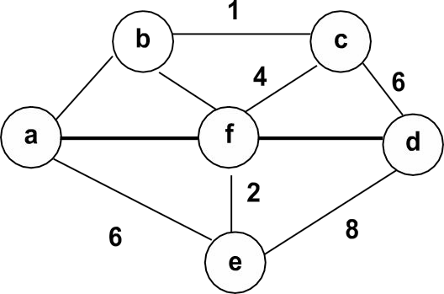
3
4
5
5
Solution:

Tree vertices | Remaining vertices | Graph
a ( -, - ) | b ( a , 3 )  c ( - , ∞ )  d ( - , ∞ )  e ( a , 6 )  f ( a , 5 ) |  | a | 3 | b
b ( a, 3 ) | c ( b , 1 )  d ( - , ∞ )  e ( a , 6 )  f ( b , 4 ) |  | a | 3 | 1  b c
c ( b, 1 ) | d ( c , 6 )  e ( a , 6 )  f ( b , 4 ) | a | 3 |  | 1  b  4  f | c

f ( b, 4) | d ( f , 5 )  e ( f , 2 ) | b | 1  4  f  2  e |  | c
f ( b, 4) | d ( f , 5 )  e ( f , 2 ) | 3 | 1  4  f  2  e
f ( b, 4) | d ( f , 5 )  e ( f , 2 ) | a | 1  4  f  2  e
e ( f, 2) | d ( f , 5 ) | b | 1  4  f 2  e |  | c  d
e ( f, 2) | d ( f , 5 ) | 3 | 1  4  f 2  e |  | c  d
e ( f, 2) | d ( f , 5 ) | a | 1  4  f 2  e | 5 | c  d
d( f, 5) |  | Algorithm stops since all vertices are included.  The weight of the minimum spanning tree is 15

Efficiency:
Efficiency of Prim‘s algorithm is based on data structure used to store priority queue.
    - Unordered array: Efficiency: Θ(n²)
    - Binary heap: Efficiency: Θ(m log n)
    - Min-heap: For graph with n nodes and m edges: Efficiency: (n + m) log n

Conclusion:
    - Prim‘salgorithmisa―vertexbasedalgorithm‖
    - Prim‘s algorithm ―Needs priority queue for locating the nearest vertex.‖ The choice of priority queue matters in Prim implementation.
- Array - optimal for dense graphs
- Binary heap - better for sparse graphs
- Fibonacci heap - best in theory, but not in practice

Kruskal’s Algorithm Algorithm:

ALGORITHM Kruskal (G)
//Kruskal‘s algorithm for constructing a MST
//Input: A weighted connected graph G = { V, E }
//Output: ET the set of edges composing a MST of G Sort E in ascending order of the edge weights
// initialize the set of tree edges and its size ET→Ø
edge_counter →0

//initialize the number of processed edges K →0
while edge_counter < |V| - 1 k→k + 1
if ET U { ei k} is acyclic
ET →ET U { ei k }
edge_counter →edge_counter + 1
return ET

The method:
STEP 1: Sort the edges by increasing weight
STEP 2: Start with a forest having |V| number of trees.
STEP 3: Number of trees are reduced by ONE at every inclusion of an edge At each stage:
- Among the edges which are not yet included, select the one with minimum weight AND which does not form a cycle.
- the edge will reduce the number of trees by one by combining two trees of the forest

Algorithm stops when |V| -1 edges are included in the MST i.e : when the number of trees in the forest is reduced to ONE.

Example:
Apply Kruskal‘s algorithm for the following graph to find MST.
b
c
3 4 4
6
a 5
f
5 d
2

Solution:
The list of edges is:

Edge | ab | af | ae | bc | bf | cf | cd | df | de | ef
Weight | 3 | 5 | 6 | 1 | 4 | 4 | 6 | 5 | 8 | 2
Sort the edges in ascending order:

Edge | bc | ef | ab | bf | cf | af | df | ae | cd | de
Weight | 1 | 2 | 3 | 4 | 4 | 5 | 5 | 6 | 6 | 8

Edge | bc |  | b | 1  f  e | c  d
Weight | 1 |  | a | 1  f  e | c  d
Insertion  status | YES
Insertion  order | 1 |  |  | 1  f  e
Edge | ef |  | 1  b c  f d  2  e
Weight | 2 | a
Insertion status | YES | a
Insertion order | 2

7

Edge | ab | 3  a | b | 1  c  f  2  e | d
Weight | 3
Insertion status | YES
Insertion order | 3
Edge | bf | 3  a | b  4 | 1  c  f 2  e | d
Weight | 4
Insertion  status | YES
Insertion order | 4
Edge | cf
Weight | 4
Insertion  status | NO
Insertion  order | -
Edge | af
Weight | 5
Insertion status | NO
Insertion order | -
Edge | df | 3  a | b  4 | 1  c  f d 5  2  e
Weight | 5
Insertion status | YES
Insertion order | 5
Algorithm stops as |V| -1 edges are included in the MST

Efficiency:
Efficiency of Kruskal‘s algorithm is based on the time needed for sorting the edge weights of a given graph.
- With an efficient sorting algorithm: Efficiency: Θ(|E| log |E| )

Conclusion:
- Kruskal‘s algorithm is an ―edgebasedalgorithm‖
- Prim‘s algorithm with a heap is faster than Kruskal‘s algorithm.

Single Source Shortest Paths. Some useful definitions:
    - Shortest Path Problem: Given a connected directed graph G with non- negative weights on the edges and a root vertex r, find for each vertex x, a directed path P
(x) from r to x so that the sum of the weights on the edges in the path P (x) is as small as possible.

Algorithm
    - By Dutch computer scientist Edsger Dijkstra in 1959.
    - Solves the single-source shortest path problem for a graph with nonnegative edge weights.
    - This algorithm is often used in routing.
E.g.: Dijkstra's algorithm is usually the working principle behind link- state routing protocols

ALGORITHM Dijkstra(G, s)
//Input: Weighted connected graph G and source vertex s
//Output: The length Dv of a shortest path from s to v and its penultimate vertex Pv for every vertex v in V

//initialize vertex priority in the priority queue Initialize (Q)
for every vertex v in V do
Dv→∞ ; Pv→null // Pv , the parent of v
insert(Q, v, Dv) //initialize vertex priority in priority queue
ds→0

/D/uepcrdeaatsee(pQr,iorsit,y odf )s with ds, making ds, the minimum
s

VT→∅

for i→0 to |V| - 1 do
u*→DeleteMin(Q)
//expanding the tree, choosing the locally best vertex VT→VT U {u*}
for every vertex u in V – VT that is adjacent to u* do if Du* + w (u*, u) < Du
Du→Du + w (u*, u); Pu u* Decrease(Q, u, Du)

The method
Dijkstra‘s algorithm solves the single source shortest path problem in 2 stages. Stage 1: A greedy algorithm computes the shortest distance from source to all other nodes in the graph and saves in a data structure.
Stage 2 : Uses the data structure for finding a shortest path from source to any vertex v.
- At each step, and for each vertex x, keep track of a “distance” D(x) and a directed path P(x) from root to vertex x of length D(x).
- Scan first from the root and take initial paths P( r, x ) = ( r, x ) with D(x) = w( rx ) when rx is an edge,
D(x) = ∞ when rx is not an edge.
For each temporary vertex y distinct from x, set
D(y) = min{ D(y), D(x) + w(xy) }

Example:
Apply Dijkstra‘s algorithm to find Single source shortest paths with vertex a as the source.
b
c
3
a 5
4
4
6
f
5 d
2

Solution:
Length Dv of shortest path from source (s) to other vertices v and Penultimate vertex Pv for every vertex v in V:
Da = 0 , Pa =
null Db = ∞ , Pb = null Dc =
∞ , Pc = null Dd
= ∞ , Pd = null De = ∞ , Pe = null Df = ∞ , Pf
= null

Tree vertices | RemainingD vertices | istance & Path vertex | Graph
a ( -, 0 ) | Da  b ( a , 3D)b=  c ( - , ∞D)c=  d ( - , ∞D)d=  e ( a , 6D)e=  f ( a , 5D)f = | 0 Pa = a  3 Pb = [ a, b ]  ∞ Pc = null  ∞ Pd = null  6 Pe = [ a, e ]  5 Pf = [ a, f ] | b  3  a
b ( a, 3 ) | Da =  c ( b , 3+D1b)  d ( - , ∞D)c=  e ( a , 6D)d=  f ( a , 5D)e =  Df = | 0 Pa = a  3 Pb = [ a, b ]  4 Pc = [a,b,c]  ∞ Pd = null  6 Pe = [ a, e ]  5 Pf = [ a, f ] | 1  3 b c a
c ( b, 4 ) | Da = d ( c , 4 Db  +  ef (( aa ,, 6DD)d6c=)=  5D)e =  Df = | 0 Pa = a  3 Pb = [ a, b ]  4 Pc = [a,b,c]  Pd = [a,b,c,d]  6 Pe = [ a, e ]  5 Pf = [ a, f ] | 5  a f
f ( a, 5) | Da =  Db Dc  d ( c , 1D0 d)=  e ( a , 6D)e =  Df = | 0 Pa = a  3 Pb = [ a, b ]  4 Pc = [a,b,c]  Pd = [a,b,c,d]  6 Pe = [ a, e ]  5 Pf = [ a, f ] | a  6  e
e ( a, 6) | Da = Db =  Dc =  d ( c, 10D)d=  De =  Df = | 0 Pa = a  3 Pb = [ a, b ]  4 Pc = [a,b,c]  Pd = [a,b,c,d]  6 Pe = [ a, e ]  5 Pf = [ a, f ] | b 1 c  3 6  d  a
d( c, 10) |  | edge | Algorithm stops since no s to scan

Conclusion:
- Doesn‘t work with negative weights
- Applicable to both undirected and directed graphs
- Use unordered array to store the priority queue: Efficiency = Θ(n²)
- Use min-heap to store the priority queue: Efficiency = O(m log n)

Module-4
Dynamic Programming

The General Method Definition
Dynamic programming (DP) is a general algorithm design technique for solving problems with overlapping sub-problems. This technique was invented by American mathematician ―Richard Bellman‖ in 1950s.

Key Idea
The key idea is to save answers of overlapping smaller sub-problems to avoid re- computation.

Dynamic Programming Properties
    - An instance is solved using the solutions for smaller instances.
    - The solutions for a smaller instance might be needed multiple times, so store their results in a table.
    - Thus each smaller instance is solved only once.
    - Additional space is used to save time.

Dynamic Programming vs. Divide & Conquer
LIKE divide & conquer, dynamic programming solves problems by combining solutions to sub-problems. UNLIKE divide & conquer, sub-problems are NOT independent in dynamic programming.

Divide & Conquer | Dynamic Programming
1. Partitions a problem into independent smaller sub-problems | 1. Partitions a problem into overlapping sub-problems
2. Doesn‘t store solutions of sub- problems. (Identical sub-problems may arise - results in the same computations are performed repeatedly.) | 2. Stores solutions of sub- problems: thus avoids calculations of same quantity twice
3. Top down algorithms: which logically progresses from the initial instance down to the smallest sub-instances via intermediate sub-instances. | 3. Bottom up algorithms: in which the smallest sub-problems are explicitly solved first and the results of these used to construct solutions to progressively larger sub-instances

Dynamic Programming vs. Divide & Conquer: EXAMPLE

Computing Fibonacci Numbers

- Using standard recursive formula:

0 if n=0
F(n) = 1 if n=1
F(n-1) + F(n-2) if n >1

Algorithm F(n)
// Computes the nth Fibonacci number recursively by using its definitions
// Input: A non-negative integer n
// Output: The nth Fibonacci number if n==0 || n==1 then
return n
else
return F(n-1) + F(n-2)

Algorithm F(n): Analysis
- Is too expensive as it has repeated calculation of smaller Fibonacci numbers.
- Exponential order of growth.

F(n)
F(n-1) + F(n-2)
F(n-2) + F(n-3) F(n-3)

+ F(n-4)

- Using Dynamic Programming:
Algorithm F(n)
// Computes the nth Fibonacci number by using dynamic programming method
// Input: A non-negative integer n
// Output: The nth Fibonacci number A[0] 0
A[1] 1
for i 2 to n do
A[i] A[i-1] + A[i-2]
return A[n]

Algorithm F(n): Analysis
- Since it caches previously computed values, saves time from repeated computations of same sub-instance
- Linear order of growth

Rules of Dynamic Programming
- OPTIMAL SUB-STRUCTURE: An optimal solution to a problem contains optimal solutions to sub-problems

- OVERLAPPING SUB-PROBLEMS: A recursive solution contains a ―small‖ number of distinct sub-problems repeated many times
- BOTTOM UP FASHION: Computes the solution in a bottom-up fashion in the final step

Three basic components of Dynamic Programming solution
The development of a dynamic programming algorithm must have the following three basic components
- A recurrence relation
- A tabular computation
- A backtracking procedure

Example Problems that can be solved using Dynamic Programming method
- Computing binomial co-efficient
- Compute the longest common subsequence
- Warshall‘s algorithm for transitive closure
- Floyd‘s algorithm for all-pairs shortest paths
- Some instances of difficult discrete optimization problems like knapsack problem traveling salesperson problem

Warshall’s Algorithm
Some useful definitions:
    - Directed Graph: A graph whose every edge is directed is called directed graph OR digraph
    - Adjacency matrix: The adjacency matrix A = {aij} of a directed graph is the boolean matrix that has
      - 1 - if there is a directed edge from ith vertex to the jth vertex
      - 0 - Otherwise
    - Transitive Closure: Transitive closure of a directed graph with n vertices can be defined as the n-by-n matrix T={tij}, in which the elements in the ith row (1≤ i ≤
n) and the jth column(1≤ j ≤ n) is 1 if there exists a nontrivial directed path (i.e., a directed path of a positive length) from the ith vertex to the jth vertex, otherwise tij is 0.
The transitive closure provides reach ability information about a digraph.

Computing Transitive Closure:
    - We can perform DFS/BFS starting at each vertex
- Performs traversal starting at the ith vertex.
- Gives information about the vertices reachable from the ith vertex
- Drawback: This method traverses the same graph several times.
- Efficiency : (O(n(n+m))
- Alternatively, we can use dynamic programming: the Warshall‘s Algorithm

Underlying idea of Warshall’s algorithm:
- Let A denote the initial boolean matrix.

- The element r(k) [ i, j] in ith row and jth column of matrix Rk (k = 0, 1, …, n) is equal to 1 if and only if there exists a directed path from ith vertex to jth vertex with intermediate vertex if any, numbered not higher than k

Recursive Definition:
  - Case 1:
A path from vi to vj restricted to using only vertices from
{v1,v2,…,vk} as intermediate vertices does not use vk, Then R(k) [ i, j ] = R(k-1) [ i, j ].

Case 2:
A path from vi to vj restricted to using only vertices from
{v1,v2,…,vk} as intermediate vertices do use vk. Then
R(k) [ i, j ] = R(k-1) [ i, k ] AND R(k-1) [ k, j ].
We conclude:
R(k)[ i, j ] = R(k-1) [ i, j ] OR (R(k-1) [ i, k ] AND R(k-1) [ k, j ] )

Algorithm:

Algorithm Warshall(A[1..n, 1..n])
// Computes transitive closure matrix
// Input: Adjacency matrix A
// Output: Transitive closure matrix R R(0) A
for k→1 to n do
for i→ 1 to n do
for j→ 1 to n do
R(k)[i, j]→ R(k-1)[i, j] OR (R(k-1)[i, k] AND R(k-1)[k, j] )
return R(n)
Find Transitive closure for the given digraph using Warshall‘s algorithm.

Solution:
R(0) =

0 | 1 | 0
0 1 | 1 | 1
0 0 | 1 | 0
1 1 | 1 | 1

R(0) | k = 1  Vertex 1  can be  intermediate node | A B C D  A 0 0 1 0  B 1 0 0 1  C 0 0 0 0  D 0 1 0 0  R1[2,3]  = R0[2,3] OR  R0[2,1] AND R0[1,3]  = 0 OR ( 1 AND 1)  = 1 |  |  |  |  |   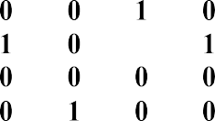  A B | C  1 | D
R(0) | k = 1  Vertex 1  can be  intermediate node |  |  |  |  | A  B C D |  | C  1
R(1) | k = 2 Vertex | A B C D A 0 |  |  |  |  |   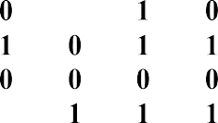  A B  0 | C | D
R(1) | k = 2 Vertex |  |  |  |  | A
R(1) | {1,2 } can |   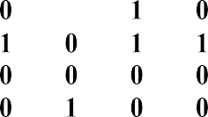  B |  |  |  | B
R(1) | be | C |  |  |  | C
R(1) | intermediate | D |  |  |  | D | 1
R(1) | nodes | R2[4,1]
R(1) |  | = R1[4,1] OR
R(1) |  | R1[4,2] AND R1[2,1]
R(1) |  | = 0 OR ( 1 AND 1)
R(1) |  | = 1
R(1) |  | R2[4,3]
R(1) |  | = R1[4,3] OR
R(1) |  | R1[4,2] AND R1[2,3]
R(1) |  | = 0 OR ( 1 AND 1)
R(1) |  | = 1
R(1) |  | R2[4,4]
R(1) |  | = R1[4,4] OR
R(1) |  | R1[4,2] AND R1[2,4]
R(1) |  | = 0 OR ( 1 AND 1)
R(1) |  | = 1
R(2) | k = 3 Vertex  {1,2,3 } can  be intermediate nodes |   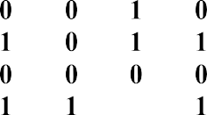  A | B | C  1 | D | A B  D A 0 B  C D  NO CHANGE |  | C
R(2) | k = 3 Vertex  {1,2,3 } can  be intermediate nodes | A  B C D |  | C  1 |  |  |  | C

R(3) k ={1,2,3,4 }can be intermediate

 |  | A B C D  A 0 0 1 0  B 1 0 1 1  C 0 0 0 0  D 1 1 1 1  R4[2,2]  = R3[2,2] OR  R3[2,4] AND R3[4,2]  = 0 OR ( 1 AND 1)  = 1 |  |  | 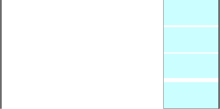  A B C D  A 0  B 1 1  C 0  D
 |  | A B C D |  |  | TRANSITIVE CLOSURE  for the given graph
 |  | A  B C | 0 0 1 0  1 1 1 1  0 0 0 0  1 1 1 1 |  | TRANSITIVE CLOSURE  for the given graph

Efficiency:
- Time efficiency is Θ(n³)
- Space efficiency: Requires extra space for separate matrices for recording intermediate results of the algorithm.
  - Floyd’s Algorithm to find -ALL PAIRS SHORTEST PATHS

Some useful definitions:
    - Weighted Graph: Each edge has a weight (associated numerical value). Edge weights may represent costs, distance/lengths, capacities, etc. depending on the problem.
    - Weight matrix: W(i,j) is
      - 0 if i=j
      - ∞ if no edge b/n i and j.
      - ―weight of edge‖ if edge b/n i and j.

Problem statement:
Given a weighted graph G( V, Ew), the all-pairs shortest paths problem is to find the shortest path between every pair of vertices ( vi, vj ) Є V.

Solution:
A number of algorithms are known for solving All pairs shortest path problem
    - Matrix multiplication based algorithm
    - Dijkstra's algorithm
    - Bellman-Ford algorithm
    - Floyd's algorithm

Underlying idea of Floyd’s algorithm:

    - Let W denote the initial weight matrix.
    - Let D(k) [ i, j] denote cost of shortest path from i to j whose intermediate vertices are a subset of {1,2,…,k}.

Recursive Definition Case 1:
A shortest path from vi to vj restricted to using only vertices from
{v1,v2,…,vk} as intermediate vertices does not use vk. Then
D(k) [ i, j ] = D(k-1) [ i, j ].

Case 2:
A shortest path from vi to vj restricted to using only vertices from{v1,v2,…,vk} as intermediate vertices do use vk. Then
D(k) [ i, j ] = D(k-1) [ i, k ] + D(k-1) [ k, j ].

We conclude:
D(k)[ i, j ] = min { D(k-1) [ i, j ], D(k-1) [ i, k ] + D(k-1) [ k, j ] }

Algorithm:

Algorithm Floyd(W[1..n, 1..n])
// Implements Floyd‘s algorithm
// Input: Weight matrix W
// Output: Distance matrix of shortest paths‘ length D W
for k → 1 to n do
for i→ 1 to n do for j→ 1 to n do
D [ i, j]→ min { D [ i, j], D [ i, k] + D [ k, j]
return D

Example:
Find All pairs shortest paths for the given weighted connected graph using Floyd‘s algorithm.

4

Solution:

D(0) =
A B C

A
0
2
B

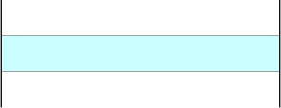
D(0) k = 1
intermediate node
B C
D1[2,3]
4
∞
0
3
∞
0
B C
4
∞
0
3
9
0
D(1)
k = 2
= min { D0 [2,3],
D0 [2,1] + D0 [1,3] }
= min { ∞, ( 4 + 5) }
= 9
can
be
A
intermediate nodes
B C
B
2
3
C
A B C
A 0
4
7
3
C 5
9
0
D(2)
k = 3
Vertex 1,2,3 can
D2[3,1]
= min { D1 [3,1],
D1 [3,2] + D1 [2,1] }
= min { ∞, ( 4 + 3) }
= 7
intermediate nodes
be A
B
D(3)
C
NO Change
ALL PAIRS SHORTEST
PATHS for the given graph

 | can be |  |  | A | B | C |  |  |  | A |  | B | C
 |  | A |  | 0 | 2 | 5 |  | A |  | 0 |  | 2 | 5

A | B | C |  | A | B | C
0 | 2 | 5 | A | 0 | 2 | 5
4 | 0 | 9 | B | 4 | 0 | 9
7 | 3 | 0 | C | 7 | 3 | 0

A | A 0 | B 2 | C 5
 | 4 | 0 | 9
B C | 7 | 3 | 0

0/1 Knapsack Problem Memory function Definition:
Given a set of n items of known weights w1,…,wn and values v1,…,vn and a
knapsack of capacity W, the problem is to find the most valuable subset of the items that fit into the knapsack.
Knapsack problem is an OPTIMIZATION PROBLEM

Dynamic programming approach to solve knapsack problem

Step 1:
Identify the smaller sub-problems. If items are labeled 1..n, then a sub-problem wouldbe to find an optimal solution for Sk = {items labeled 1, 2, .. k}

Step 2:
Recursively define the value of an optimal solution in terms of solutions to smaller problems.
Initial conditions:
V[ 0, j ] = 0 for j ≥
0 V[ i, 0 ] = 0 for i
≥ 0

Recursive step:
max { V[ i-1, j ], vi +V[ i-1, j - wi ] }
V[ i, j ] = if j - wi ≥ 0
V[ i-1, j ] if j - wi < 0
Step 3:
Bottom up computation using iteration

Question:
Apply bottom-up dynamic programming algorithm to the following instance of the knapsack problem Capacity W= 5

Item # | Weight (Kg) | Value (Rs.)
1 | 2 | 3
2 | 3 | 4
3 | 4 | 5
4 | 5 | 6

Solution:
Using dynamic programming approach, we have:

Step | Calculation |  | Table
1 | Initial conditions: V[ 0, j ] = 0 for j ≥ 0 V[ i, 0 ] = 0 for i ≥ 0 |  | 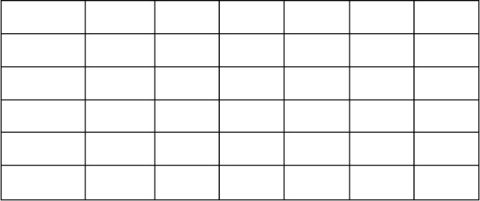  V[i,j] i=0 | j=0
2 | W1 = 2,  Available knapsack capacity = 1 W1 > WA, CASE 1 holds: V[ i, j ] = V[ i-1, j ]  V[ 1,1] = V[ 0, 1 ] = 0 |  | 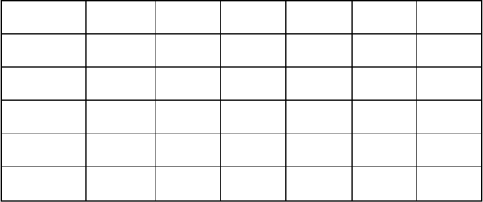  V[i,j] i=0 | j=0
3 | W1 = 2,  Available knapsack capacity = 2 W1 = WA, CASE 2 holds:  V[ i, j ] = max { V[ i-1, j ],  vi +V[ i-1, j - wi ] }  V[ 1,2] = max { V[ 0, 2 ],  3 +V[ 0, 0 ] }  = max { 0, 3 + 0 } = 3 |  | 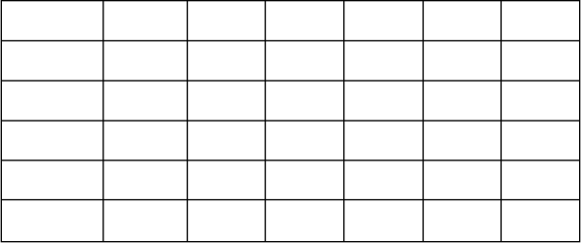  V[i,j] i=0 | j=0
4 | W1 = 2,
4 | Available knapsack capacity = |  | 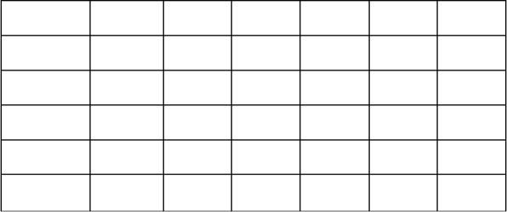  V[i,j] | j=0
4 | W1 < WA, | 3,4,5  CASE 2 holds: | i=0
4 | V[ i, j ] = max { V[ i-1, j ],
4 | vi +V[ i-1, j - wi ] }
4 | V[ 1,3] = max { V[ 0, 3 ],
4 | 3 +V[ 0, 1 ] }
4 | = max { 0, 3 + 0 } = 3
5 | W2 = 3,  Available knapsack capacity = 1 W2 >WA, CASE 1 holds: V[ i, j ] = V[ i-1, j ]  V[ 2,1] = V[ 1, 1 ] = 0 |  | 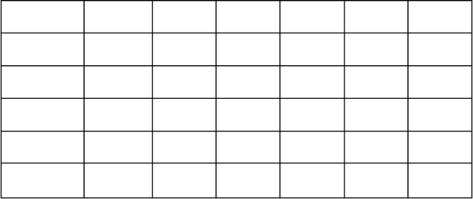  V[i,j] i=0 | j=0

6 | W2 = 3,  Available knapsack capacity  = 2 W2 >WA,  CASE 1 holds: V[ i, j ]  = V[ i-1, j ]  V[ 2,2] = V[ 1, 2 ] = 3 | 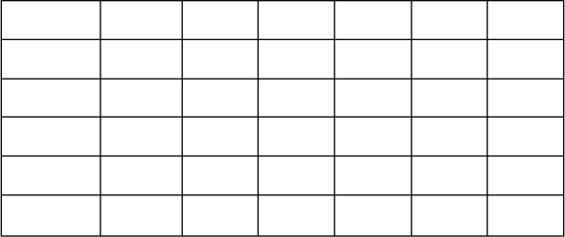  V[i,j] j=0 i=0
7 | W2 = 3,  Available knapsack capacity  = 3 W2 = WA, CASE 2  holds:  V[ i, j ] = max { V[ i-1, j ],  vi +V[ i-1, j - wi ] }  V[ 2,3] = max { V[ 1, 3 ], | 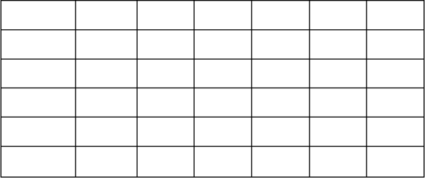  V[i,j] j=0 i=0
8 | 4 +V[ 1, 0 ] }  = max { 3, 4 + 0 } = 4  W2 = 3,  Available knapsack capacity  = 4 W2 < WA, CASE 2  holds:  V[ i, j ] = max { V[ i-1, j ],  vi +V[ i-1, j - wi ] }  V[ 2,4] = max { V[ 1, 4 ], | 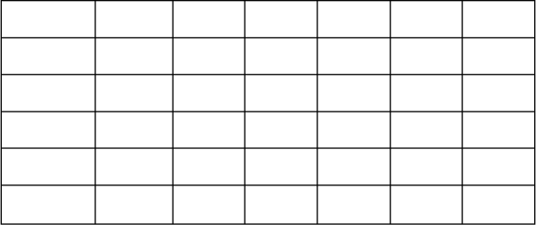  V[i,j] j=0 i=0
9 | 4 +V[ 1, 1 ] }  = max { 3, 4 + 0 } = 4  W2 = 3,  Available knapsack capacity  = 5 W2 < WA, CASE 2  holds:  V[ i, j ] = max { V[ i-1, j ],  vi +V[ i-1, j - wi ] } | V[i,j] j=0 i=0
10 | V[ 2,5] = max { V[ 1, 5 ],
10 | 4 +V[ 1, 2 ] }
10 | = max { 3, 4 + 3 } = 7
10 | W3 = 4,
10 | Available knapsack capacity = | V[i,j] j=0
10 | 1,2,3  W3 > WA, CASE 1 | i=0
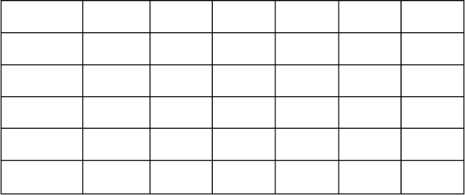
holds: V[ i, j ] = V[ i-1, j ]

11 | W3 = 4,  Available knapsack capacity = 4 W3 = WA, CASE 2 holds:  V[ i, j ] = max { V[ i-1, j ],  vi +V[ i-1, j - wi ] }  V[ 3,4] = max { V[ 2, 4 ],  5 +V[ 2, 0 ] }  = max { 4, 5 + 0 } = 5 | 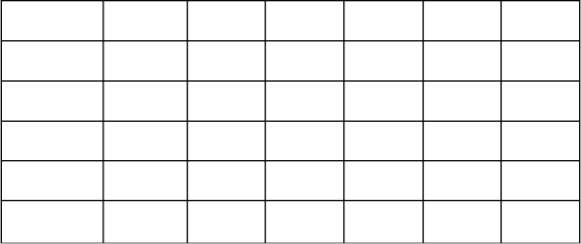  V[i,j] j=0 i=0
12 | W3 = 4,  Available knapsack capacity = 5 W3 < WA, CASE 2 holds:  V[ i, j ] = max { V[ i-1, j ],  vi +V[ i-1, j - wi ] }  V[ 3,5] = max { V[ 2, 5 ],  5 +V[ 2, 1 ] }  = max { 7, 5 + 0 } = 7 | 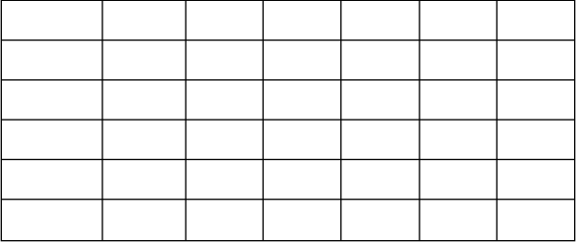  V[i,j] j=0 i=0
13 | W4 = 5,  Available knapsack capacity =  1,2,3,4  W4 < WA, CASE 1 holds: V[ i, j ] = V[ i-1, j ] | V[i,j] j=0 i=0
14 | W4 = 5,  Available knapsack capacity = 5 W4 = WA, CASE 2 holds:  V[ i, j ] = max { V[ i-1, j ],  vi +V[ i-1, j - wi ] }  V[ 4,5] = max { V[ 3, 5 ],  6 +V[ 3, 0 ] }  = max { 7, 6 + 0 } = 7 | V[i,j] j=0 i=0
Maximal value is V [ 4, 5 ] = 7/-

What is the composition of the optimal subset?
The composition of the optimal subset if found by tracing back the computations for the entries in the table.

Step | Table | Remarks
1 | 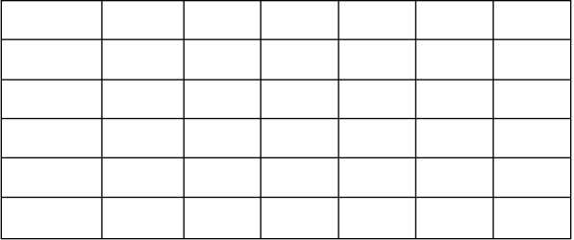  V[i,j] j=0 i=0 | V[ 4, 5 ] = V[ 3, 5 ]  ITEM 4 NOT included in the subset
2 | 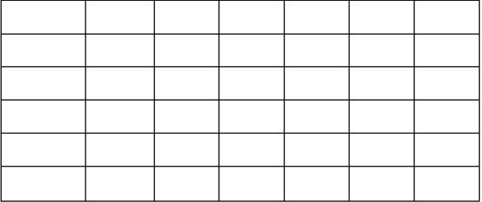  V[i,j] j=0 i=0 | V[ 3, 5 ] = V[ 2, 5 ]  ITEM 3 NOT included in the subset
3 | 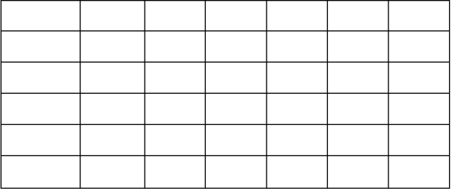  V[i,j] j=0 i=0 | V[ 2, 5 ] ≠ V[ 1, 5 ]  ITEM 2 included in the subset
4 | Since item 2 is included in the knapsack:  Weight of item 2 is 3kg, therefore, remaining capacity of  the knapsack is  (5 - 3 =) 2kg  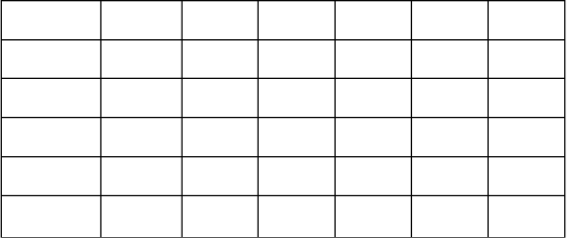  V[i,j] j=0 i=0 | V[ 1, 2 ] ≠ V[ 0, 2 ]  ITEM 1 included in the subset
5 | Since item 1 is included in the knapsack:  Weight of item 1 is 2kg, therefore, remaining capacity of  the knapsack is  (2 - 2 =) 0 kg. | Optimal subset: { item 1, item 2 }  Total weight is: 5kg (2kg + 3kg) Total profit is: 7/- (3/- + 4/-)

Efficiency:
- Running time of Knapsack problem using dynamic programming algorithmis: ( n * W )
- Time needed to find the composition of an optimal solution is: O( n + W )

Memory function
- Memory function combines the strength of top-down and bottom-up approaches
- It solves ONLY sub-problems that are necessary and does it ONLY ONCE.

The method:
- Uses top-down manner.
- Maintains table as in bottom-up approach.
- Initially, all the table entries are initialized with special ―null‖ symbol to indicate that they have not yet been calculated.
- Whenever a new value needs to be calculated, the method checks the corresponding entry in the table first:
- If entryis NOT ―null‖, it is simplyretrieved from the table.
- Otherwise, it is computed by the recursive call whose result is then recorded in the table.

Algorithm:
Algorithm MFKnap( i, j ) if V[ i, j] < 0
if j < Weights[ i ]
value → MFKnap( i-1, j )
else
value → max {MFKnap( i-1, j ),
Values[i] + MFKnap( i-1, j - Weights[i] )}
V[ i, j ]→ va
lue return V[ i, j]

Example:
Apply memory function method to the following instance of the knapsack problem Capacity W= 5

Item # | Weight (Kg) | Value (Rs.)
1 | 2 | 3
2 | 3 | 4
3 | 4 | 5
4 | 5 | 6

Solution:
Using memory function approach, we have:

 | Computation | Remarks
1 | Initially, all the table entries are initialized with special ―null‖ symbol to indicate that they have not yet been calculated. Here null is indicated with -1 value.
1 |  |  | V[i,j] | j=0 | 1 | 2 | 3 | 4 | 5
1 |  |  | i=0 | 0 | 0 | 0 | 0 | 0 | 0
1 |  |  | 1 | 0 | -1 | -1 | -1 | -1 | -1
1 |  |  | 2 | 0 | -1 | -1 | -1 | -1 | -1
1 |  |  | 3 | 0 | -1 | -1 | -1 | -1 | -1
1 |  |  | 4 | 0 | -1 | -1 | -1 | -1 | -1
2 | MFKnap( 4, 5 )
 |  |  | V[ 1, 5 ] = 3
 | MFKnap( 3, 5 ) 6 + MFKnap( 3, 0 ) |  | 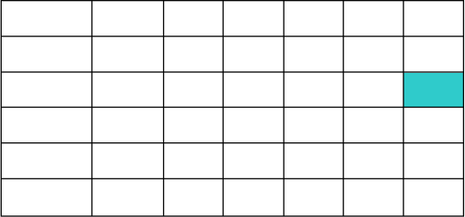  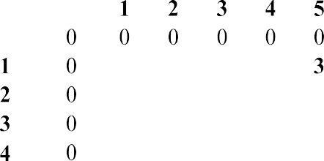  V[i,j] j=0
 | MFKnap( 2, 5 ) 5 + MFKnap( 2, 1 ) |  | i=0 |  | -1 | -1 | -1 | -1
 |  |  |  |  | -1 | -1 | -1 | -1 | -1
 | MFKnap( 1, 5 ) 4 + MFKnap( 1, 2 ) |  |  |  | -1 | -1 | -1 | -1 | -1
 | 0  3 |  |  |  | -1 | -1 | -1 | -1 | -1
 | MFKnap( 0, 5 ) 3 + MFKnap( 0, 3 )
 | 0 3 + 0
3 | MFKnap( 4, 5 )
 |  |  | V[ 1, 2 ] = 3
 | MFKnap( 3, 5 ) 6 + MFKnap( 3, 0 ) |  | 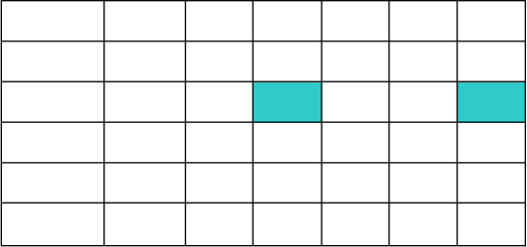  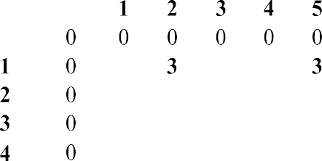  V[i,j] j=0
 | MFKnap( 2, 5 ) 5 + MFKnap( 2, 1 ) |  | i=0
 |  |  |  |  | -1 |  | -1 | -1
 | MFKnap( 1, 5 ) 4 + MFKnap( 1, 2 )    3 0 3 |  |  |  | -1  -1  -1 | -1  -1  -1 | -1  -1  -1 | -1  -1  -1 | -1  -1  -1
 | MFKnap( 0, 2 ) 3 + MFKnap( 0, 0 | )
 | 0 3 + 0
4 |   MFKnap( 4, 5 )
 |  |  | V[ 2, 5 ] = 7
 |   MFKnap( 3, 5 ) 6 + MFKnap( 3, 0 | )
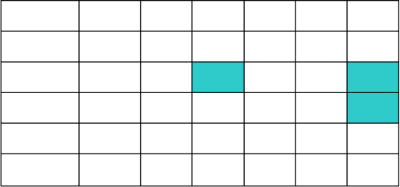
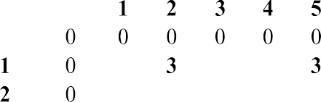
V[i,j] j=0
 | MFKnap( 2, 5 ) 5 + MFKnap( 2, 1 )    3 7 |  | i=0 |  | -1  -1 | -1 | -1  -1 | -1  -1
 | MFKnap( 1, 5 ) 4 + MFKnap( 1, 2 ) |  |  |  | -1 | -1 | -1 | -1 | -1
 | 3 3 |  |  |  | -1 | -1 | -1 | -1 | -1

Efficiency:
- Time efficiency same as bottom up algorithm: O( n * W ) + O( n + W )
- Just a constant factor gain by using memory function Less space efficient than a space efficient version of a bottom-up algorithm
111


Lecture Notes on
Design and Analysis of Algorithms BCS401

Module-5 : Backtracking
Contents

- Backtracking:
General method
N-Queens problem Sum of subsets problem Graph coloring Hamiltonian cycles
- Branch and Bound:
Assignment Problem, Travelling Sales Person problem
- 0/1Knapsack problem
LC Branch and Bound solution FIFO Branch and Bound solution
- NP-Complete and NP-Hard problems Basic concepts
Non-deterministic algorithms
P, NP, NP-Complete, and NP-Hard classes

Backtracking
Some problems can be solved, by exhaustive search. The exhaustive-search technique suggests generating all candidate solutions and then identifying the one (or the ones) with a desired property.
Backtracking is a more intelligent variation of this approach. The principal idea is to construct solutions one component at a time and evaluate such partially constructed candidates as follows. If a partially constructed solution can be developed further without violating the problem‘s constraints, it is done by taking the first remaining legitimate option for the next component. If there is no legitimate option for the next component, no alternatives for any remaining component need to be considered. In this case, the algorithm backtracks to replace the last component of the partially constructed solution with its next option.
It is convenient to implement this kind of processing by constructing a tree of choices being made, called the state-space tree. Its root represents an initial state before the search for a solution begins. The nodes of the first level in the tree represent the choices made for the first component of a solution; the nodes of the second level represent the choices for the second component, and soon. A node in a state-space tree is said to be promising if it corresponds to a partially constructed solution that may still lead to a complete solution; otherwise, it is called non-promising. Leaves represent either non-promising dead ends or complete solutions found by the algorithm.
In the majority of cases, a statespace tree for a backtracking algorithm is constructed in the manner of depth-first search. If the current node is promising, its child is generated by adding the first remaining legitimate option for the next component of a solution, and the processing moves to this child. If the current node turns out to be non-promising, the algorithm backtracks to the node‘s parent to consider the next possible option for its last component; if there is no such option, it backtracks one more level up the tree, and so on. Finally, if the algorithm reaches a complete solution to the problem, it either stops (if just one solution is required) or continues searching for other possible solutions.

General method (Textbook T2:7.1)
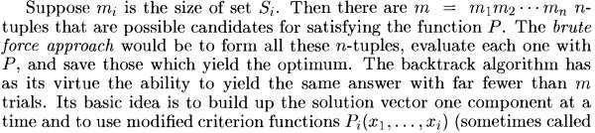

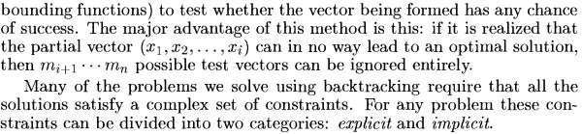
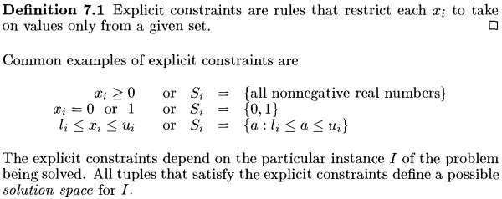
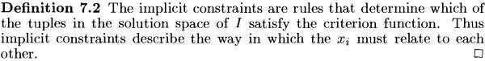

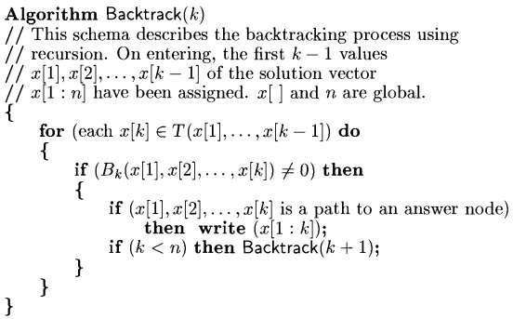
General Algorithm (Recursive)

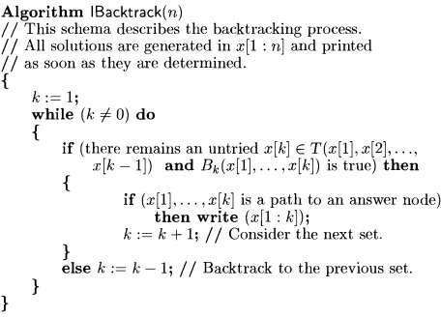
General Algorithm (Iterative)

General Algorithm for backtracking (From textbook T1)
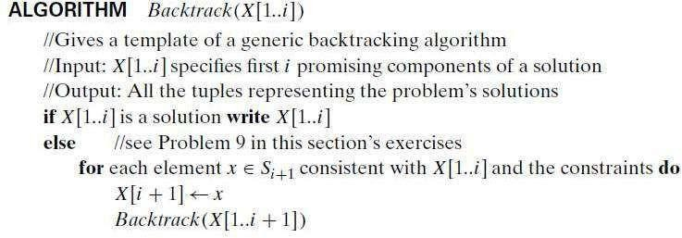

N-Queens problem
The problem is to place n queens on an n × n chessboard so that no two queens attack each other by being in the same row or in the same column or on the same diagonal.
So let us consider the four-queens problem and solve it by the backtracking technique. Since each of the four queens has to be placed in its own row, all we need to do is to assign a column for each queen on the board presented in figure.
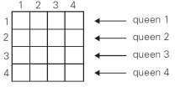

We start with the empty board and then place queen 1 in the first possible position of its row, which is in column 1 of row 1. Then we place queen 2, after trying unsuccessfully columns 1 and 2, in the first acceptable position for it, which is square (2, 3), the square in row 2 and column 3. This proves to be a dead end because there is no acceptable position for queen 3. So, the algorithm backtracks and puts queen 2 in the next possible position at (2, 4). Then queen 3 is placed at (3, 2), which proves to be another dead end. The algorithm then backtracks all the way to queen 1 and moves it to (1, 2). Queen 2 then goes to (2, 4), queen 3 to(3, 1), and queen 4 to (4, 3), which is a solution to the problem. The state-space tree of this search is shown in figure.
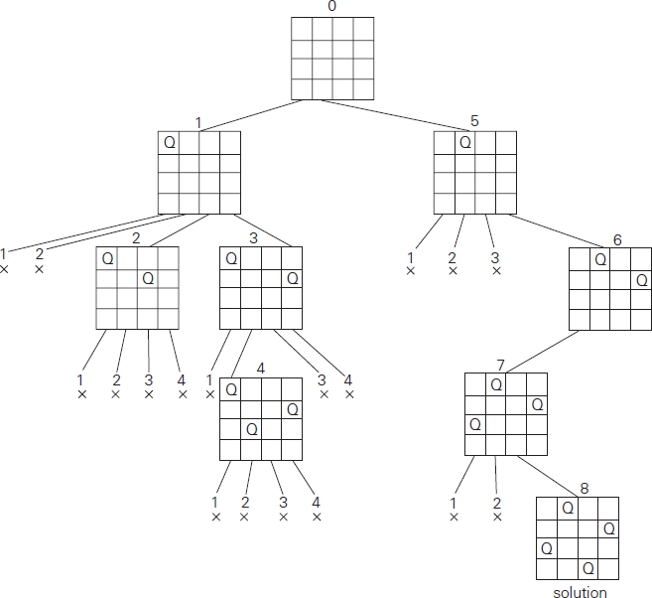
Figure: State-space tree of solving the four-queens problem by backtracking. × denotes an unsuccessful attempt to place a queen in the indicated column. The numbers above the nodes indicate the order in which the nodes are generated.

If other solutions need to be found, the algorithm can simply resume its operations at the leaf at which it stopped. Alternatively, we can use the board‘s symmetry for this purpose.
Finally, it should be pointed out that a single solution to the n-queens problem for any n ≥ 4 can be found in linear time.

Note: The algorithm NQueens() is not in the syllabus. It is given here for interested learners. The algorithm is referred from textbook T2.

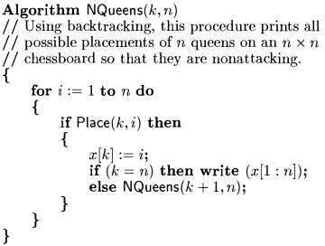
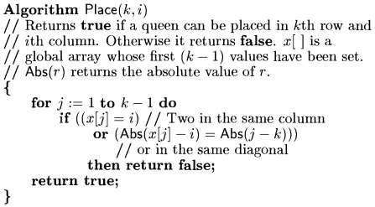

Sum of subsets problem
Problem definition: Find a subset of a given set A = {a1, . . . , an} of n positive integers whose sum is equal to a given positive integer d.
For example, for A = {1, 2, 5, 6, 8} and d = 9, there are two solutions: {1, 2, 6} and {1, 8}. Of course, some instances of this problem may have no solutions.
It is convenient to sort the set‘s elements in increasing order. So, we will assume that
a1< a2< . . . < an.
The state-space tree can be constructed as a binary tree like that in Figure shown below for the instance A = {3, 5, 6, 7} and d = 15.
The number inside a node is the sum of the elements already included in the subsets represented by the node. The inequality below a leaf indicates the reason for its termination.

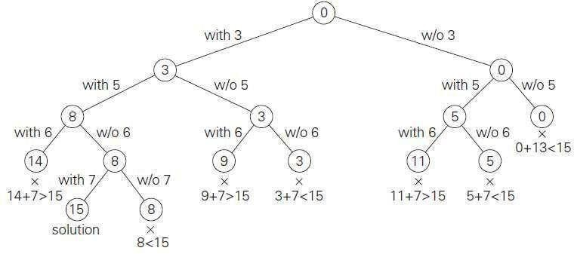
The root of the tree represents the starting point, with no decisions about the given elements made as yet. Its left and right children represent, respectively, inclusion and exclusion of a1 in a set being sought.
Similarly, going to the left from a node of the first level corresponds to inclusion of a2 while going to the right corresponds to its exclusion, and so on. Thus, a path from the root to a node on the i^{th} level of the tree indicates which of the first in numbers have been included in the subsets represented by that node.
We record the value of s, the sum of these numbers, in the node. If s is equal to d, we have a solution to the problem. We can either report this result and stop or, if all the solutions need to be found, continue by backtracking to the node‘s parent. If s is not equal to d, we can terminate the node as non-promising if either of the following two inequalities holds:
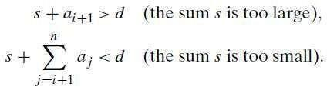
Example: Apply backtracking to solve the following instance of the subset sum problem: A
= {1, 3, 4, 5} and d = 11.

Graph coloring
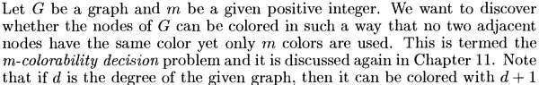

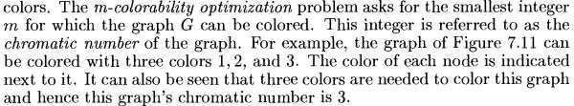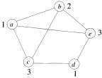
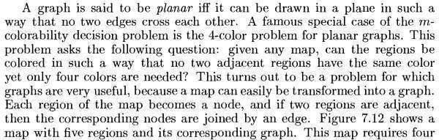
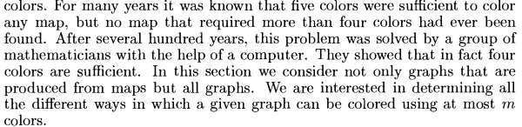
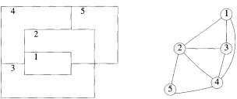
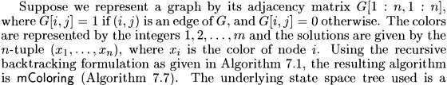

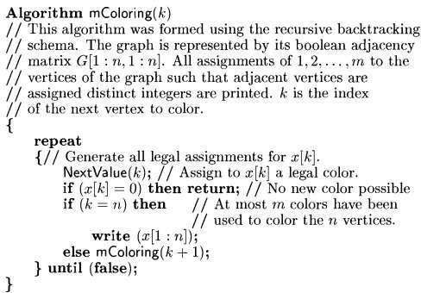
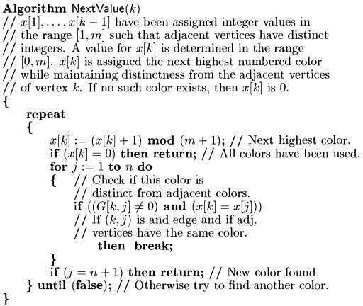

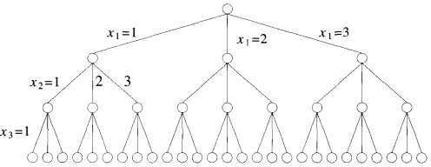
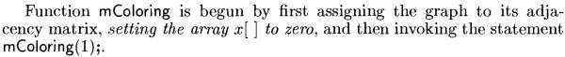
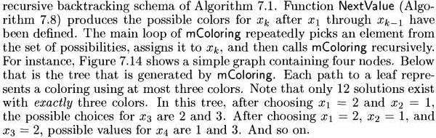
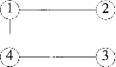
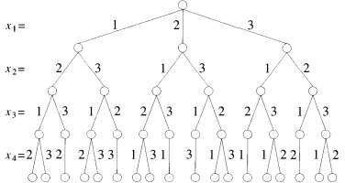

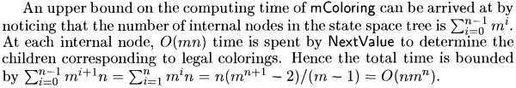
Analysis

Hamiltonian cycles
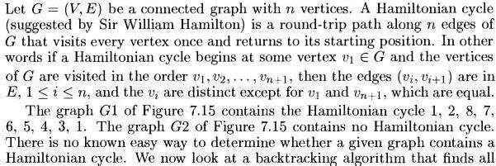
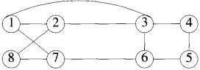
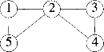
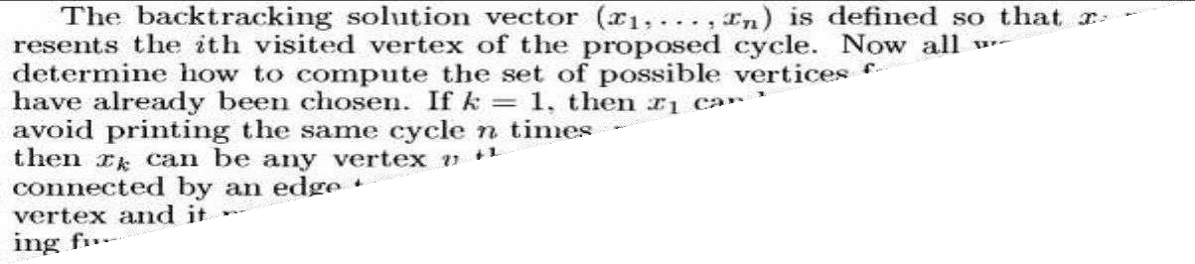
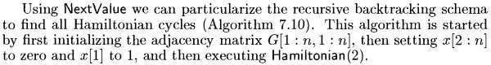
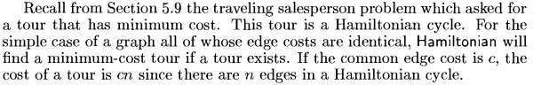

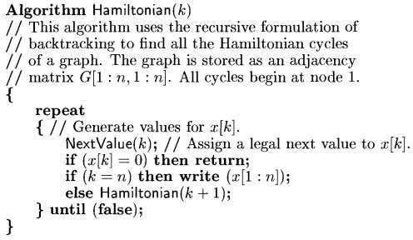
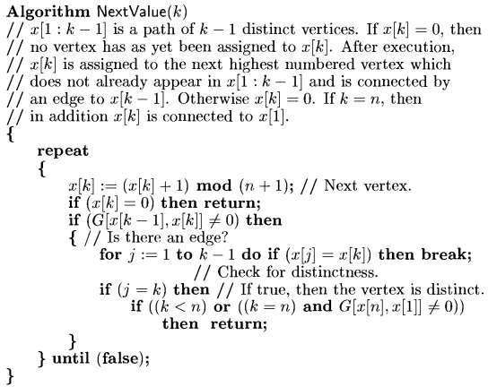

Branch and Bound
Recall that the central idea of backtracking, discussed in the previous section, is tocut off a branch of the problem‘s state-space tree as soon as we can deduce that it cannot lead to a solution. This idea can be strengthened further if we deal with an optimization problem.
An optimization problem seeks to minimize or maximize some objective function (a tour length, the value of items selected, the cost of an assignment, and the like), usually subject to some constraints. An optimal solution is a feasible solution with the best value of the objective function (e.g., the shortest Hamiltonian circuit or the most valuable subset of items that fit the knapsack).
Compared to backtracking, branch-and-bound requires two additional items:
  - a way to provide, for every node of a state-space tree, a bound on the best value of the objective function on any solution that can be obtained by adding further components to the partially constructed solution represented by the node
  - the value of the best solution seen so far
In general, we terminate a search path at the current node in a state-space tree of a branch- and-bound algorithm for any one of the following three reasons:
- The value of the node‘s bound is not better than the value of the best solution seen so far.
- The node represents no feasible solutions because the constraints of the problem are already violated.
- The subset of feasible solutions represented by the node consists of a single point (and hence no further choices can be made)—in this case, we compare the value of the objective function for this feasible solution with that of the best solution seen so far and update the latter with the former if the new solution is better.

Assignment Problem
Let us illustrate the branch-and-bound approach by applying it to the problem of assigning n people to n jobs so that the total cost of the assignment is as small as possible.
An instance of the assignment problem is specified by an n × n cost matrix C so that we can state the problem as follows: select one element in each row of the matrix so that no two selected elements are in the same column and their sum is the smallest possible. We will demonstrate how this problem can be solved using the branch-and-bound technique by considering the small instance of the problem. Consider the data given below.
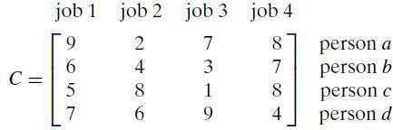

How can we find a lower bound on the cost of an optimal selection without actually solving the problem?
We can do this by several methods. For example, it is clear that the cost of any solution, including an optimal one, cannot be smaller than the sum of the smallest elements in each of the matrix’s rows. For the instance here, this sum is 2 + 3+ 1+ 4 = 10.We can and will apply the same thinking to partially constructed solutions. For example, for any legitimate selection that selects 9 from the first row, the lower bound will be 9 + 3 + 1+ 4 = 17.
Rather than generating a single child of the last promising node as we did in backtracking, we will generate all the children of the most promising node among non-terminated leaves in the current tree. (Non terminated, i.e., still promising, leaves are also called live.) How can we tell which of the nodes is most promising? We can do this by comparing the lower bounds of the live nodes. It is sensible to consider a node with the best bound as most promising, although this does not, of course, preclude the possibility that an optimal solution will ultimately belong to a different branch of the state-space tree. This variation of the strategy is called the best-first branch-and-bound.
We start with the root that corresponds to no elements selected from the cost matrix. The lower-bound value for the root, denoted lb, is 10. The nodes on the first level of the tree correspond to selections of an element in the first row of the matrix, i.e., a job for person a. See the figure given below.
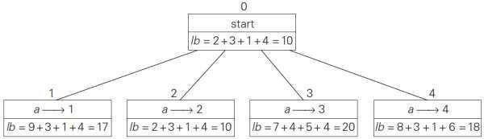
Figure: Levels 0 and 1 of the state-space tree for the instance of the assignment problem being solved with the best-first branch-and-bound algorithm. The number above a node shows the order in which the node was generated. A node‘s fields indicate the job number assigned to person a and the lower bound value, lb, for this node.

So we have four live leaves—nodes 1 through 4—that may contain an optimal solution. The most promising of them is node 2 because it has the smallest lower bound value. Following our best-first search strategy, we branch out from that node first by considering the three different ways of selecting an element from the second row and not in the second column - the three different jobs that can be assigned to person b. See the figure given below (Fig 12.7).

Of the six live leaves—nodes 1, 3, 4, 5, 6, and 7—that may contain an optimal solution, we again choose the one with the smallest lower bound, node 5. First, we consider selecting the third column‘s element from c‘s row (i.e., assigning person c to job 3); this leaves us with no choice but to select the element from the fourth column of d‘s row (assigning person d to job 4). This yields leaf 8 (Figure 12.7), which corresponds to the feasible solution {a→2, b→1, c→3, d →4} with the total cost of 13. Its sibling, node 9, corresponds to the feasible solution
{a→2,b→1, c→4, d →3} with the total cost of 25. Since its cost is larger than the cost of the solution represented by leaf 8, node 9 is simply terminated. (Of course, if its cost were smaller than 13, we would have to replace the information about the best solution seen so far with the data provided by this node.)
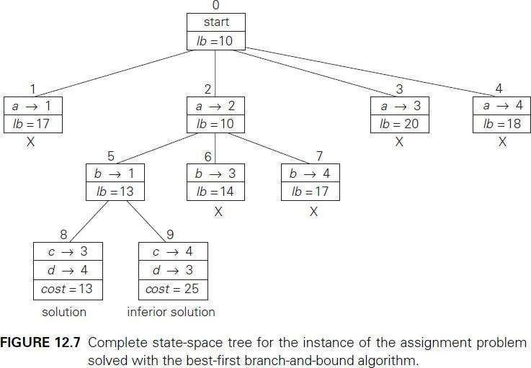

Now, as we inspect each of the live leaves of the last state-space tree—nodes1, 3, 4, 6, and 7 in Figure 12.7—we discover that their lower-bound values are not smaller than 13, the value of the best selection seen so far (leaf 8). Hence, we terminate all of them and recognize the solution represented by leaf 8 as the optimal solution to the problem.

Travelling Sales Person problem
We will be able to apply the branch-and-bound technique to instances of the traveling salesman problem if we come up with a reasonable lower bound on tour lengths. One very simple lower bound can be obtained by finding the smallest element in the intercity distance matrix D and multiplying it by the number of cities n.

But there is a less obvious and more informative lower bound for instances with symmetric matrix D, which does not require a lot of work to compute. We can compute a lower bound on the length l of any tour as follows. For each city i, 1≤ i ≤ n, find the sum si of the distances from city i to the two nearest cities; compute the sums of these n numbers, divide the result by 2, and, if all the distances are integers, round up the result to the nearest integer:
lb = ⌈s/2⌉... (1)
For example, for the instance in Figure 2.2a, formula (1) yields
Moreover, for any subset of tours that must include particular edges of a given graph, we can modify lower bound (formula 1) accordingly. For example, for all the Hamiltonian circuits of the graph in Figure 2.2a that must include edge (a, d), we get the following lower bound by summing up the lengths of the two shortest edges incident with each of the vertices, with the required inclusion of edges (a, d)and (d, a):
We now apply the branch-and-bound algorithm, with the bounding function given by formula-1, to find the shortest Hamiltonian circuit for the graph in Figure 2.2a.
To reduce the amount of potential work, we take advantage of two observations.
- First, without loss of generality, we can consider only tours that start at a.
- Second, because our graph is undirected, we can generate only tours in which b is visited before c. (Refer Note at the end of section 2.2 for more details)
In addition, after visiting n−1= 4 cities, a tour has no choice but to visit the remaining unvisited city and return to the starting one. The state-space tree tracing the algorithm‘s application is given in Figure 2.2b.

Note: An inspection of graph with 4 nodes (figure given below) reveals three pairs of tours that differ only by their direction. Hence, we could cut the number of vertex permutations by half. We could, for example, choose any two intermediate vertices, say, b and c, and then consider only permutations in which b precedes c. (This trick implicitly defines a tour‘s direction.)
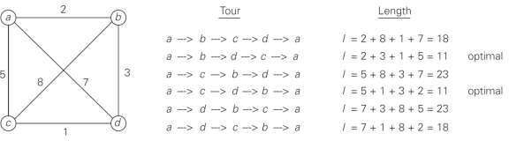
Figure: Solution to a small instance of the traveling salesman problem by exhaustive search.

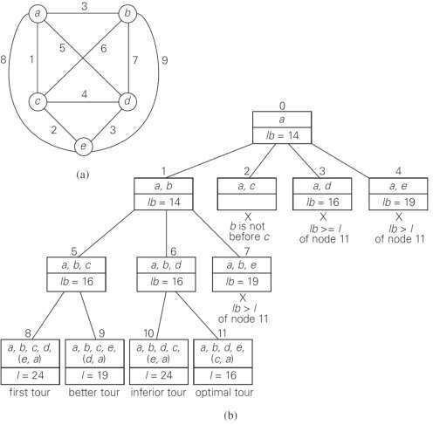
Figure 2.2(a)Weighted graph. (b) State-space tree of the branch-and-bound algorithm to find a shortest Hamiltonian circuit in this graph. The list of vertices in a node specifies a beginning part of the Hamiltonian circuits represented by the node.

Discussion
The strengths and weaknesses of backtracking are applicable to branch-and-bound as well. The state-space tree technique enables us to solve many large instances of difficult combinatorial problems. As a rule, however, it is virtually impossible to predict which instances will be solvable in a realistic amount of time and which will not.
In contrast to backtracking, solving a problem by branch-and-bound has both the challenge and opportunity of choosing the order of node generation and finding a good bounding function. Though the best-first rule we used above is a sensible approach, it may or may not lead to a solution faster than other strategies. (Artificial intelligence researchers are particularly interested in different strategies for developing state-space trees.)
Finding a good bounding function is usually not a simple task. On the one hand, we want this function to be easy to compute. On the other hand, it cannot be too simplistic - otherwise, it would fail in its principal task to prune as many branches of a state-space tree as soon as possible. Striking a proper balance between these two competing requirements may require intensive experimentation with a wide variety of instances of the problem in question.

0/1 Knapsack problem
Note: For this topic as per the syllabus both textbooks T1 & T2 are suggested. Here we discuss the concepts from T1 first and then that of from T2.

Topic form T1 (Levitin)
Let us now discuss how we can apply the branch-and-bound technique to solving the knapsack problem. Given n items of known weights wi and values vi, i = 1, 2, . . . , n, and a knapsack of capacity W, find the most valuable subset of the items that fit in the knapsack.

∑ 𝑤𝑖𝑥𝑖 ≤ 𝑊
𝑎𝑛𝑑
∑ 𝑝𝑖𝑥𝑖 𝑖𝑠 𝑚𝑎𝑥𝑖𝑚𝑖𝑧𝑒𝑑, 𝑤ℎ𝑒𝑟𝑒 𝑥𝑖 = 0 𝑜𝑟 1
1≤𝑖≤𝑛

1≤𝑖≤𝑛
It is convenient to order the items of a given instance in descending order by their value-to- weight ratios.
Each node on the i^{th} level of state space tree, 0 ≤ i ≤ n, represents all the subsets of n items that include a particular selection made from the first i ordered items. This particular selection is uniquely determined by the path from the root to the node: a branch going to the left indicates the inclusion of the next item, and a branch going to the right indicates its exclusion.
We record the total weight w and the total value v of this selection in the node, along with some upper bound ub on the value of any subset that can be obtained by adding zero or more items to this selection. A simple way to compute the upper bound ub is to add to v, the total value of the items already selected, the product of the remaining capacity of the knapsack W
– w and the best per unit payoff among the remaining items, which is vi+1/wi+1:
ub = v + (W − w)(vi+1/wi+1).
Example: Consider the following problem. The items are already ordered in descending order of their value-to-weight ratios.
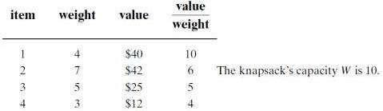

Let us apply the branch-and-bound algorithm. At the root of the state-space tree (see Figure 12.8), no items have been selected as yet. Hence, both the total weight of the items already selected w and their total value v are equal to 0. The value of the upper bound is 100.
Node 1, the left child of the root, represents the subsets that include item 1. The total weight and value of the items already included are 4 and 40, respectively; the value of the upper bound is 40 + (10 − 4) * 6 = 76.

Node 2 represents the subsets that do not include item 1. Accordingly, w = 0, v = 0, and ub = 0 + (10 − 0) * 6 = 60. Since node 1 has a larger upper bound than the upper bound of node 2, it is more promising for this maximization problem, and we branch from node 1 first. Its children—nodes 3 and 4—represent subsets with item 1 and with and without item 2, respectively. Since the total weight w of every subset represented by node 3 exceeds the knapsack‘s capacity, node 3 can be terminated immediately.
Node 4 has the same values of w and v as its parent; the upper bound ub is equal to 40 + (10
− 4) * 5 = 70. Selecting node 4 over node 2 for the next branching (Due to better ub), we get nodes 5 and 6 by respectively including and excluding item 3. The total weights and values as well as the upper bounds for these nodes are computed in the same way as for the preceding nodes.
Branching from node 5 yields node 7, which represents no feasible solutions, and node 8, which represents just a single subset {1, 3} of value 65. The remaining live nodes 2 and 6 have smaller upper-bound values than the value of the solution represented by node 8. Hence, both can be terminated making the subset {1, 3} of node 8 the optimal solution to the problem.
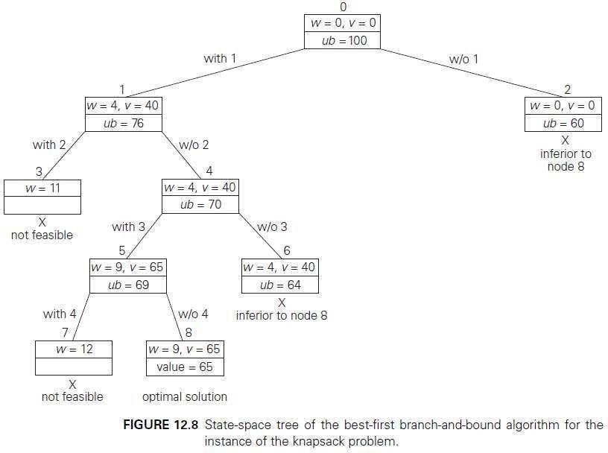
Solving the knapsack problem by a branch-and-bound algorithm has a rather unusual characteristic. Typically, internal nodes of a state-space tree do not define a point of the problem‘s search space, because some of the solution‘s components remain undefined. (See, for example, the branch-and-bound tree for the assignment problem discussed in the

preceding subsection.) For the knapsack problem, however, every node of the tree represents a subset of the items given. We can use this fact to update the information about the best subset seen so far after generating each new node in the tree. If we had done this for the instance investigated above, we could have terminated nodes 2 and 6 before node 8 was generated because they both are inferior to the subset of value 65 of node 5.

Concepts form textbook T2 (Horowitz)
Let us understand some of the terminologies used in backtracking &branch and bound.
→ Live node - a node which has been generated and all of whose children are not yet been generated.
→ E-node - is a live node whose children are currently being explored. In other words, an E- node is a node currently being expanded.
→ Dead node - a node that is either not to be expanded further, or for which all of its children have been generated
→ Bounding Function - will be used to kill live nodes without generating all their children.
→ Backtracking - is depth first node generation with bounding functions.
→ Branch-And-Bound is a method in which E-node remains E-node until it is dead.
→ Breadth-First-Search: Branch-and Bound with each new node placed in a queue. The front of the queen becomes the new E-node.
→ Depth-Search (D-Search): New nodes are placed in to a stack. The last node added is the first to be explored.
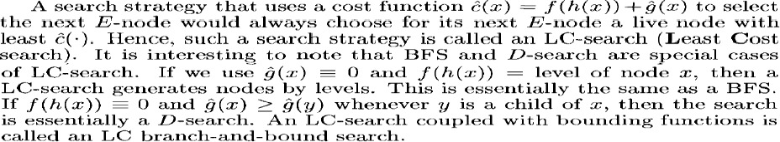

0/1 Knapsack problem - Branch and Bound based solution
As the technique discussed here is applicable for minimization problems, let us convert the knapsack problem (maximizing the profit) into minimization problem by negating the objective function
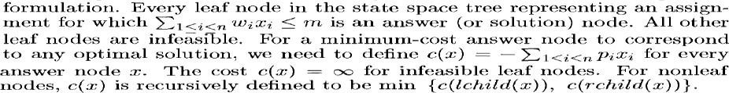
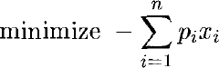
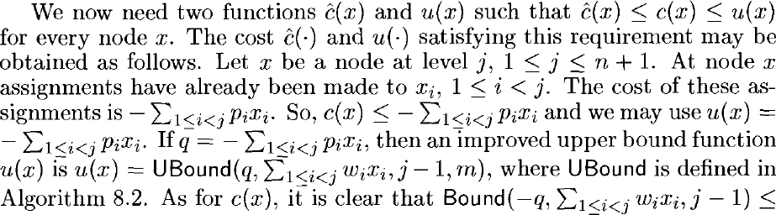
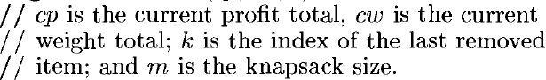
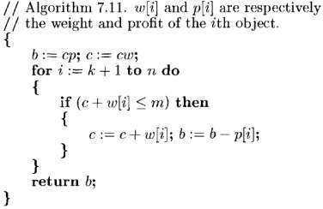

LC (Least Cost) Branch and Bound solution
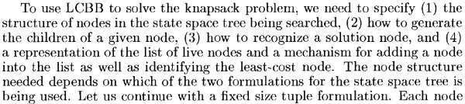
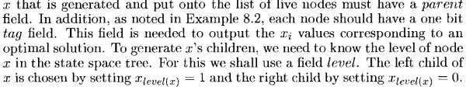
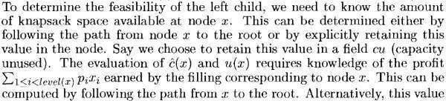
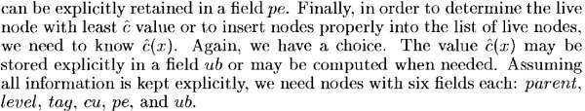
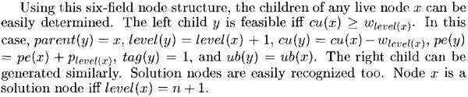
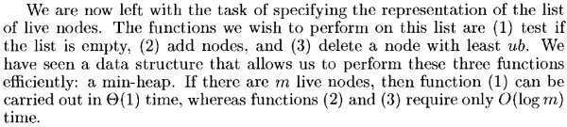

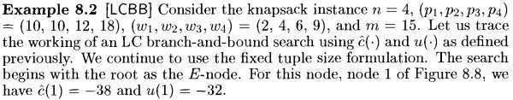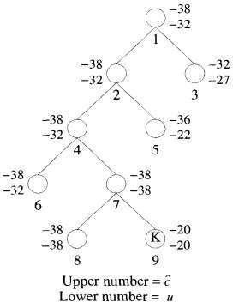
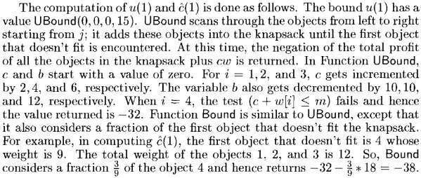
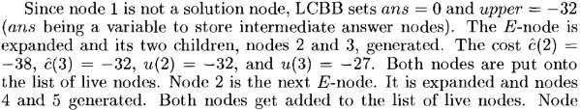

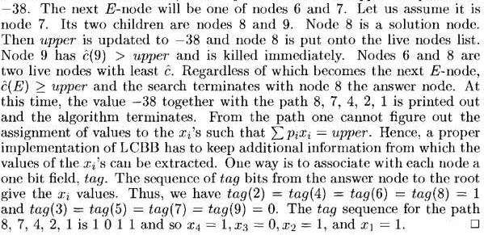

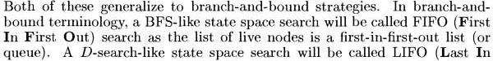
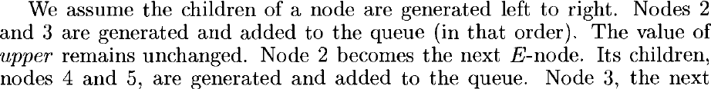
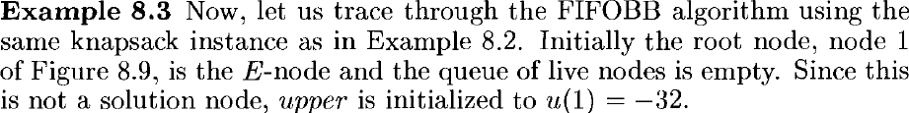
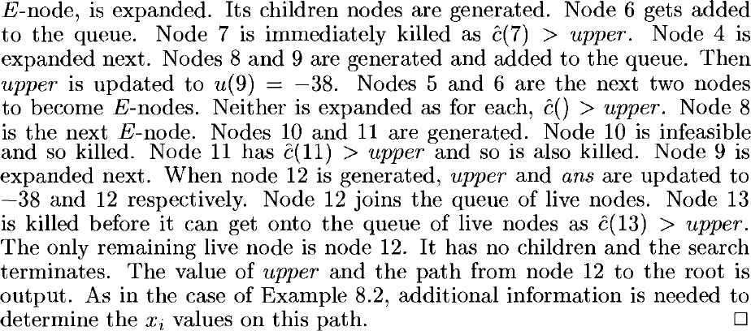
FIFO Branch and Bound solution

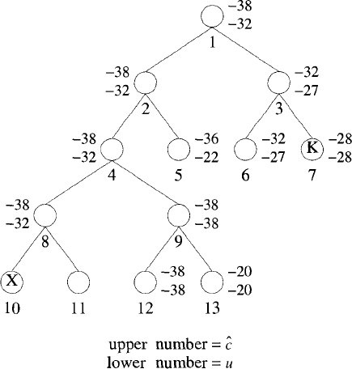

Conclusion
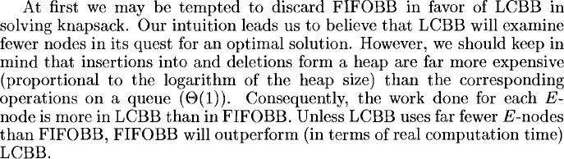

NP-Complete and NP-Hard problems

Basic concepts
For many of the problems we know and study, the best algorithms for their solution have computing times can be clustered into two groups;
  - Solutions are bounded by the polynomial- Examples include Binary search O(log n), Linear search O(n), sorting algorithms like merge sort O(n log n), Bubble sort O(n²) &matrix multiplication O(n³) or in general O(n^{k}) where k is a constant.
  - Solutions are bounded by a non-polynomial-Examples include travelling salesman problem O(n²2^{n}) & knapsack problem O(2^{n/2}). As the time increases exponentially, even moderate size problems cannot be solved.
So far, no one has been able to device an algorithm which is bounded by the polynomial for the problems belonging to the non-polynomial. However impossibility of such an algorithm is not proved.

Non deterministic algorithms
We also need the idea of two models of computer (Turing machine): deterministic and non- deterministic. A deterministic computer is the regular computer we always thinking of; a non- deterministic computer is one that is just like we‘re used to except that is has unlimited parallelism, so that any time you come to a branch, you spawn a new ―process‖ and examine both sides.
When the result of every operation is uniquely defined then it is called deterministic algorithm.
When the outcome is not uniquely defined but is limited to a specific set of possibilities, we call it non deterministic algorithm.
We use new statements to specify such non deterministic algorithms.
- choice(S) - arbitrarily choose one of the elements of set S
- failure - signals an unsuccessful completion
- success - signals a successful completion
The assignment X = choice(1:n) could result in X being assigned any value from the integer
range[1..n]. There is no rule specifying how this value is chosen.
―The nondeterministic algorithms terminates unsuccessfully iff there is no set of choices which leads to the successful signal‖.
Example-1: Searching an element x in a given set of elements A(1:n). We are required to determine an index j such that A(j) = x or j = 0 if x is not present.
j := choice(1:n)
if A(j) = x then print(j); success endif

print(‗0‘); failure
Example-2: Checking whether n integers are sorted or not procedure NSORT(A,n);
//sort n positive integers// var integer A(n), B(n), n, i, j; begin
B := 0; //B is initialized to zero// for i := 1 to n do
begin
j := choice(1:n);
if B(j) <> 0 then failure; B(j) := A(j);
end;

for i := 1 to n-1 do //verify order// if B(i) > B(i+1) then failure;
print(B); success;
end.
―A nondeterministic machine does not make any copies of an algorithm every time a choice is to be made. Instead it has the ability to correctly choose an element from the given set‖.
A deterministic interpretation of the nondeterministic algorithm can be done by making unbounded parallelism in the computation. Each time a choice is to be made, the algorithm makes several copies of itself, one copy is made for each of the possible choices.

Decision vs Optimization algorithms
An optimization problem tries to find an optimal solution.
A decision problem tries to answer a yes/no question. Most of the problems can be specified in decision and optimization versions.
For example, Traveling salesman problem can be stated as two ways
- Optimization - find hamiltonian cycle of minimum weight,
- Decision - is there a hamiltonian cycle of weight ≤ k? For graph coloring problem,
- Optimization – find the minimum number of colors needed to color the vertices of a graph so that no two adjacent vertices are colored the same color
- Decision - whether there exists such a coloring of the graph‘s vertices with no more than m colors?
Many optimization problems can be recast in to decision problems with the property that the decision algorithm can be solved in polynomial time if and only if the corresponding optimization problem.

P, NP, NP-Complete and NP-Hard classes
NP stands for Non-deterministic Polynomial time.
Definition: P is a set of all decision problems solvable by a deterministic algorithm in polynomial time.
Definition: NP is the set of all decision problems solvable by a nondeterministic algorithm in

polynomial time. This also implies P ⊆ NP
Problems known to be in P are trivially in NP — the nondeterministic machine just never troubles itself to fork another process, and acts just like a deterministic one. One example of a problem not in P but in NP is Integer Factorization.
But there are some problems which are known to be in NP but don‘t know if they‘re in P. The traditional example is the decision-problem version of the Travelling Salesman Problem (decision-TSP). It‘s not known whether decision-TSP is in P: there‘s no known poly-time solution, but there‘s no proof such a solution doesn‘t exist.
There are problems that are known to be neither in P nor NP; a simple example is to enumerate all the bit vectors of length n. No matter what, that takes 2^{n} steps.
Now, one more concept: given decision problems P and Q, if an algorithm can transform a solution for P into a solution for Q in polynomial time, it‘s said that Q is poly-time reducible (or just reducible) to P.
The most famous unsolved problem in computer science is ―whether P=NP or P≠NP? ‖
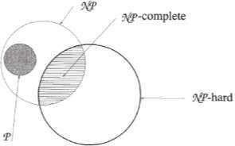
Figure: Commonly believed relationship between P and NP
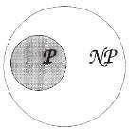
Figure: Commonly believed relationship between P, NP, NP- Complete and NP-hard problems
Definition: A decision problem D is said to be NP-complete if:
- it belongs to class NP
- every problem in NP is polynomially reducible to D
The fact that closely related decision problems are polynomially reducible to each other is not very surprising. For example, Hamiltonian circuit problem is polynomially reducible to the decision version of the traveling salesman problem.

NP-Complete problems have the property that it can be solved in polynomial time if all other NP-Complete problems can be solved in polynomial time. i.e if anyone ever finds a poly-time solution to one NP-complete problem, they‘ve automatically got one for all the NP-complete problems; that will also mean that P=NP.
Example for NP-complete is CNF-satisfiability problem. The CNF-satisfiability problem deals with boolean expressions. This is given by Cook in 1971. The CNF-satisfiability problem asks whether or not one can assign values true and false to variables of a given boolean expression in its CNF form to make the entire expression true.
Over the years many problems in NP have been proved to be in P (like Primality Testing). Still, there are many problems in NP not proved to be in P. i.e. the question still remains whether P=NP? NP Complete Problems helps in solving this question. They are a subset of NP problems with the property that all other NP problems can be reduced to any of them in polynomial time. So, they are the hardest problems in NP, in terms of running time. If it can be showed that any NP-Complete problem is in P, then all problems in NP will be in P (because of NP-Complete definition), and hence P=NP=NPC.
NP Hard Problems - These problems need not have any bound on their running time. If any NP-Complete Problem is polynomial time reducible to a problem X, that problem X belongs to NP-Hard class. Hence, all NP-Complete problems are also NP-Hard. In other words if a NP-Hard problem is non-deterministic polynomial time solvable, it is a NP- Complete problem. Example of a NP problem that is not NPC is Halting Problem.
If a NP-Hard problem can be solved in polynomial time then all NP-Complete can be solved in polynomial time.
―All NP-Complete problems are NP-Hard but not all NP-Hard problems are not NP- Complete.‖NP-Complete problems are subclass of NP-Hard
The more conventional optimization version of Traveling Salesman Problem for finding the shortest route is NP-hard, not strictly NP-complete.
*****

Module-1

- Find gcd(31415,14142) by applying Euclid’s algorithm. Estimate how many times it is faster when compared to the algorithm based on consecutive integer checking.
- Compare the order of growth of 1/2n (n-1) and n^2.
- Explain the mathematical analysis of Fibonacci recursive algorithm.
- Write Bruteforce string matching algorithm.
- Define three asymptotic notations.
- Design a recursive algorithm for solving tower of Hanoi problem and give the general plan of analyzing that algorithm. Show that the time complexity of tower of Hanoi algorithm is exponential in nature.
- With algorithm and a suitable example, explain how the brute force string matching algorithm works.
- AWnitahlytsheefhoerliptsocfoamflpolwexcithya.rt, explain the various steps of algorithm design and analysis process.

- If f1(n) ∈ O(g1(n)) and f2(n) ∈ O O(g2(n)) prove that f1(n)+f2(n) ∈ O(max {g(n),g2(n)}).
- Write an algorithm for selection sort and show that the time complexity of this algorithm is quadratic.
- What is an algorithm? What are the properties of an algorithm? Explain with an example.
- Express using asymptotic notation i) n! ii) 6*2^{n}+n².
- Give formal definitions of asymptoticnotations.
- Give informal definitions of asymptotic notations.

Module-2
- 1Find the upper bound of recurrences given below by substitution method. a. 2T(n/2)+n ii) T(n/2)+1
- Sort the following elements using merge sort. Write the recursion tree.70,20,30,40,10,50,60
- Write the algorithm for quick sort. Derive the worst case time efficiency of the algorithm.
- Give general divide and conquer recurrence with necessary explanation. Solve the recurrence a.
i)T (n) =2T (n/2) +1
b. ii)T (n) =T (n/2) +n
- Explain with suitable example a sorting algorithm that uses divide and conquer technique which divides the problem size by considering position. Give the corresponding algorithms and analyse for time complexity.
- Give the problem definition of a defective chess board? Explain clearly how divide and conquer method can be applied to solve 4 * 4 defective chess board problem.
- What is divide and conquer method. Show that the worst case efficiency of binary search algorithm is(log).
- What is stable algorithm? Is quick sort stable? Explain with example.
- Give an algorithm for merge sort.
- Trace the merge sort algorithm for the data : 60,50,25,10,35,25,75,30
- Explain matrix multiplication with respect to divide and conquer technique.

Module-3
- Write greedy method control abstraction for subset paradigm.
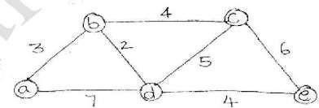
- Using greedy method, trace the following graph to get shortest path from vertex ‘a’ to all other vertices
- What is the solution generated by the function job scheduling (JS) when n=5,[P1,P2,P3,P4,P5]=[10,15,10,5,1] and [d1,d2,d3,d4,d5]=[2,2,1,3,3]
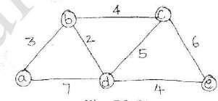
- Apply PRIMS algorithm for the following graph to find minimum spanning tree.
- What is job sequencing with deadline problem?Find solution generated by job sequencing problem with deadlines for 7 jobs given profits 3,5,20,18,1,6,30 and deadlines 1,3,4,3,2,1,2 respectively.
- Define minimum cost spanning tree. Give high level description of Prim’s algorithm to find minimum spanning tree and find minimum spanning tree for graph shown in following figure using Prim’s algorithm.
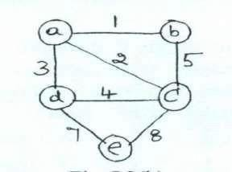
- What is a knapsack problem? Obtain solution for the knapsack problem using greedy method for n=3, capacity m=20 values 25, 24, 15 and weights 18, 15, 10 respectively.
Write Krushal’s algorithm to construct a minimum spanning tree and
8. show that the time efficiency is

O (| ∈ |log| ∈ |).

- Apply Kruskal’s algorithm to find the min spanning tree of the graph.

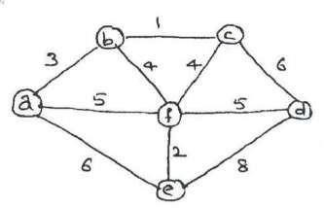
- Write Dijkstra’s algorithm to find single source shortest path.
- Explain the concept of greedy technique for Prim’s algorithm. Obtain minimum cost spanning tree for the graph below Prim’s algorithm.
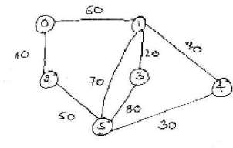
- Solve the following single source shortest path problem assuming vertex 5 as the source.
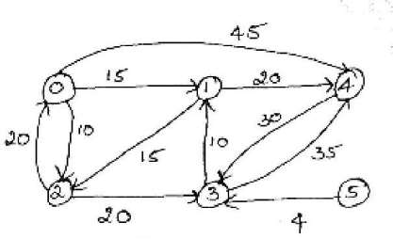
- Define the following: i) Optimal solution ii) Feasible solution
- Design an algorithm for the problem job sequencing with deadlines.
- Design an algorithm for knapsack problem that uses greedymethod.

Module-4
- Use Dynamic programming, compute the shortest path from vertex 1 to all other vertices
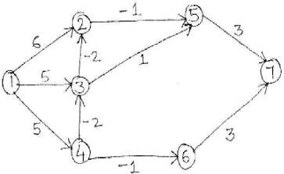
- Solve the Knapsack instance n=3,{W1,W2,W3}={1,2,2} and {P1,P2,P3}={18,16,6} and M=4 by dynamic programming.
- For the given graph, obtain optimal cost tour using dynamic programming.

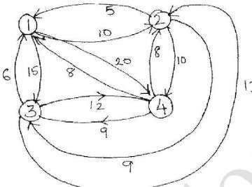
- What is dynamic programming? Explain how you would solve all pair shortest paths problem using dynamic programming.
- Give the necessary recurrence relation used to solve 0/1 knapsack problem using dynamic programming. Apply it to solve the following instance and show the results n=4, m=5 values 12,10,20,15 and weights are 2,1,3,2 respectively.
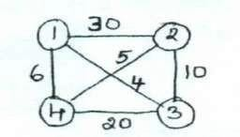
- Solve the following TSP which is represented as a graph shown in the figure using dynamic programming
- Write the dynamic programming algorithm to compute binomial co-efficient and obtain its time complexity.
- Explain Warshall algorithm to find the transitive closure of a directed graph. Apply this algorithm to the graph given below.
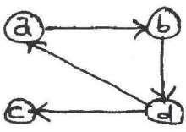
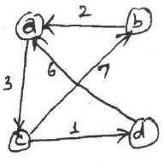
- State Floyd’s algorithm. Solve all pairs shortest path problem for the given graph using Floyd algorithm

- Using Floyd’s algorithm solve the all pair shortest problem for the graph whose weight matrix is given below:
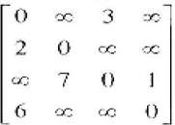

- Using dynamic programming, solve the following knapsack instance.
- N=4 M=5 (W1, W2, W3, W4) = (2, 1, 3, 2) (P1, P2, P3, P4) = (12, 10, 20, 15).
- Outline an exhaustic search algorithm to solve traveling salesman problem.
- Prove that the time efficiency of Warshall’s algorithm is cubic.
- Write a pseudocode of the algorithm that finds the composition of an optimal subset from the table generated by the bottom-up dynamic programming algorithm for the knapsack problem.

- What are the three variations of decrease and conquer technique.
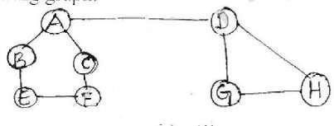
- Conduct DFS for the following graph:
- Apply DFS based algorithm to solve topological sorting problem for the following graph:
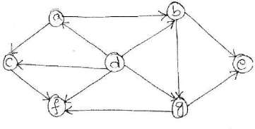
- Construct shift table for the pattern EARN and search for the same in text FAIL-MEANS-FIRST- ATTEMPT- IN-LEARNING using Horspool algorithm.
- Explain the working of depth-first search algorithm for the graph shown in following figure.
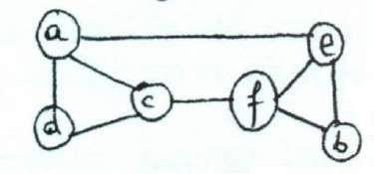
- With pseudocode, explain how the searching for a pattern BARBER in the given text JIM_SAW_ME_IN_BARBER_SHOP is performed using Horspool’s algorithm.
- With suitable example, explain topological sorting.
- Explain decrease and conquer method, with a suitable example.
- Apply the DFS – based algorithm to solve the topological sorting problem for given graph.
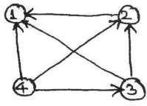

- Write and explain DFS and BFS algorithm with example.
- Obtain topologies sorting for the given digraph using source removal method.
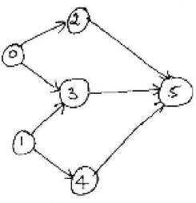
- What are the various applications of BFS and DFS?
- Define the terms a) tree edge b) cross edge c) back edge.
- How do you obtain topological sort using source removal method? Explain with an example and write the algorithm for the same.

Module-5
- Explain the four methods used to establish lower bounds of algorithm.
- Define Decision tress. Write the decision tree for the three element selection sort.
- Define P, NP and NP complete problems.
- What are NP-complete problems and NP-hard problems? Apply four iterations of Newton’s method to compute √2 and estimate the absolute and relative errors of the computations.
- What do you mean by lower bound algorithm? What are the advantages of finding the lower bound?
- Prove that the classic recursive algorithm for the tower of Hanoi puzzle makes the minimum number of disks moves needed to solve it.
- Write short notes on:
  - Tight lower bound
  - Trivial lower bound
- What is numeric analysis? Brief overflow and underflow in numeric analysis algorithms.
- What are tractable problems and intractable problems?
- What are decision trees? Obtain the decision tree to find minimum of 3 numbers.
- Explain how back tracking used for solving 4-queens problem. Write the state space tree.
- Explain Information theoretic lower bound.
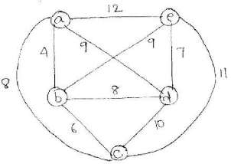
- Apply twice-bound-the tree algorithm for the travelling sales person problem for the following graph.
- Explain how the TSP problem can be solved, using branch and bound method. 15 Solve 8 – queens problem for a feasible sequence (6, 4, 7, 1).
- What is back tracking? Apply back tracking problem to solve the instance of the sum of subset problem: S= {3, 5, 6, 7} and d=15.
- Write an algorithm to place all queens on the chess board.
- What is Nearest-neighbor algorithm to compute TSP problem?
- Explain the various models for parallel computations.

- Let the i/p to the prefix computation be 5,12,8,6,3,9,11,12,1,5,6,7,10,4,3,5 and there are four

processors and ⊕ stands for addition. With diagram explain how prefix computation is done
- bLyetptahrealil/epl atolgothreithpmre.fix computation be 5,12,8,6,3,9,11,12,1,5,6,7,10,4,3,5 and there are four processors and ⊕ stands for addition. With diagram explain how prefix computation is done by work optimal algorithm.
- Explain how M is calculated using parallel algorithm for given graph.
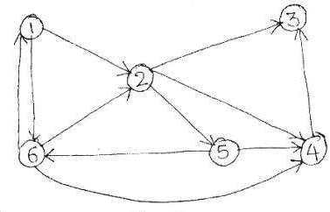
- Write short notes on:
  - Hamiltonian problem
  - ii)M-Coloring
- Explain prefix computation problem and list ranking algorithm, with suitable examples. 26 What are the different ways of resolving read and write conflicts?
27 What is prefix computation problem? Give the algorithms for prefix computation which uses:
28 i) n processors ii) n/logn processors. Obtain the time complexities of these algorithms.
29 What is linear speed up? Obtain the maximum speed up when P = 10 and various values of 30 f = 0.5, 0.1, 0.01.
31 What is fixed connection model? What is shared memory model? 32 What is EREW PRAM, CREW PRAM, and CRCW PRAM?
33 What is super linear speedup? Explain.

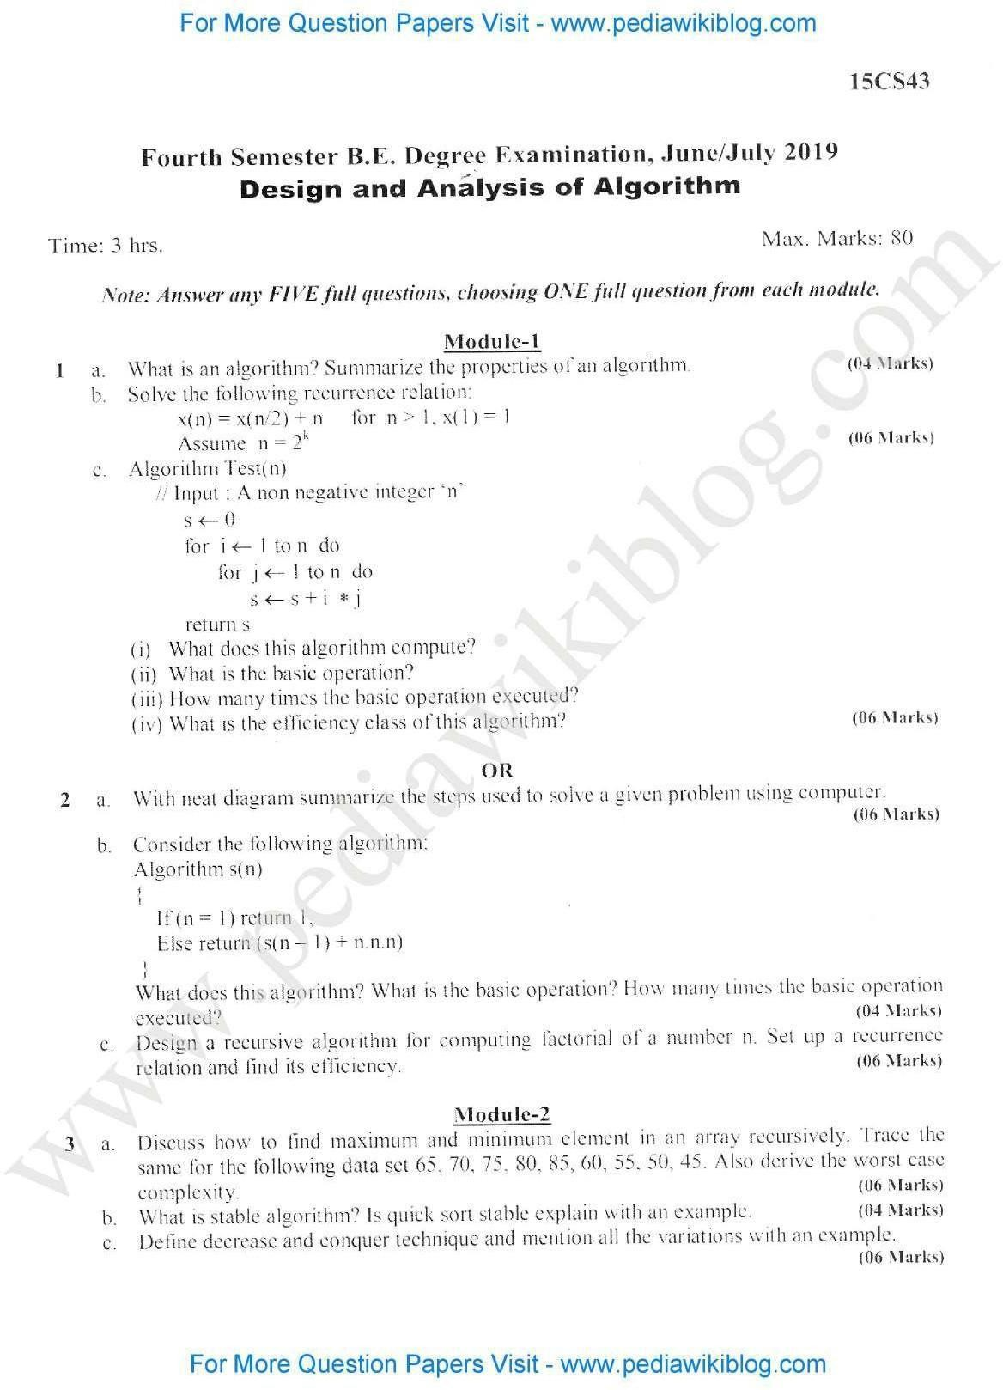

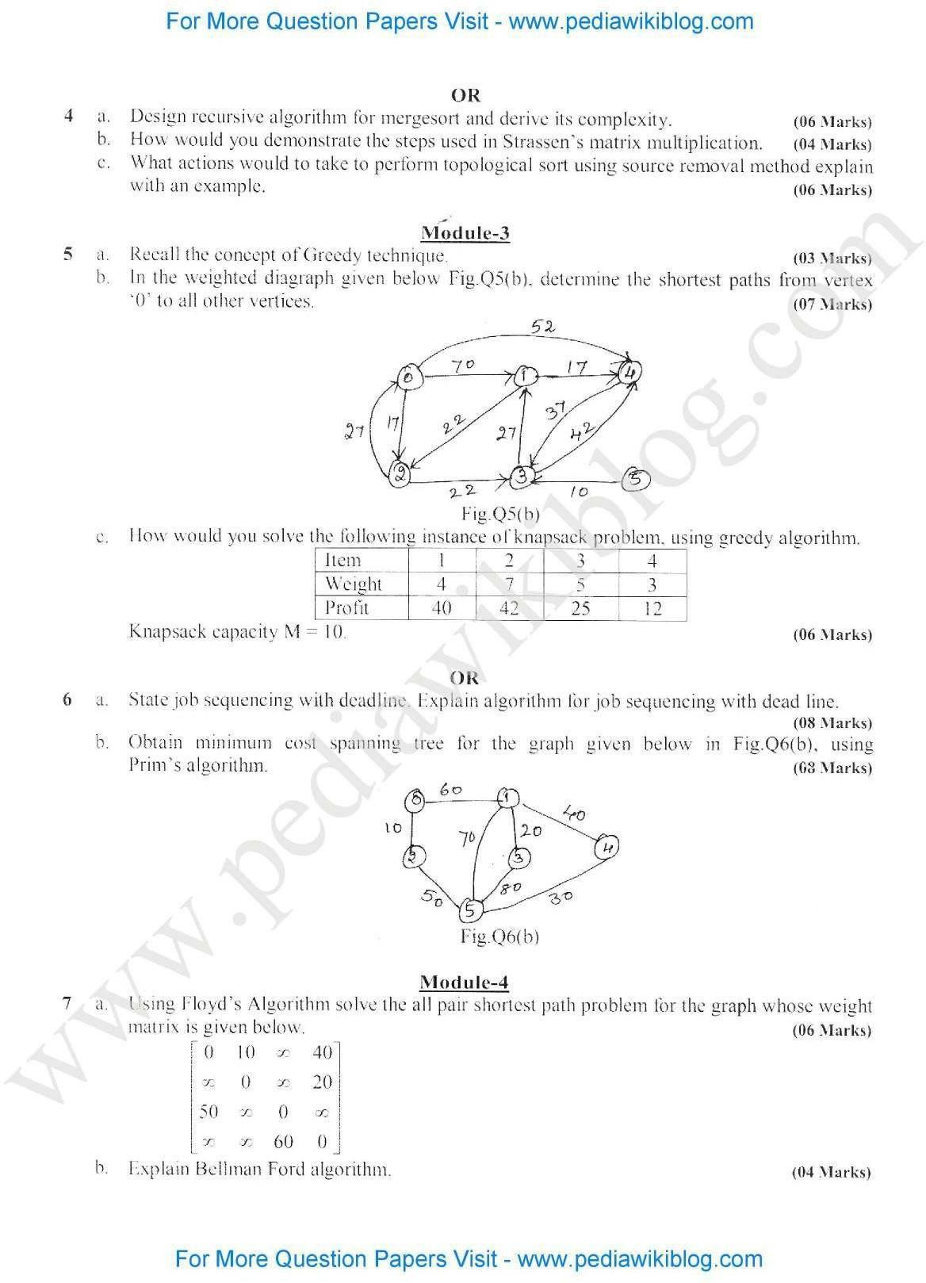



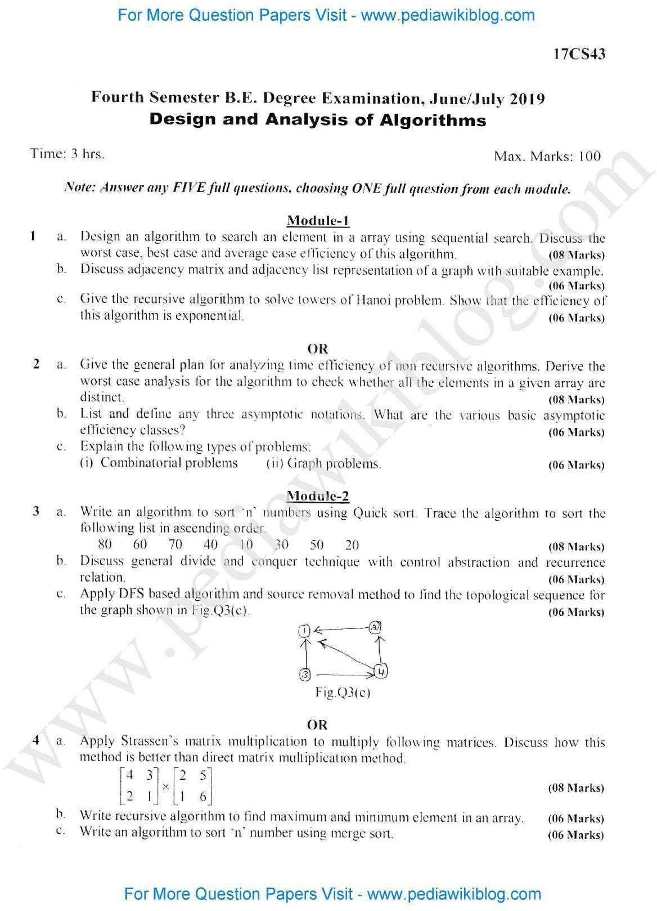

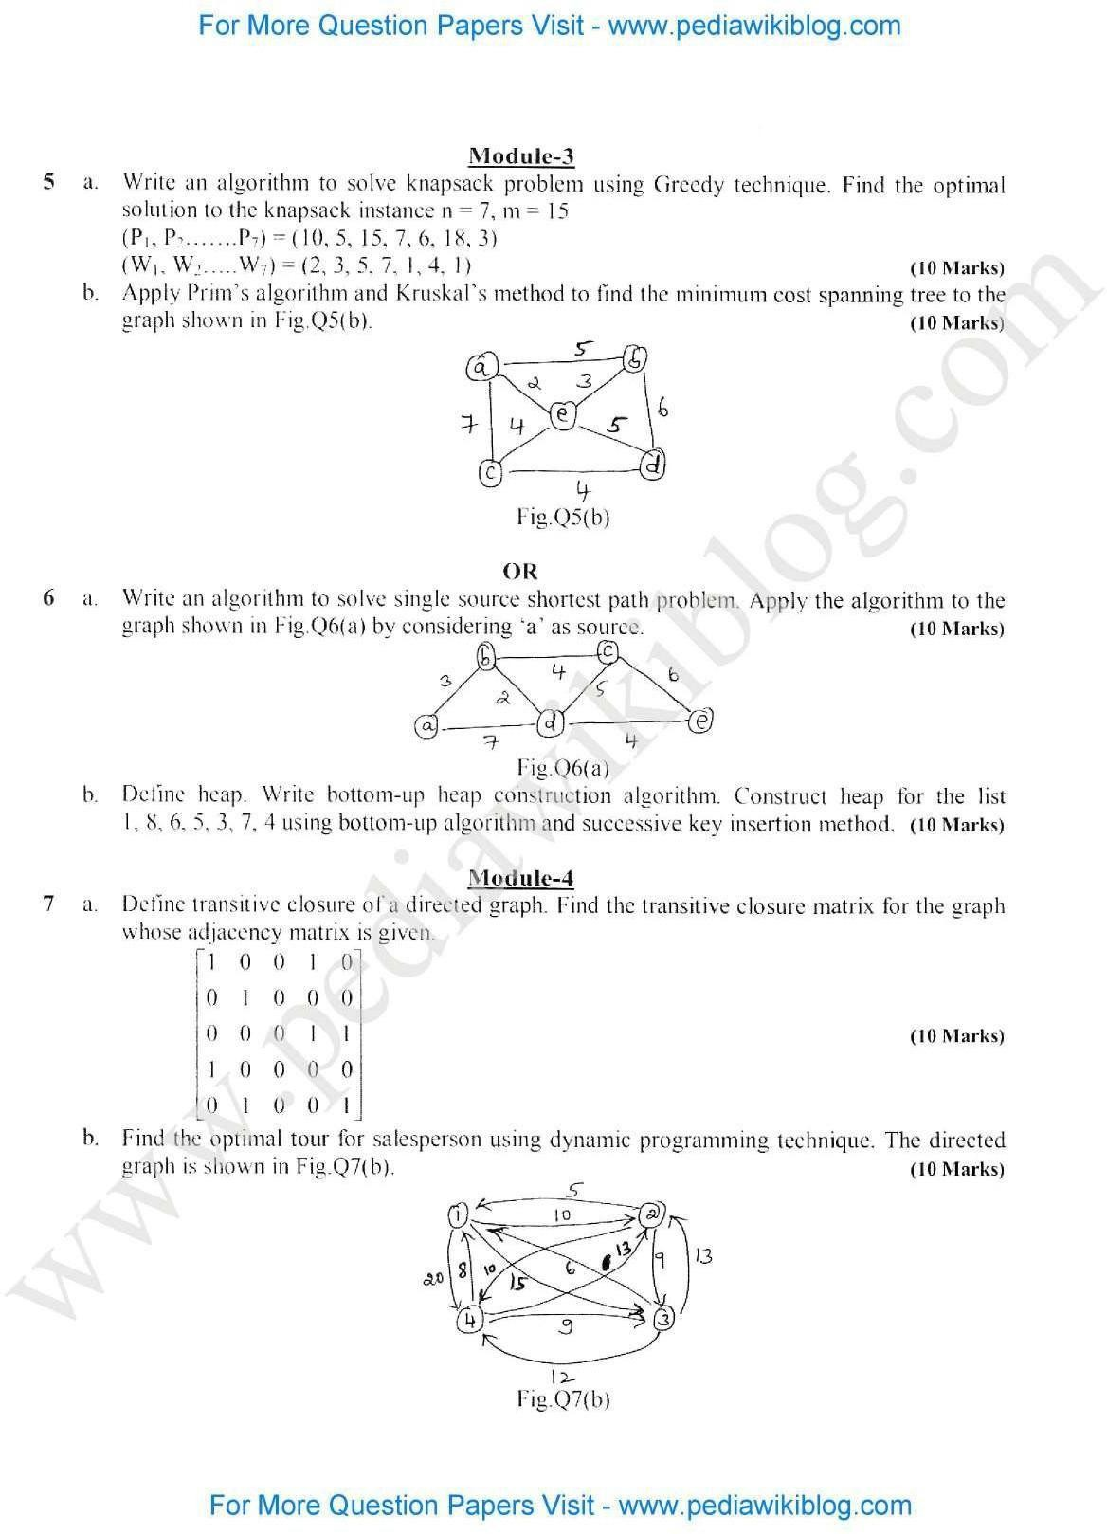

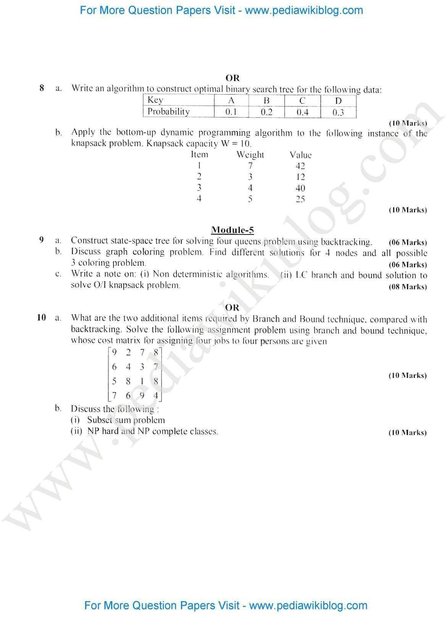

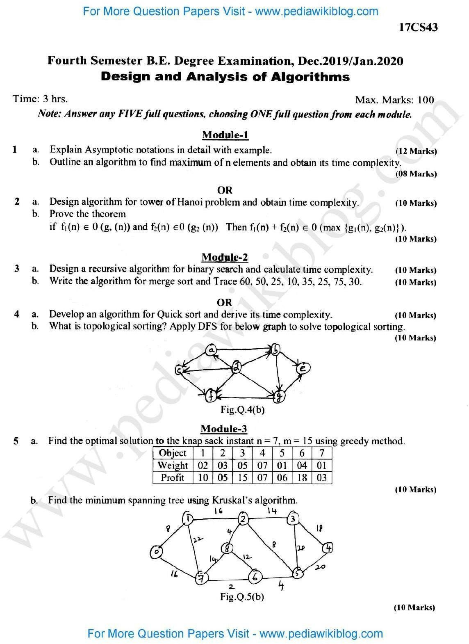



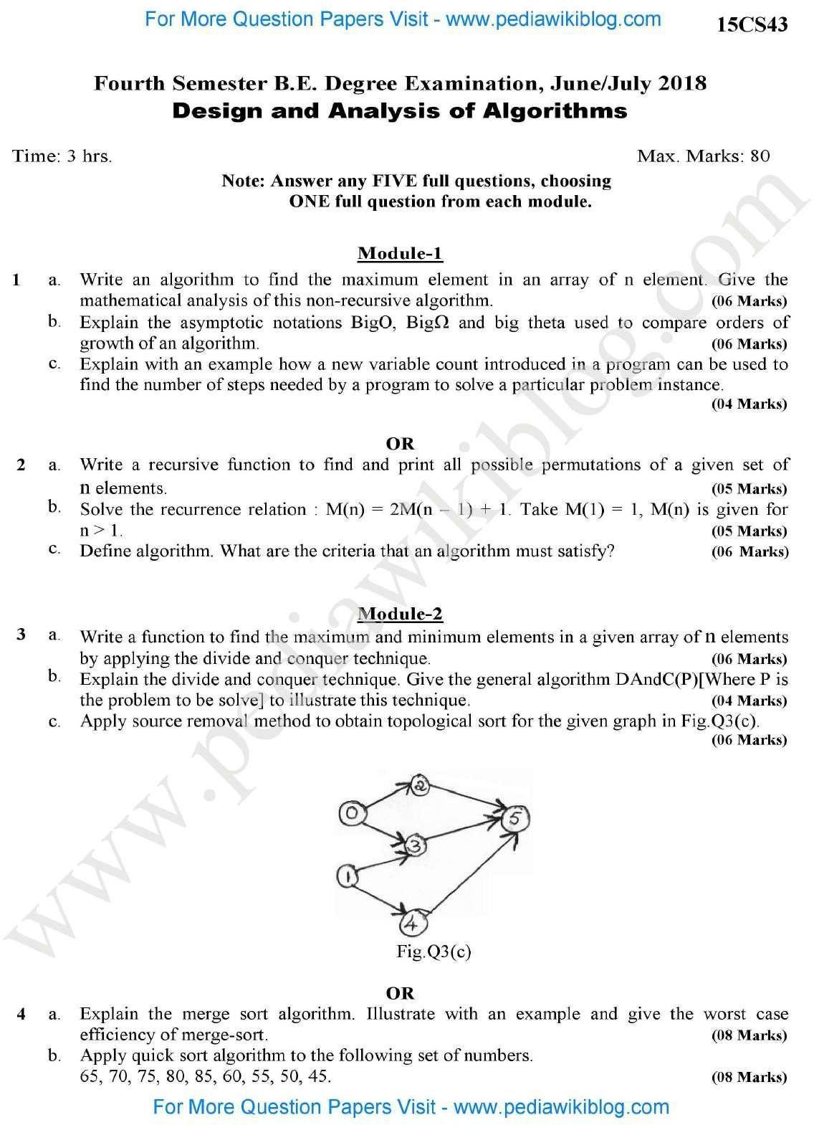

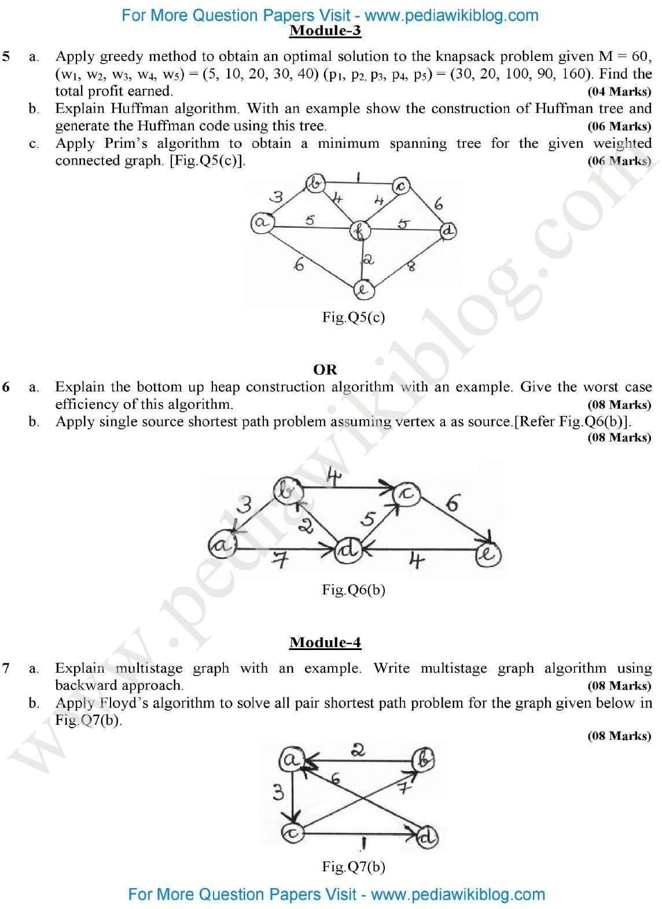

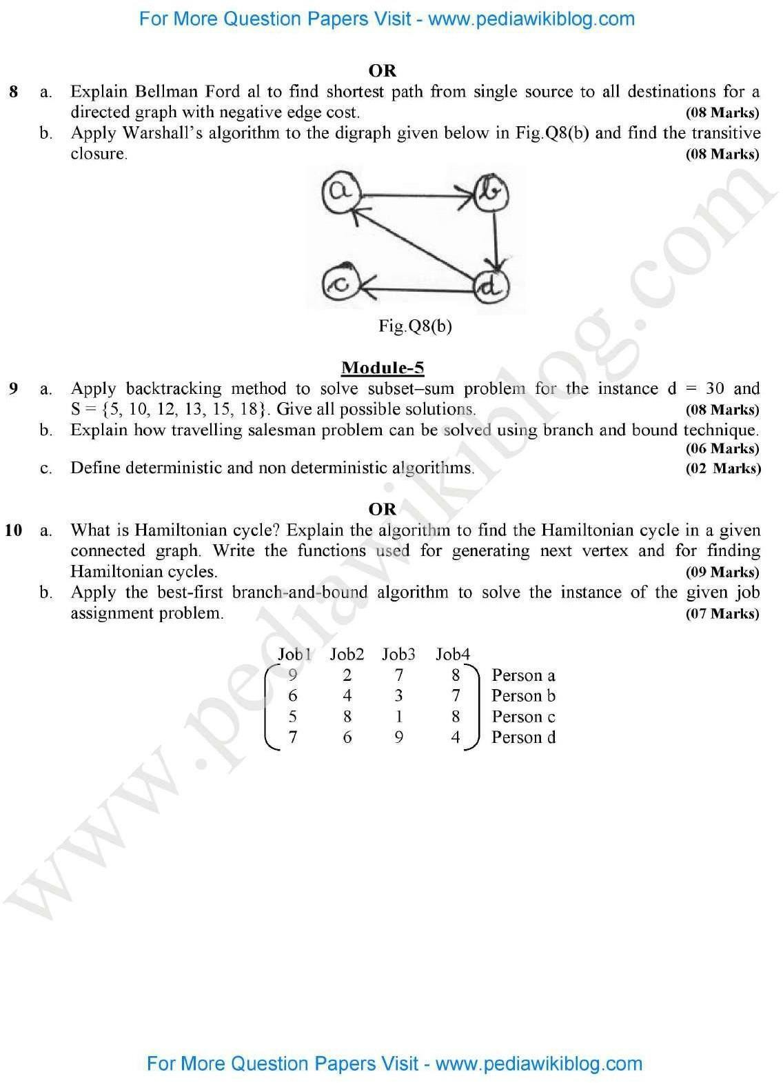



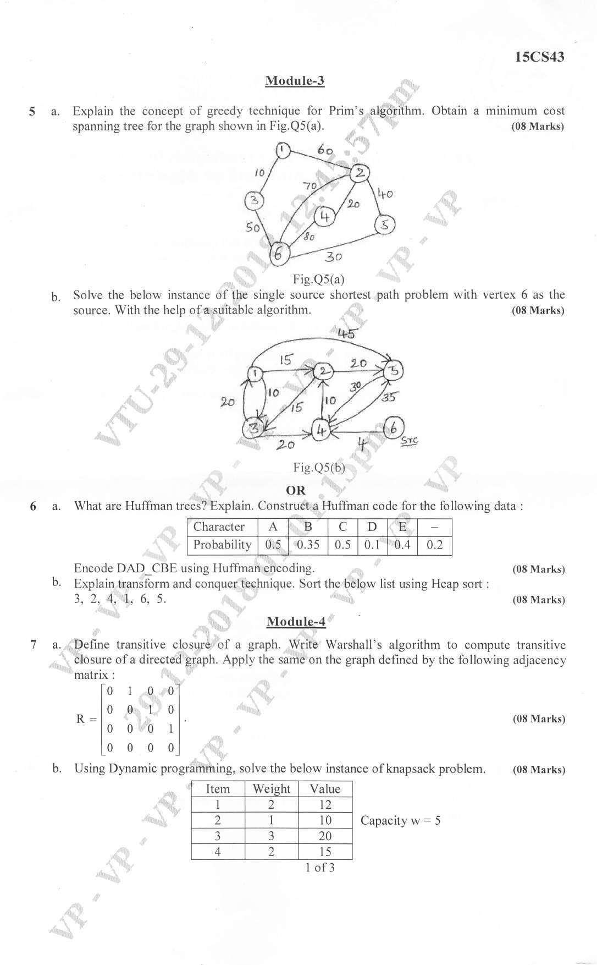

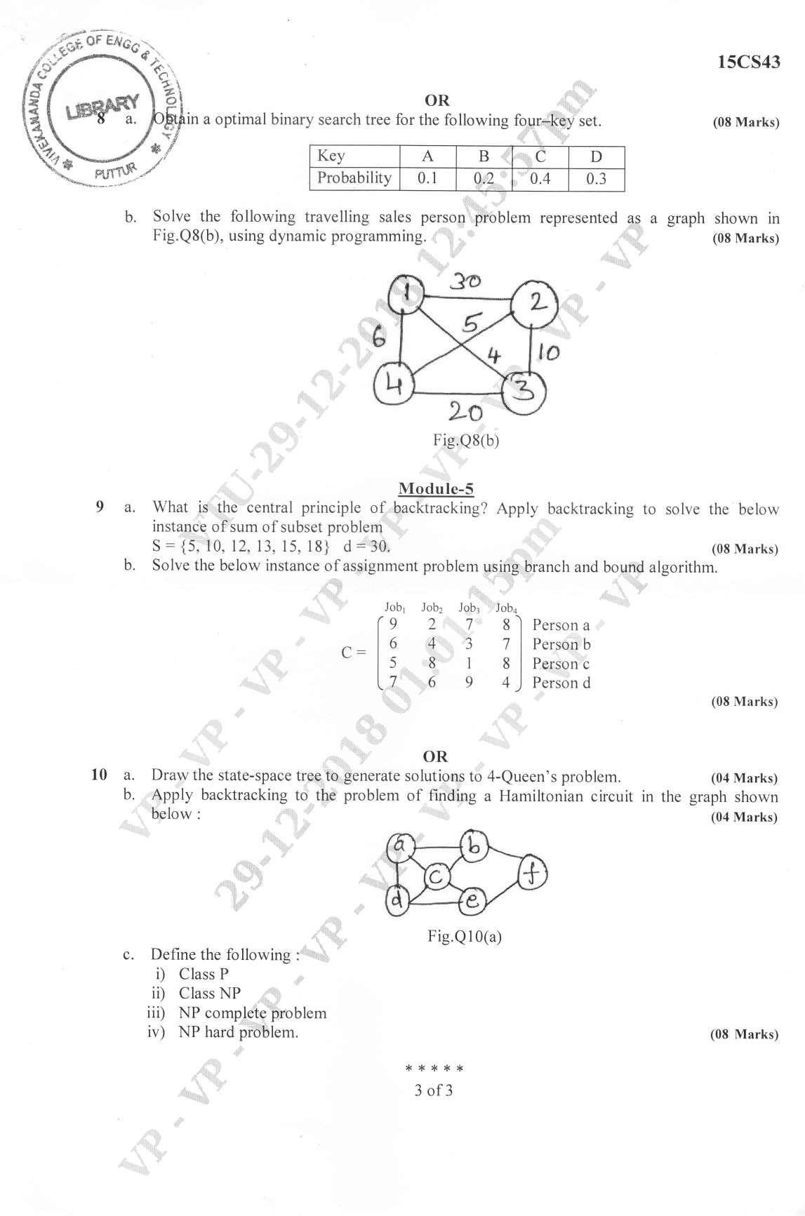

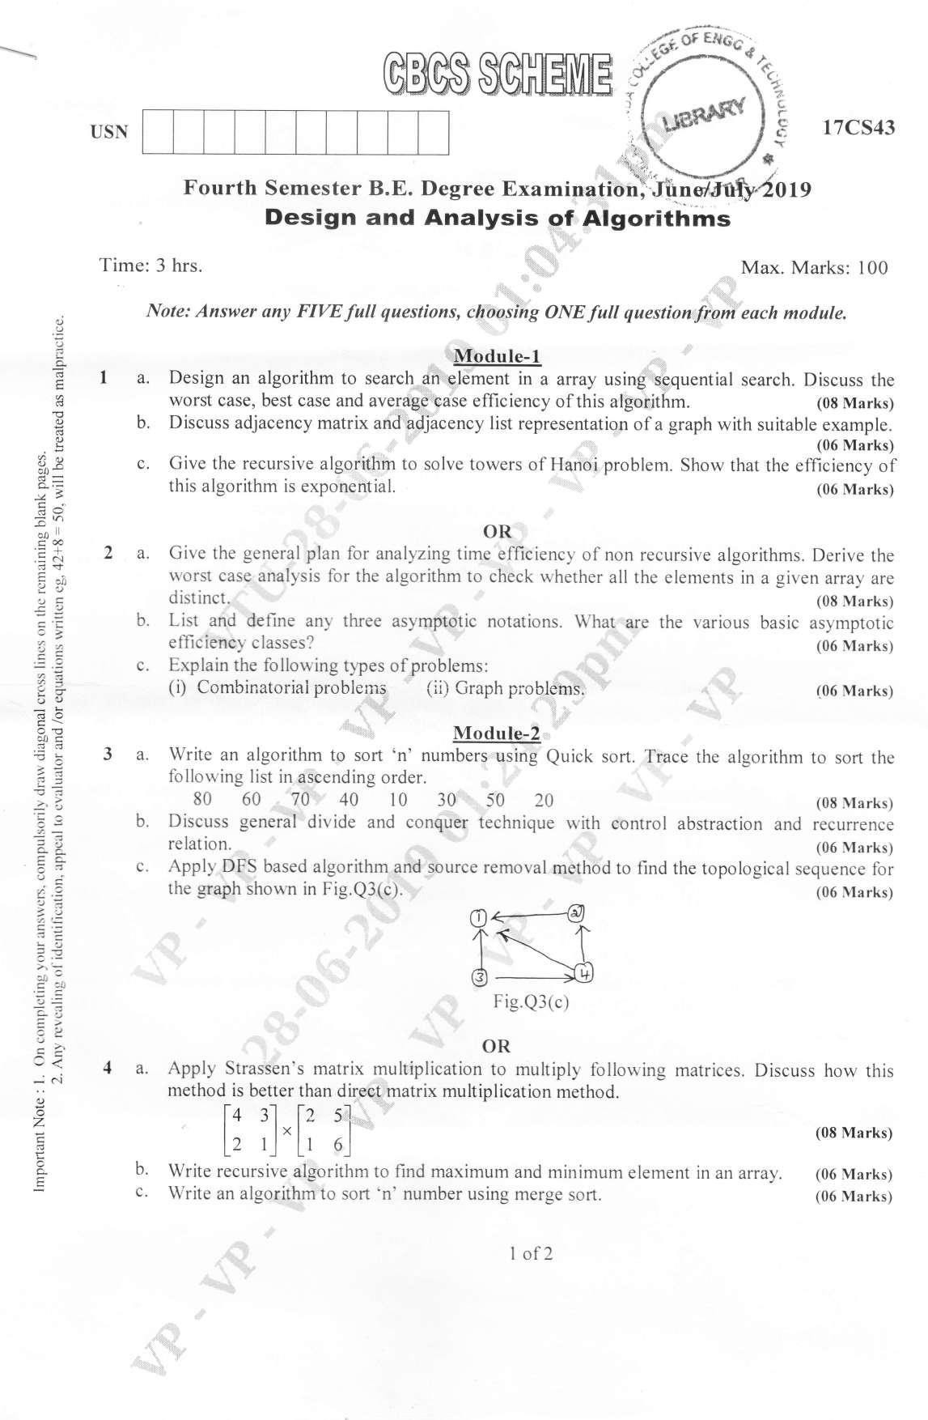

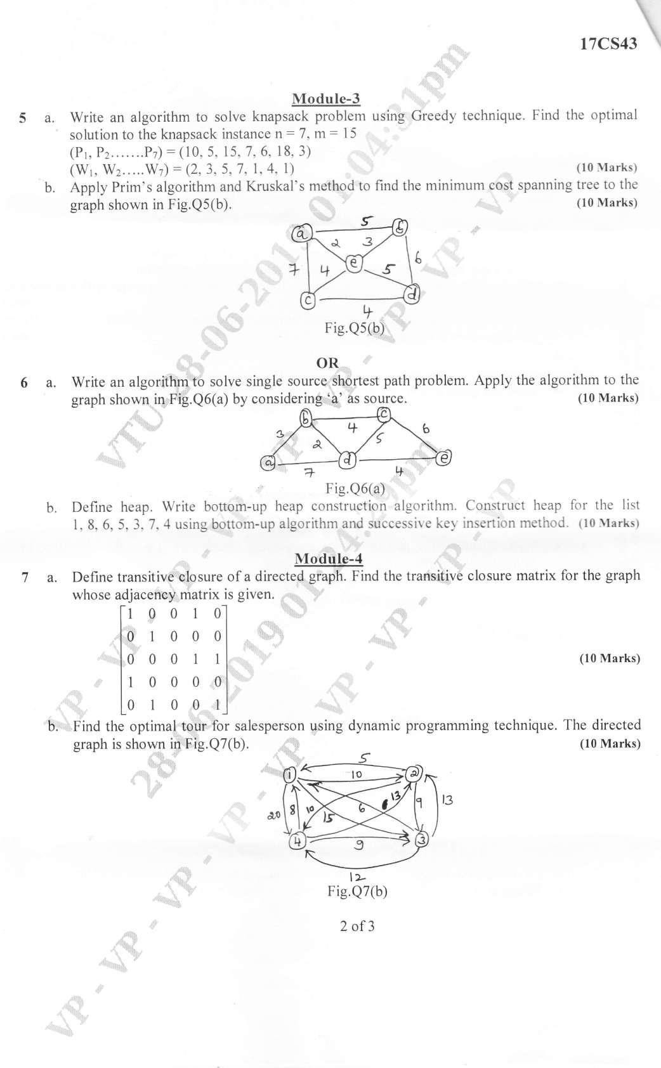
Analysis and Design of Algorithms (B



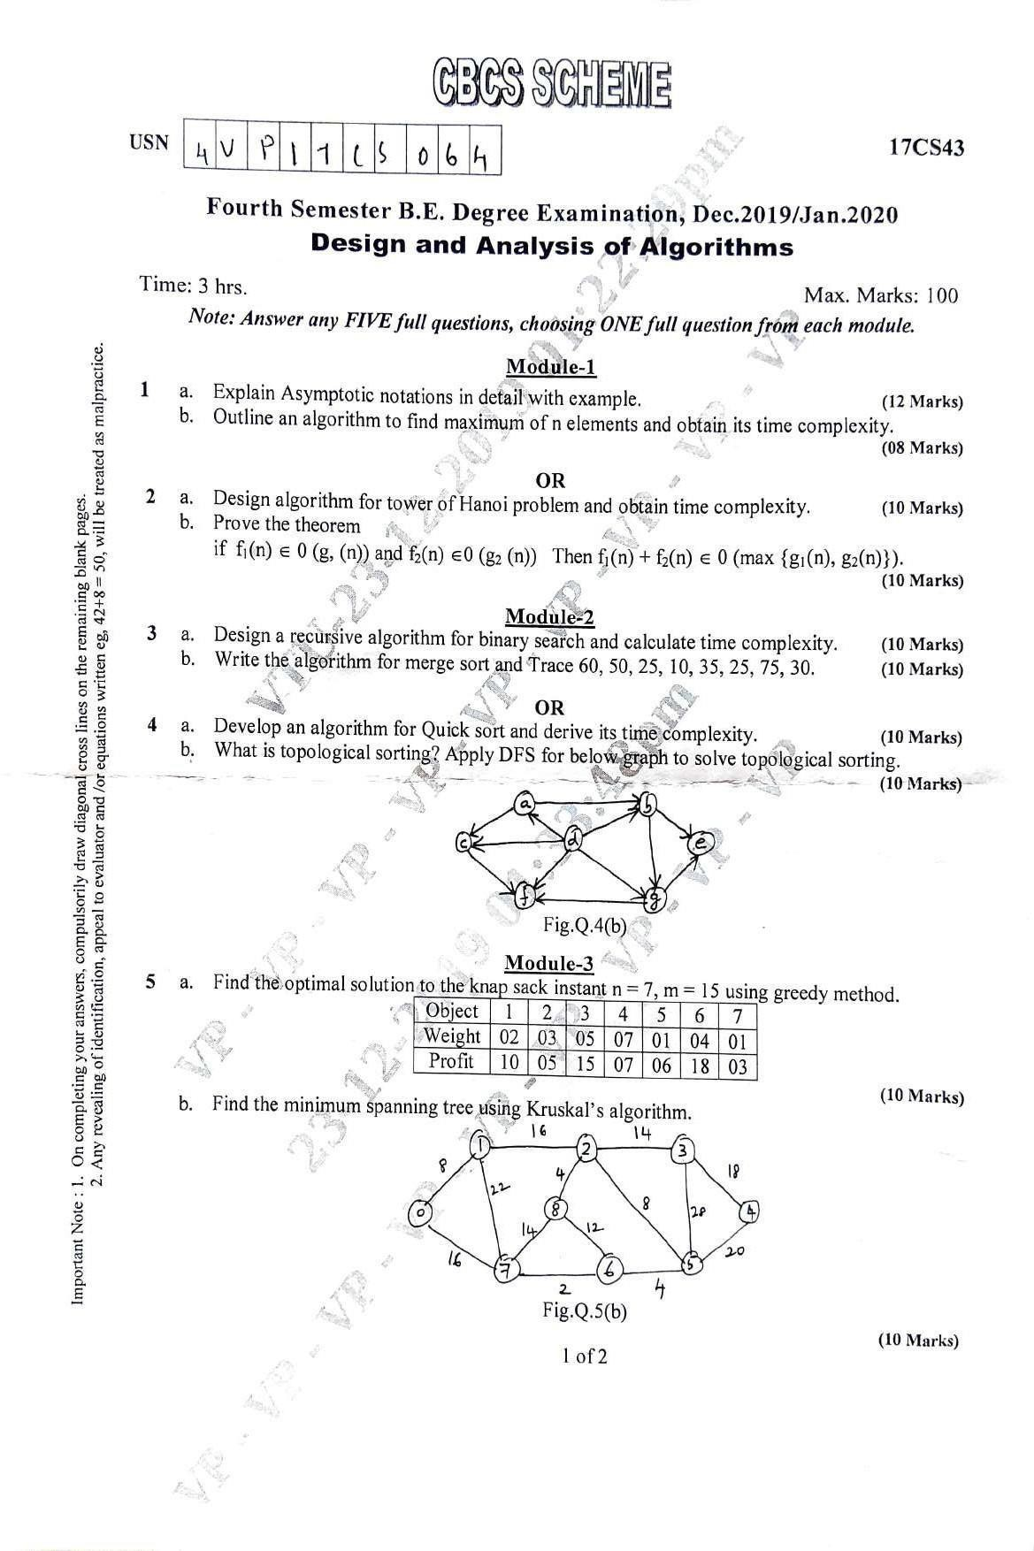



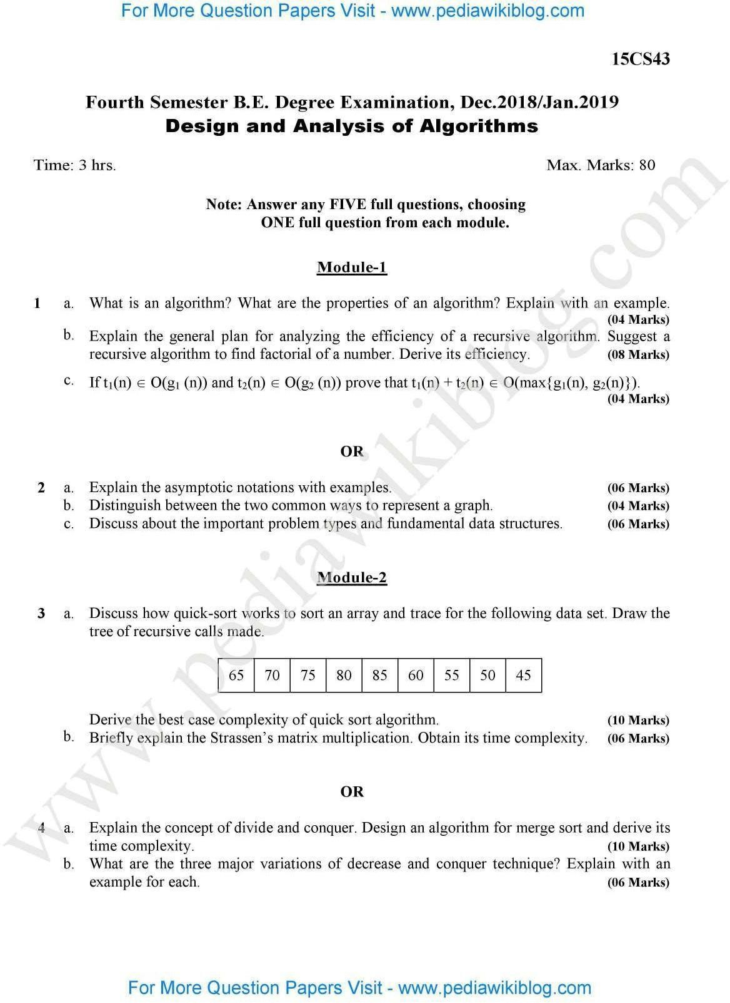

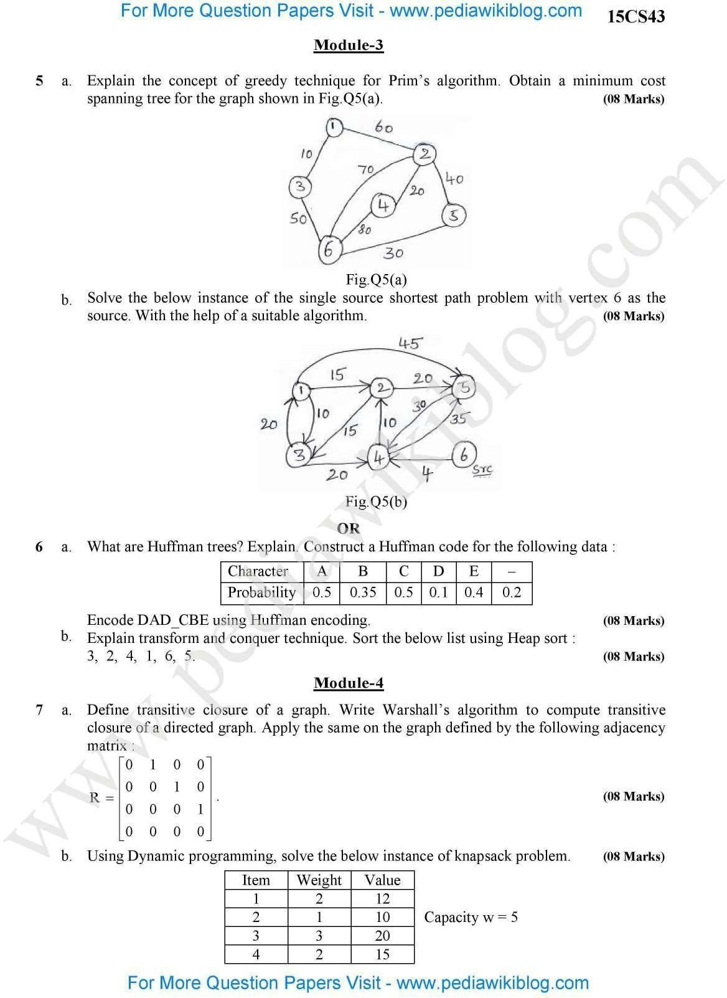

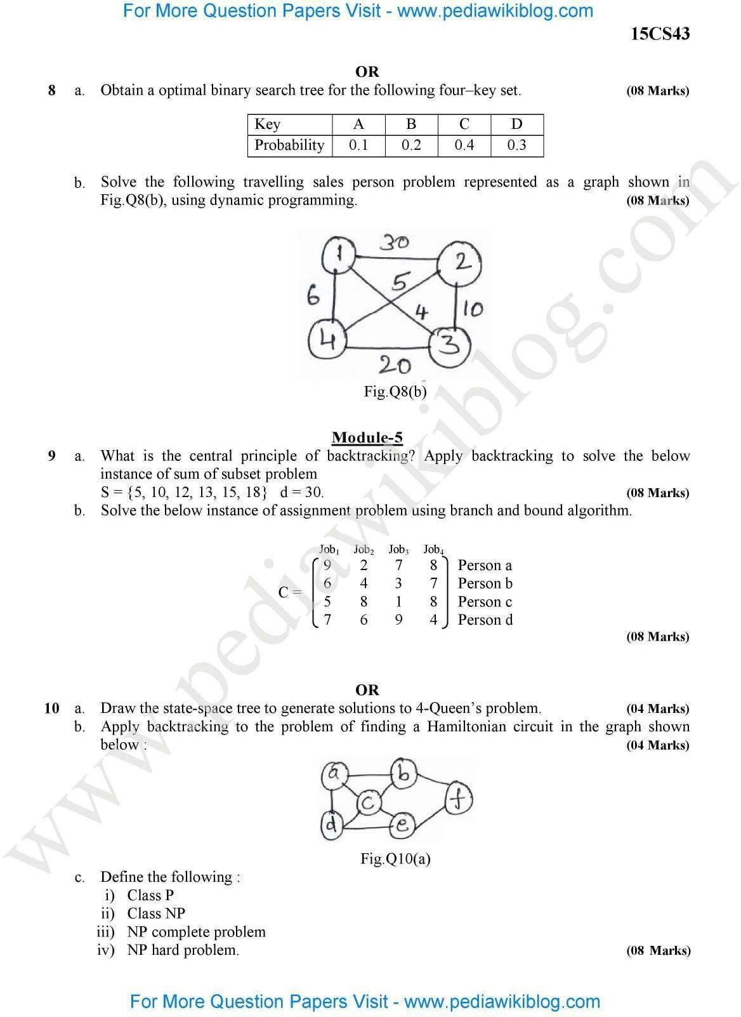

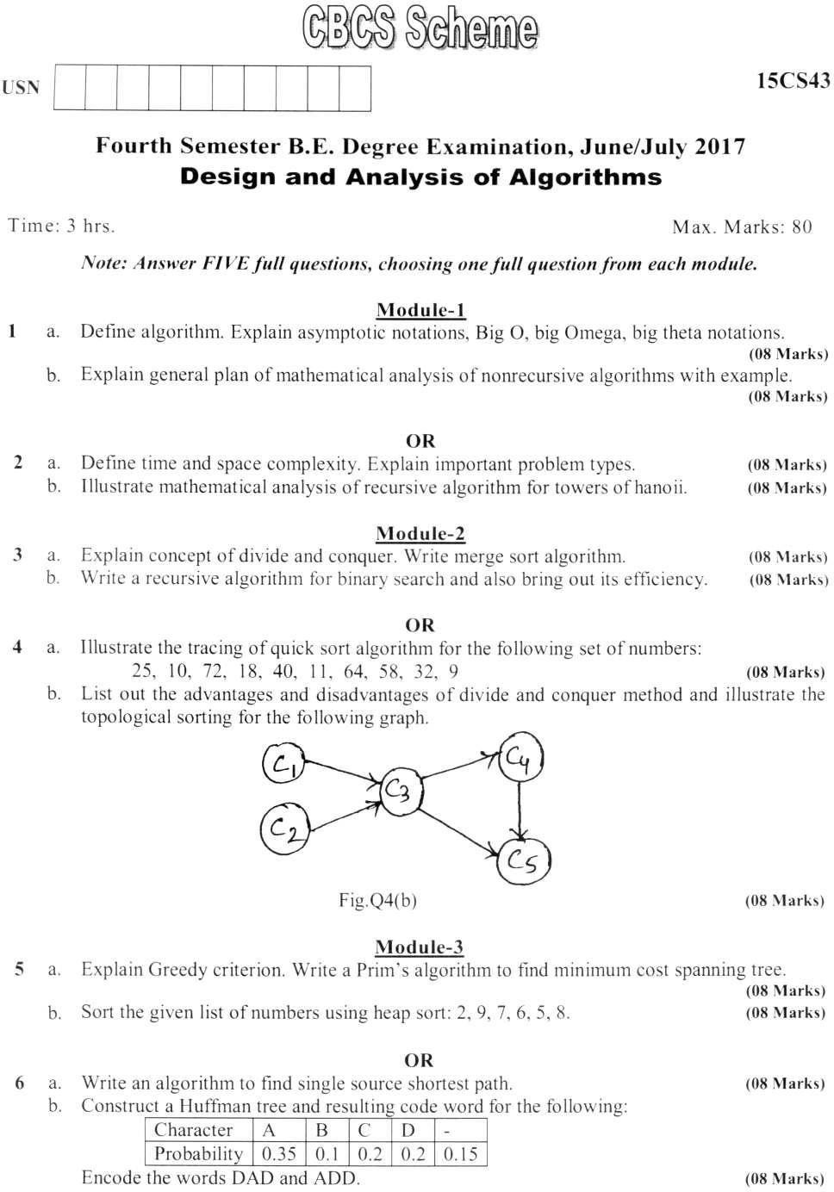

Analysis and Design of Algorithms (BCS401)

For More Question Papers Visit - www.pediawikiblog.com

For More Question Papers Visit - www.pediawikiblog.com

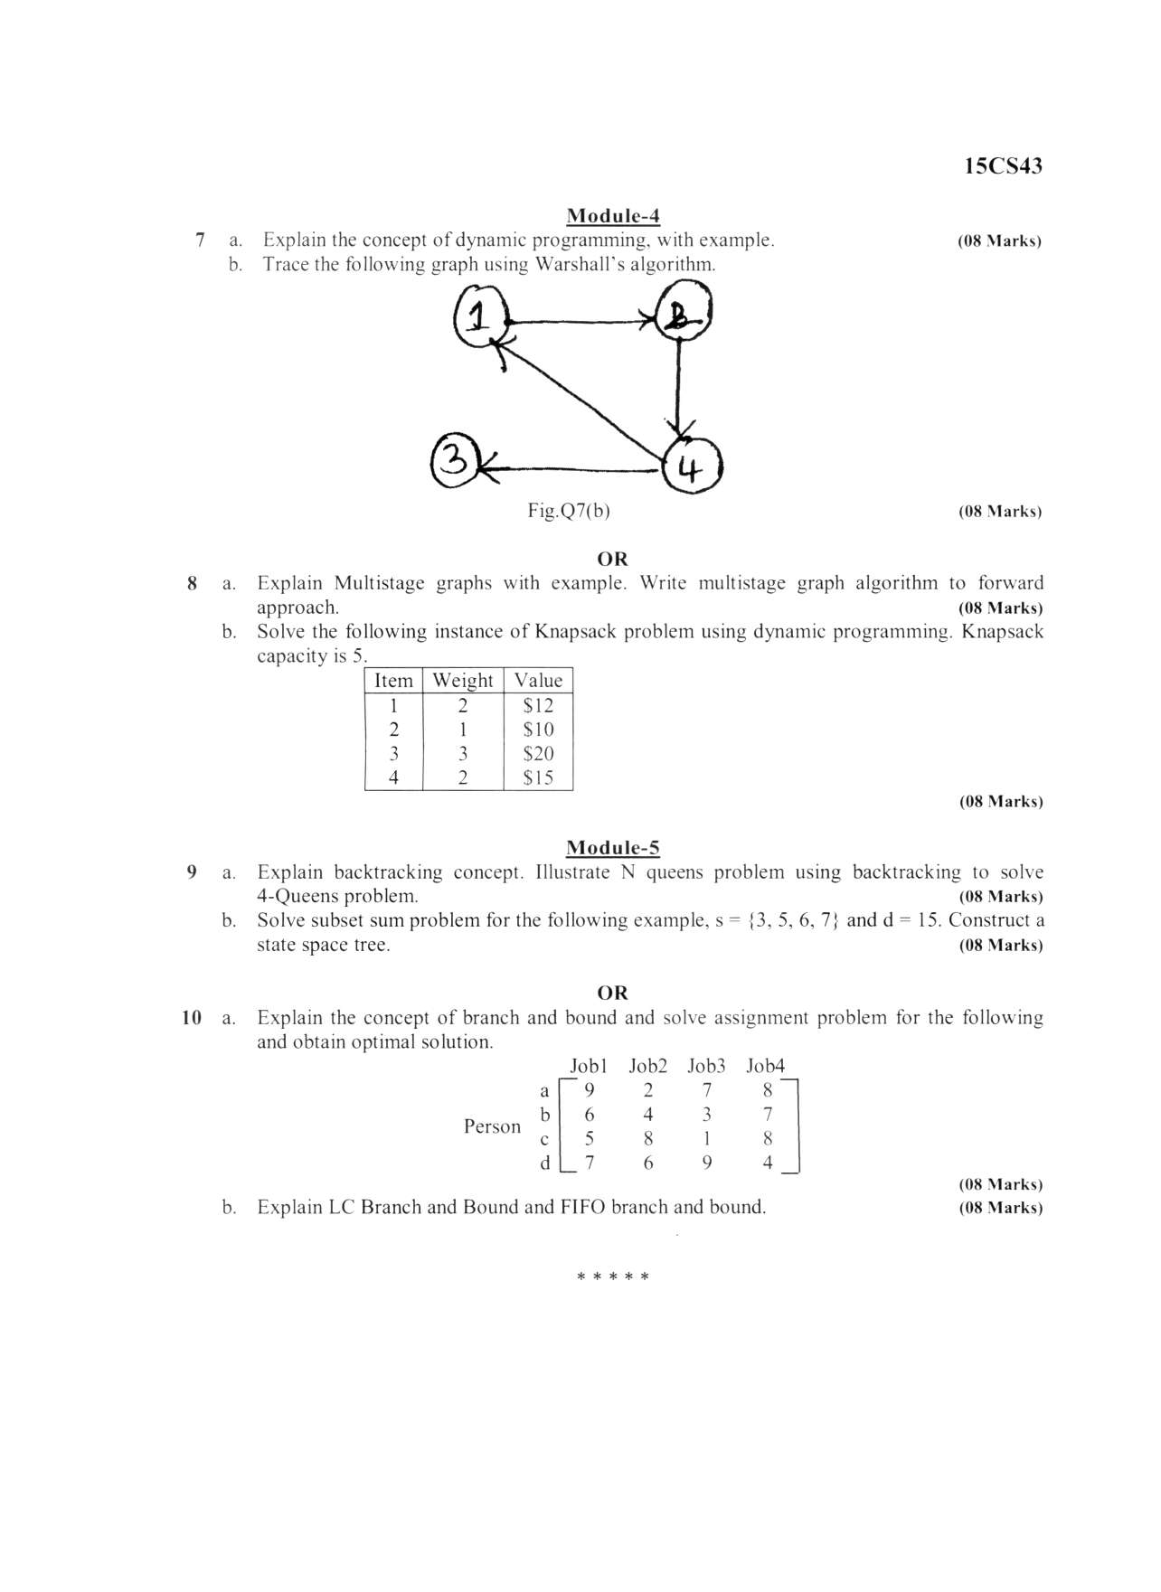

For More Question Papers Visit - www.pediawikiblog.com
Analysis and Design of Algorithms (BCS401)

For More Question Papers Visit - www.pediawikiblog.com

Analysis and Design of Algorithms (BCS401)




Institute Vision
"To become a recognized world class Women Educational Institution, by imparting professional education to the students, creating technical opportunities through academic excellence and technical achievements, with ethical values"

Institute Mission
- To support value-based education with state of art infrastructure.
- To empower women with the additional skill for professional future career
- To enrich students with research blends in order to fulfil the international challenges
- To create multidisciplinary centre of excellence
- To achieve Accreditation standards towards international education recognition.
- To establish more Post Graduate & Research course.
- To increase Doctorates numbers towards the Research quality of academics.

