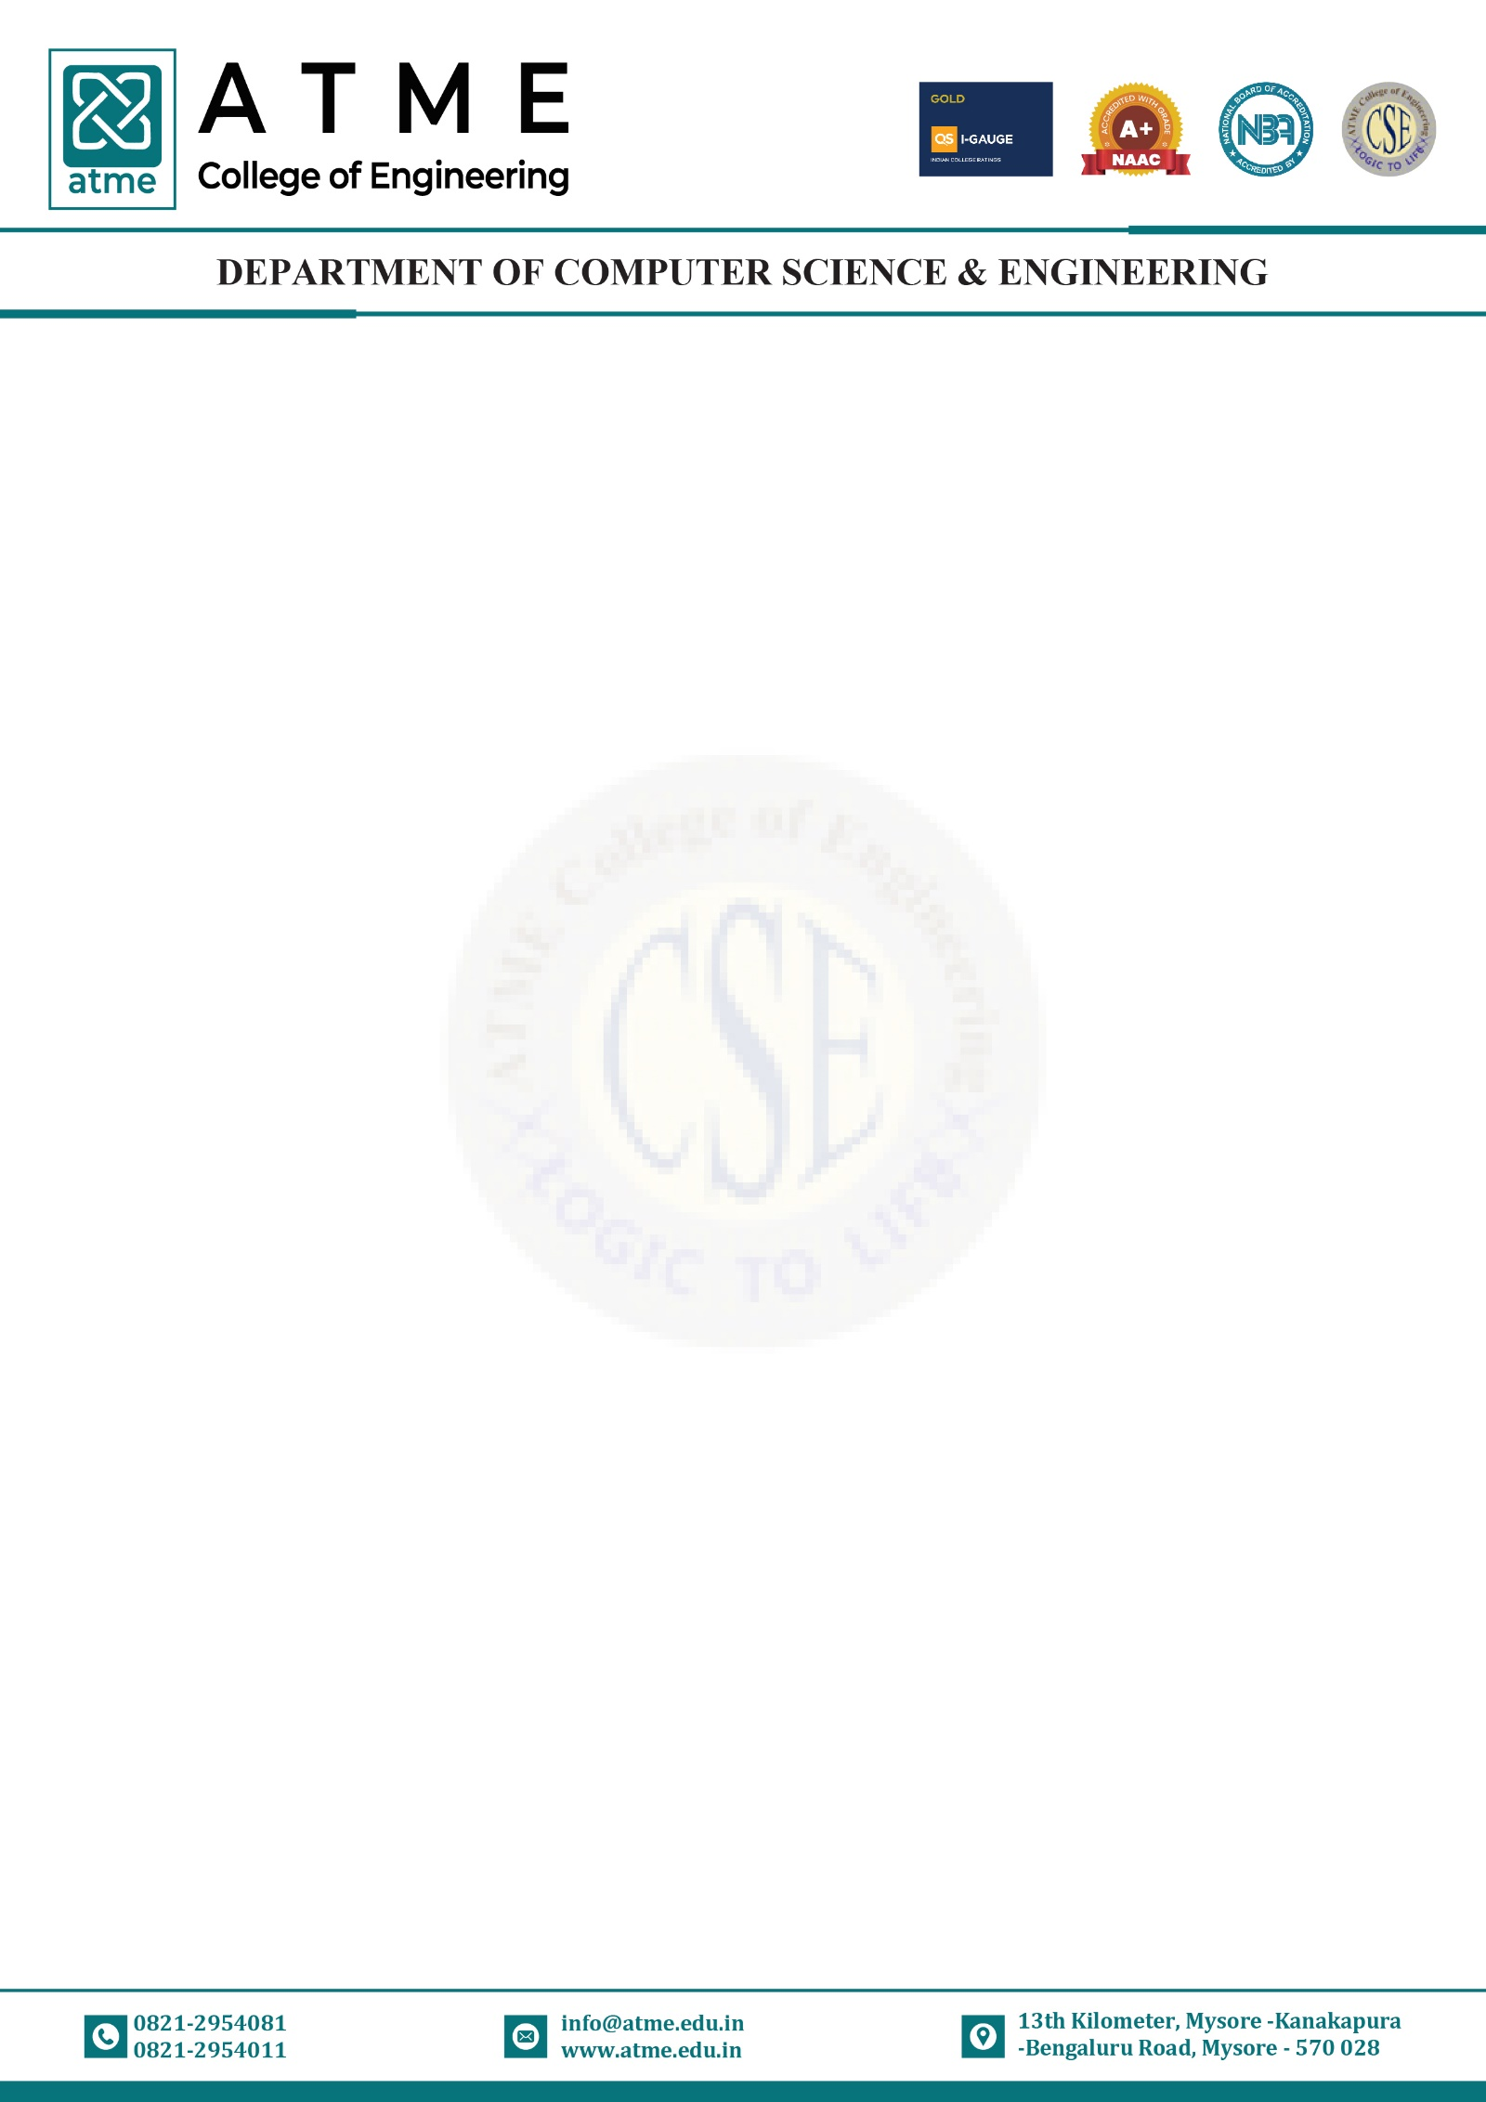

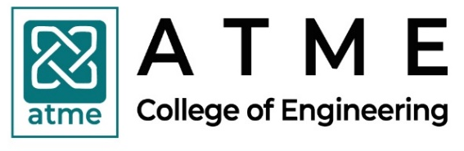
Department of Computer Science & Engineering
Lesson Plan & Work Done Diary for AY: 2025-2026
EVEN SEMESTER
Course with Code: DATABASE MANAGEMENT SYSTEMS- BCS403 |  |  |  | Faculty Name: Mrs.Gadi Divyasree |  |  | Semester & Section: IV
Class No. | Date Planned (DD/MM/YYYY) | Topics to be covered | TLP Planned | Class No. | Date of Conduction (DD/MM/YYYY) | Topics Covered | TLP Executed | Remarks if any deviation
1 | 23/02/26 | Bridge Course - 1 |  | 1
2 | 24/02/26 | Bridge Course - 2 |  | 2
3 | 26/02/26 | Bridge Course - 3 |  | 3
MODULE-1
4 | 02/03/26 | Introduction,  Characteristics Of Database Approach. | Chalk and Talk | 4
5 | 03/03/26 | Advantages of using the DBMS approach,  History of database applications. | Chalk and Talk | 5
6 | 05/03/26 | Data Models,  Schemas and Instances. | Chalk and Talk | 6
7 | 09/03/26 | Three Schema Architecture and Data Independence | Chalk and Talk | 7
8 | 10/03/26 | Database Languages & Interfaces, The Database System Environment. | Chalk and Talk | 8
9 | 12/03/26 | Entity types, Entity sets,  Structural Constraints. | Chalk and Talk | 9
10 | 16/03/26 | Weak Entity Types, ER Diagrams, Examples, Specialization and Generalization. | Chalk and Talk | 10
11 | 17/03/26 | ER Diagrams, Examples | Chalk and Talk | 11

Course with Code: DATABASE MANAGEMENT SYSTEMS- BCS403 |  |  |  | Faculty Name: Mrs.Gadi Divyasree |  |  | Semester & Section: IV
Class No. | Date Planned (DD/MM/YYYY) | Topics to be covered | TLP Planned | Class No. | Date of Conduction (DD/MM/YYYY) | Topics Covered | TLP Executed | Remarks if any deviation
MODULE-2
12 | 23/03/26 | Relational Model Concepts, Relational Model Constraints. | Chalk and Talk | 12
13 | 24/03/26 | Relational Database Schemas, Update Operations. | Chalk and Talk | 13
14 | 26/03/26 | Transactions and Dealing With Constraint Violations. | Chalk and Talk | 14
15 | 06/04/26 | Unary & Binary Relational Operations. | Chalk and Talk | 15
16 | 07/04/26 | Additional Relational Operations (Aggregate, Grouping, Etc.) | Chalk and Talk | 16
17 | 09/04/26 | Examples of Queries in Relational Algebra. | Chalk and Talk | 17
18 | 13/04/26 | Examples of Queries in Relational Algebra | Chalk and Talk | 18
19 | 16/04/26 | Relational Database Design using ER-to-Relational mapping. | Chalk And Talk | 19

Course with Code: DATABASE MANAGEMENT SYSTEMS- BCS403 |  |  |  | Faculty Name: Mrs.Gadi Divyasree |  |  | Semester & Section: IV
Class No. | Date Planned (DD/MM/YYYY) | Topics to be covered | TLP Planned | Class No. | Date of Conduction (DD/MM/YYYY) | Topics Covered | TLP Executed | Remarks if any deviation
MODULE-3
20 | 21/04/26 | Informal Design Guidelines for Relation Schema,  Functional Dependencies. | Chalk and Talk | 20
21 | 23/04/26 | Normal Forms based on Primary Keys, Second and Third Normal Forms, Boyce-Codd Normal Form. | Chalk and Talk | 21
22 | 27/04/26 | Multivalued Dependency and Fourth Normal Form, | Chalk and Talk | 22
23 | 28/04/26 | Join Dependencies and Fifth Normal Form. | Chalk and Talk | 23
24 | 30/04/26 | SQL Data Definition & Data Types. | Chalk and Talk | 24
25 | 04/05/26 | Schema change statements in SQL. | Chalk and Talk | 25
26 | 05/05/26 | Specifying Constraints in SQL, Retrieval Queries in SQL. | Chalk and Talk | 26
27 | 07/05/26 | INSERT, DELETE, UPDATE Statements in SQL,  Additional Features Of SQL. | Chalk and Talk | 27

Course with Code: DATABASE MANAGEMENT SYSTEMS- BCS403 |  |  |  | Faculty Name: Mrs.Gadi Divyasree |  |  | Semester & Section: IV
Class No. | Date Planned (DD/MM/YYYY) | Topics to be covered | TLP Planned | Class No. | Date of Conduction (DD/MM/YYYY) | Topics Covered | TLP Executed | Remarks if any deviation
MODULE-4
28 | 14/05/26 | More Complex SQL Retrieval Queries. Specifying Constraints As Assertions And Action Triggers | Chalk and Talk | 28
29 | 18/05/26 | Views in SQL. Introduction to Transaction Processing,  Transaction & System Concepts | Chalk and Talk | 29
30 | 19/05/26 | . Desirable Properties of Transactions,  Characterizing Schedules Based on Recoverability | Chalk and Talk | 30
31 | 21/05/26 | Characterizing Schedules Based on Serializability. Transaction Support In SQL | Chalk and Talk | 31
32 | 25/05/26 | Two-Phase Locking Techniques For Concurrency Control. Concurrency Control Based on Timestamp Ordering | Chalk and Talk | 32
33 | 26/05/26 | Multiversion Concurrency Control Techniques,  Validation Concurrency Control Techniques. Granularity Of Data Items & Multiple Granularity Locking | Chalk and Talk | 33
34 | 01/06/26 | Introduction to NOSQL Systems, The CAP Theorem. Document-Based NOSQL Systems and MongoDB, NOSQL Key-Value Stores. | Chalk and Talk | 34
35 | 02/06/26 | Column-Based or Wide Column NOSQL Systems, | Chalk and Talk | 35
36 | 04/06/26 | NOSQL Graph Databases and Neo4j. | Chalk and Talk | 36

 | Activity | Planned | Actual | Remarks
1 | Theory Classes | 36
2 | Assignments/ Quizzes/ Self-study | 1
3 | Tutorials / Extra classes / Bridge Course | 3
4 | Internal Assessments | 3
5 | ICT based Teaching  (% of usage in Curriculum) | 100%
Planning |  |  | Execution
Faculty Signature: |  |  | Faculty Signature:
HoD Signature: |  |  | HoD Signature:

