ATME College of Engineering
13th K M Stone, Bannur Road, Mysore – 570028



DEPARTMENT OF CIVIL ENGINEERING (ACADEMIC YEAR 2025-26)
Students Reference Manual

Quantum- Geographic Information Systems Practical

QGIS-BCVL456B

Index

Sr. No | Practical | Title | Page No
1 | --- | Pre requisites to GIS Practical | 3
2 | 1A | Creating and Managing Vector Data  - Adding vector layer  - Setting properties  - Vector Layer Formatting | 14
3 | 1B |  | 14
4 | 1C |  | 14
5 | 1D | Calculating line lengths and statistics | 26
6 | 2A | Adding raster layers | 31
7 | 2B | Raster Styling and Analysis | 32
8 | 2C | Raster Mosaicking and Clipping | 35
9 | 3A | Making a Map | 40
10 | 3B | Importing Spreadsheets or CSV files | 49
11 | 3C | Using Plug-in | 51
12 | 3D | Searching and Downloading Open Street Map Data | 52
13 | 4A | Working with attributes | 54
14 | 4B | Terrain Data and Hill shade analysis | 56
15 | 5A | Working with Projections and WMS Data | 64
16 | 6A | Georeferencing Topo Sheets and Scanned Maps | 66
17 | 6B | Georeferencing Aerial Imagery | 71
18 | 6C | DigitizingMapData | 75
19 | 7A | TableJoin | 80
20 | 7B | SpatialJoin | 83
21 | 7C | Points in polygon | 85

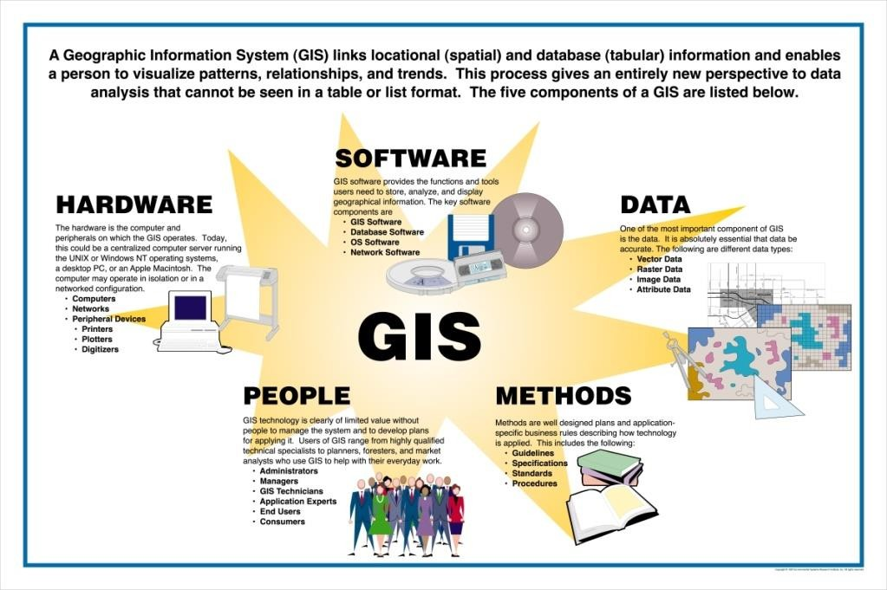Pre requisites to GIS Practical

What is a Geographic Information System(GIS)?
A Geographical Information System (GIS) is an organized collection of computer hardware, software and data used to link, analyze and display geographically referenced information.

The foundation of GIS is the ability to locate objects and events (streams, villages, disease cases) and link them with appropriate information in order to identify patterns and provide a basis for map making and analysis. Keytypes of geographical data, represented as separate map layers in a GIS, are outlined in the table below.
Sr.  No | DataType | Example | Layeron Map | 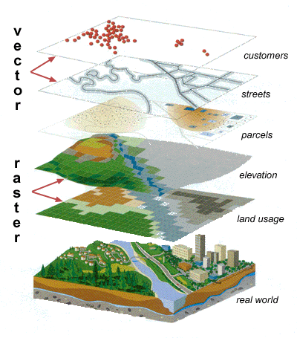
1 | POINT | Building,Hospital, City, Well. | 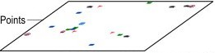
2 | LINE | River,Road | 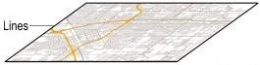
3 | POLYGON | Administrative Boundaries,Census tacts. | 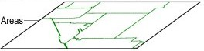
4 | RASTER | Pixelorgriddata
Vector data: A representation of the world using points, lines, and polygons. Vector models are useful for storing data that has discrete boundaries, such as country borders, land parcels, and streets.

Point features: Amapfeaturethat has neitherlength norareaat a givenscale,such as acityon aworld map or a building on a city map.
Line features:A map feature that haslength but not area at a given scale, suchas a river ona worldmap or a street on a city map.
Polygonfeatures:Amapfeaturethatboundsanareaatagivenscale,suchasacountry onaworld map or a district on a city map.

Raster data. A representation of the world as a surface divided into a regular grid of cells. Raster models are useful for storingdata that varies continuously, as in an aerial photograph, a satellite image, a surface of chemical concentrations, or an elevation surface.
With a GIS application you can open digital maps on your computer, create new spatial information to add to a map, create printed maps customised to your needs and perform spatial analysis.

UnderstandingQGIS

Whatis QuantumGIS?
Quantum GIS (QGIS) is a user friendly Open Source GIS application licensed under the GNU General Public License. QGIS is an official project of the Open Source Geospatial Foundation (OSGeo). It runs on Linux, Unix, Mac OSX, Windows and Android and supports numerous vector, raster, and database formats and functionalities.
Like all GIS applications, QGIS provides a graphical user interface allowing displayof map layers and manipulation of data for analyses and map-making.
A Geographical Information System (GIS) is a collection of software that allows you to create, visualize, queryand analyze geospatial data. Geospatial data refers to information about the geographic location of an entity. This often involves the use of a geographic coordinate, like a latitude or longitude value. Spatial data is another commonly used term, as are: geographic data, GIS data, map data,location data, coordinate data and spatial geometry data. Applications using geospatial data perform a variety of functions. Map production is the most easily understood function of geospatial applications. Mapping programs take geospatial data and render it in a form that is viewable, usually on a computer screen or printed page. Applications can present static maps(a simple image) or dynamic maps that are customized by the person viewing the map through a desktop program or a web page.
Many people mistakenly assume that geospatial applications just produce maps, but geospatial data analysis is another primary function of geospatial applications. Some typical types of analysis include computing:
- Distancesbetweengeographic locations
- Theamount ofarea(e.g., squaremeters)within acertain geographic region
- Whatgeographicfeaturesoverlapotherfeatures?
- Theamountofoverlapbetweenfeatures
- Thenumberof locationswithina certaindistanceof another
- andso on...
These may seem simplistic, but can be applied in all sorts of ways across many disciplines. The results of analysis may be shown on a map, but are often tabulated into a report to support management decisions. The recent phenomena of location-based services promises to introduce all sorts of other features, but many will be based on a combination of maps and analysis. For example, you have a cell phonethattracks yourgeographiclocation.Ifyou havetherightsoftware, yourphonecantell youwhat kinds of restaurants are within walking distance. While this is a novel application of geospatial technology, it is essentially doing geospatial data analysis and listing the results for you.

SystemRequirements
WindowsOS:
Minimum: Pentium III / 256 MB RAM. Recommended:1GBofRAMand1.6GHzprocessor.
OperationSystem:PlatformsWindows andLinux(WinXPornewer,LinuxSuse8.2/9.0/9.2, Linux Debian (Lliurex))
MAC OS:
PC/DesktopwithatleastPentiumIV Tiger OS, Leopard OS.

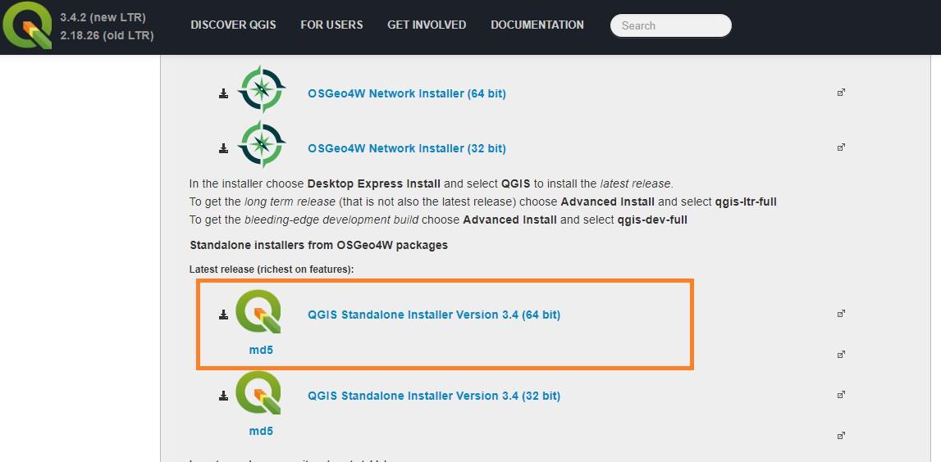InstallationofQGIS

Step Bystep procedure
- Create a folder on your D:/ drive on your computer called QGISlab by right clicking on the D: drive and navigating down to the New / Folder.
- GototheQGISdownloadpageanddownloadthelatest64bitversionofQGISforwindows which is QGIS 3.4 'Madeira’ by clicking once.
- Ifyou have a 32 bit machine or using another operating system search the bottom of the pagefor your operating system and download the correct operating system version of QGIS. http://www.qgis.org/en/site/forusers/download.html

- Youbrowserwill download the fileto thebrowsersdefault download directory. Bypressing the controlkeyand theletterJ atthesametimeapopupwindowwillshow youthefolder wherethe QGIS file has been downloaded. The QGIS file will be called:
QGIS-OSGeo4W-3.4.2-1-Setup-x86.exe
- Move or copy the abovefile toyour C:/QGISlabfolder and double clickon the file. You willget a popup window with a security warning.
- Hit the run button to start the installation process and follow the prompts. There is noneed toinstall the data sets suggested by QGIS.

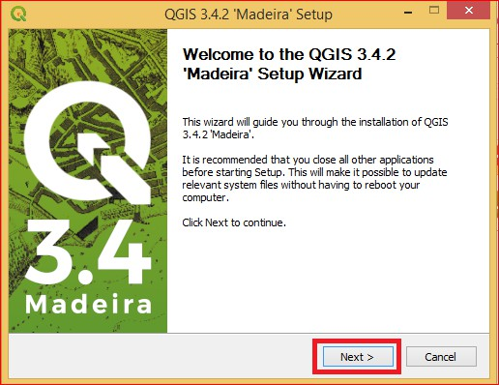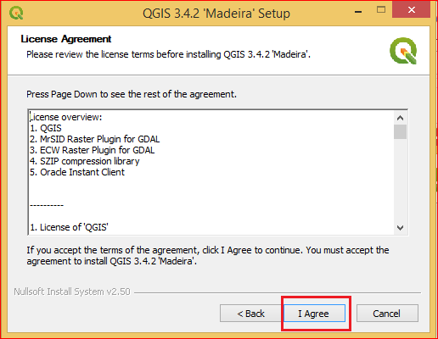

- Fromtheabovewindow, click Nextbutton andcontinuewiththeinstallation.
- Please go through the license agreement and click on the button> I agree and proceed with the installation as shown in the screen.

- Asthesoftwareisveryheavyitisadvisabletoinstallitinthedifferentdriveotherthanthe windows drive. As per our example, we will be installing in QGIS folder on D:\ drive.

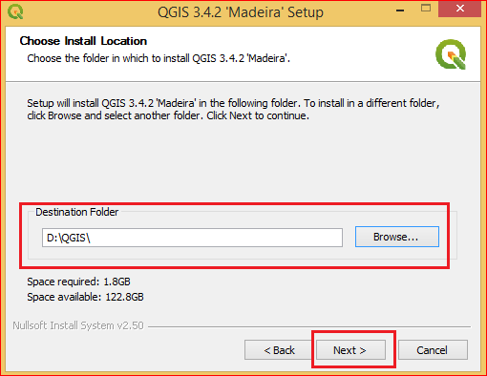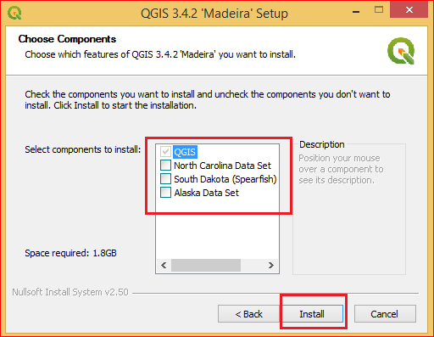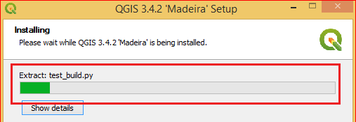

- Afterbrowsing thefolderclicktheNextbuttonandproceedwiththeinstallationasshownin above figure.
- BydefaultQGIScomponentisselected.Donotinstallanyotherdatasetatthispoint.Click Install to proceed with installation.

- Youwillseetheprogressof theinstallation onthe screen.

- 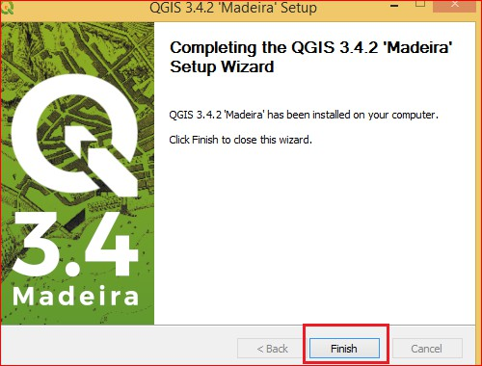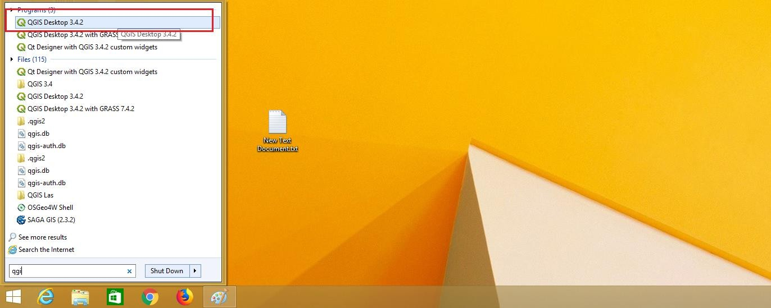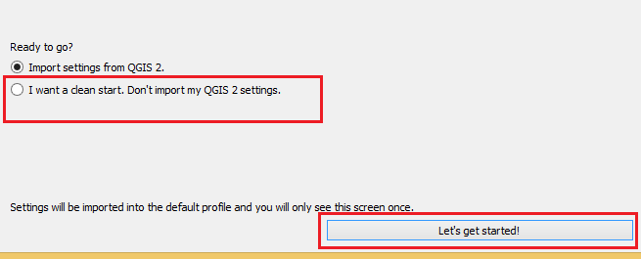Pleaserebootyourmachineoncetheinstallationiscompleted.Clickfinishtocompletethe installation.

- Aftermachineisrestarted,typeQGIS onRunandopenQGISDesktop3.4.2.

- Itwillopen anew wizard forthe firsttimeafterinstallationas shownin thefigurebelow.

- Select Iwantacleanstart.Don’timportmyQGIs 2settings and clickon let’sgetstarted button. You will be redirected now to the home screen of QGIS Desktop.

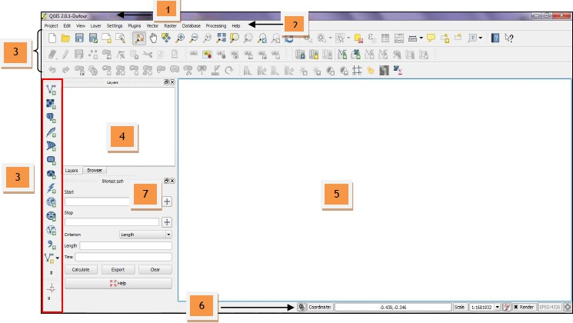UnderstandingQGISDesktopEnvironment.

Quantum GIS interfaces change from one project to another depending on the required interface of the project. Below are the basic menus that you will encounter in Quantum GIS during the practicals.
- TitleoftheProject -Shows thetitleofprojectthatyouaregoingto view.
- Menu Bar – This provides access to various Quantum GIS features using a standard hierarchical menu.
- Toolbars –Theseprovideaccesstomost ofthesamefunctionsasthemenus,plusadditionaltools for interacting with the map. It shows the command for zoom in, zoom out, pan, back to original view, go back to previous extent, go to next extent, object-information, coordinate read-out, measure, print and help.
- Table of Contents/Map Legend (TOC) - Shows the layers that can be turned on or off and the legend, attributes symbols and query symbols available for the corresponding project.
- DisplayWindow -Showsthe feature/sthatyouhaveturnonfromtheTOC.
- Status Bar -Shows you your currentpositioninmapcoordinates (e.g.metresordecimaldegrees) as the mouse pointer is moved across the map view. To the left of the coordinate display in the status bar is a small button that will toggle between showing coordinate position or the view extents of the map view as you pan and zoom in and out.
- Data sources browser – In previous versions, QGIS browser was only provided as an external application which enables us to explore our spatial data sets. In QGIS 2.0.1-Dufour this application is also integrated in the QGIS framework as an additional panel just below the Table of Contents.
QuantumGIStoolbarsandsomeothercomponents
Toolbars are divided by thematic (greyed icons means they are inactive because the appropriate conditions to use them are not fulfilled). Some of them are included by default in QGIS and others can be added/removed from the interface:

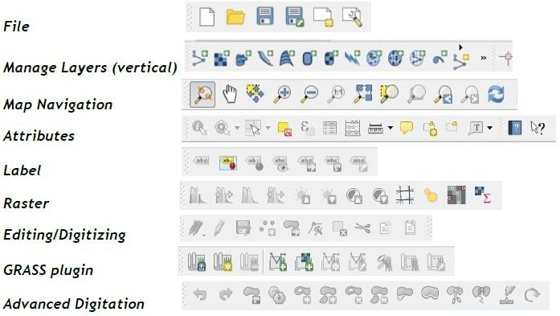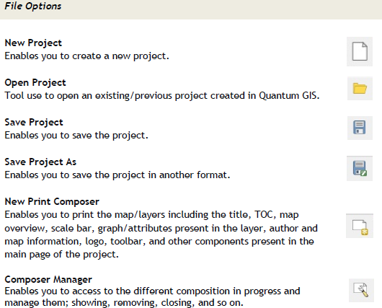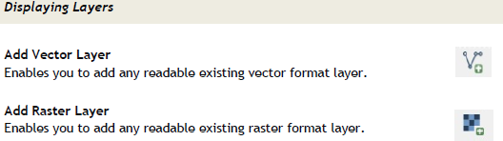

Key functions:
Here, you will learn how to QGIS‟ different mapping tools and other components that you‟ll be using in this practical.

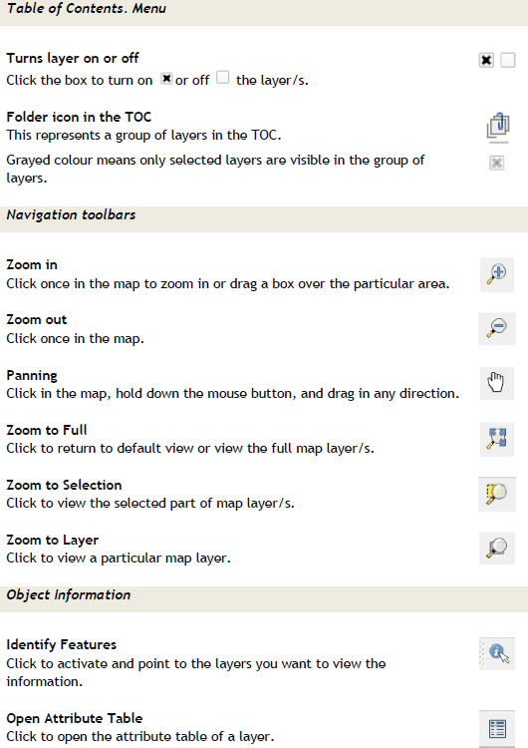

Principlesof GIST.Y. B. Sc.ITSemester VI
List ofSample/Datafilesusedfor Practical

PracticalNo. | Data setName
1D | IND_rails.zip  IND_adm0.zip
2A | gl_gpwv3_pdens_00_ascii_one.zip  gl_gpwv3_pdens_90_ascii_one.zip
2C | FAS_India1.2018349.terra.367.2km.tif FAS_India2.2018349.terra.367.2km.tif FAS_India3.2018349.terra.367.2km.tif  FAS_India4.2018349.terra.367.2km.tif
3B | Sample.csv
4A | ne_10m_populated_places_simple.zip
4B | GMTED2010N10E060_300.zip

5A | ne_10m_populated_places_simple.zip
6A | IND_adm0.zip  Bombay_1990.jpg
6B | GateWay_Aerial_Imagery.tif
6C | ChristchurchTopo50map.tif
7A | tl_2013_06_tract.zip  ca_tracts_pop.csv
7B | OEM_NursingHomes_001.zip  nybb_12c.zip
7C | EarthQuakeDatabase.txt  ne_10m_admin_0_countries.zip ne_10m_populated_places_simple.zip
7D | ne_10m_populated_places_simple.zip  ne_10m_rivers_lake_centerlines.zip
8A | ca_tracts_pop.csv EarthQuakeDatabase.txt ne_10m_populated_places_simple.zip  tl_2013_06_tract.zip
8B | us.tmax_nohads_ll_20140525_float.tif 2013_Gaz_ua_national.txt tl_2013_us_county.shp
8C | tl_2013_us_county.shp Boundary2004_550_stpl83.shp
9A | ne_10m_admin_0_countries.shp ne_10m_admin_0_District.shp ne_10m_admin_0_port.shp ne_10m_admin_0_railroads.shp
9B | LC_hd_global_2001.tif.gz
9C | HI_Wetlands.shp.zip
10 | Kenya admin.shp Kenya_epidemiological_data.xls Kenya_epidemiological_dict.xlsx Kenya_school_dict.xlsx  Kenya_school_location.csv

Theabovedatacanbedownloadedfrom:
www.muresults.net→TYBScITSemVIeBooks→GIS→Practicals

Ordirectlyfrom:https://drive.google.com/drive/folders/191tJ4L7O-VJm2Q2AB8dZDpIj7vyyPM3I?usp=sharing

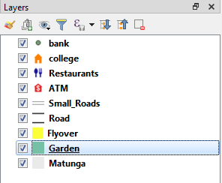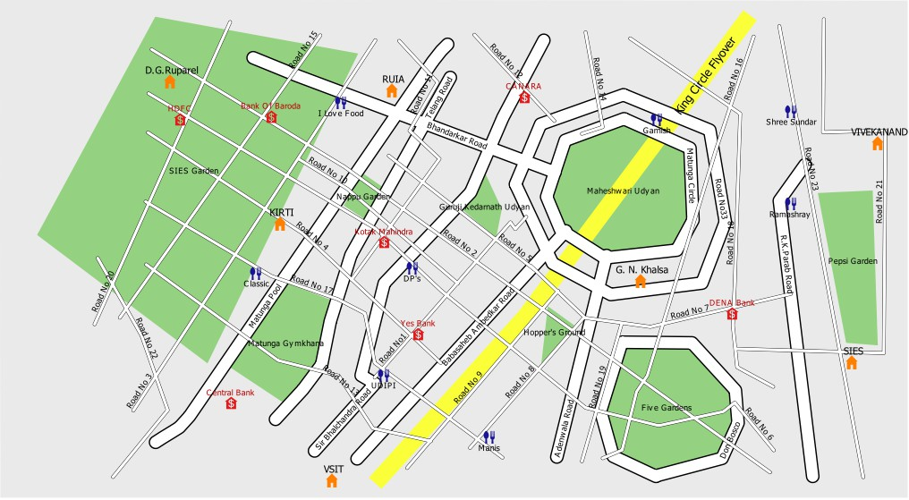PRACTICAL-1
B.AIM:-CreatingandManagingVectorData:
- Addingvectorlayer
- Settingproperties
- VectorLayerFormatting

Procedure:
- Addingvectorlayers(Polygon,Line,Points)
  - Polygonlayers (Wehave taken 2layersMatunga, Garden)
  - Linelayers(Wehavetaken3layersSmall_Roads,Road,Flyover)
  - Pointlayers(Wehavetaken4layersbank,college,Restaurants,ATM)
- Settingproperties(Labeling, Symbolism)

Ouraimistocreatemaprepresentingalocationanditssurroundingas follows:

- 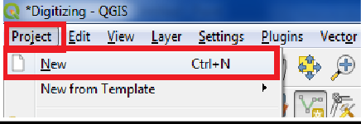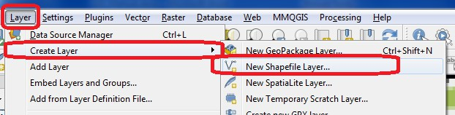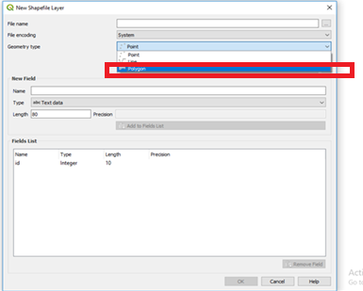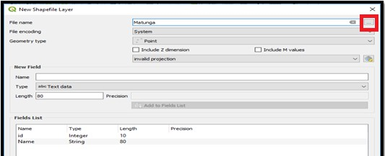CreatingPolygonvectorlayer
- SelectProject→New

SelectLayer→CreateLayer→NewShapefile Layer

- Followingdialogboxwillappear onthescreen.Select Polygonoption fromGeometrytype.

- Filltheappropriateinformation ineachtext box.
  - Filename:
    - Bydefault the filewill besavedin bin folder.
    - Toavoid itclickon followingbuttontochangethe locationoffile.

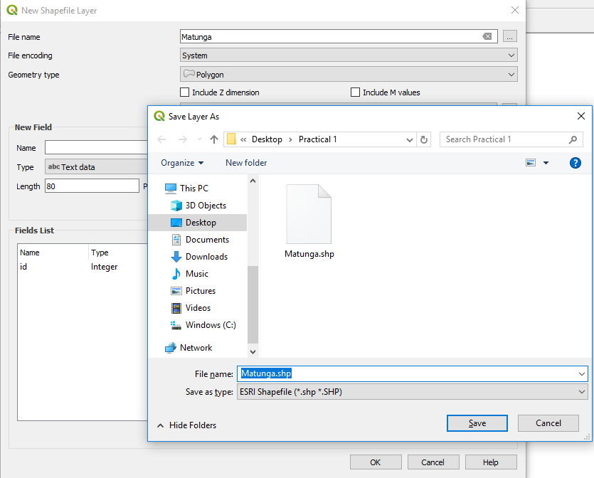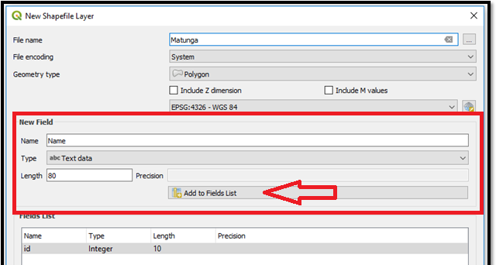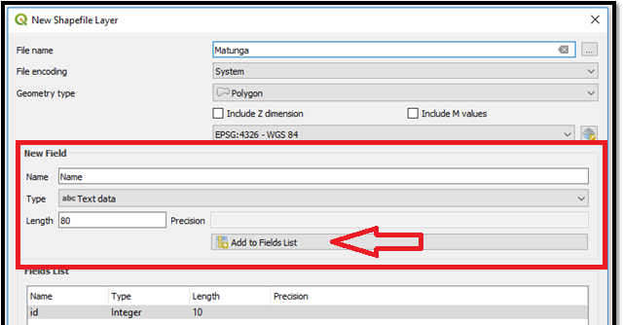

FieldPanel
- AddtheAttributeyouwanttoshow.(ColumnNameforTable)
b.SpecifyType(DataType:Text Data/DecimalData/WholeNumber/Date)of Attribute
c.Specifythe Lengthof the Attribute.SpecifyPrecision (IfData TypeisDecimal)

- ClickonAdd toFieldListButton.
- Youcanaddasmanyfields(ColumnName)asyouwantforthe layer.

- 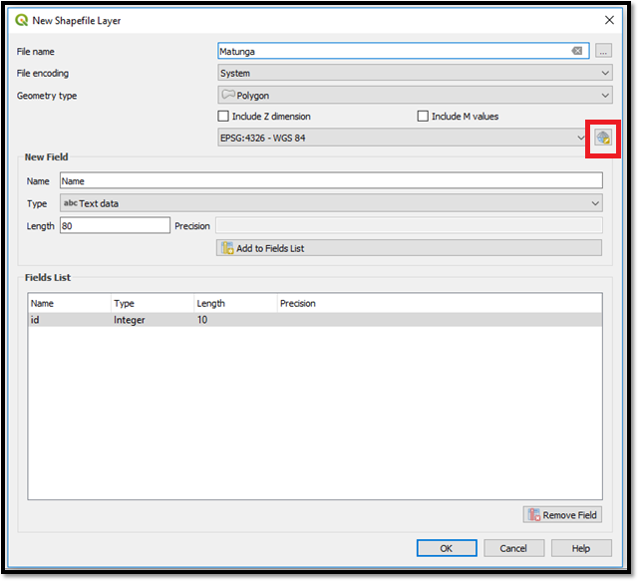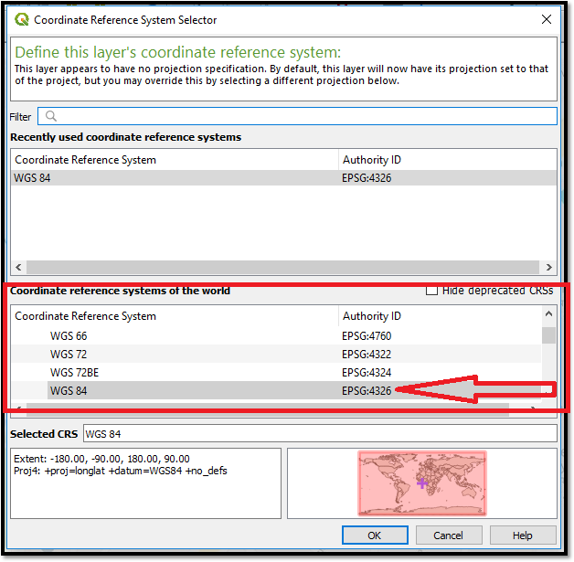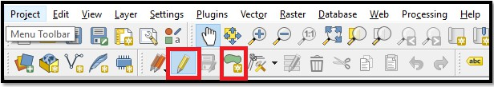SelectGeometryTypeasfollows
  - Clickonthefollowingbutton

- TheCRSdialogboxwillappearonscreen.ClickontheWGS84optionanditwillbeselected as follows. click on OK

- Followthestepstoplot Polygonfeatures.
- SelectthePolygon Feature(Inour caseitis Matungaforbackground)fromlayerpanel

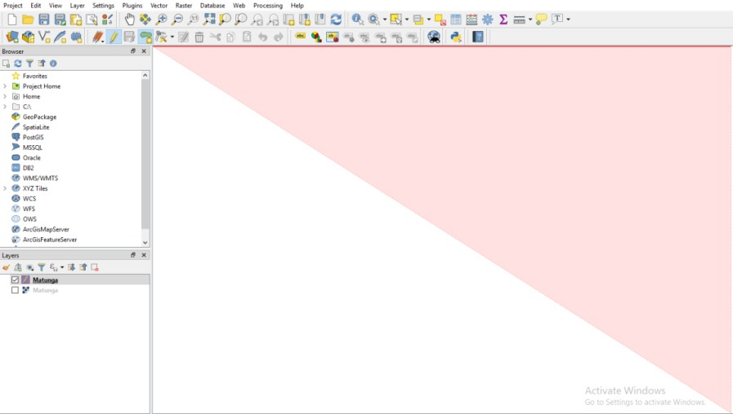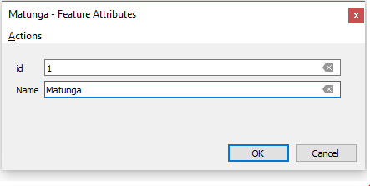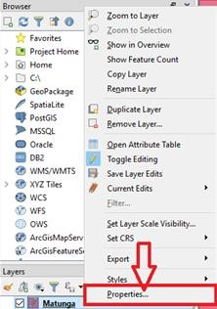

- Click Toggle Editing Button →Click on Add Polygon →Nowplacethecursor at the location where you want to place the polygon. for polygon layer minimum 3 points should be selected

- Savethe newlyadded polygon as follows.

- Setstyleforpolygon byusingpropertywindow(Right clickon MatungaLayer)

- Followingscreenwillappearonthescreen.Selectpattern asyouwantandclick onOK.

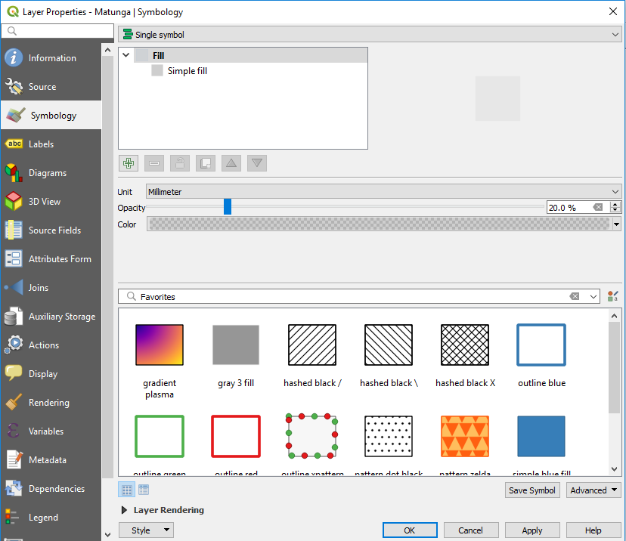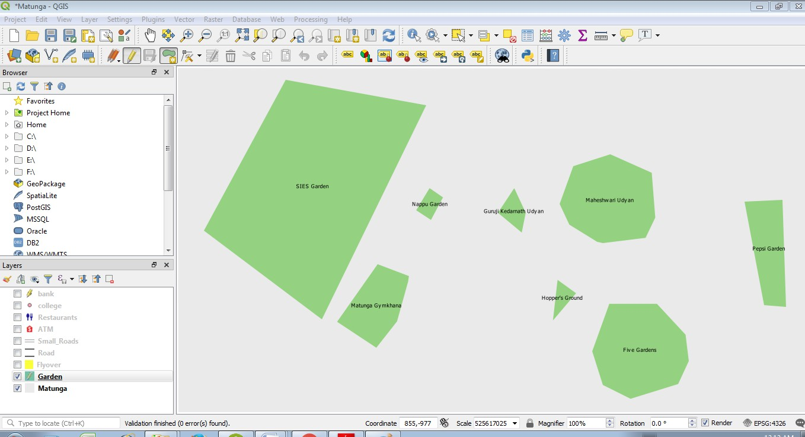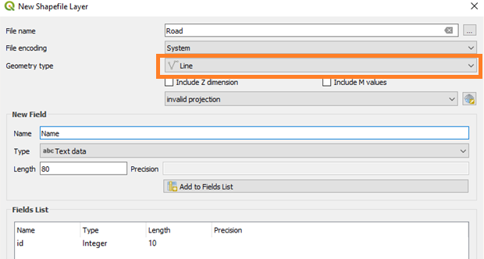

- Same waywecanadd onemorepolygon layer for Gardens.

- CreatingLinevector layer
- Repeatthesame stepsaswehavedoneforpolygon layer.
- Select geometrytypeLine.

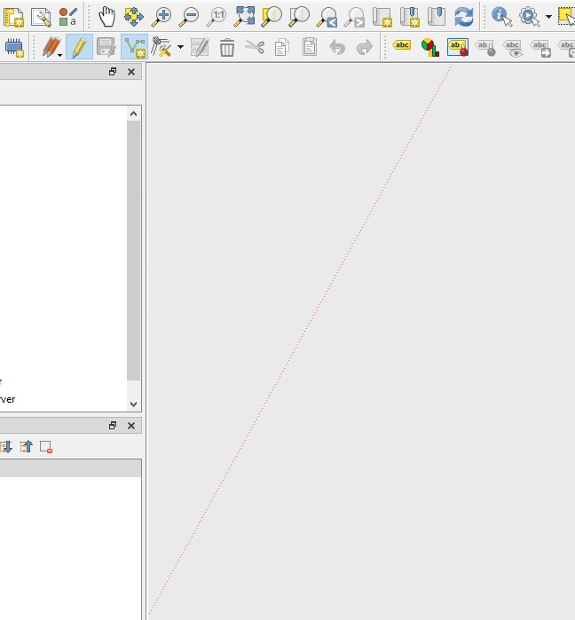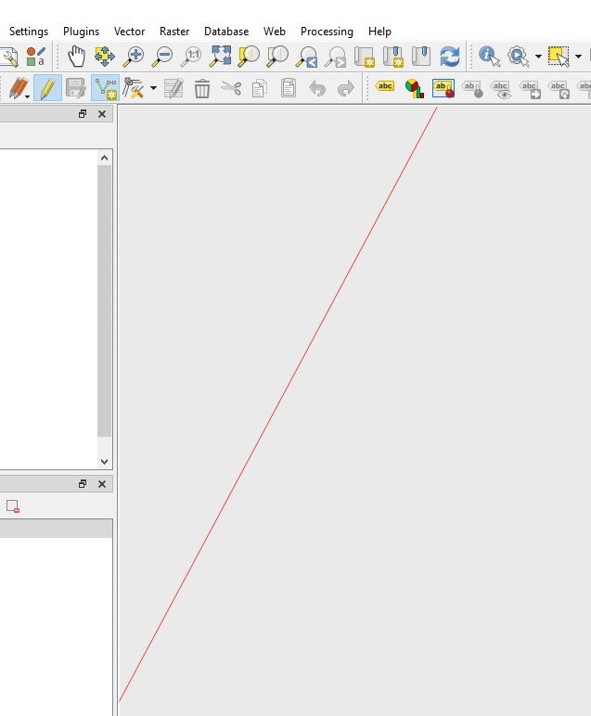

- Roadlayer:
  - Toplot roadclickonAddLineFeature.

  - Clickonthemapwhereyouwanttodrawline.

  - Once youaredonethenrightclickonmap(Dottedline turnintosolidline)

  - saveyourdata

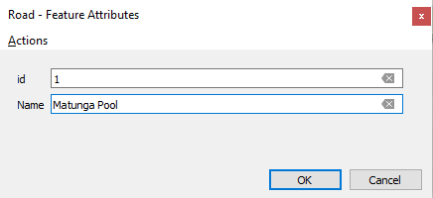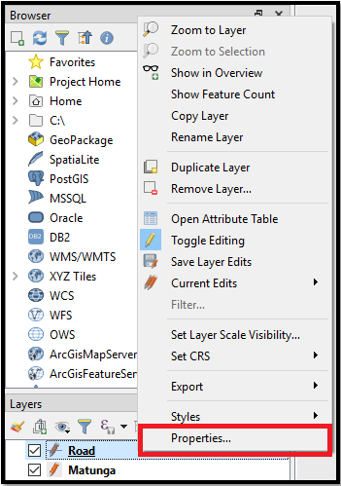

  - setstyleforRoads in thesame wayaswehavedoneforpolygon

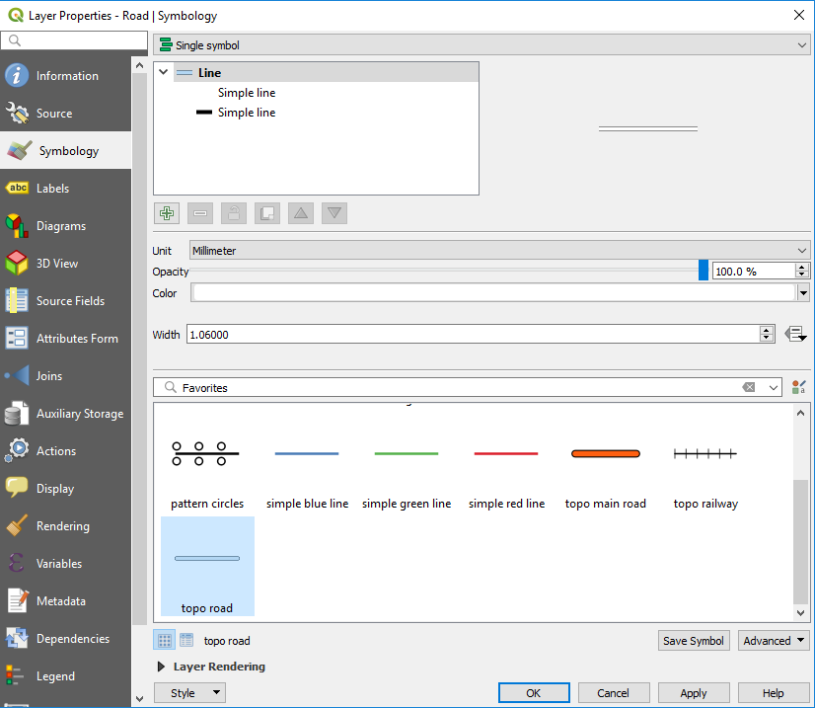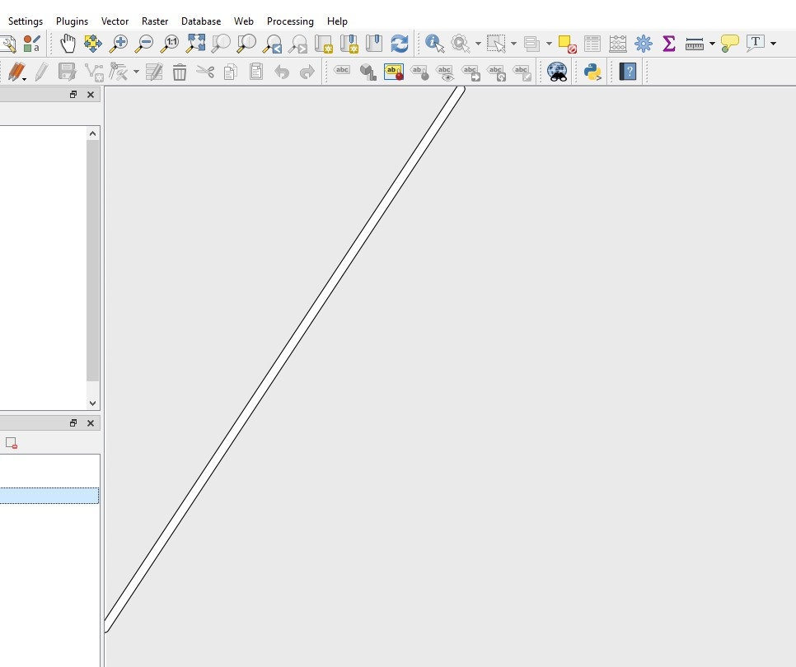

  - Roadwill look as below

  - Tolabelyourroads RightclickonRoadlayer.Gotopropertieswindowthenselectlabeland set single label property

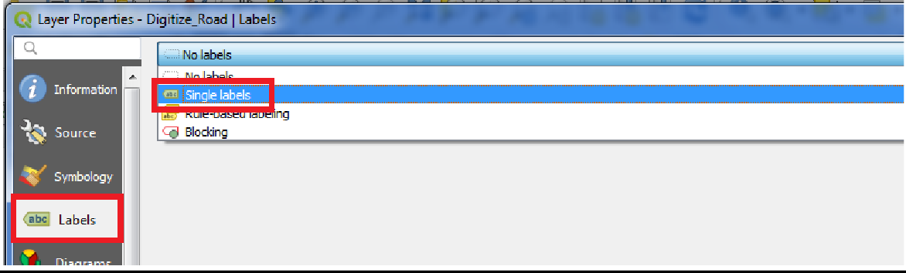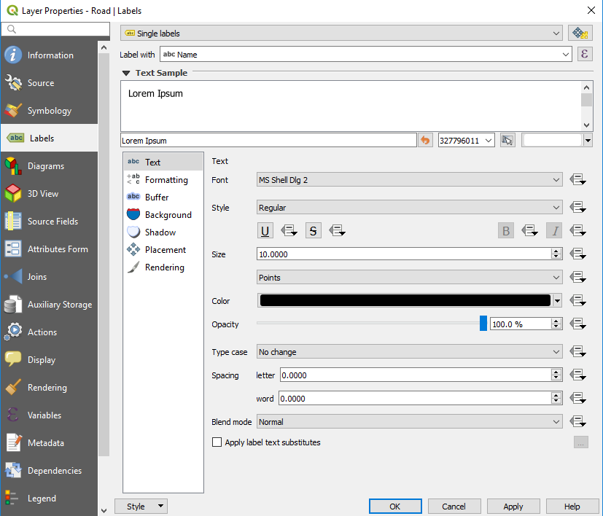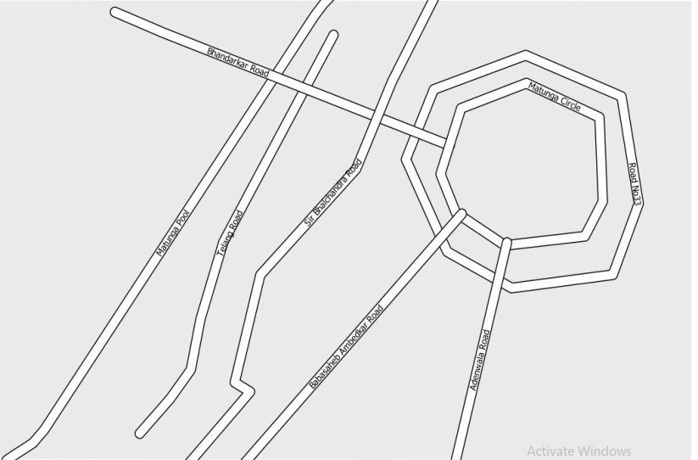

  - Followingwindow willappearonthe screen

  - Roadswill look likethese

  - 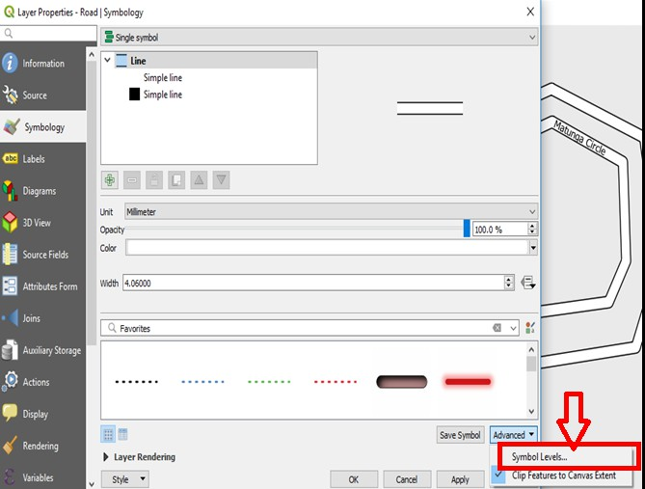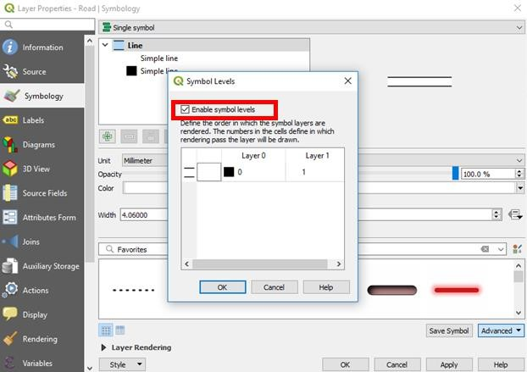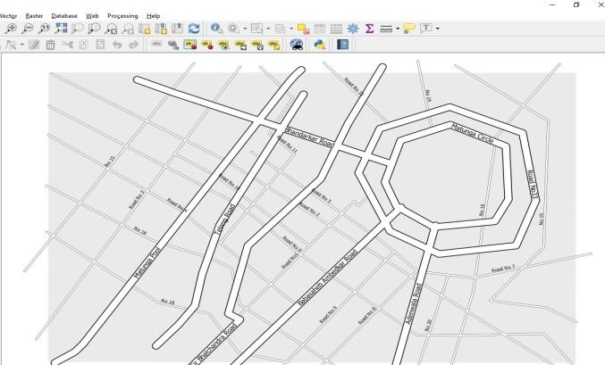Tomerge roads
    - Gotopropertiesofroadthenselectsymbology.ClickonAdvancedbuttonselect Symbol levels.

  - CheckEnablesymbollevels option

  - Clickok&Road willappearasfollows

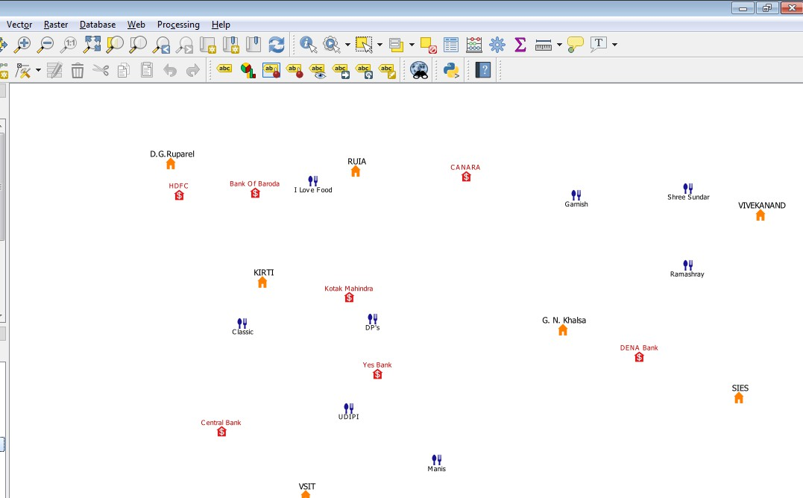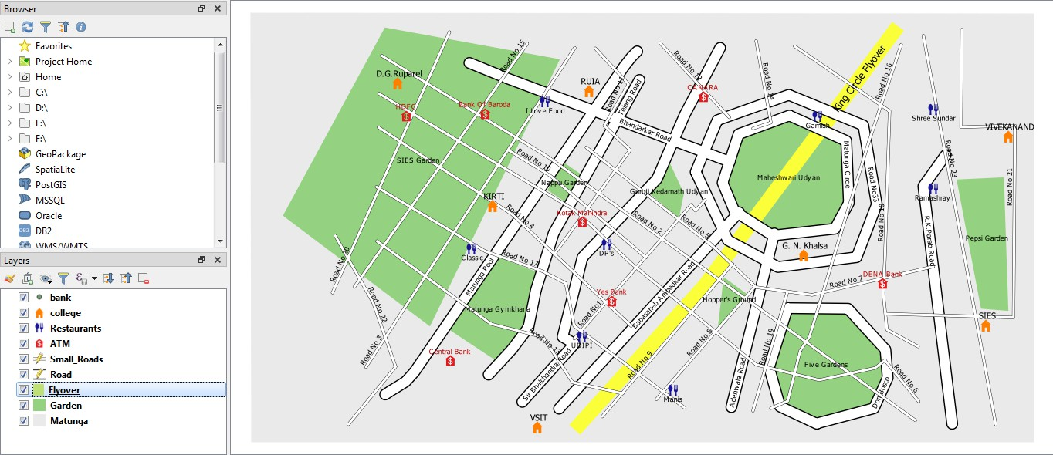C.CreatePointvector layer
- Repeatsamestepstoaddpointlayersaswehavedoneinpreviouslayers.(For ATM, Restaurants, Banks, Bus Stops etc)

Finaloutput:

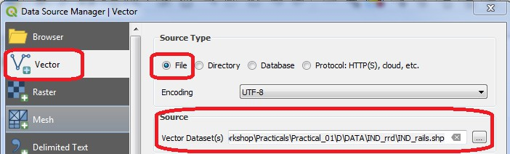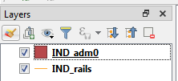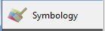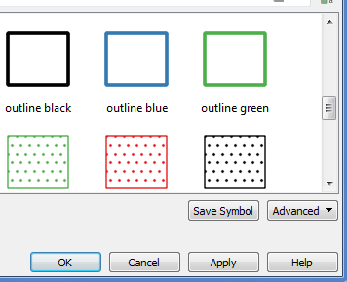
- Calculatinglinelengthsandstatistics
  - Goto Layer→ AddLayer →AddVector Layer
  - Add thefollowing fileto project

"\GIS_Workshop\Practicals\Practical_01\D\DATA\IND_rrd\IND_rails.shp"Press “ADD”
  - Also add India Administrative Map “GIS_Workshop\Practicals\Practical_01\D\DATA\IND_adm\IND_adm0.shp”
  - DoubleClick onIND_adm0

Select →Select anyoutline style frombelowgiven options.

PressOK
  - Thedisplaywindow willappear like

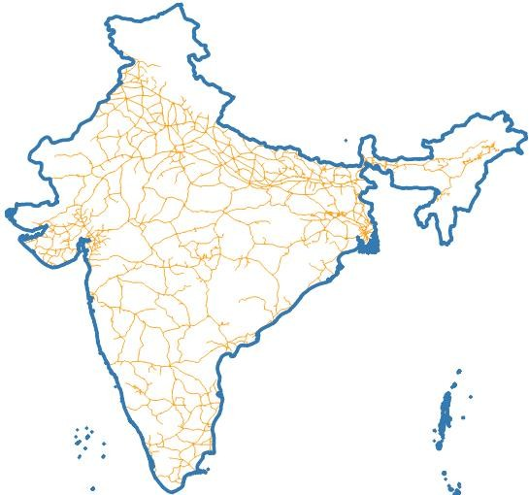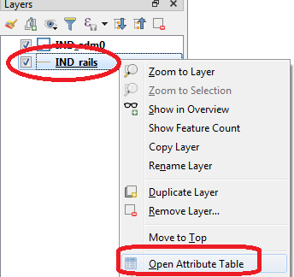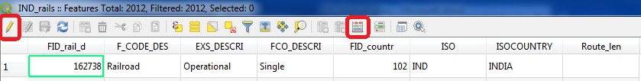

  - InLayerPane,Rightclickon IND_rails→Open Attribute Table

  - PressToggle Editingbuttonusing button,onAttributetablewindowtoolbar.

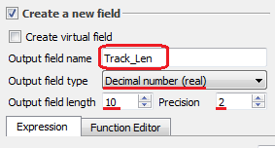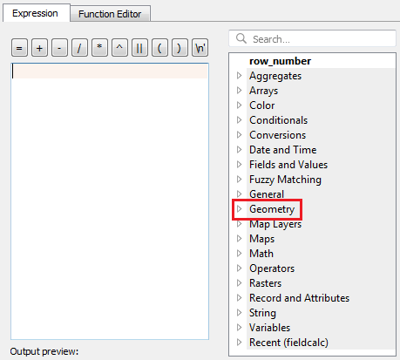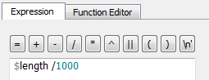
  - PressOpenFieldCalculatorusing button.
  - Settheoutputfieldas“Track_Len”,fieldtypeto“DecimalNumber”.

  - FromFunctionListsearch$lengthor gotoGeometry→Select$length

  - Setexpressionas

Press “OK”
  - Anewcolumnis addedtothe attributetablewithvalue representingthelength oftrackin KM.

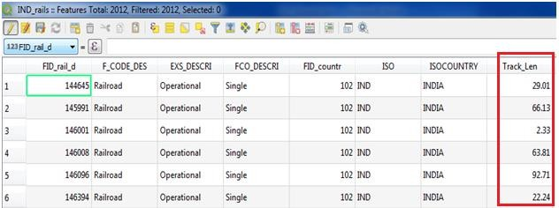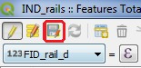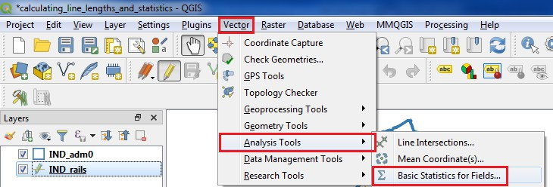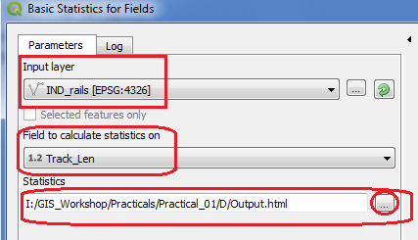

  - PressCTRL+SorclickonSaveEditsoptionontoolbar
  - Closetheattributetablewindow.
  - Forcalculatingthe total lengthof Railwaytracks inIndia.
  - SelectVector→AnalysisTools→BasicStaticsforFields

  - SelectIND_railslayerfrominputlayer.AndselectTrack_Lenin“FieldtoCalculatestatistics on”

  - PressRUN

  - 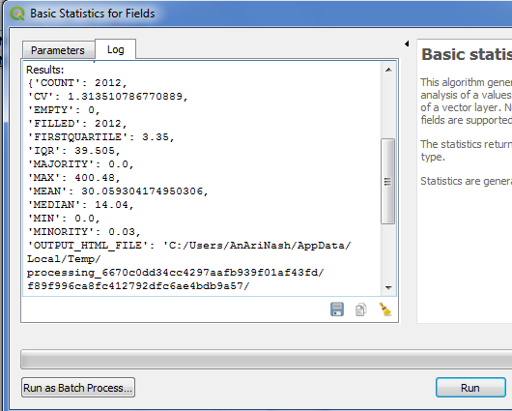TheResult is

  - Openthe“output.html”filetogetthefieldstatistics. Analyzed field: Track_Len
Count: 2012
Unique values: 1608 NULL(missing)values:0 Minimum value: 0.0
Maximum value: 400.48
Range:400.48
Sum: 60479.320000000014
Meanvalue:30.059304174950306
Medianvalue:14.04
Standard deviation: 39.483220276624444 Coefficient of Variation: 1.313510786770889 Minority (rarest occurring value): 0.03 Majority(mostfrequentlyoccurringvalue):0.0 First quartile: 3.35
Thirdquartile:42.855000000000004 Interquartile Range (IQR): 39.505
  - Theabovestatisticsshowthat thetotallengthof RailwaytrackinIndiais60,479.32 KM.

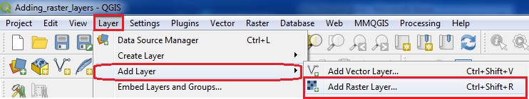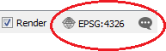PRACTICAL-2
ExploringandManagingRasterdata:
- Addingrasterlayers
  - Frommenubarselect Layer→Add Layer→AddRaster Layer

- Select Gridded Population of the World (GPW) v3 dataset from Columbia University, Population Density Grid for the entire globe in ASCII format and for the year 1990 and 2000. “\GIS_Workshop\Practicals\Practical_02\A\Data\gl_gpwv3_pdens_90_ascii_one\glds90ag60.asc” “\GIS_Workshop\Practicals\Practical_02\A\Data\gl_gpwv3_pdens_90_ascii_one\glds00ag60.asc”

- Go to Project → Properties OR Press the SetCRSoptiononbottom right corner.
SelectWGS84EPSG:4326 andPressOK

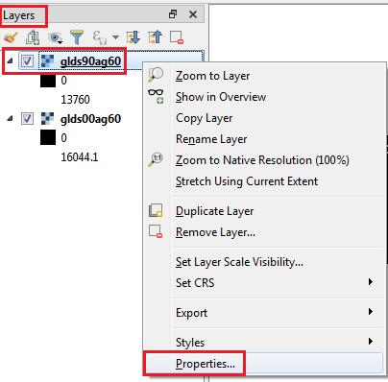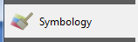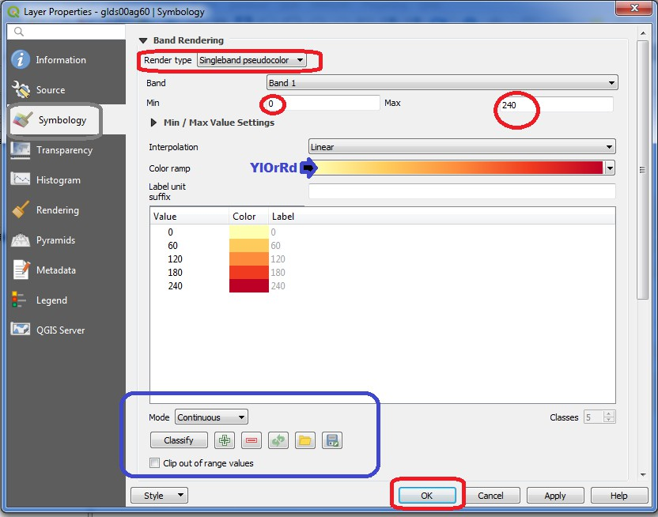
- RasterStylingandAnalysis

  - Tostartwith analysisof population data,convert thepixelfrom grayscaleto Color.
  - Select“glds90ag60.asc” LayerformlayerPane→ selectpropertyORdoubleclickonit.

  - Select

  - Press“APPLY”
  - Repeatthesamefor“glds00ag60.asc”Layer

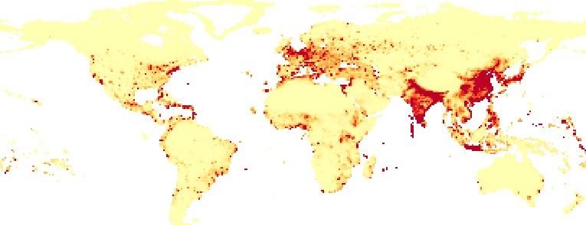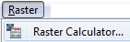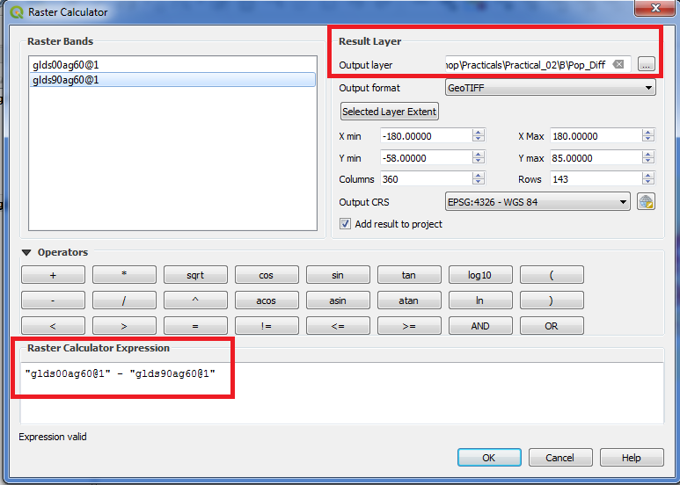

Layeroutputafterapplyingstyle.
  - The objective this experiment is to analyze raster data, as an example we will find areas with largestpopulationchangebetween1990and2000,bycalculatingthedifferencebetweeneach pixel values.
  - Goto Raster→ RasterCalculator

  - Puttheexpression"glds00ag60@1"-"glds90ag60@1"
  - Selecttheoutput filelocation &nameandPress OK.

  - 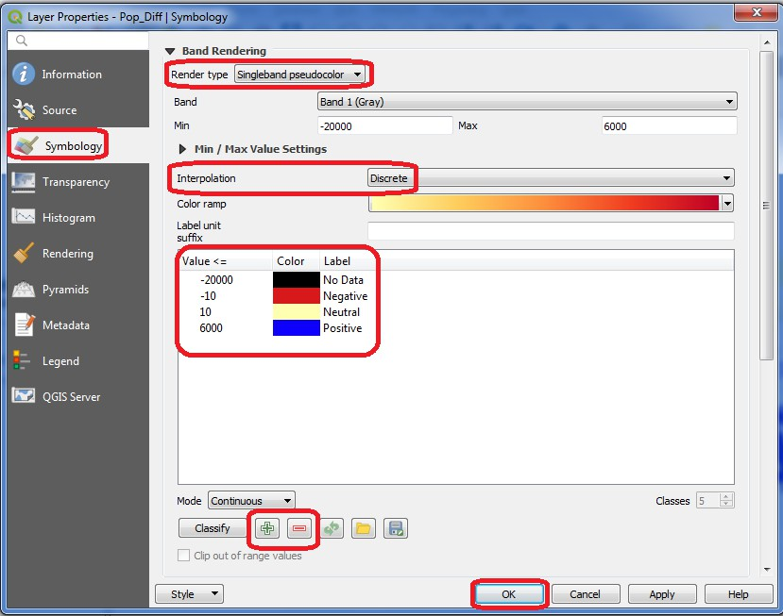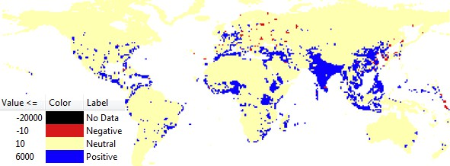Removetheothertwolayers i.e.glds00ag60.ascand glds90ag60.asc
  - Doubleclick onpop_difflayer.

  - Select

  - SetRenderTypeto“SinglebandPseudocolor”,InterpolationasDiscrete,andremove all
classification and add as shown in figure above using button.Afterallsettingspress “OK”.
  - Layerwillappearlike

  - Explore an area of your choice and check the raster band value using toverifythe classification rule.
  - Thered pixel showsnegativechanges andblueshows positive changes.

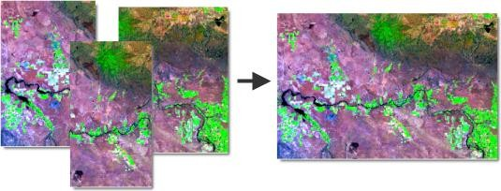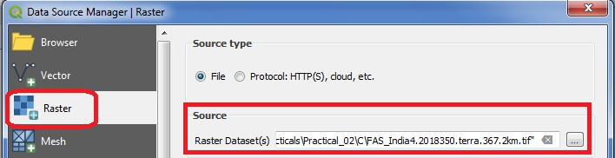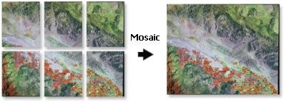
- RasterMosaickingandClipping
Amosaicisa combinationormergeof twoor more images.
InGIS,asinglerasterdatasetcanbecreatedfrommultiplerasterdatasetsbymosaickingthem together.

Inmanycases,therewillbesomeoverlapoftherasterdatasetedgesthatarebeing mosaicked together, as shown below.

Theseoverlappingareascanbehandledinseveralways;forexample, youcanchoosetoonlykeep raster data from the first or last dataset, you can blend the overlapping cell values using a weight- based algorithm, you can take the mean of the overlapping cell values, or you can take the minimum or maximum value. When mosaicking discrete data, the First, Minimum, or Maximum options give the most meaningful results. The Blend and Mean options are best suited for continuous data. If any of the input rasters are floating point, the output is floating point. If all the inputs are integer and First, Minimum, or Maximum is used, the output is integer.

  - Goto Layer→ AddLayer →AddRaster Layer.

  - 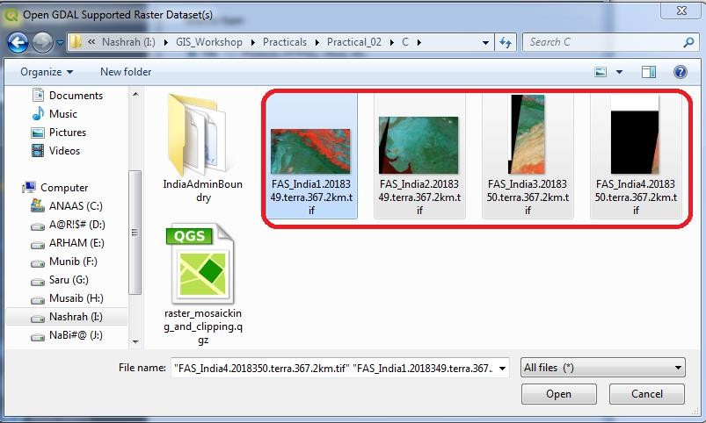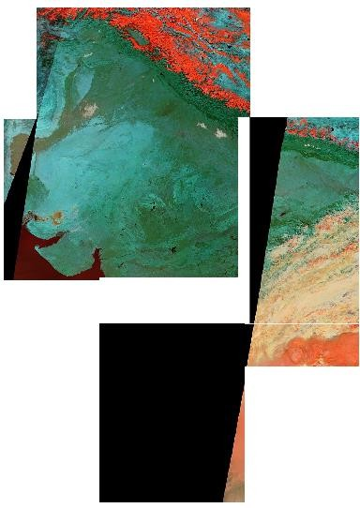Selectthefollowing“.tif”rasterimagesforIndiafromdatafolder. FAS_India1.2018349.terra.367.2km.tif FAS_India2.2018349.terra.367.2km.tif FAS_India3.2018349.terra.367.2km.tif FAS_India4.2018349.terra.367.2km.tif

  - Pressopen
  - Indatasourcemanager |Raster windowclickAdd.

  - Goto Raster→ Miscellaneous →Merge

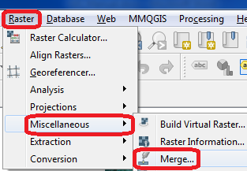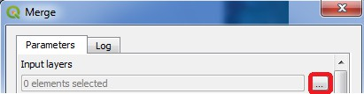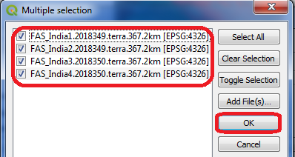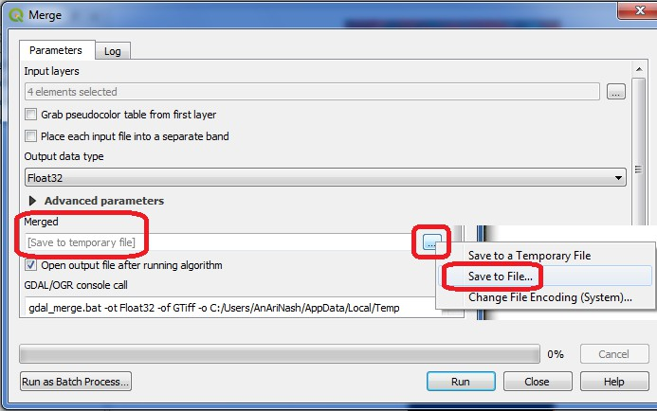

  - IntheMergedialog window

  - SelectalllayersandPressOK.

  - InMergedialogwindow selectafilenameandlocationtosavemergedimages.

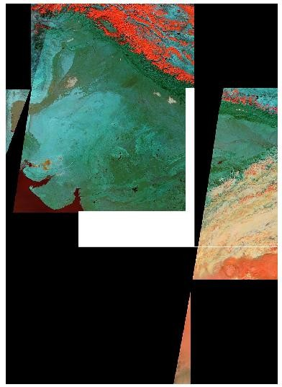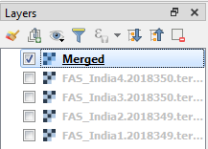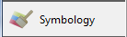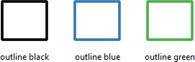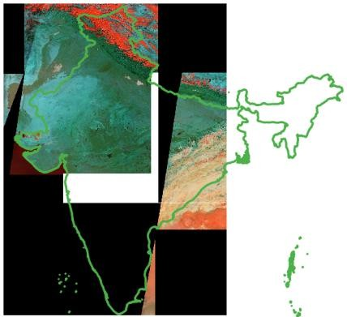

  - Savethefileto“GIS_Workshop/Practicals/Practical_02/C/”locationwiththenameas Merge_Files.tif
  - PressRunandafter completionofoperationclose theMergewindowdialogbox.

  - Youcannow deselect individuallayers fromlayer paneandonlykeepthemergedrasterfile.

  - GotoLayer→AddVectorLayer→Select
\GIS_Workshop\Practicals\Practical_02\C\IndiaAdminBoundry\IND_adm0.shpfile.
  - Fromlayerproperties →select →select anyoneof thefollowing

  - Theresultwill be

  - 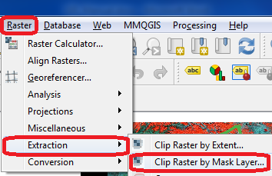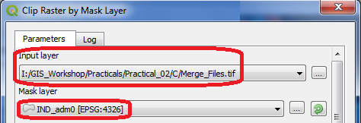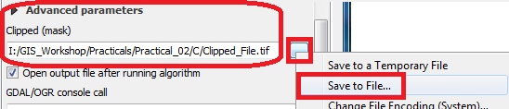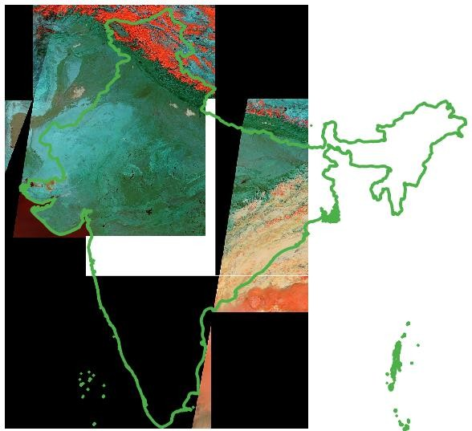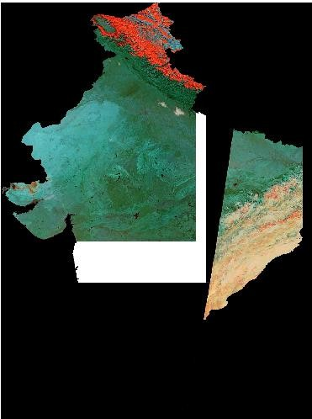Goto Raster→Extraction→ ClipRasterbyMaskLayer

  - Selectthemerge raster imageasinputand Ind_adm0asmasklayer.

  - Selectafilenameandlocationforclippedrasteras/Practical_02/C/Clipped_File.tif.

  - PressRUN.

After Clipping

- MakingaMap

PRACTICAL-3

- 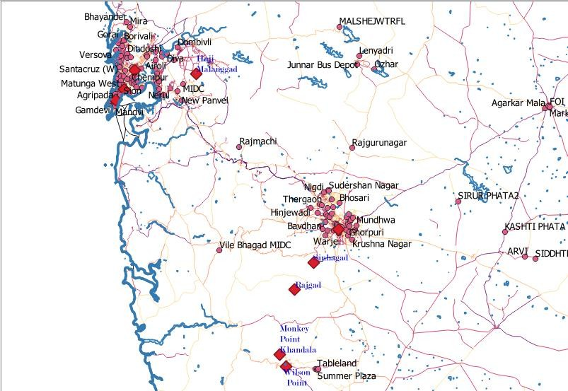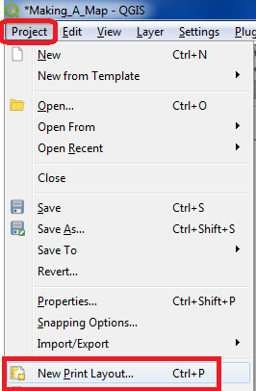Createanew Thematic Mapor openandexistingone
- Considerthefollowing mapas anexamplemap

- GotoProject→NewPrintLayout

- Insertasuitabletitleandpress“OK”.

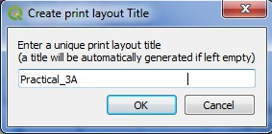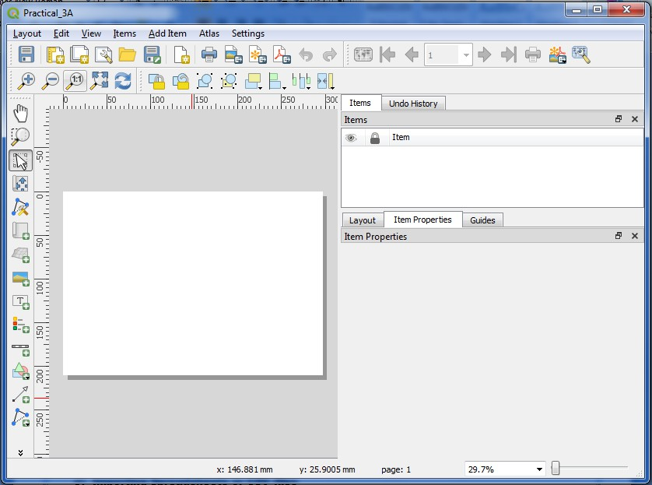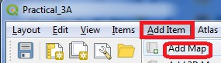

- AnewPrint Layoutwindow willopen

- SelectAddItem→Add Map

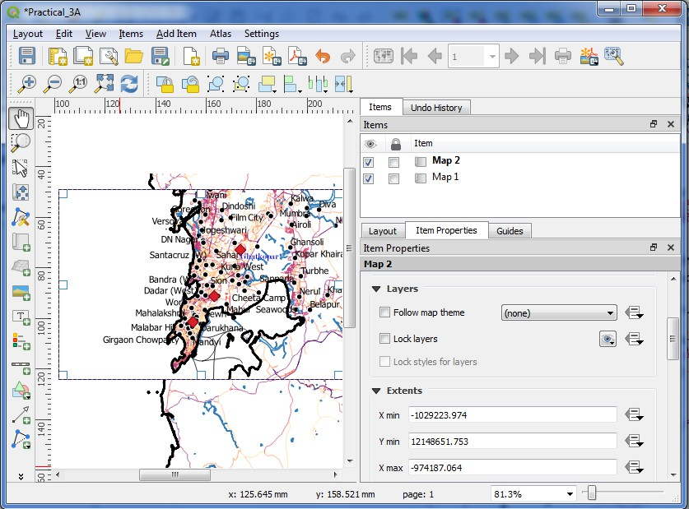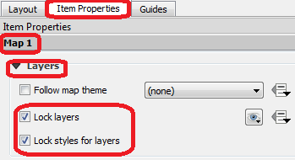

- AfteraddingmapgotoItemProperties→Map1→Layers Check on Lock Layers and Lock Styles for Layers

Thiswillensurethatifanychangein layersorchangetheirstyles,thePrint Layoutviewwillnot change.
- GotoAdd Item→ Add Picture→Placeapicture boxatappropriate location.

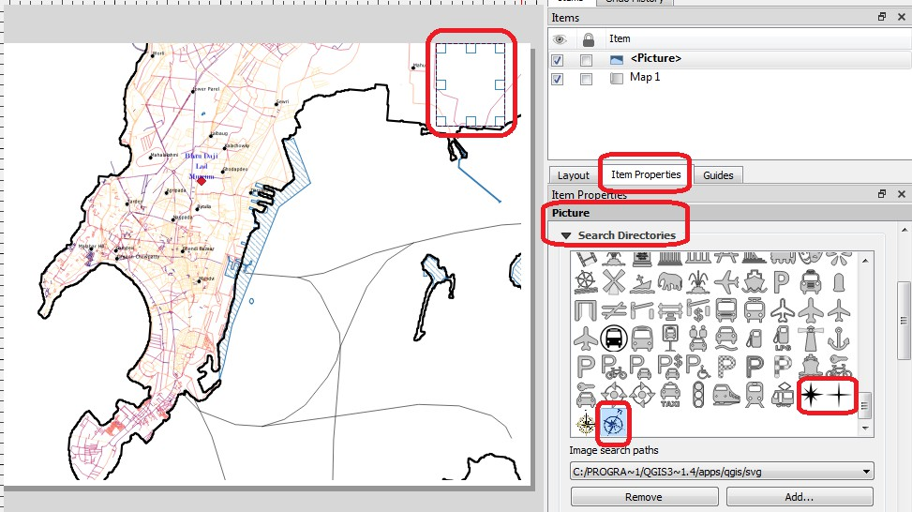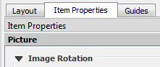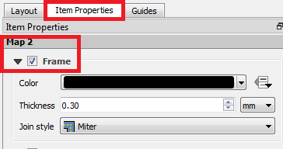

- AlsoadjustImageRotationtoitsappropriatevalue.
- ItemProperties→ImageRotation

- AddaninsetUsingAdd Item→AddPicture→SelectanareatobehighlightedonmainMap.
- Setaframe forInsetbyenablingthe checkboxfor Frame.

- Tohighlightthe areashowninInset
- SelectthePicturerepresentingmainMapfromItemspane.
- InItemProperties→Overviews→ using iconaddanoverview.
- SelectthecheckboxDrawOverview
- NamethePictureobjectrepresentinginset(Map1in ourcase).

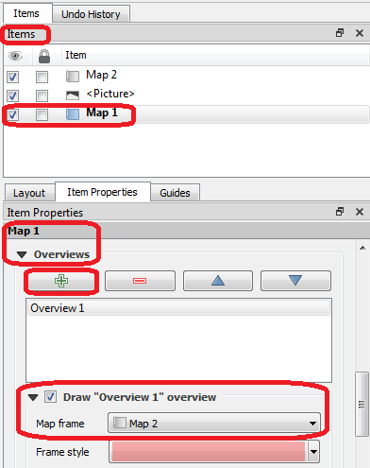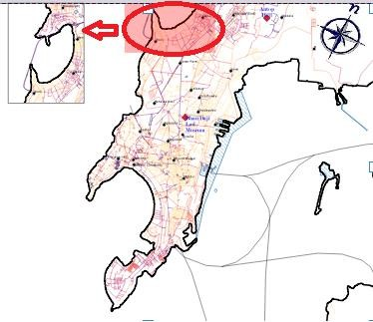

- ThePrint Layoutwillappearlike

- AddItem→Add Label

- 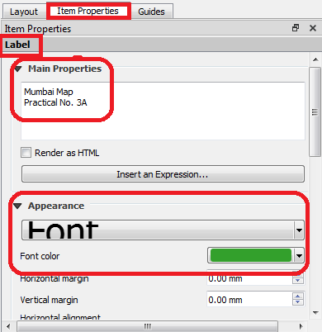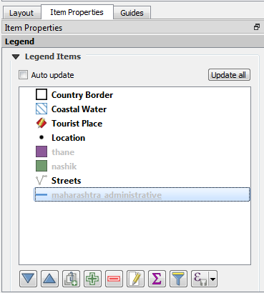ChangetheLabeltextTo“MumbaiMap”,SetappropriatefontsizeandcolorusingItem Properties→ Main Properties.

- AddItem→Add Legend→Placethelegendindicatoratappropriate location.
- Uncheckautoupdate andusesuitablelegendindicatorlabel.

- 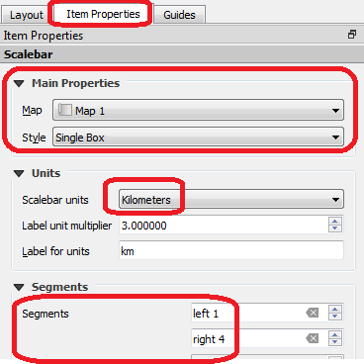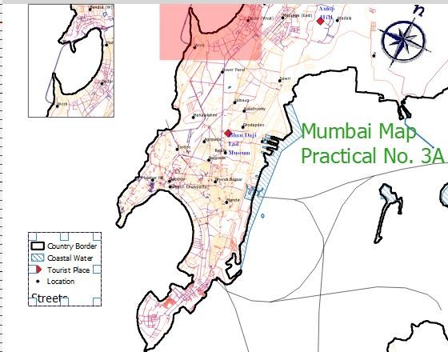ThePrint Layoutwill appear

- AddItem→AddScale Bar

- AddItem→Add Label→Add aLabelusingHTMLrendering

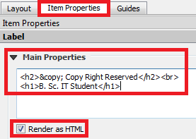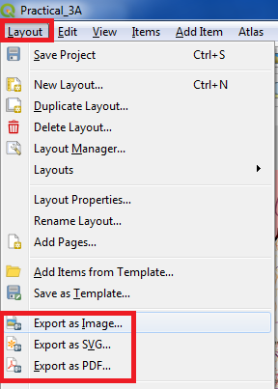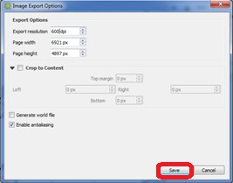

- AMapcan besavedinImageor PDFusingLayout→Export asImage/ Exportas PDF

- SavetheMapto alocationappropriatelocation asPDForImage.

- 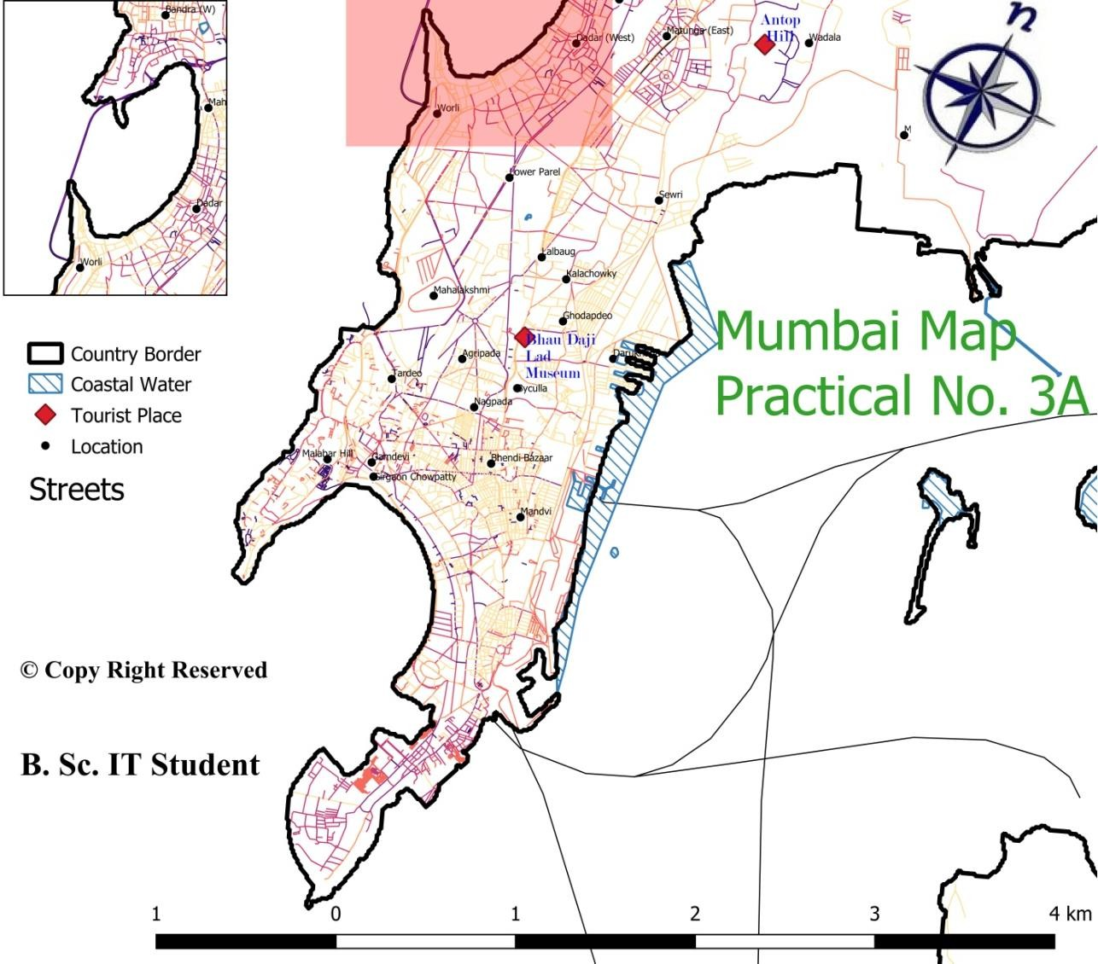OpenthePDFor Image from location.

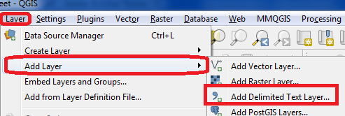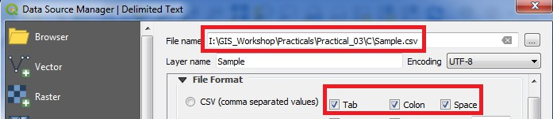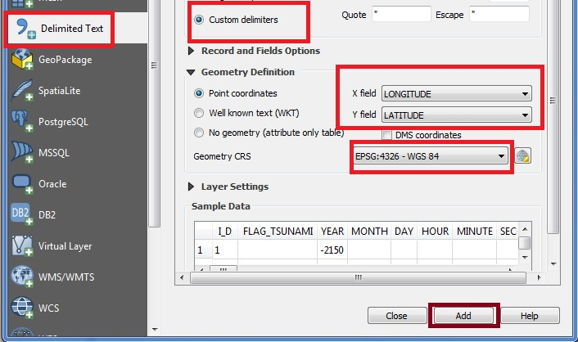
- ImportingSpreadsheetsorCSVfiles
- ManytimestheGISdatacomesinatableoranExcelspreadsheet oralistlat/longcoordinates, therefore it has to be imported in a GIS project.
- SamplefileforEarthquakedata will beused in this practical.
- GotoLayer→Add Layer →AddDelimitedtext Layer

- DataSourceManager |DelimitedTextwindowwill appear
- Selectthe\GIS_Workshop\Practicals\Practical_03\C\Sample.csvfilefromdatafolder.

- 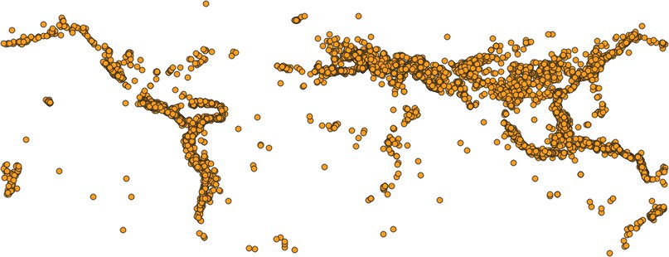PressADDandclosethewindow.
- Output:

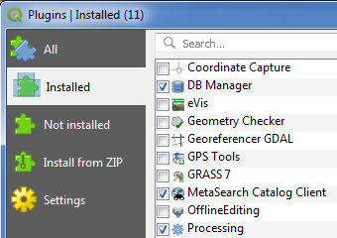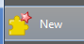
- UsingPlugins
- Coreplugins arealreadypart ofthe standardQGIS installation. To usethese, just enable them.
- OpenQGIS.ClickonPlugins→ManageandInstallPlugins....

- Toenablea plugin,checkon thecheckboxnexttoPlugin. Thiswill enabletheplugin touseit.
- ExternalpluginsareavailableintheQGISPluginsRepositoryandneedto beinstalledbytheusers before using them.
- ClickonNotInstalledor InstallfromZIP.
- Oncethepluginisdownloadedandinstalled,youwillseeaconfirmationdialog.
- ClickonPlugins →<<newPluginName>>
- ThePluginifmarked Experimentalplugincanbeinstalled,fromSetting→checkon

or

- A tabwillbe addedto PluginManager Window.
- Clickon aplugin name and ClickInstall.

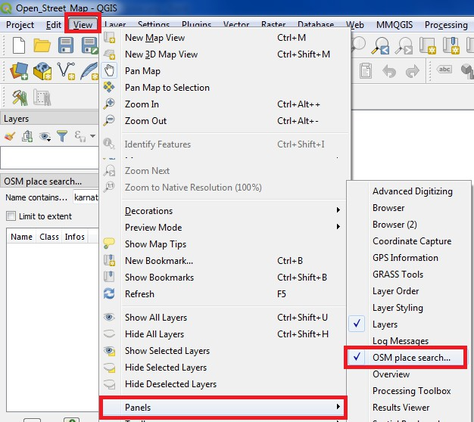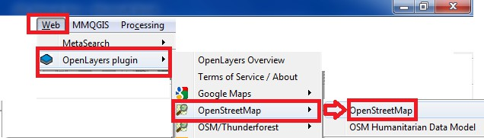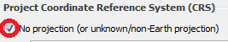
- SearchingandDownloadingOpenStreetMapData
OpenStreetMap (OSM) created by Steve Coast in the UK in 2004 is a collaborative project to create a free editable map of the world. Rather than the map itself, the data generated bythe project is considered its primary output. The creation and growth of OSM has been motivated by restrictions on use or availability of map information across much of the world, and the advent of inexpensive portable satellite navigation devices.
- Add“OpenLayer”and“OSMSearch”PluginfromNotInstalledoptionfromPluginManager Dialog Box.
- TheOSMPlaceSearchpluginwillinstall itselfasa PanelinQGIS,if notgoto View→Panels→
selectOSMPlace Search.

- GotoWeb→OpenLayerPluginandselectOpenStreetMap

- AWorldmap willappear on screen.
- Ifanerroroccurs inloadingmaps,gotoproject properties→CRS→

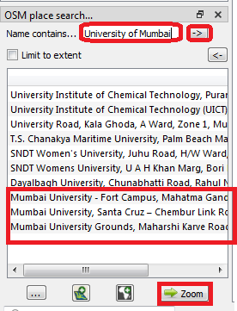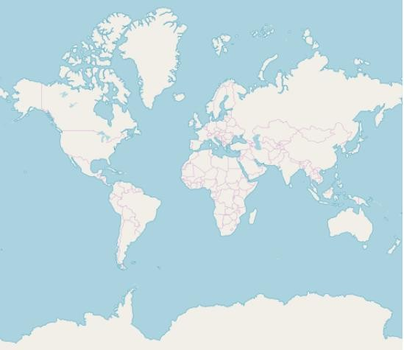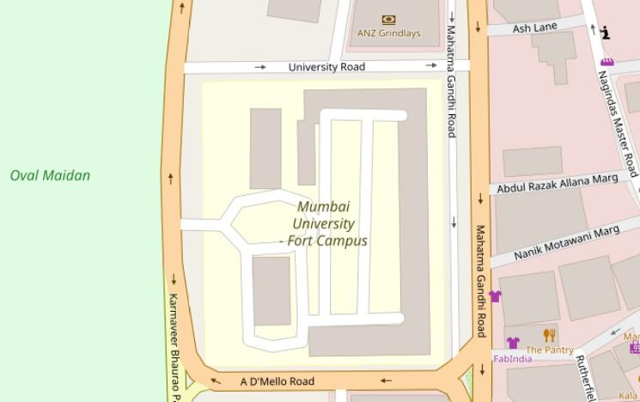

- InOSM Placesearch Pane→ EnterMumbai or anyplacenameto search
- Doubleclickonthedesired placeinOSMPlacesearch PanelorClickandpress
Output:

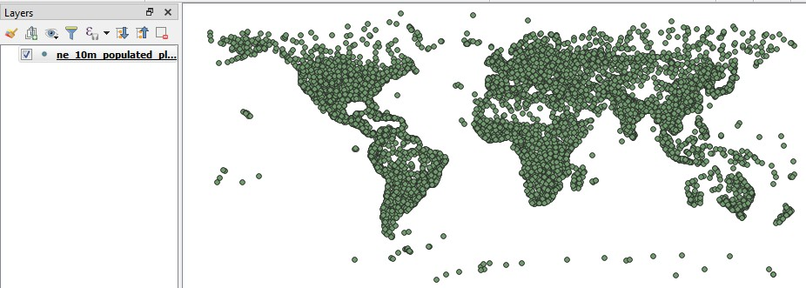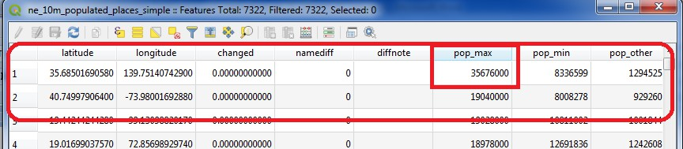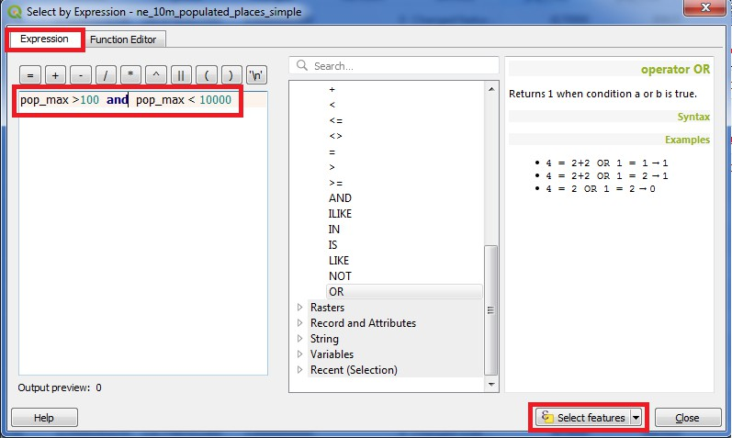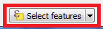PRACTICAL-4
A.Workingwith attributes
- Startanewproject.
- Goto Layer→ AddLayer →AddVector Layer
- Select“\GIS_Workshop\Practicals\Practical_04\A\Data\ne_10m_populated_places_simple.zip”

- Rightclickon Layerin LayerPanel→Open AttributeTable.
- Explorevarious attributesand theirvalues intheAttributetable.
- TofindthePlacewithmaximumpopulationclickon“pop_max” file

- OnclickingtheSelect featureusingexpression buttonthe followingwindow will appear.

- Enter pop_max>100 and pop_max<10000 and click buttontogetalltheplaceswith population between 100 and 10000.

- 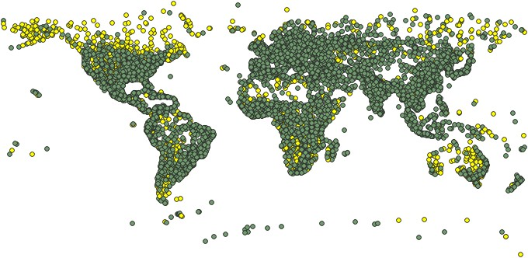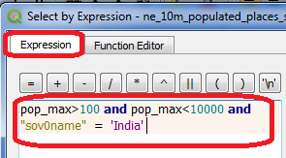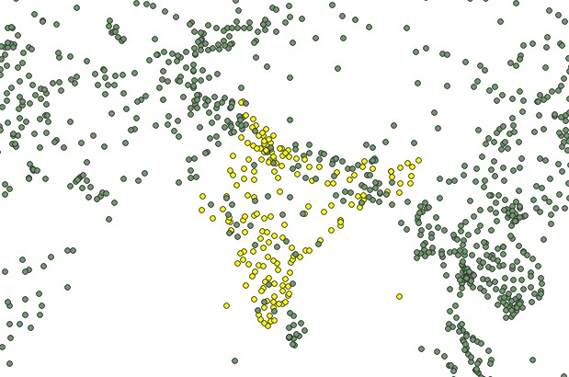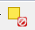Theplacesmatchingthe criteriawill appearindifferentcolor.

- Differentqueries canbe performedusingthedataset.
- Try this

Willgive

- Usethedeselect button todeselectthe featuretoberenderedinoriginalcolor.

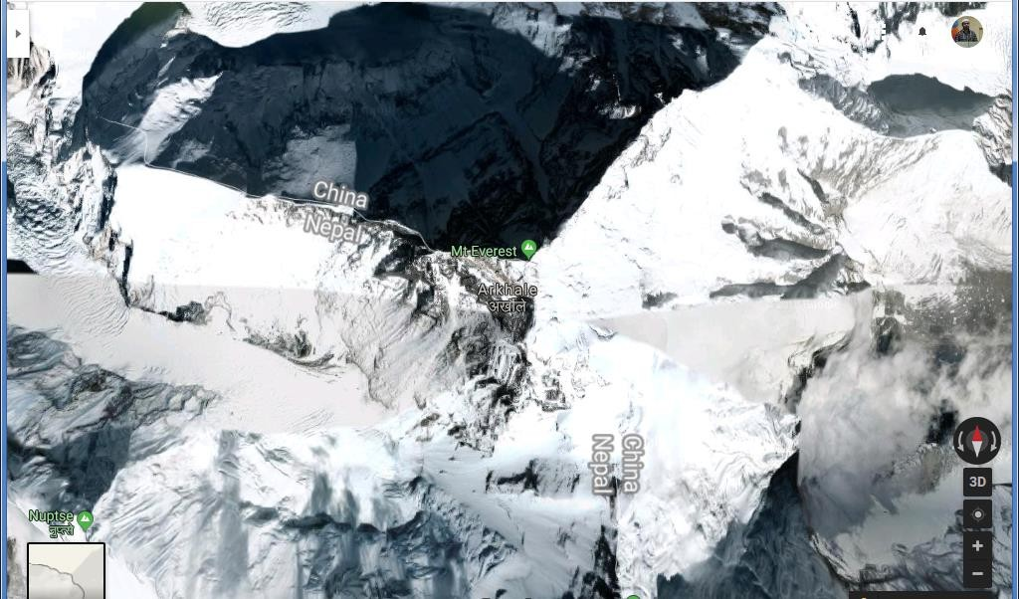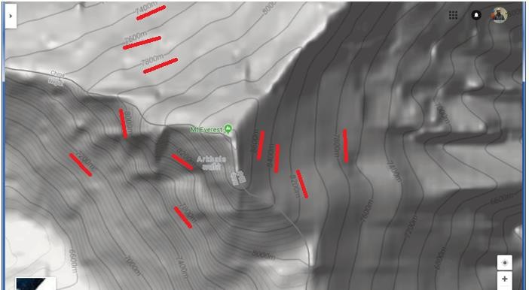
- TerrainDataandHillshadeanalysis
Aterraindatasetisamultiresolution,TIN-basedsurfacebuiltfrommeasurementsstoredasfeatures in a geodatabase.Terrain or elevation data is useful for many GIS Analysis like, to generate various products from elevation data such as contours, hillshade etc.

https://www.google.com/maps/@27.9857765,86.9285378,14.75z/data=!5m1!1e4?hl=en-US
  - GotoLayer→AddRasterLayer→select“10n060e_20101117_gmted_mea300.tif”,from Data folder

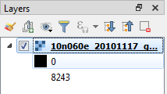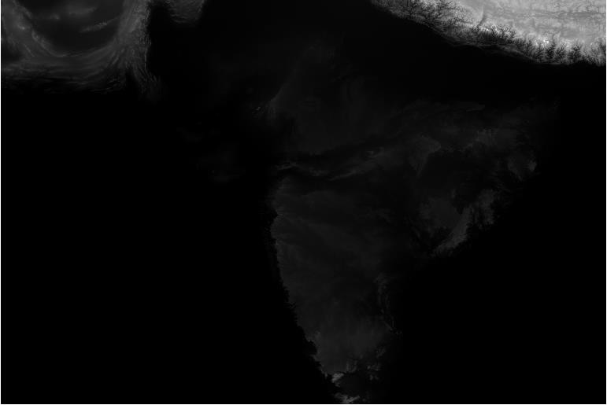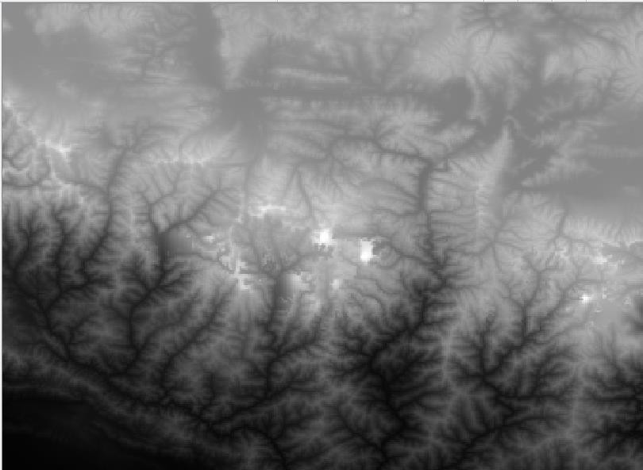

  - TheLoweraltituderegionsareshownusingdarkcolorandhigherusinglightshadeasseenon top region containing Himalaya and Mt Everest.
  - Mt.Everest-islocatedatthecoordinates27.9881° N,86.9253° E.
  - Enter86.92,27.98inthecoordinatefield,Scale900000andMagnifier100%atthebottomof QGIS.

  - PressentertheviewportwillbecenteredonHimalaya Region.

  - Croptherasterlayer onlyforthe region under study.
  - Goto Raster→Extraction→ Clip RasterbyExtent

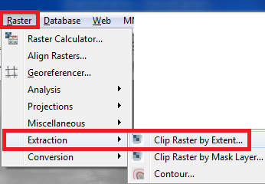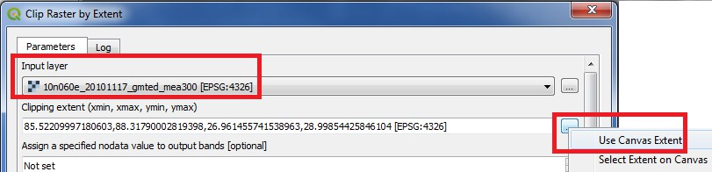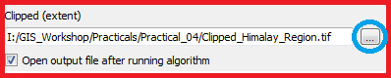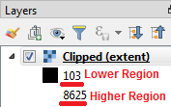

  - Selecttherasterlayer(ifprojectcontainsmultiplelayers).
  - Selecttheclippingareabyselectingtheoption UseCanvasExtendsifthevisiblepartofmap is to be selected or manually select an area on canvas by using Select Extent on Canvas.
  - Selectthelocationandfilenameforstoringclippedrasterlayer.

  - PressRUN.
  - Deselecttheoriginallayerandkeeptheclippedone.
  - TheClippedrasterlayeris representingaltitudearefrom103 Meters.

OriginalRaster ClippedRaster
  - Counter lines are the lines on a map joining points of equal height above or below sea level. A contourintervalinsurveyingistheverticaldistanceorthedifferenceintheelevationbetween the two contour lines in a topographical map.
  - Toderivecounterlinesfromgiven raster.
  - Goto Raster→ Extraction→Contour

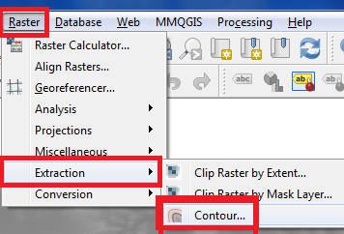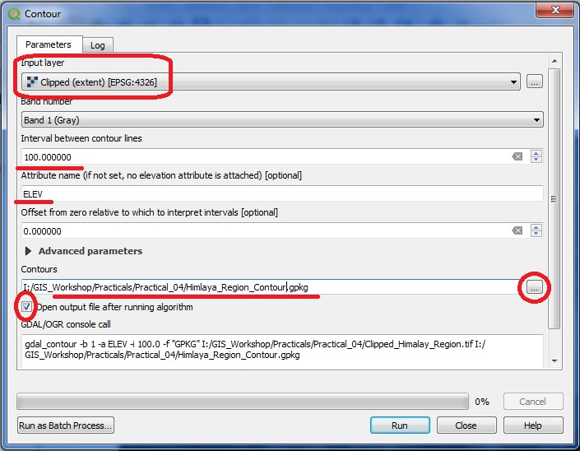

  - TheContourconfigurationwindowwillappear

  - Selecttheinputrasterlayername.Setcontourinterval100.00meters,selecttheoutputfile name & location and check the option to add output file to project after processing.
  - Press“RUN”.
  - Thecontourlayerwillappearlikethis

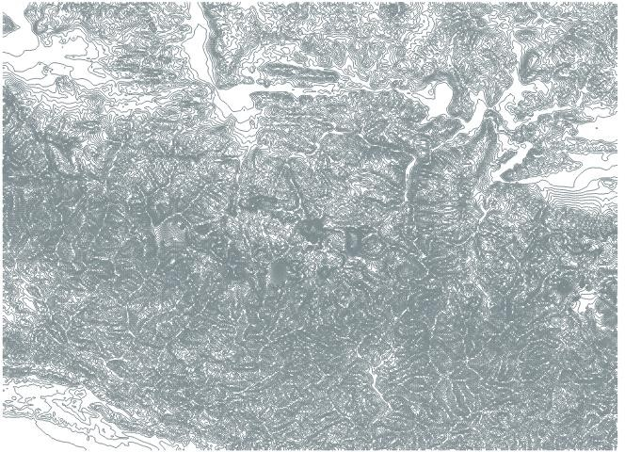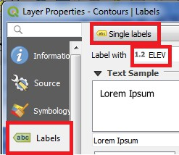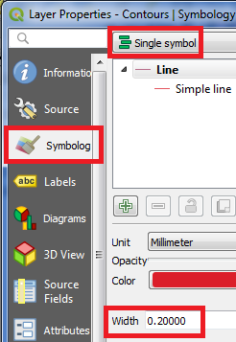

  - Labelthelayerusing“ELEV”fieldandsetappropriatesymbolsforline.

  - IntheLayerpanel right clickonContourRasterLayerandselect“OpenAttributetable”,
  - Arrangethe tablein descendingorder based onthevalueof “ELEV”column.
  - ​

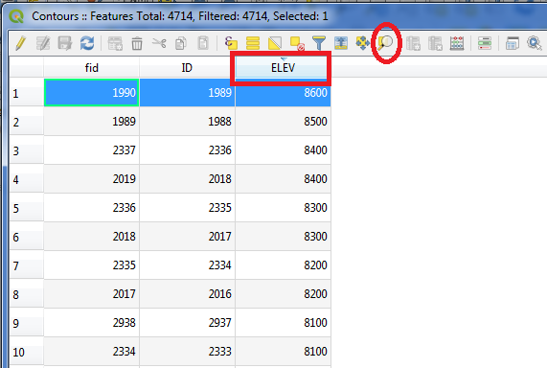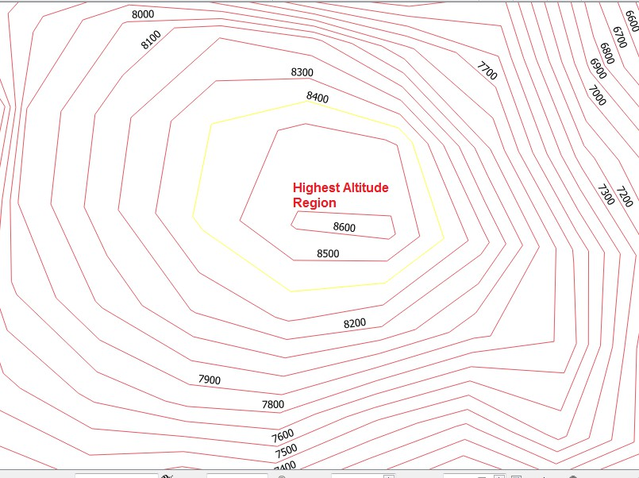

Comparetheabovecounterlinerasterlayer withthepreviousGooglemap imageor visit
https://www.google.com/maps/@27.9857765,86.9285378,14.75z/data=!5m1!1e4?hl=en-US
  - Toverifythe abovecontour files usingGoogleMap
  - Makeacopyof ContourLayer,Go toLayer →SaveAs
  - Selectfileformat as“KeyholeMarkup Language”,setfilename,locationandLayerName.
  - Also set CRStoWGS 84EPSG:4326

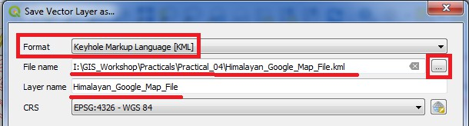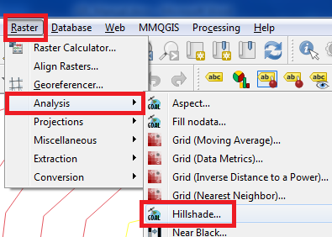

  - GotothestoredlocationonHardDiskandopenthe“Himalayan_Google_Map_File.kml”with Google Map.\

A Hillshade is a grayscale 3D representation of the surface, showing the topographical shape of hills andmountainsusingshading(levelsofgray)onamap,justtoindicaterelativeslopes,mountainridges, not absolute height.
  - ForHillShadesurfaceanalysis
  - GotoPlugin→ InstallGeoreferencerGADL.
  - AftersuccessfulinstallationofpluginGotoRaster→Analysis →Hill Shade

    - Selecttheinputrasterlayer, selectfilename andlocationfor storingHillShadeoutput file.

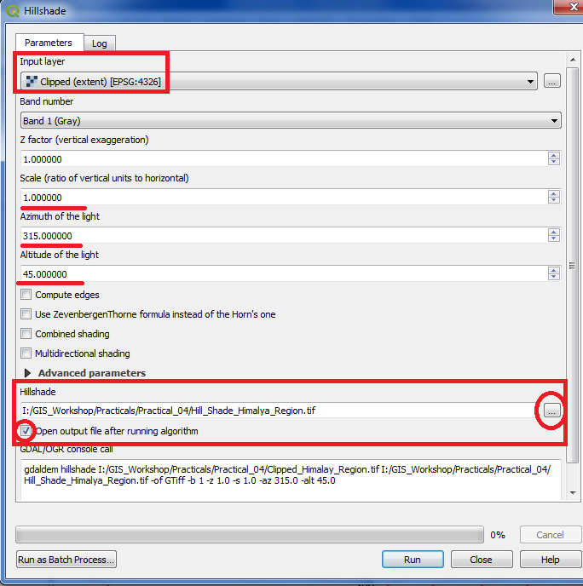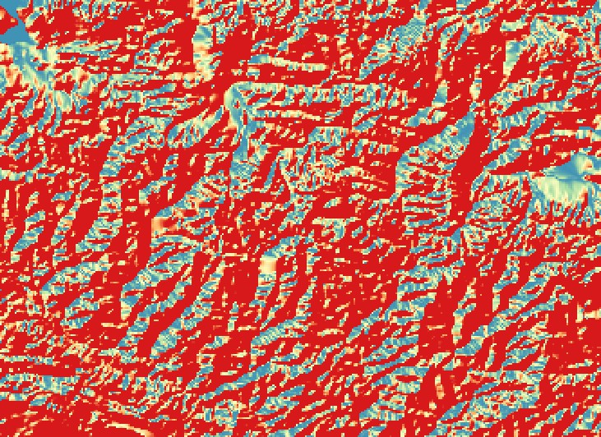

    - Press“RUN”andClosetheHillShapeDialogwindow.
    - AfterRasterstylingtheOutputwill appearlikethis.

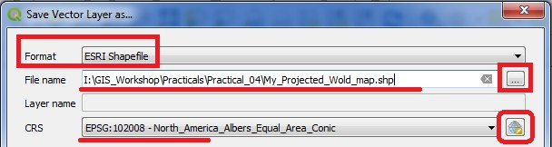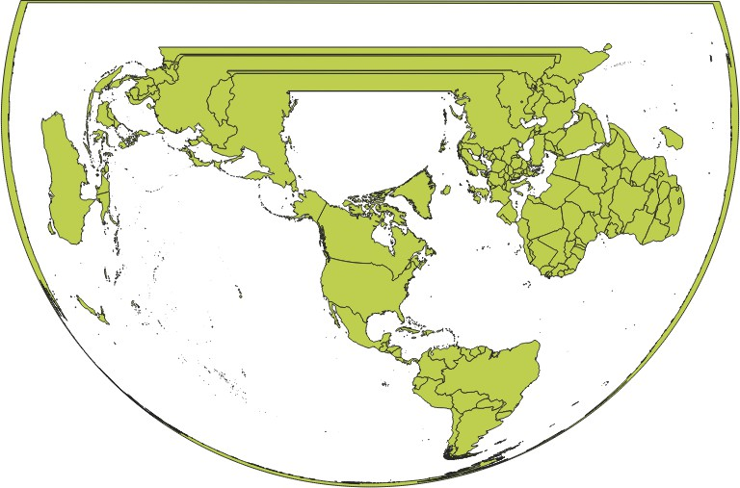PRACTICAL-5
WorkingwithProjectionsandWMSData
A Web Map Service (WMS) is a standard protocol developed by the Open Geospatial Consortium in 1999forservinggeoreferencedmapimagesovertheInternet.Theseimagesaretypicallyproducedbya map server from data provided by a GIS database
    - StartanewProject.
    - Layer→AddLayer→Vector Layer
    - Select“ne_10m_admin_0_countries.zip”Layerfromdata folder.
    - GotoLayer→SaveAs
Select format as ESRI Shape File Selectfolderlocationandfilename
SetCRSNorth_America_Albers_Equal_Area_ConicEPSG: 102008

    - Press“OK”.
    - Deselecttheoriginal Imageandkeeptheprojectedlayervisible.

    - SelectLayer→AddLayer→AddRasterLayer →SelectMiniScale_(standard)_R17.tiffrom Location

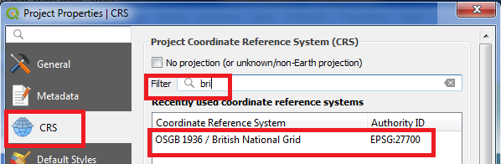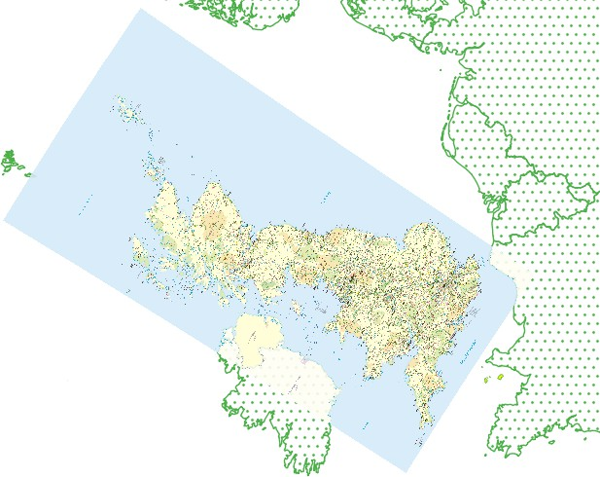“GIS_Workshop\Practicals\Practical_05\DATA\minisc_gb\minisc_gb\data\RGB_TIF_compres sed\MiniScale_(standard)_R17.tif”
    - TheLayerappearsonadifferentlocationthanthelocationwhereGreatBritainisshownon Map.

    - Open LayerProperties→CRS→Searchbri→selectBritishNationalGrid EPSG27700.
    - Processingmaytakesometime.
    - LocateUnitedKingdomon Layer;thevectorlayerexactlycoincidesbytherasterlayer covering United Kingdom.

    - Georeferencing

PRACTICAL-6

      - 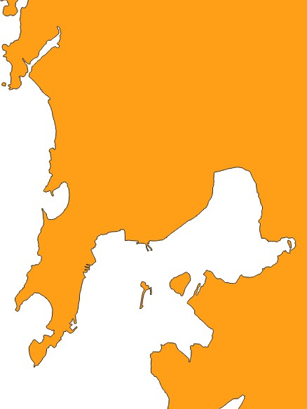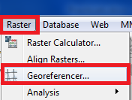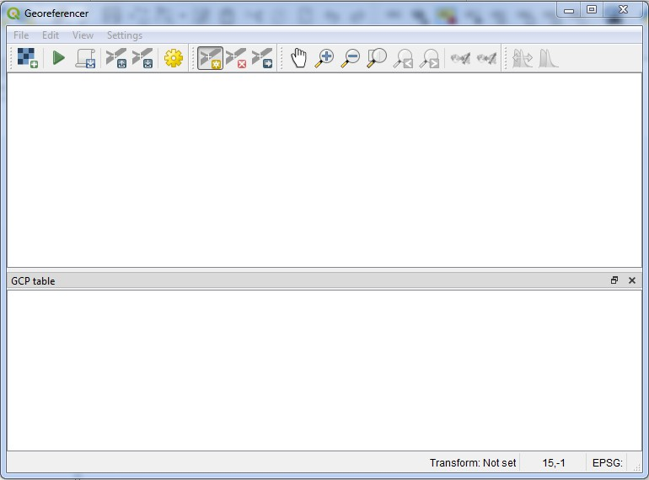GeoreferencingTopoSheetsandScannedMaps
  - Startanewproject
  - Goto Layers→ AddLayer →Addvector Layer
  - SelectGIS_Workshop\Manual\Prac06\IND_adm0.shp
  - ZoomintoMumbairegioninthelayer.

  - GotoPlugins→Manageand InstallPlugins
  - Ensurethat ischecked,ifnotinstallGeoreferencerGDALplugin.
  - Goto Raster→Georefrencer

  - AnewGeoreferencerwindowwillopen

  - File→OpenRaster

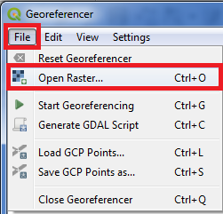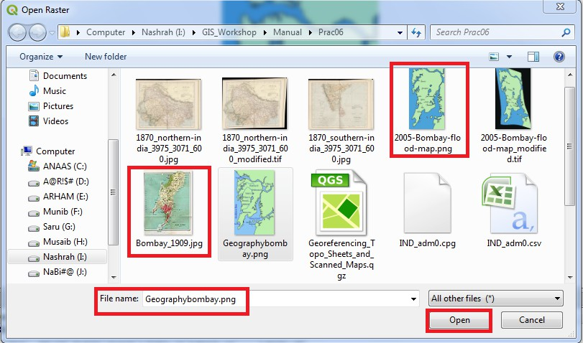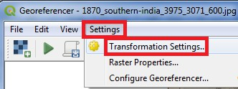

  - Selectfile“1870_southern-india_3975_3071_600.jpg”fromprojectdatafolder

  - GotoSettings→TransformationSettings

  - IntheTransformationSettings window

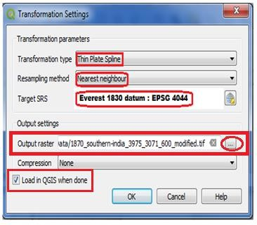 | - SelectTransformationtype→ThinPlate Spline  - Re-samplingMethod→ NearestNeighbour  - TargetTRS→Everest1830datum:EPSG 4044  - SelectOutputRasterNameandLocation  - ChecktheLoadinQGISWhenDone Option  - Press“OK”.
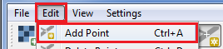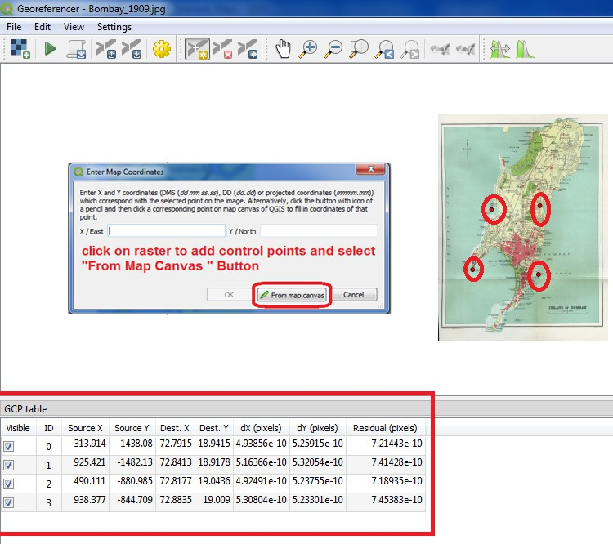

  - In Georeferencerwindow GotoEdit→ AddPoints

  - Selectthesetofcontrol points.
  - Goto,Setting→transformation settings.

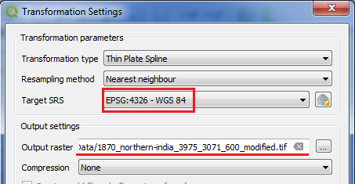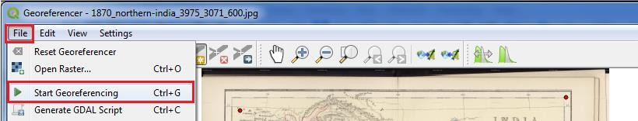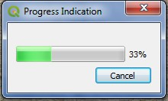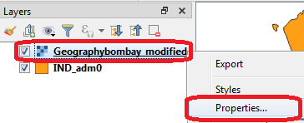

  - Press“RUN”
  - InGeoreferencingwindowgoto→ File→StartGeoreferencing

  - Theprogressindicatorwill appear

  - ThecanvasareawillnowhavethescannedmapofMumbaireferencedwithcontrol points.
  - Selectthenewlyaddedlayer inLayerPanelRightclickandgotoproperty.

  - SetTransparencylevel ofrasterlayer toappropriate level.

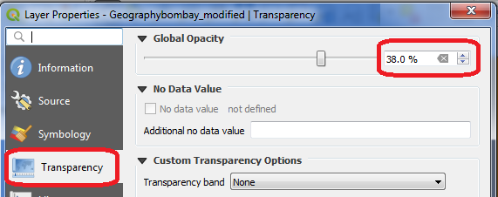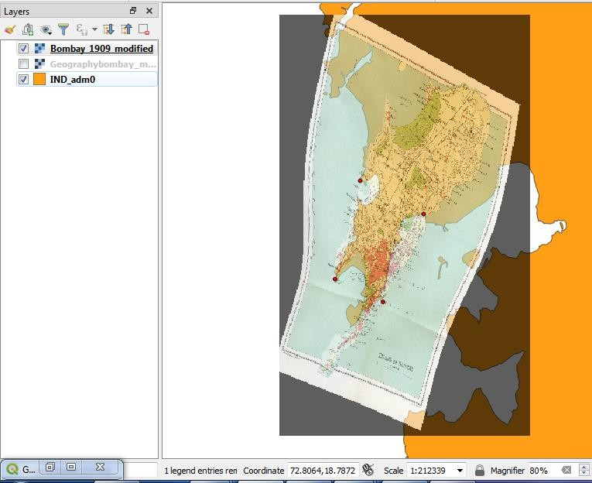

Output:

  - TheScannedImagemapcoincideswiththeexisting map.

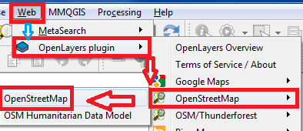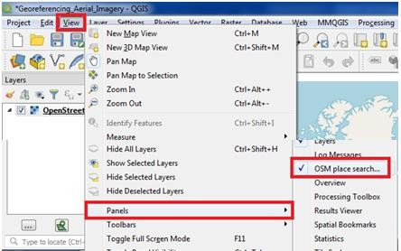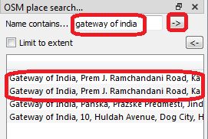
      - GeoreferencingAerialImagery
    - Installplugin OpenStreetMap
    - GotoWebMenu→OpenLayerPlugin →OpenStreetMap→OpenStreetMap

    - GotoProject→Properties →SetCRStoEPSG 3857
    - GotoView→Panels →selectOSMPlacesearch

    - TheGatewayofIndia, Mumbai is located at 18.92°N72.83°E
    - SearchGatewayof India inOSMSearchPanel

    - Zoomintoappropriatelevel.
    - Themap willappear likethis

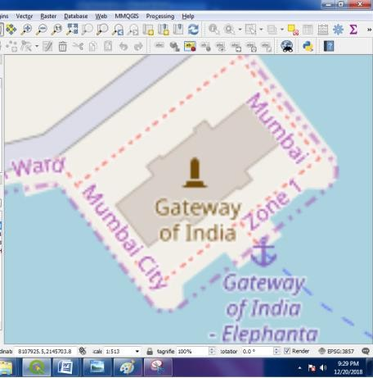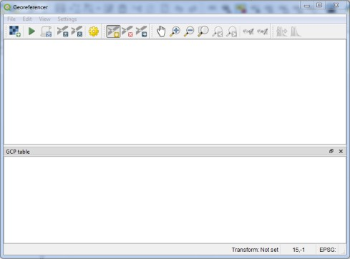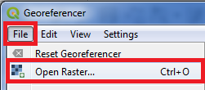

    - Goto Raster→Georefrencer

    - AnewGeoreferencerwindowwillopen

    - File→OpenRaster

    - Selectfile“Gateway_Imagery.tif”fromprojectdatafolder

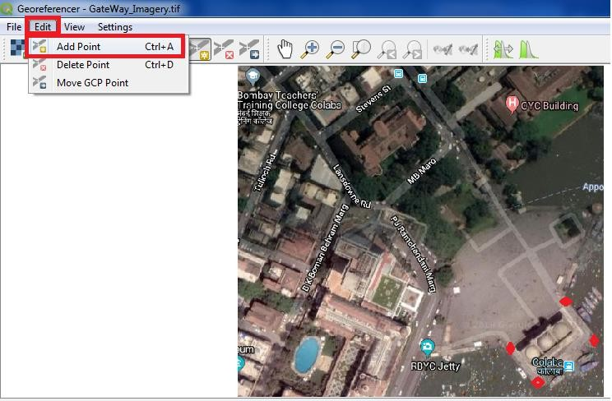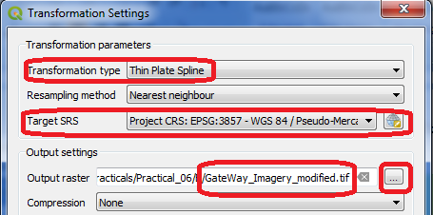

    - Go to Edit → Add Point
    - Selectcontrolpointsfrommap(Indicatedinredcolor).

- GotoSetting→Transformation Setting

- GotoFile→ StartGeoreferencingorPress the buttoninGeoregerencing Window.
- Theprogressindicatorwill appear

- 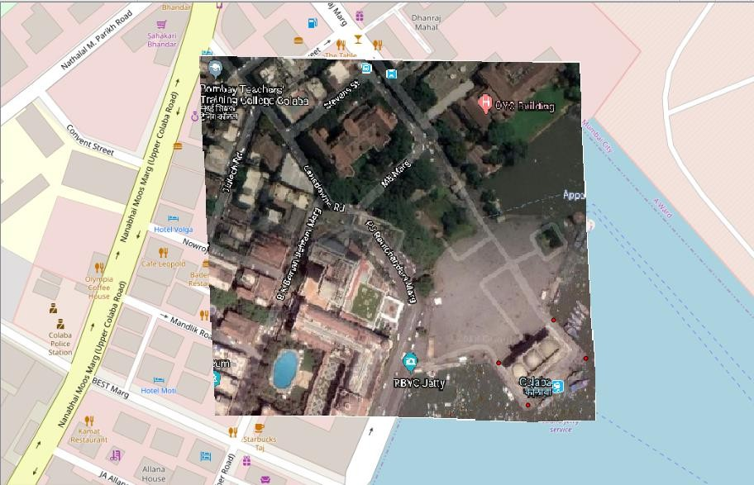ObservethattheaerialimageoftheGatewayofIndiaisgeoreferencedon OSMinthemap canvas.

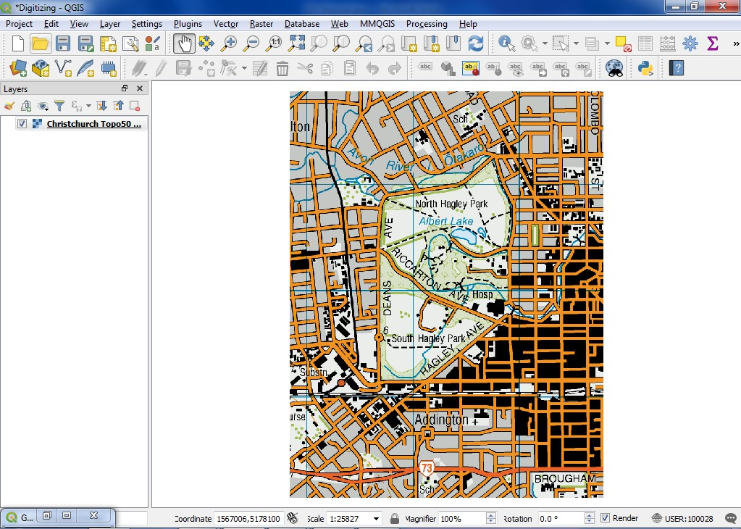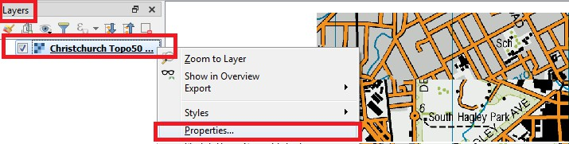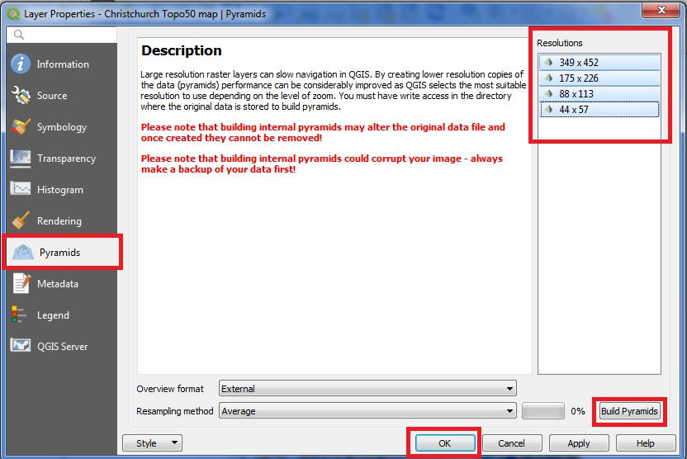
C.DigitizingMapData
Spatialite is an open database format similar to ESRI's geodatabase format. Spatialite database is contained within a single file on your hard drive and can contain diferent types of spatial (point, line,polygon)aswellasnon-spatiallayers.Thismakesismucheasiertomoveitaroundinsteadof a bunch of shapefiles.

DigitizingMap Data
- Goto Layer‣AddRaster→Select“ChristchurchTopo50map.tif”fromprojectFolder.

- QGISoffers asimple solution to makerasterloadmuch fasterbyusingImagePyramids.
- Right-clicktheChristchurchTopo50map.tiflayerandselectProperties.

- ChoosethePyramidstab.HoldtheCtrlkeyandselectalltheresolutionsofferedinthe Resolutions panel.

- 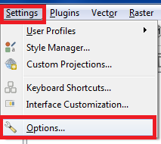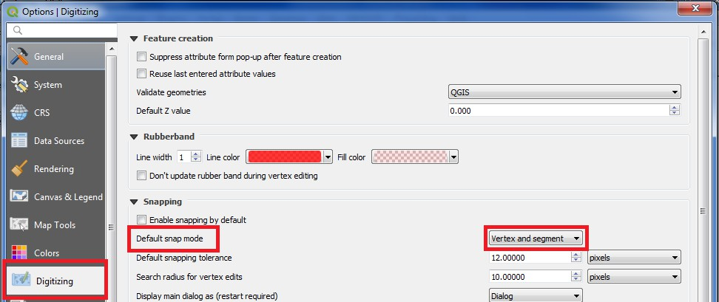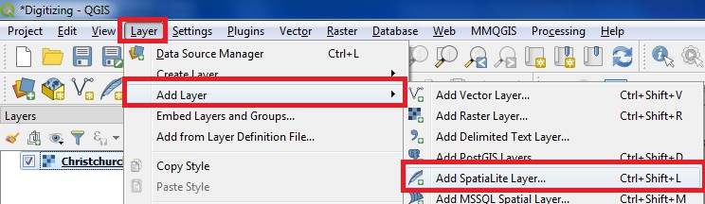ClickBuildpyramids.ThenclickOK.
- GotoSettings→Options SelecttheDigitizingtabin theOptions dialog.

- SettheDefaultsnapmodetovertex and segment.

- PressOK.

- GotoLayer→Add Layer→AddSpatialite Layer.

- Select the name and location for Spatial database eg: “GIS_Workshop\Practicals\Practical_06\C\MySpatialDataBase.sqlite”.
- NametheLayeras “Digitized_Road
- SetGeometrytypeas“Line”
- SetCRSEPSG:4167 – NZGD2000

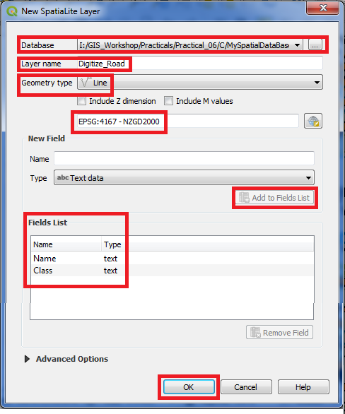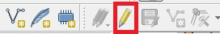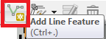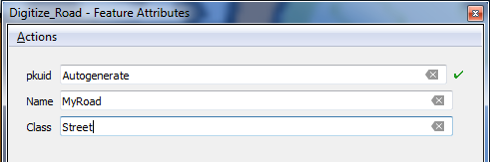

- Add“Name”and“Class”fieldsusing“AddtoFieldsList”.

- Oncethelayerisloaded,clicktheToggleEditingbuttontoputthelayerin editing mode.

- Click the Addfeaturebutton.Clickonthemapcanvastoaddanewvertex. Addnewverticesalongtheroadfeature.Once youhavedigitizedaroadsegment,right-clickto end the feature.

- OnLayerPanelRightClickonDigitze_Road,SelecttheStyletabintheLayerProperties dialog.

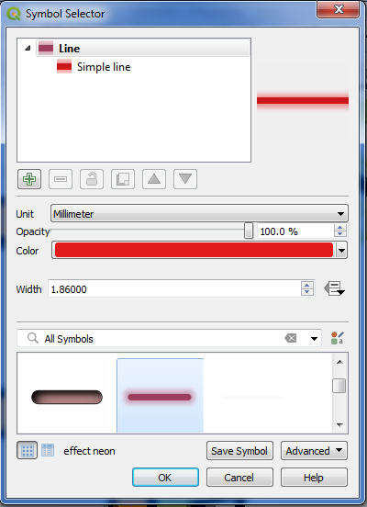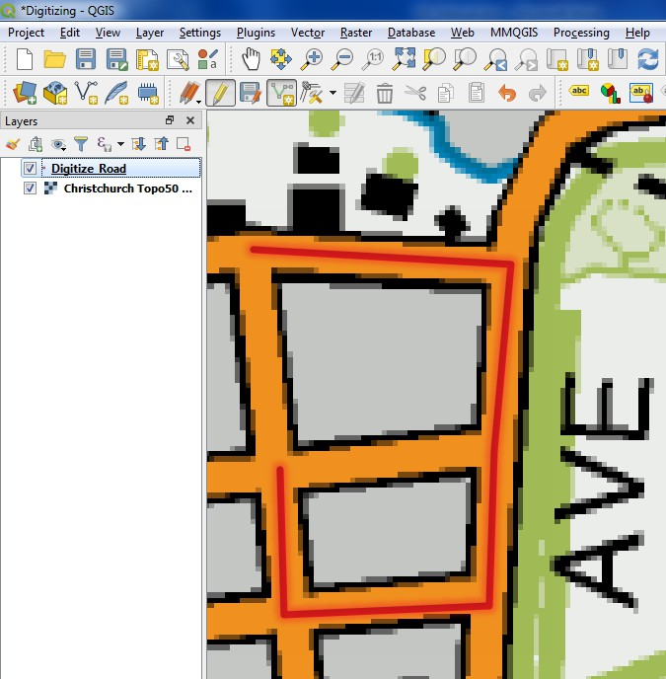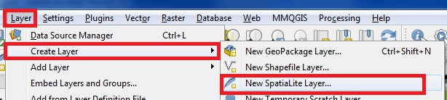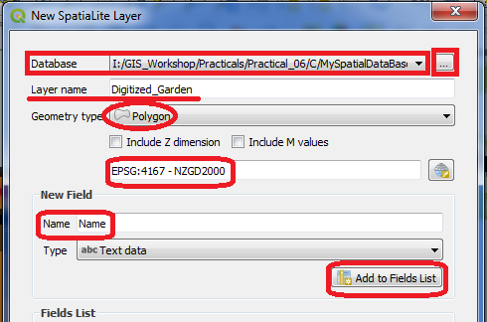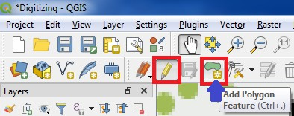

Result
- Selectappropriatestyletoseethedigitizedroadfeatureclearly.

- Aftercreatinganew Spatialite layer

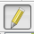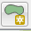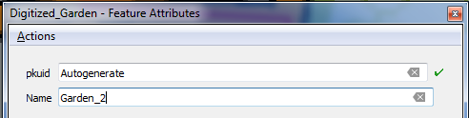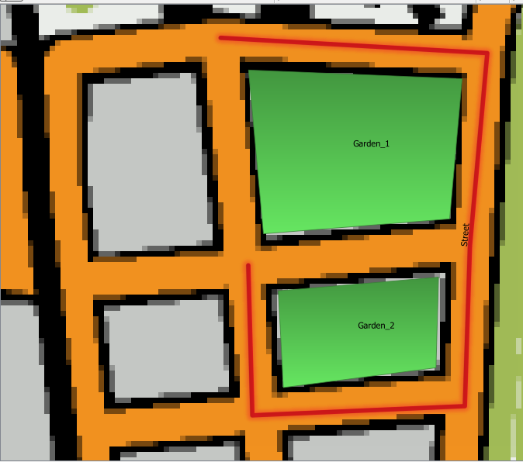

- Select Digitized_Garden layer in Layer Panel and click on Toggle Editing buttonand then Add Polygon Feature button on Tool bar.
- Addtwo gardensto theregionbyadding polygon.

- TheLayerwillappearon mapcanvas

- Usingtheaboveprocedureapoint feature can also bedigitized.
- Thedigitizingtaskisnowcomplete.Youcanplaywiththestylingandlabelingoptionsinlayer properties to create a nice looking map from the data you created.

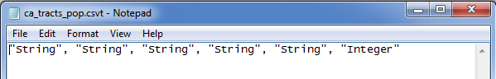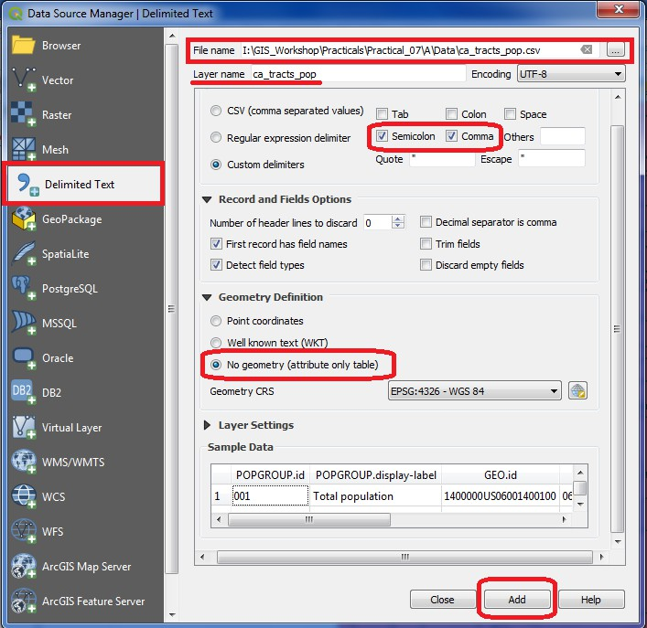PRACTICAL-7
ManagingDataTablesandSaptialdataSets:
- Tablejoins
- Startanewproject
- Go to Layer → Add Layer → Add new Vector Layer “I:\GIS_Workshop\Practicals\Practical_07\A\Data\tl_2013_06_tract.zip”
- Wecouldimportthiscsv filewithout anyfurther actionand itwouldbeimported. But,thedefault type of each column would be a String (text). That is ok except for the D001 field which contains numbers for the population. Having those imported as text would not allow us to run any mathematical operations on this column. To tell QGIS to import the field as a number, we need to create a sidecar file with a .csvt extension.

- Thisfilewillhaveonly1rowspecifyingdatatypesforeachcolumn.Savethisfileas ca_tracts_pop.csvt in the same directory as the original .csv file.
- GotoLayer→Add Layer→AddDelimitedTextLayer
AndaddI:\GIS_Workshop\Practicals\Practical_07\A\Data\ca_tacts_pop.csv”

- Inthelayerpanel,Rightclickon“tl_2013_06_tract”,layer andselectProperties

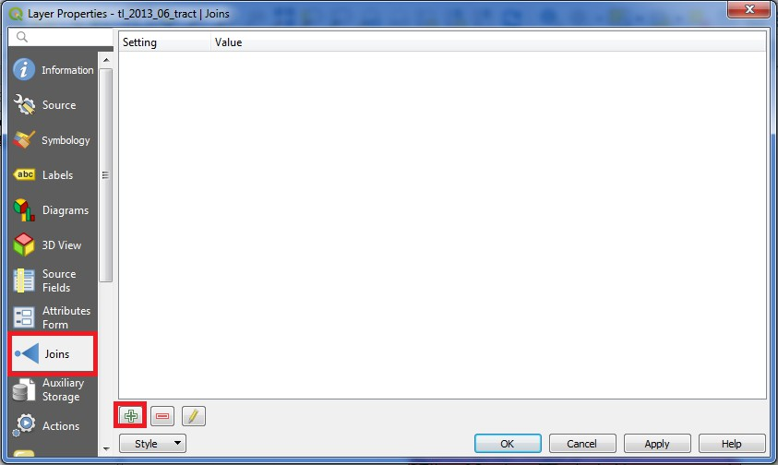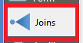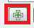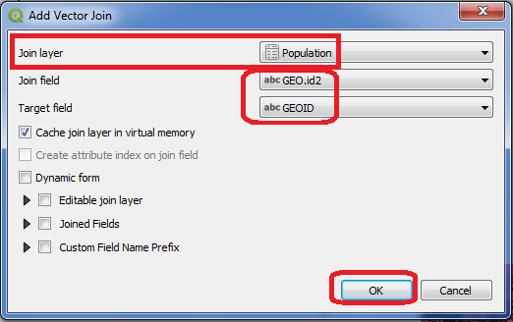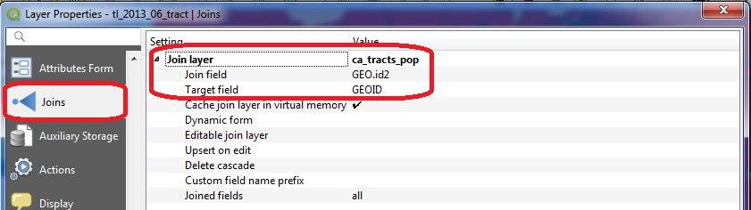

- Selectthe optioninProperties,andclickon buttontoadd newtable join.
- Inthe Add VectorJoinwindow setthefollowingpropertiesandclick OK.

- Afterperformingjoin

- Formoreclearoutput,select“tl_2013_06_tact”fromLayerPanel,rightclickandselect properties. Go to Symbology and set the following properties.

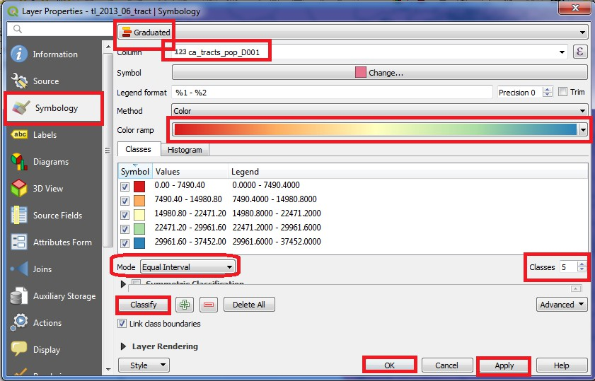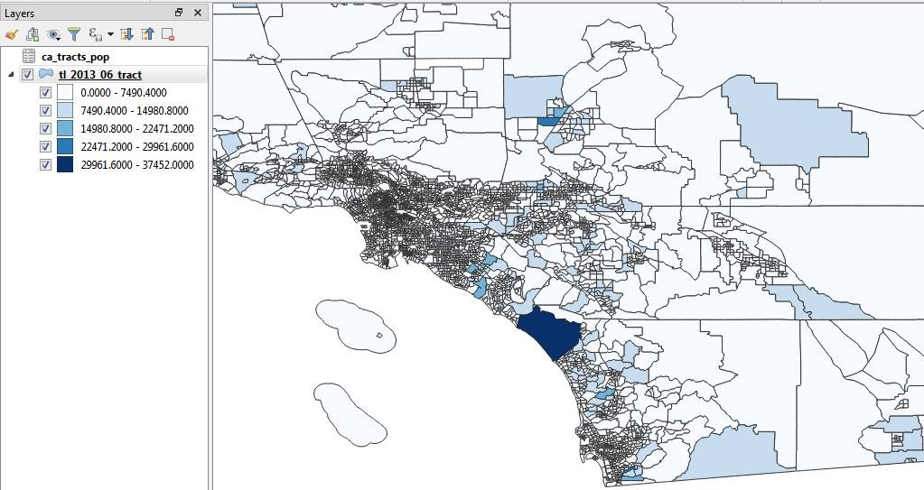

- AdetailedandaccuratepopulationmapofCaliforniacanbeseenastheresult.Sametechnique can be used to create maps based on variety of census data.

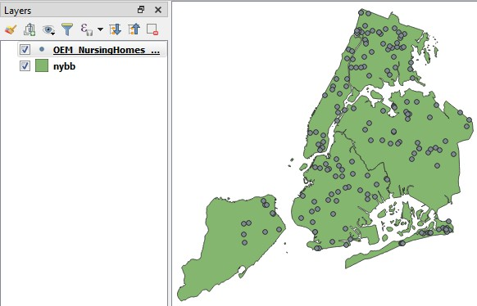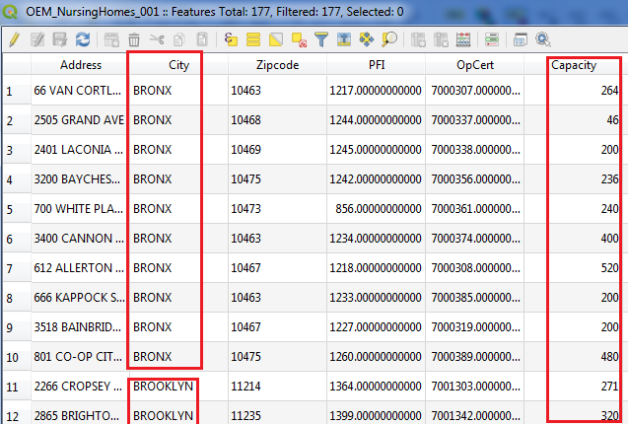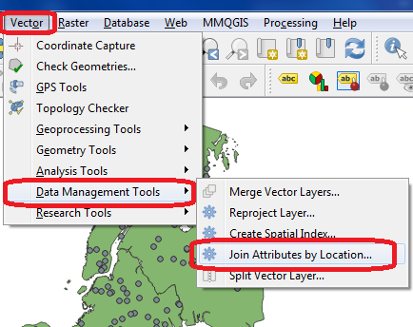
- spatialjoins
  - Go to Layer → Add Layer → Add Vector Layer → Select “I:\GIS_Workshop\Practicals\Practical_07\B\Data\nybb_12c\nybb_13c_av\nybb.shp”and “I:\GIS_Workshop\Practicals\Practical_07\B\Data\OEM_NursingHomes_001\OEM_NursingHo mes_001.shp”, from data folder.

- Goto attributetableandobservethe data.
- TablebeforeperformingJoin

- Goto Vector→ Data ManagementTools→ JoinAttributes byLocation

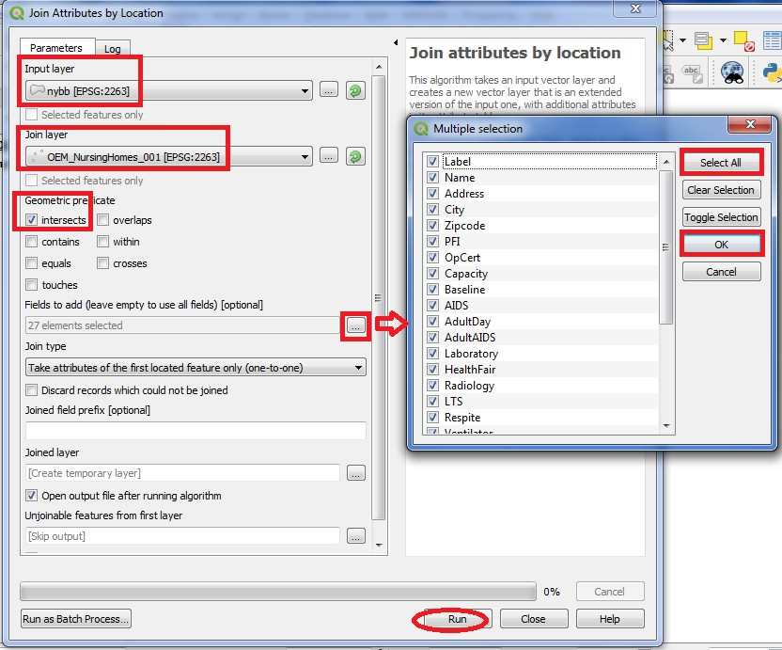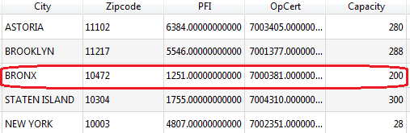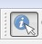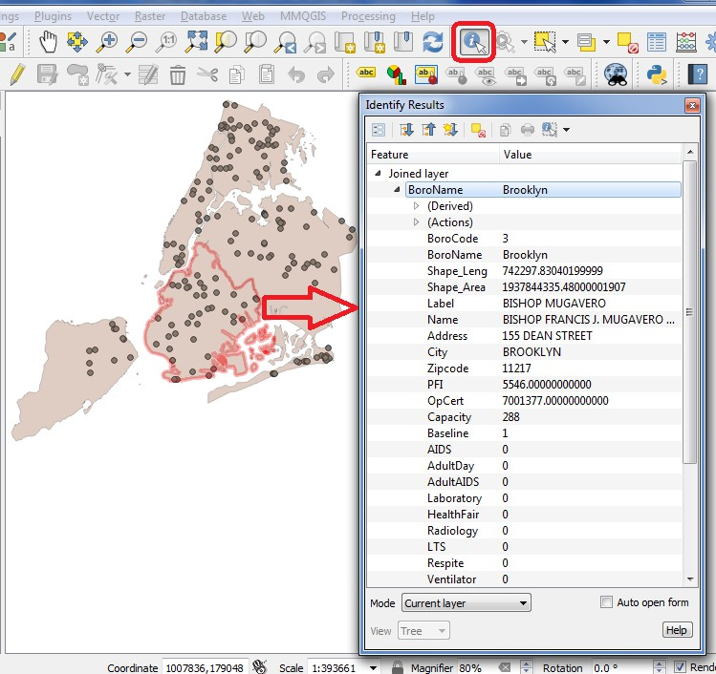

- Attributetableafterjoin

- UsetheIdentifyFeature ButtontoselectaregiontoviewjoindataonmapLayer.
- Output

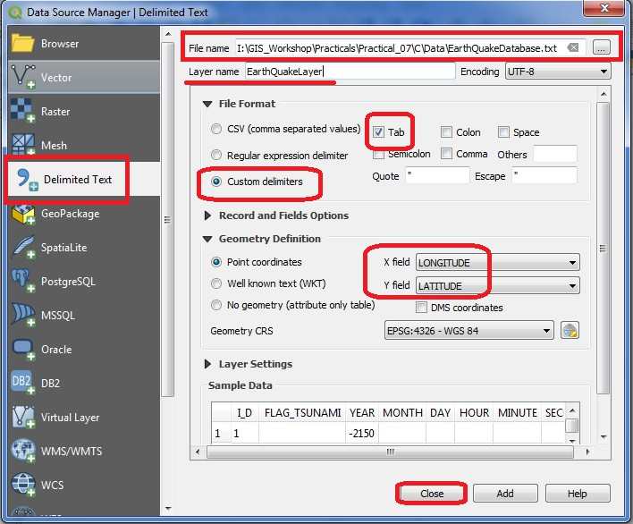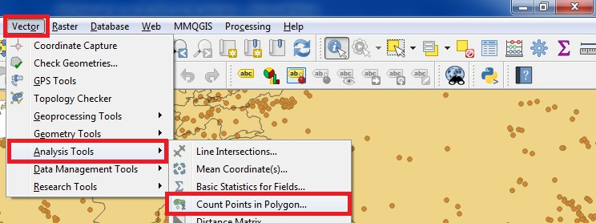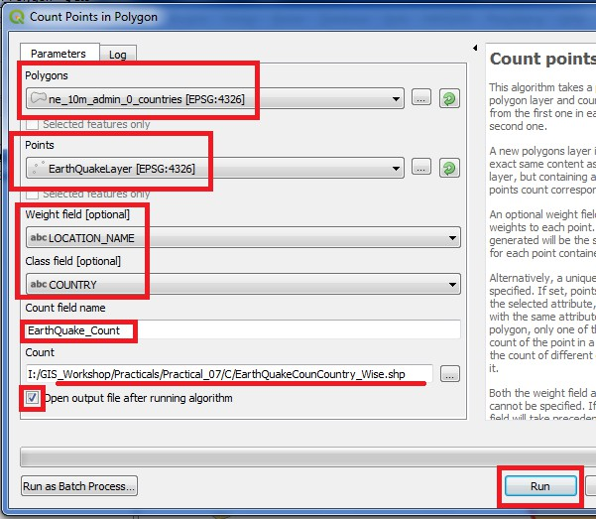
- Pointsinpolygonanalysis
- GotoLayer→AddLayer→AddDelimitedTextLayer Select “EarthQuakeDatabase.txt”

- Go to Layer → Add Layer → Add Delimited Text Layer “I:\GIS_Workshop\Practicals\Practical_07\C\Data\ne_10m_admin_0_countries.zip”

→

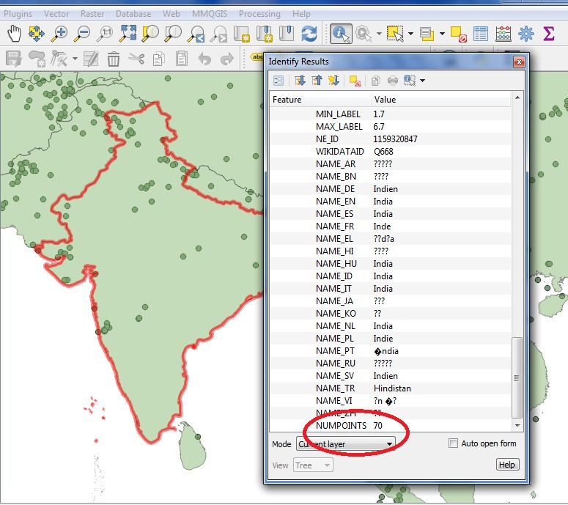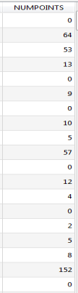

- Usetheselect Feature buttonto checkcountrywise countingofEarthquakes.

- Alsoanewcolumnisaddedtoattributetable“NumPoints”indicatingnumberofearthquake points in each country

