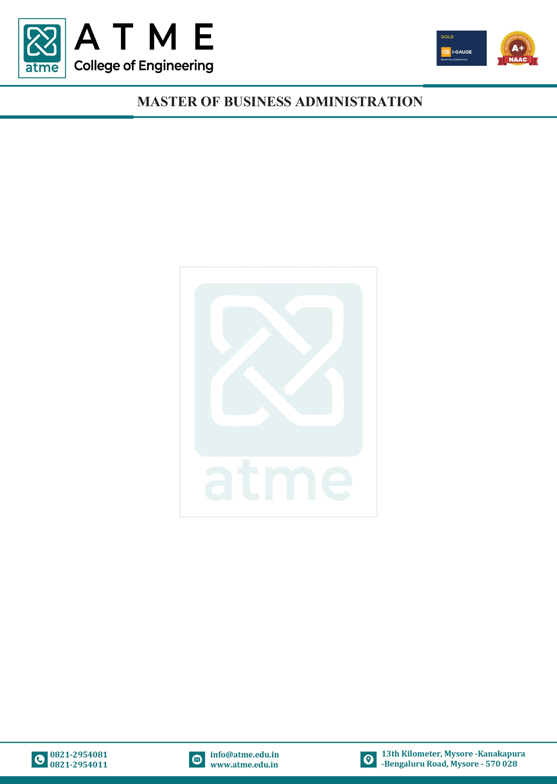

COURSE MODULE: MARKETING MANAGEMENT
Course Coordinator: Dr. Oscar Abhishek |  |  |  | Academic Year: 2025-26
Department: Master of Business Administration
Course Code | Course Title | Core/Elective | Prerequisite |  | Contact Hours | Total Hrs./ Sessions
 |  |  |  |  | L: T: P | Total Hrs./ Sessions
MBA105 | Marketing Management | Core | - |  | 4:0:0 | 50
Course Learning Objective:
- To make students understand the fundamental concepts of marketing and environment in
which marketing system operates.
- To gain knowledge on consumer buying behaviour and influencing factors
- To describe major bases for segment marketing, target marketing, and market positioning.
- To develop a Conceptual framework, covering basic elements of the marketing mix.
- To understand fundamental premise underlying market driven strategies and hands on
practical approach.
Teaching-Learning Process (General Instruction):
- Deliveries of theoretical concepts, models, processes etc., through Power Point presentations, chalk n Talk and Video demonstrations.
- Analyze and solve Case Studies from the real world in order to enable the application of theoretical knowledge to practical situations.
- Organize industry visits, special talks by experts from industry, workshops etc., to gain insights into the current trends, challenges, requirements and best practices in the industry
- Gain conceptual understanding through group discussions, simulations, seminars etc.;
Module-1
Introduction to Marketing: Importance of marketing, Definitions of market and marketing, Types
of Needs, Elements of Marketing Concept, Functions of Marketing, evolution of marketing,
Marketing V/s Selling, Customer Value and Satisfaction, 4P’s of Marketing, Marketing Environment,
Techniques used in environment analysis, Characteristics (Micro and Macro), Marketing to the 21st
Century customer.
TLP: Power Point Presentation, Video demonstration or simulations, Chalk and Talk
Module-2
Analysing Consumer Behaviour: Meaning and Characteristics, Importance of consumer behaviour,
Factors influencing Consumer Behaviour, Consumer characteristics influencing buying behaviour
personal factors and cultural factors. Consumer Buying Decision Process, Buying Roles, Buying Motives. The black box model of consumer behaviour. Psychological factors consumer.
TLP: Power Point Presentation, Video demonstration or simulations, Chalk and Talk and Case Study analysis
Module-3
Product management and Pricing: Importance and primary objective of product management,

product levels, product hierarchy, Classification of products, product mix, product mix strategies,
Managing Product Life Cycle. New Product Development, packing as a marketing tool, Role of
labeling in packing. Concept of Branding, Brand Equity, branding strategies, selecting logo, brand
extension- effects. Introducing to pricing, Significance of pricing, factor influencing pricing (Internal
factor and External factor), objectives, Pricing Strategies-Value based, Cost based, Market based,
Competitor based, Pricing Procedure.
TLP: Power Point Presentation, Video demonstration or simulations, Chalk and Talk, Industry Visits and Case Study analysis
Module-4
Distribution and Promotion: Roles and purpose of Marketing Channels, Factors Affecting Channel
Choice, Channel Design, Channel Management Decision, Channel Conflict, Designing a physical
Distribution System. Promotions- Marketing communications- Integrated Marketing Communications
(IMC)-communication objectives, steps in developing effective communication. Advertising:
Advertising Objectives, Advertising Budget, Advertising Copy, AIDA model, Traditional Vs Modern
Media- Online and Mobile Advertising, social media for Advertising. Push-pull strategies of
promotion.

TLP: Power Point Presentation, Video demonstration or simulations, Chalk and Talk, Simulations and Case Study analysis
Module-5
Market segmentation, Targeting and Brand Positioning: Concept of Market Segmentation,
Benefits, Requisites of Effective Segmentation, Bases for Segmenting Consumer Markets, Market
Segmentation Strategies. Types of Segmentation. Targeting - Bases for identifying target Customer
target Marketing strategies, Positioning - Meaning, Tasks involved in Positioning. Monitoring brands
performance and positioning. Product Differentiation Strategies.
TLP: Power Point Presentation, Video demonstration or simulations, Chalk and Talk Video demonstration, topic presentations
Module-6
Emerging Trends in Marketing: Marketing Planning. Concepts of B2B marketing, Service
Marketing, Digital and social media Marketing, Green Marketing, Event Marketing, Marketing Audit,
Sponsorship, Cause Related Marketing, Marketing for Non-Profit Organizations, Relationship
marketing, Marketing Strategies for Leaders, Challengers, Followers and Startups. Social
Responsibility of marketing, Neuro Marketing, Sensory Marketing, societal marketing concept,
premiumization.
TLP: Power Point Presentation, Video demonstration or simulations, Chalk and Talk Video demonstration.
Course Outcomes:
At the end of the course, the student will be able to:
CO1 Comprehend the concepts of Marketing Management. L1
CO2 Gain knowledge on consumer behaviour and buying process
CO3 Understand concept of Product and Brand Management, Branding and Pricing strategies

CO4 Identify marketing channels and the concept of product distribution,
techniques of sales promotion
CO5 Simply ideas into a viable marketing plan for various modes of marketing

Assessment Details (both CIE and SEE)
The Weightage of Continuous Internal Evaluation (CIE) is 50% and for Semester End Exam (SEE) is
50%. The minimum passing marks for the CIE is 50% of the maximum marks. Minimum passing
marks in SEE is 40% of the maximum marks of SEE. A student shall be deemed to have satisfied the
academic requirements (passed) and earned the credits allotted to each course if the student secures
not less than 50% in the sum total of the CIE (Continuous Internal Evaluation) and SEE (Semester
End Examination) taken together.

Continuous Internal Evaluation:
1. Two Unit Tests each of 50 Marks (Will be reduced to 25 marks)
2. Two assignments each of 25 Marks or one Skill Development Activity of 50 marks
to attain the COs and POs
The sum of two tests, two assignments/Skill Development Activities, will be scaled down to 50 marks
CIE methods /question paper is designed to attain the different levels of Bloom’s taxonomy as per the outcome defined for the course.
Semester End Examination:
The SEE question paper will be set for 100 marks and the marks scored will be proportionately reduced to 50.
- The question paper will have 8 full questions carrying equal marks.
- Each full question is for 20 marks with 3 sub questions.
- Each full question will have sub question covering all the topics.
- The students will have to answer five full questions: selecting four full questions from
question number one to seven in the pattern of 3, 7 & 10 Marks and question number eight is
compulsory
List of Textbooks
Textbooks:
1. Marketing Management- Indian Context, Global Perspective by Ramaswamy & Namakumari
by SAGE publication, 6th Edition.
2. Marketing Management: A South Asian Perspective by Kotler, Keller, Koshy & Jha by
Pearson publication, Latest Edition.

Reference books:
- Marketing in India: Text and Cases by Neelamegham S by Vikas publication, Latest edition.
- Fundamentals of Marketing Management, Etzel M J BJ Walker & William J Stanton by Tata
McGraw Hill, Latest edition.
List of URLs, Textbooks, Notes, Multimedia Content, etc.
Weblinks:
links and Video Lectures (e-Resources):
• https://youtu.be/5fdx5Laavkc
• https://youtu.be/Ule8n6GgE1g
• https://youtu.be/ob5KWs3I3aY?t=131
• https://youtu.be/U1VWUHLhmdk
• https://youtu.be/iWuYUhSHXHg
• https://youtu.be/IErR_YYfP3Y
• https://youtu.be/mLV7MASrDlQ

