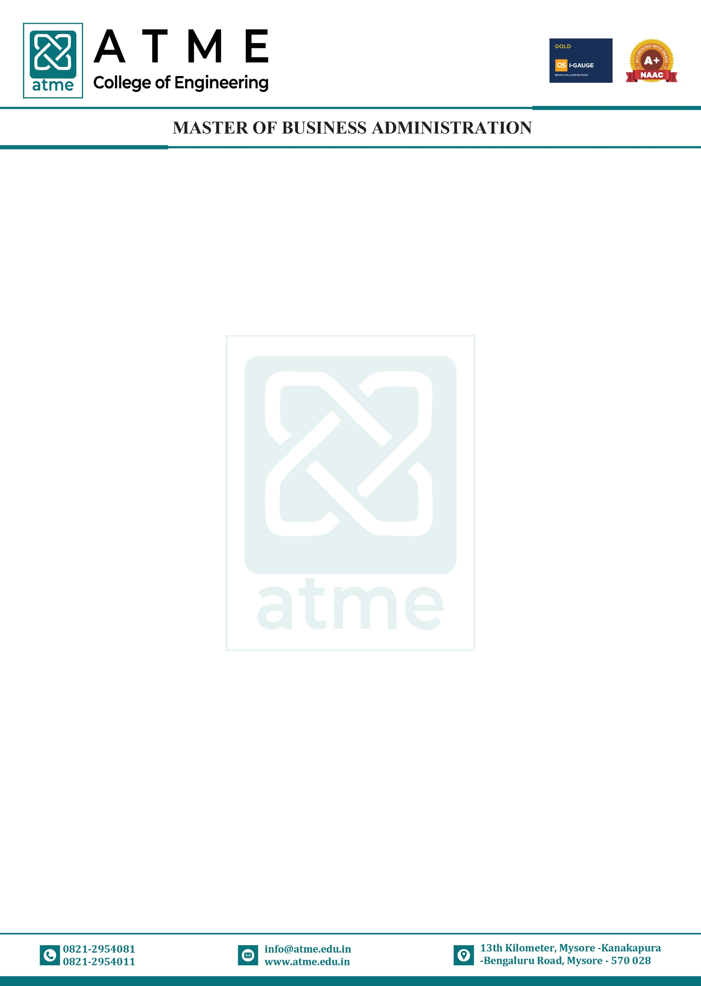

COURSE MODULE: CONSUMER BEHAVIOUR
Course Coordinator: Dr. Oscar Abhishek |  |  |  | Academic Year: 2025-26
Department: Master of Business Administration
Course Code | Course Title | Core/Elective | Prerequisite |  | Contact Hours | Total Hrs./ Sessions
 |  |  |  |  | L: T: P | Total Hrs./ Sessions
MBA MM313 | CONSUMER BEHAVIOUR | Core | - |  | 4:0:0 | 50
Course Learning Objective:
- To develop an understanding of consumer behaviour theories and apply this
understanding in a marketing decision making context.
- To identify the multitude of factors influencing consumers so that each of us will be able
to apply this knowledge to improve market strategy.
- To Create better marketing programs and strategies basing on the knowledge of consumer
behaviour.
Teaching-Learning Process (General Instruction):
- Deliveries of theoretical concepts, models, processes etc., through Power Point presentations, chalk n Talk and Video demonstrations.
- Analyze and solve Case Studies from the real world to enable the application of theoretical knowledge to practical situations.
- Organize industry visits, special talks by experts from industry, workshops etc., to gain insights into the current trends, challenges, requirements and best practices in the industry
- Gain conceptual understanding through group discussions, simulations, seminars etc.;
Module-1
Introduction to Consumer Behaviour: Meaning, Nature and Importance of Consumer Behaviour; Difference between Consumer & Customer; Nature & characteristics of Indian Consumers; Consumer Movement in India; Rights & Responsibilities of consumers in India; Consumerism: Meaning and benefits of consumerism. Consumer Research process.
TLP: Power Point Presentation, Video demonstration or simulations, Chalk and Talk
Module-2
Consumer Decision Making: Consumer Buying Decision Process, Levels of Consumer Decision Making – Four views of consumer decision making. On-line Decision Making: Meaning & Process/Stages. Situational Influences- Nature of Situational Influence, Situational Characteristics and consumption behaviour. Models of Consumer Behaviour: Input-Process-Output Model, Nicosia Model, Howard
Sheth Model, Engel-Kollat-Blackwell Models of Consumer Behaviour, Class Exercise: Conducting consumer experiments.
TLP: Power Point Presentation, Video demonstration or simulations, Chalk and Talk and Case Study analysis

Module-3
Individual Determinants of Consumer Behaviour: Perception: Process, Consumer Imagery, Perceived Risk. Learning: Principles and Theories Personality: Nature, Theories, Self Concept, Psychographic and Life Style. Attitude: Structural model of attitude, attitude formation & change. Motivation: needs/motives & goals, dynamic nature of motivation, Arousal of motives, theories.
Module-4
Group Determinants of Consumer Behaviour: Groups: Meaning and Nature of Groups, Reference Group Influence: Types of consumer relevant groups, factors affecting group influence, Application of reference group concept. Family: Functions of family, family
decision making, Family Life Cycle (FLC). Dynamics of husband-wife decision making, Opinion Leadership and Personal influence. Dynamics of opinion leadership process, Measurement of opinion leadership, Market Mavens, Opinion Leadership & Marketing Strategy, Creation of Opinion Leaders. Diffusion of Innovation: Adoption process, Diffusion process.
TLP: Power Point Presentation, Video demonstration or simulations, Chalk and Talk, Simulations and Case Study analysis
Module-5 (9 Hours)
Environmental Influences on Consumer Behaviour: Social Class: Social Class Basics, Social class and Social status, The dynamics of status consumption, Lifestyle profile of social class, Features of Social Class, Five Social-Class Categories in India. Culture: Basics, Meaning, Characteristics, Factors affecting culture, Role of customs, values and beliefs in Consumer Behaviour. Subculture: Meaning, Subculture division and consumption pattern in India, Types of subcultures. Cross Culture - Cross-cultural consumer
analysis - Cross-cultural marketing strategy: Cross-cultural marketing problems in India, Strategies to overcome cross-cultural problem.
Module-6
Customer Relationship Management: CRM Concepts - Acquiring customers, - Customer loyalty and optimizing customer relationships - CRM defined - success factors, the three levels of Service/ Sales Profiling - Service Level Agreements (SLAs), creating and managing effective SLAs. CRM in Marketing - One-to-one Relationship Marketing - Cross Selling & Up Selling - Customer Retention, Behaviour Prediction - Customer Profitability & Value Modelling, - Channel Optimization - Event-based marketing. - CRM and Customer Service -The Call Centre, Call Scripting - Customer Satisfaction Measurement.
TLP: Power Point Presentation, Video demonstration or simulations, Chalk and Talk Video demonstration.
Course Outcomes:
CO1: The students will be able understand the background and concepts of consumer behaviour
CO2: The students will be able to identify the dynamics of consumer behaviour and the basic factors that influence the consumers decision process
CO3: The students will be able to demonstrate how concepts may be applied to marketing strategy.
CO4: Students will be able to apply and demonstrate theories to real world marketing situations by profiling and identifying marketing segments.
Assessment Details (both CIE and SEE)
The weightage of Continuous Internal Evaluation (CIE) is 50% and for Semester End Exam (SEE) is 50%. The minimum passing marks for the CIE is 50% of the maximum marks. Minimum passing marks in SEE is 40% of the maximum marks of SEE. A student shall be deemed to have satisfied the academic

requirements (passed) and earned the credits allotted to each course if the student secures not less than 50% in the sum total of the CIE
(Continuous Internal Evaluation) and SEE (Semester End Examination) taken together.
Continuous Internal Evaluation:

1. Two Unit Tests each of 50 Marks (Will be reduced to 25 marks)
2. Two assignments each of 25 Marks or one Skill Development Activity of 50 marks to attain the COs and POs The sum of two tests, two assignments/Skill Development Activities, will be scaled down to 50 marks
CIE methods /question paper is designed to attain the different levels of Bloom’s taxonomy as per the outcome defined for the course.
Semester End Examination:
The SEE question paper will be set for 100 marks and the marks scored will be proportionately reduced to 50.
- The question paper will have 8 full questions carrying equal marks.
- Each full question is for 20 marks with 3 sub questions.
- Each full question will have sub question covering all the topics.
- The students will have to answer five full questions: selecting four full questions from
question number one to seven in the pattern of 3, 7 & 10 Marks and question number eight is
compulsory
List of Textbooks
Textbooks:
1. Consumer Behaviour, Schiffman Kanuk and S. Ramesh Kumar- Pearson, Latest Edition.
2. Consumer Behaviour: A Managerial Perspective, Dr. Dheeraj Sharma, Jagdish N Sheth,
Banwari Mittal, Cengage Learning, latest Edition.
Reference books:
1. Consumer Behaviour in Indian Perspective, Himalaya Publications-latest Edition.
2. Consumer Behaviour, Blackwell and Engel, Cengage Publication, Indian Edition.
3. Indian Consumers, S.C.Mehta – Tata McGraw Hill
List of URLs, Textbooks, Notes, Multimedia Content, etc.
Weblinks:(E Resources)
1. https://youtu.be/ctMpHpJouoU
2. https://youtu.be/jSrC-EWYIJQ
3. https://youtu.be/dptzjrKRAm8
4. https://youtu.be/60eRK7AwgwM
5. https://youtu.be/KILsxmXUm_M
6. https://youtu.be/0srjdRDh99Y
7. https://youtu.be/AGYxSskyuq0
8. https://books.mec.biz/tmp/books/NXHQRTHBQ2L87NIU6YVN.pdf
9. https://www.oup.com.au/__data/assets/file/0025/131983/9780195597080_SC.pdf
10. https://www.pdfdrive.com/consumer-behaviour-books.html

