LABORATORY MANUAL

(ACADEMIC YEAR 2025-26)

SUBJECT: MACHINE LEARNING LABORATORY SUB CODE: BCSL606
SEMESTER: VI
As per Choice Based Credit System (CBCS) AND
Outcome Based Education (OBE) (Effective from the academic year 2025 -2026)

Composed By Verified By Approved by

Mr. Nagappa
Programmer

Mrs.Ashwini P and Ms.Vanishree B S
Faculties Coordinators

Dr. PutteGowda D
HOD,CSE

INSTITUTIONAL MISSION AND VISION

Objectives

- To provide quality education and groom top-notch professionals, entrepreneurs and leaders for different fields of engineering, technology and management.
- To open a Training-R & D-Design-Consultancy cell in each department, gradually introduce doctoral and postdoctoral programs, encourage basic & applied research in areas of social relevance, and develop the institute as a center of excellence.
- To develop academic, professional and financial alliances with the industry as well as the academia at national and transnational levels.
- To develop academic, professional and financial alliances with the industry as well as the academia at national and transnational levels.
- To cultivate strong community relationships and involve the students and the staff in local community service.
- To constantly enhance the value of the educational inputs with the participation of students, faculty, parents and industry.

Vision

- Development of academically excellent, culturally vibrant, socially responsible and globally competent human resources.

Mission.

- To keep pace with advancements in knowledge and make the students competitive and capable at the global level.
- To create an environment for the students to acquire the right physical, intellectual, emotional and moral foundations and shine as torch bearers of tomorrow's society.
- To strive to attain ever-higher benchmarks of educational excellence.

Department of Computer Science & Engineering

Vision of the Department

- To develop highly talented individuals in Computer Science and Engineering to deal with real world challenges in industry, education, research and society.

Mission of the Department

- To inculcate professional behavior, strong ethical values, innovative research capabilities and leadership abilities in the young minds & to provide a teaching environment that emphasizes depth, originality and critical thinking.
- Motivate students to put their thoughts and ideas adoptable by industry or to pursue higher studies leading to research.

Program Outcomes (POs)

Engineering Graduates will be able to:
PO1. Engineering knowledge: Apply the knowledge of mathematics, science, engineering fundamentals, and an engineering specialization to the solution of complex engineering problems.
PO2. Problem analysis: Identify, formulate, review research literature, and analyze complex engineering problems reaching substantiated conclusions using first principles of mathematics, natural sciences, and engineering sciences.
PO3. Design/development of solutions: Design solutions for complex engineering problems and design system components or processes that meet the specified needs with appropriate consideration for the public health and safety, and the cultural, societal, and environmental considerations.
PO4. Conduct investigations of complex problems: Use research-based knowledge and research methods including design of experiments, analysis and interpretation of data, and

synthesis of the information to provide valid conclusions.
PO5. Modern tool usage: Create, select, and apply appropriate techniques, resources, and modern engineering and IT tools including prediction and modeling to complex engineering activities with an understanding of the limitation.

PO6. The engineer and society: Apply reasoning informed by the contextual knowledge to assess societal, health, safety, legal and cultural issues and the consequent responsibilities relevant to the professional engineering practice.
PO7. Environment and sustainability: Understand the impact of the professional engineering solutions in societal and environmental contexts, and demonstrate the knowledge of, and need for sustainable development.
PO8. Ethics: Apply ethical principles and commit to professional ethics and responsibilities and norms of the engineering practice.
PO9. Individual and team work: Function effectively as an individual, and as a member or leader in diverse teams, and in multidisciplinary settings.
PO10. Communication: Communicate effectively on complex engineering activities with the engineering community and with society at large, such as, being able to comprehend and write effective reports and design documentation, make effective presentations, and give and receive clear instructions.
PO11. Project management and finance: Demonstrate knowledge and understanding of the engineering and management principles and apply these to one’s own work, as a member and leader in a team, to manage projects and in multidisciplinary environments.
PO12. Life-long learning: Recognize the need for, and have the preparation and ability to engage in independent and life-long learning in the broadest context of technological change.

Program Educational Objectives (PEO'S):
- Empower students with a strong basis in the mathematical, scientific and engineering fundamentals to solve computational problems and to prepare them for employment, higher learning and R&D.
- Gain technical knowledge, skills and awareness of current technologies of computer science engineering and to develop an ability to design and provide novel engineering solutions for software/hardware problems through entrepreneurial skills.

- Exposure to emerging technologies and work in teams on interdisciplinary projects with effective communication skills and leadership qualities.
- Ability to function ethically and responsibly in a rapidly changing environment by Applying innovative ideas in the latest technology, to become effective professionals in Computer Science to bear a life-long career in related areas.

Program Specific Outcomes (PSOs)
  - Ability to apply skills in the field of algorithms, database design, web design, cloud computing and data analytics.
  - Apply knowledge in the field of computer networks for building network and internet based applications.

Machine Learning lab |  |  | Semester | 6
Course Code |  | BCSL606 | CIE Marks | 50
Teaching Hours/Week (L:T:P: S) |  | 0:0:2:0 | SEE Marks | 50
Credits |  | 01 | Exam Hours | 100
Examination type (SEE) |  | Practical
Course objectives:
- To become familiar with data and visualize univariate, bivariate, and multivariate data using statistical techniques and dimensionality reduction.
- To understand various machine learning algorithms such as similarity-based learning, regression, decision trees, and clustering.
- To familiarize with learning theories, probability-based models and developing the skills required for decision- making in dynamic environments.
Sl.NO | Experiments
1 | Develop a program to create histograms for all numerical features and analyze the distribution of each feature. Generate box plots for all numerical features and identify any outliers. Use California Housing dataset.  Book 1: Chapter 2
2 | Develop a program to Compute the correlation matrix to understand the relationships between pairs of features. Visualize the correlation matrix using a heatmap to know which variables have strong positive/negative correlations. Create a pair plot to visualize pairwise relationships between features. Use California Housing dataset.  Book 1: Chapter 2
3 | Develop a program to implement Principal Component Analysis (PCA) for reducing the dimensionality of the Iris dataset from 4 features to 2.  Book 1: Chapter 2
4 | For a given set of training data examples stored in a .CSV file, implement and demonstrate the Find-S algorithm to output a description of the set of all hypotheses consistent with the training examples.  Book 1: Chapter 3
5 | Develop a program to implement k-Nearest Neighbour algorithm to classify the randomly generated 100 values of x in the range of [0,1]. Perform the following based on dataset generated.  Label the first 50 points {x1,……,x50} as follows: if (xi ≤ 0.5), then xi Class1, else xi Class1 Classify the remaining points, x51,……,x100 using KNN. Perform this for k=1,2,3,4,5,20,30  Book 2: Chapter – 2
6 | Implement the non-parametric Locally Weighted Regression algorithm in order to fit data points. Select appropriate data set for your experiment and draw graphs  Book 1: Chapter – 4
7 | Develop a program to demonstrate the working of Linear Regression and Polynomial Regression. Use Boston Housing Dataset for Linear Regression and Auto MPG Dataset (for vehicle fuel efficiency prediction) for Polynomial Regression.  Book 1: Chapter – 5
8 | Develop a program to demonstrate the working of the decision tree algorithm. Use Breast Cancer Data set for building the decision tree and apply this knowledge to classify a new sample.  Book 2: Chapter – 3

9 | Develop a program to implement the Naive Bayesian classifier considering Olivetti Face Data set for training. Compute the accuracy of the classifier, considering a few test data sets.  Book 2: Chapter – 4
10 | Develop a program to implement k-means clustering using Wisconsin Breast Cancer data set and visualize the clustering result.  Book 2: Chapter – 4
Course outcomes (Course Skill Set):
At the end of the course the student will be able to:
- Illustrate the principles of multivariate data and apply dimensionality reduction techniques.
- Demonstrate similarity-based learning methods and perform regression analysis.
- Develop decision trees for classification and regression problems, and Bayesian models for probabilistic learning.
- Implement the clustering algorithms to share computing resources.
Laboratory outcomes: The students should be able to
- Implement and demonstrate ML algorithms.
- Evaluate different algorithms.

Conduction of Practical Examination:

  - Experiment distribution
    - For laboratories having only one part: Students are allowed to pick one experiment from the lot with equal opportunity.
    - For laboratories having PART A and PART B: Students are allowed to pick one experiment from PART A and one experiment from PART B, with equal opportunity.
  - Students Change of experiment is allowed only once and marks allotted for procedure to be made zero of the changed part only.
  - Marks Distribution (Courseed to change in accoradance with university regulations)
- For laboratories having only one part – Procedure + Execution + Viva-Voce: 15+70+15 = 100 Marks
- For laboratories having PART A and PART B
- Part A – Procedure + Execution + Viva = 6 + 28 + 6 = 40 Marks

- Part B – Procedure + Execution + Viva = 9 + 42 + 9 = 60 Marks

CONTENT LIST

SL.NO. | EXPERIMENT NAME | PAGE NO.
1. | Introduction | 1
2. | Program 1: Develop a program to create histograms for all numerical features and analyze the distribution of each feature. Generate box plots for all numerical features and identify any outliers. Use California Housing dataset. | 19
3. | Program 2: Develop a program to Compute the correlation matrix to understand the relationships between pairs of features. Visualize the correlation matrix using a heatmap to know which variables have strong positive/negative correlations. Create a pair plot to visualize pairwise relationships between features. Use California Housing dataset. | 23
4. | Program 3: Develop a program to implement Principal Component Analysis (PCA) for reducing the dimensionality of the Iris dataset from 4 features to 2. | 26
5. | Program 4: For a given set of training data examples stored in a .CSV file, implement and demonstrate the Find-S algorithm to output a description of the set of all hypotheses consistent with the training examples. | 28
6. | Program 5: Develop a program to implement k-Nearest Neighbour algorithm to classify the randomly generated 100 values of x in the range of [0,1]. Perform the following based on dataset generated.  Label the first 50 points {x1,……,x50} as follows: if (xi ≤ 0.5), then xi  Class1, else xi Class1  Classify the remaining points, x51,……,x100 using KNN. Perform this for  k=1,2,3,4,5,20,30 | 30
7. | Program 6: Implement the non-parametric Locally Weighted Regression algorithm in order to fit data points. Select appropriate data set for your experiment and draw graphs | 40
8. | Program 7: Develop a program to demonstrate the working of Linear Regression and Polynomial Regression. Use Boston Housing Dataset for Linear Regression and Auto MPG Dataset (for vehicle fuel efficiency prediction) for Polynomial Regression. | 42
9. | Program 8: Develop a program to demonstrate the working of the decision tree algorithm. Use Breast Cancer Data set for building the decision tree and apply this knowledge to classify a new sample. | 46
10. | Program 9: Develop a program to implement the Naive Bayesian classifier considering Olivetti Face Data set for training. Compute the accuracy of the classifier, considering a few test data sets. | 48
11. | Program 10: Develop a program to implement k-means clustering using Wisconsin Breast Cancer data set and visualize the clustering result. | 50
12. | Viva Questions | 54

INTRODUCTION

Machine Learning
Machine Learning is used anywhere from automating mundane tasks to offering intelligent insights, industries in every sector try to benefit from it. You may already be using a device that utilizes it. For example, a wearable fitness tracker like Fitbit, or an intelligent home assistant like Google Home. But there are much more examples of ML in use.
    - Prediction: Machine learning can also be used in the prediction systems. Considering the loan example, to compute the probability of a fault, the system will need to classify the available data in groups.
    - Image recognition: Machine learning can be used for face detection in an image as well. There is a separate category for each person in a database of several people.
    - Speech Recognition: It is the translation of spoken words into the text. It is used in voice searches and more. Voice user interfaces include voice dialing, call routing, and appliance control. It can also be used a simple data entry and the preparation of structured documents.
    - Medical diagnoses: ML is trained to recognize cancerous tissues.
    - Financial industry: and trading: companies use ML in fraud investigations and credit checks.

Types of Machine Learning?
Machine learning can be classified into 3 types of algorithms
- Supervised Learning
- Unsupervised Learning
- Reinforcement Learning

Overview of Supervised Learning Algorithm
In Supervised learning, an AI system is presented with data which is labeled, which means that each data tagged with the correct label. The goal is to approximate the mapping function so well that when you have new input data (x) that you can predict the output variables (Y) for that data

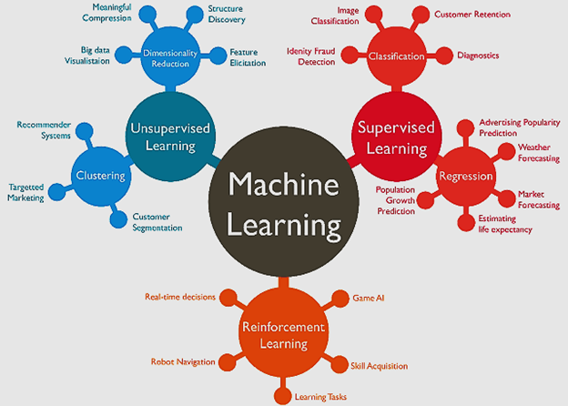

Types of Supervised learning
  - Classification: A classification problem is when the output variable is a category, such as “red” or “blue” or “disease” and “no disease”.
  - Regression: A regression problem is when the output variable is a real value, such as “dollars” or “weight”

Overview of Unsupervised Learning Algorithm
In unsupervised learning, an AI system is presented with unlabeled, uncategorized data and the system’s algorithms act on the data without prior training. The output is dependent upon the coded algorithms. Subjecting a system to unsupervised learning is one way of testing AI.

Types of Unsupervised learning:
- Clustering: A clustering problem is where you want to discover the inherent groupings in the data, such as grouping customers by purchasing behavior.
- Association: An association rule learning problem is where you want to discover rules that describe large portions of your data, such as people that buy X also tend to buy Y.

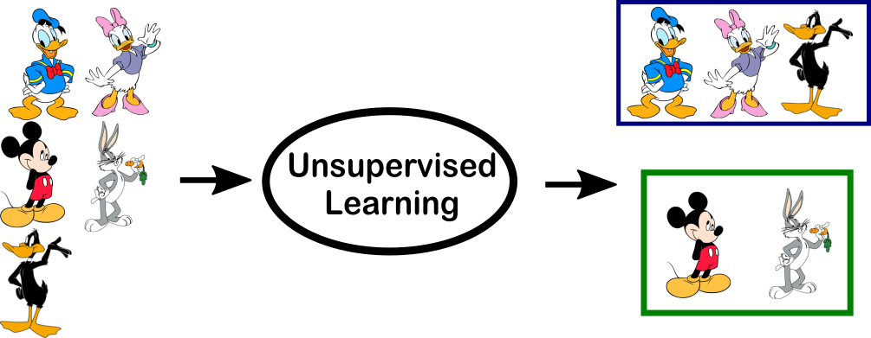

Overview of Reinforcement Learning
A reinforcement learning algorithm, or agent, learns by interacting with its environment. The agent receives rewards by performing correctly and penalties for performing incorrectly. The agent learns without intervention from a human by maximizing its reward and minimizing its penalty. It is a type of dynamic programming that trains algorithms using a system of reward and punishment. Some more examples of tasks that are best solved by using a learning algorithm
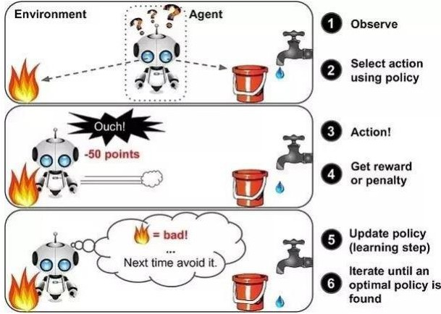

in the above example, we can see that the agent is given 2 options i.e. a path with water or a path with fire. A reinforcement algorithm works on reward a system i.e. if the agent uses

the fire path then the rewards are subtracted and agent tries to learn that it should avoid the fire path. If it had chosen the water path or the safe path then some points would have been added to the reward points, the agent then would try to learn what path is safe and what path isn’t. It is basically leveraging the rewards obtained; the agent improves its environment knowledge to select the next action.

Machine learning Approaches
Decision tree learning: Decision tree learning uses a decision tree as a predictive model, which maps observations about an item to conclusions about the item's target value. Association rule learning Association rule learning is a method for discovering interesting relations between variables in large databases.

Artificial neural networks
An artificial neural network (ANN) learning algorithm, usually called "neural network" (NN), is a learning algorithm that is vaguely inspired by biological neural networks. Computations are structured in terms of an interconnected group of artificial neurons, processing information using a connectionist approach to computation. Modern neural networks are non-linear statistical data modeling tools. They are usually used to model complex relationships between inputs and outputs, to find patterns in data, or to capture the statistical structure in an unknown joint probability distribution between observed variables.

Deep learning
Falling hardware prices and the development of GPUs for personal use in the last few years have contributed to the development of the concept of deep learning which consists of multiple hidden layers in an artificial neural network. This approach tries to model the way the human brain processes light and sound into vision and hearing. Some successful applications of deep learning are computer vision and speech recognition.

Inductive logic programming
Inductive logic programming (ILP) is an approach to rule learning using logic programming as a uniform representation for input examples, background knowledge, and hypotheses. Given an encoding of the known background knowledge and a set of examples represented as a logical database of facts, an ILP system will derive a hypothesized logic program that entails all positive and no negative examples. Inductive programming is a related field that considers any kind of programming languages for representing hypotheses (and not only logic programming), such as functional programs.

Clustering Cluster
analysis is the assignment of a set of observations into subsets (called clusters) so that observations within the same cluster are similar according to some pre designated criterion or criteria, while observations drawn from different clusters are dissimilar. Different clustering techniques make different assumptions on the structure of the data, often defined by some similarity metric and evaluated for example by internal compactness (similarity

between members of the same cluster) and separation between different clusters. Other methods are based on estimated density and graph connectivity. Clustering is a method of unsupervised learning, and a common technique for statistical data analysis.

Bayesian networks
A Bayesian network, belief network or directed acyclic graphical model is a probabilistic graphical model that represents a set of random variables and their conditional independencies via a directed acyclic graph (DAG). For example, a Bayesian network could represent the probabilistic relationships between diseases and symptoms. Given symptoms, the network can be used to compute the probabilities of the presence of various diseases. Efficient algorithms exist that perform inference and learning.

What is Python?
    - A programming language with strong similarities to PERL, but with powerful typing and object oriented features.
      - Commonly used for producing HTML content on websites. Great for text files.
      - Useful built-in types (lists, dictionaries).
      - Clean syntax, powerful extensions.

Why Python?
    - Natural Language ToolKit
    - Ease of use; interpreter
    - AI Processing: Symbolic
      - Python’s built-in datatypes for strings, lists, and more.
      - Java or C++ requires the use of special classes for this.
    - AI Processing: Statistical
      - Python has strong numeric processing capabilities: matrix operations, etc.
      - Suitable for probability and machine learning code.

Look at a sample of code…
x = 34 - 23 # A comment.
y = “Hello” # Another one.
z = 3.45
if z == 3.45 or y == “Hello”: x = x + 1

y = y + “World” # String concat.
print x print y

Enough to Understand the Code
- Assignment uses = and comparison uses ==.
- For numbers +-*/% are as expected.
  - Special use of + for string concatenation.
  - Special use of % for string formatting.
- Logical operators are words (and, or, not) not symbols (&&, ||!).
- The basic printing command is “print.”
- First assignment to a variable will create it.
  - Variable types don’t need to be declared.
  - Python figures out the variable types on its own.

Basic Datatypes
- Integers (default for numbers)
z = 5 / 2 # Answer is 2, integer division.
- Floats
x = 3.456
- Strings
Can use “” or ‘’ to specify. “abc” ‘abc’ (Same thing.) Unmatched ones can occur within the string. “matt’s” Use triple double-quotes for multi-line strings or strings than contain both ‘ and “ inside of them: “““a‘b“c”””

Whitespace
- Whitespace is meaningful in Python: especially indentation and placement of newlines.
  - Use a newline to end a line of code. (Not a semicolon like in C++ or Java.) (Use \ when must go to next line prematurely.)

  - No braces { } to mark blocks of code in Python… Use consistent indentation instead. The first line with a new indentation is considered outside of the block.

  - Often a colon appears at the start of a new block. (We’ll see this later for function and class definitions.)

Comments
- Start comments with # – the rest of line is ignored.
- Can include a “documentation string” as the first line of any new function or class that you define.
- The development environment, debugger, and other tools use it: it’s good style to include one.
def my_function(x, y):
“““This is the docstring. This function does blah blah blah.””” # The code would go here...

Look at a sample of code…
x = 34 - 23 # A comment.
y = “Hello” # Another one.
z = 3.45
if z == 3.45 or y == “Hello”: x = x + 1
y = y + “ World” # String concat. print x
print y

Python and Types
Python determines the data types in a program automatically. “Dynamic Typing”
But Python’s not casual about types, it enforces them after it figures them out. “Strong Typing”
So, for example, you can’t just append an integer to a string. You must first convert the integer to a string itself.
x = “the answer is ” # Decides x is string. y = 23 # Decides y is integer.
print x + y # Python will complain about this.

Naming Rules
- Names are case sensitive and cannot start with a number. They can contain letters, numbers, and underscores.
bob Bob _bob _2_bob_ bob_2 BoB
- There are some reserved words:
and, assert, break, class, continue, def, del, elif, else, except, exec, finally, for, from, global, if, import, in, is, lambda, not, or, pass, print, raise, return, try, while

Accessing Non-existent Name
- If you try to access a name before it’s been properly created (by placing it on the left side of an assignment), you’ll get an error.
>>> y
Traceback (most recent call last):
File "<pyshell#16>", line 1, in -toplevel-y NameError: name ‘y' is not defined
>>> y = 3
>>> y

Multiple Assignment
- You can also assign to multiple names at the same time.
>>> x, y = 2, 3
>>> x 2
>>> y 3

String Operations
- We can use some methods built-in to the string data type to perform some formatting operations on strings:
>>> “hello”.upper() ‘HELLO’
- There are many other handy string operations available. Check the Python documentation for more.

Printing with Python
- You can print a string to the screen using “print.”

- Using the % string operator in combination with the print command, we can format our output text.
>>> print “%s xyz %d” % (“abc”, 34) abc xyz 34
“Print” automatically adds a newline to the end of the string. If you include a list of strings, it will concatenate them with a space between them.
>>> print “abc”
>>> print “abc”, “def” abc
abc def

Numpy
Let’s start with NumPy. Among other things, NumPy contains:
A powerful N-dimensional array object. Sophisticated (broadcasting/universal) functions. Tools for integrating C/C++ and Fortran code.
Useful linear algebra, Fourier transform, and random number capabilities.
Besides its obvious scientific uses, NumPy can also be used as an efficient multi-dimensional container of generic data.
The key to NumPy is the ndarray object, an n-dimensional array of homogeneous data types, with many operations being performed in compiled code for performance. There are several important differences between NumPy arrays and the standard Python sequences:
NumPy arrays have a fixed size. Modifying the size means creating a new array. NumPy arrays must be of the same data type, but this can include Python objects. More efficient mathematical operations than built-in sequence types.

Numpy datatypes
To begin, NumPy supports a wider variety of data types than are built-in to the Python language by default. They are defined by the numpy.dtype class and include:
intc (same as a C integer) and intp (used for indexing) int8, int16, int32, int64
uint8, uint16, uint32, uint64

float16, float32, float64 complex64, complex128
bool_, int_, float_, complex_ are shorthand for defaults.

These can be used as functions to cast literals or sequence types, as well as arguments to numpy functions that accept the dtype keyword argument.
To begin, NumPy supports a wider variety of data types than are built-in to the Python language by default. They are defined by the numpy.dtype class and include:
intc (same as a C integer) and intp (used for indexing) int8, int16, int32, int64
uint8, uint16, uint32, uint64 float16, float32, float64 complex64, complex128 Some examples:
>>> import numpy as np
>>> x = np.float32(1.0)
>>> x 1.0
>>> y = np.int_([1,2,4])
>>> y
array([1, 2, 4])
>>> z = np.arange(3, dtype=np.uint8)
>>> z
array([0, 1, 2], dtype=uint8)
>>> z.dtype dtype('uint8')

Numpy arrays
There are a couple of mechanisms for creating arrays in NumPy:
- Conversion from other Python structures (e.g., lists, tuples).
- Built-in NumPy array creation (e.g., arange, ones, zeros, etc.).
- Reading arrays from disk, either from standard or custom formats (e.g. reading in from a CSV file).
- and others …
In general, any numerical data that is stored in an array-like container can be converted to an ndarray through use of the array() function. The most obvious examples are sequence types like lists and tuples.

>>> x = np.array([2,3,1,0])
>>> x = np.array([2, 3, 1, 0])
>>> x = np.array([[1,2.0],[0,0],(1+1j,3.)])
>>> x = np.array([[ 1.+0.j, 2.+0.j], [ 0.+0.j, 0.+0.j], [ 1.+1.j, 3.+0.j]])
There are a couple of built-in NumPy functions which will create arrays from scratch.
- zeros(shape) -- creates an array filled with 0 values with the specified shape. The default dtype is float64.
>>>np.zeros((2,3))
array([[ 0., 0., 0.], [ 0., 0., 0.]])
- ones(shape) -- creates an array filled with 1 values.
- arange() -- creates arrays with regularly incrementing values.
>>>np.arange(10)
array([0, 1, 2, 3, 4, 5, 6, 7, 8, 9])
>>>np.arange(2,10,dtype=np.float)
array([2.,3.,4.,5.,6.,7.,8.,9.])
>>>np.arange(2,3,0.1)
array([ 2. , 2.1, 2.2, 2.3, 2.4, 2.5, 2.6, 2.7, 2.8, 2.9])

- linspace() -- creates arrays with a specified number of elements, and spaced equally between the specified beginning and end values.
>>>np.linspace(1.,4.,6)
array([ 1. , 1.6, 2.2, 2.8, 3.4, 4. ])

- random.random(shape) – creates arrays with random floats over the interval [0,1).
>>>np.random.random((2,3))
array([[0.75688597,0.41759916,0.35007419],[ 0.77164187, 0.05869089, 0.98792864]])

Printing an array can be done with the print statement.
>>> import numpy as np
>>> a = np.arange(3)
>>> print a [0 1 2]
>>> a
array([0, 1, 2])
>>> b = np.arange(9).reshape(3,3)
>>> print b [[0 1 2]
[3 4 5]
[6 7 8]]
>>> c = np.arange(8).reshape(2,2,2)
>>> print c [[[0 1]
[2 3]]

[[4 5]
[6 7]]]

Indexing
Single-dimension indexing is accomplished as usual.
>>> x = np.arange(10)
>>> x[2]
2 >>> x[-2]
8
0 1 2 3 4 5 6 7 8 9

Multi-dimensional arrays support multi-dimensional indexing.
>>> x.shape = (2,5) # now x is 2-dimensional
>>> x[1,3] 8
>>> x[1,-1] 9
0 1 2 3 4
5 6 7 8 9
Using fewer dimensions to index will result in a subarray.
>>> x[0]
array([0, 1, 2, 3, 4])
This means that x[i, j] == x[i][j] but the second method is less efficient. Slicing is possible just as it is for typical Python sequences.
>>> x = np.arange(10)
>>> x[2:5]
array([2, 3, 4])
>>> x[:-7]
array([0, 1, 2])
>>> x[1:7:2]
array([1, 3, 5])
>>> y = np.arange(35).reshape(5,7)
>>> y[1:5:2,::3]
array([[ 7, 10, 13], [21, 24, 27]])

Array operations
>>> a = np.arange(5)
>>> b = np.arange(5)
>>> a+b
array([0, 2, 4, 6, 8])

>>> a-b
array([0, 0, 0, 0, 0])
>>> a**2
array([ 0, 1, 4, 9, 16])
>>> a>3
array([False, False, False, False, True], dtype=bool)
>>> 10*np.sin(a)
array([ 0., 8.41470985, 9.09297427, 1.41120008, -7.56802495])
>>> a*b
array([ 0, 1, 4, 9, 16])
Basic operations apply element-wise. The result is a new array with the resultant elements. Operations like *= and += will modify the existing array.

Since multiplication is done element-wise, you need to specifically perform a dot product to perform matrix multiplication.

>>> a = np.zeros(4).reshape(2,2)
>>> a
array([[ 0., 0.],
[ 0., 0.]])
>>> a[0,0] = 1
>>> a[1,1] = 1
>>> b = np.arange(4).reshape(2,2)
>>> b
array([[0, 1],
[2, 3]])
>>> a*b array([[ 0., 0.],
[ 0., 3.]])
>>> np.dot(a,b) array([[ 0., 1.],
[ 2., 3.]])
There are also some built-in methods of ndarray objects. Universal functions which may also be applied include exp, sqrt, add, sin, cos, etc…
>>> a = np.random.random((2,3))

>>> a
array([[ 0.68166391, 0.98943098, 0.69361582],
[ 0.78888081, 0.62197125, 0.40517936]])
>>> a.sum() 4.1807421388722164
>>> a.min() 0.4051793610379143
>>> a.max(axis=0)
array([ 0.78888081, 0.98943098, 0.69361582])
>>> a.min(axis=1)
array([ 0.68166391, 0.40517936])

Pandas
Pandas is an open-source, BSD-licensed Python library providing high-performance, easy-to-use data structures and data analysis tools for the Python programming language. Python with Pandas is used in a wide range of fields including academic and commercial domains including finance, economics, Statistics, analytics, etc.In this tutorial, we will learn the various features of Python Pandas and how to use them in practice.
Pandas is an open-source Python Library providing high-performance data manipulation and analysis tool using its powerful data structures. The name Pandas is derived from the word Panel Data – an Econometrics from Multidimensional data.
In 2008, developer Wes McKinney started developing pandas when in need of high performance, flexible tool for analysis of data.
Prior to Pandas, Python was majorly used for data munging and preparation. It had very little contribution towards data analysis. Pandas solved this problem. Using Pandas, we can accomplish five typical steps in the processing and analysis of data, regardless of the origin of data — load, prepare, manipulate, model, and analyze.
Python with Pandas is used in a wide range of fields including academic and commercial domains including finance, economics, Statistics, analytics, etc.

Key Features of Pandas
  - Fast and efficient Data Frame object with default and customized indexing.
  - Tools for loading data into in-memory data objects from different file formats.
  - Data alignment and integrated handling of missing data.
  - Reshaping and pivoting of date sets.
  - Label-based slicing, indexing and sub setting of large data sets.
  - Columns from a data structure can be deleted or inserted.
  - Group by data for aggregation and transformations.
  - High performance merging and joining of data.
  - Time Series functionality.
Standard Python distribution doesn't come bundled with Pandas module. A lightweight alternative is to install NumPy using popular Python package installer, pip.
pip install pandas
If you install Anaconda Python package, Pandas will be installed by default with the following

CSV File
Python has a vast library of modules that are included with its distribution. The csv module gives the Python programmer the ability to parse CSV (Comma Separated Values) files. A CSV file is a human readable text file where each line has a number of fields, separated by commas or some other delimiter. You can think of each line as a row and each field as a column. The CSV format has no standard, but they are similar enough that the csv module will be able to read the vast majority of CSV files. You can also write CSV files using the csv module.
Reading a CSV File
There are two ways to read a CSV file. You can use the csv module’s reader function or you can use the DictReader class. We will look at both methods. But first, we need to get a CSV file so we have something to parse. There are many websites that provide interesting information in CSV format. We will be using the World Health Organization’s (WHO) website to download some information on Tuberculosis. You can go here to get it: http://www.who.int/tb/country/data/download/en/. Once you have the file, we’ll be ready to start. Ready? Then let’s look at some code!
import csv #
def csv_reader(file_obj): """
Read a csv file """
reader = csv.reader(file_obj) for row in reader:
print(" ".join(row))
#
if name == " main ":
csv_path = "TB_data_dictionary_2014-02-26.csv" with open(csv_path, "rb") as f_obj:
csv_reader(f_obj) Writing a CSV File
The csv module also has two methods that you can use to write a CSV file. You can use the writer function or the DictWriter class. We’ll look at both of these as well. We will be with the writer function. Let’s look at a simple example:
import csv #
def csv_writer(data, path): """
Write data to a CSV file path """
with open(path, "wb") as csv_file:
writer = csv.writer(csv_file, delimiter=',') for line in data:
writer.writerow(line)
#

if name == " main ":
data = ["first_name,last_name,city".split(","), "Tyrese,Hirthe,Strackeport".split(","), "Jules,Dicki,Lake Nickolasville".split(","), "Dedric,Medhurst,Stiedemannberg".split(",")
]
path = "output.csv" csv_writer(data, path)

Anaconda Navigator
Anaconda Navigator is a desktop graphical user interface (GUI) included in Anaconda distribution that allows users to launch applications and manage conda packages, environments and channels without using command-line commands. Navigator can search for packages on Anaconda Cloud or in a local Anaconda Repository, install them in an environment, run the packages and update them. It is available for Windows, macOS and Linux.
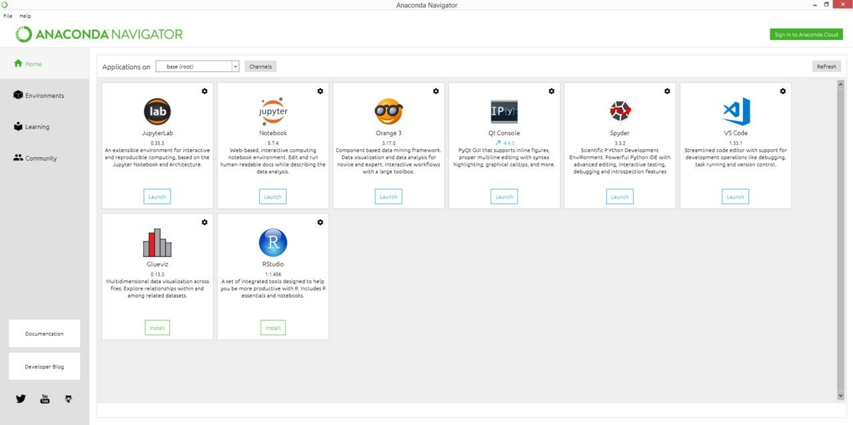

The following applications are available by default in Navigator:
JupyterLab, Jupyter Notebook, QtConsole[19], Spyder, Glue, Orange, RStudio, Visual Studio Code

Conda
Conda is an open source cross-platform, language-agnostic package manager and environment management system that installs, runs, and updates packages and their

dependencies. It was created for Python programs, but it can package and distribute software for any language (e.g., R), including multi-language projects. The conda package and environment manager is included in all versions of Anaconda, Miniconda, and Anaconda Repository.

Jupyter Notebook
Jupyter Notebook can colloquially refer to two different concepts, either the user-facing application to edit code and text, or the underlying file format which is interoperable across many implementations.

Jupyter Notebook (formerly IPython Notebook) is a web-based interactive computational environment for creating notebook documents. Jupyter Notebook is built using several open- source libraries, including IPython, ZeroMQ, Tornado, jQuery, Bootstrap, and MathJax. A Jupyter Notebook application is a browser-based REPL containing an ordered list of input/output cells which can contain code, text (using Github Flavored Markdown), mathematics, plots and rich media.
Jupyter Notebook is similar to the notebook interface of other programs such as Maple, Mathematica, and SageMath, a computational interface style that originated with Mathematica in the 1980s.

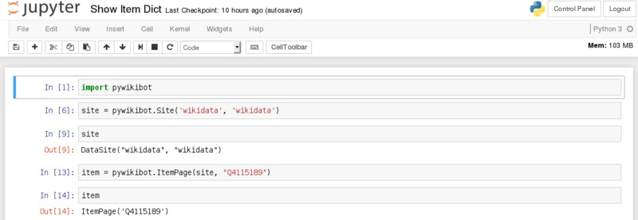

Spyder (software)
Spyder is an open-source cross-platform integrated development environment (IDE) for scientific programming in the Python language. Spyder integrates with a number of prominent packages in the scientific Python stack, including NumPy, SciPy, Matplotlib, pandas, IPython, SymPy and Cython, as well as other open-source software.

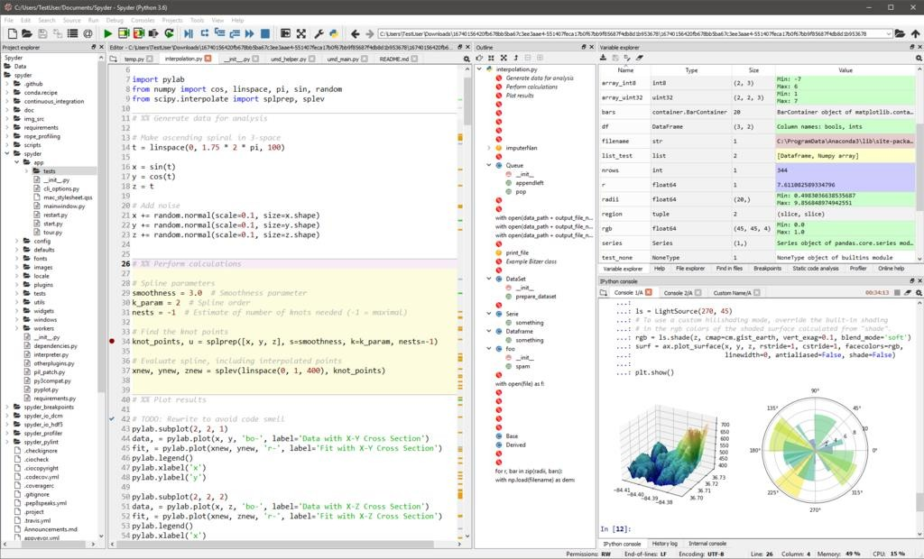

Experiment 1

Develop a program to create histograms for all numerical features and analyze the distribution of each feature. Generate box plots for all numerical features and identify any outliers. Use California Housing dataset.

import pandas as pd import numpy as np import seaborn as sns
import matplotlib.pyplot as plt
from sklearn.datasets import fetch_california_housing # Step 1: Load the California Housing dataset
data = fetch_california_housing(as_frame=True) housing_df = data.frame
# Step 2: Create histograms for numerical features
numerical_features = housing_df.select_dtypes(include=[np.number]).columns # Plot histograms
plt.figure(figsize=(15, 10))
for i, feature in enumerate(numerical_features): plt.subplot(3, 3, i + 1)
sns.histplot(housing_df[feature], kde=True, bins=30, color='blue') plt.title(f'Distribution of {feature}')
plt.tight_layout() plt.show()
# Step 3: Generate box plots for numerical features plt.figure(figsize=(15, 10))
for i, feature in enumerate(numerical_features): plt.subplot(3, 3, i + 1)

sns.boxplot(x=housing_df[feature], color='orange')

plt.title(f'Box Plot of {feature}') plt.tight_layout()
plt.show()
# Step 4: Identify outliers using the IQR method print("Outliers Detection:")
outliers_summary = {}
for feature in numerical_features:
Q1 = housing_df[feature].quantile(0.25) Q3 = housing_df[feature].quantile(0.75)
IQR = Q3 - Q1
lower_bound = Q1 - 1.5 * IQR upper_bound = Q3 + 1.5 * IQR
outliers = housing_df[(housing_df[feature] < lower_bound) | (housing_df[feature] > upper_bound)]
outliers_summary[feature] = len(outliers) print(f"{feature}: {len(outliers)} outliers") # Optional: Print a summary of the dataset print("\nDataset Summary:") print(housing_df.describe())

output:

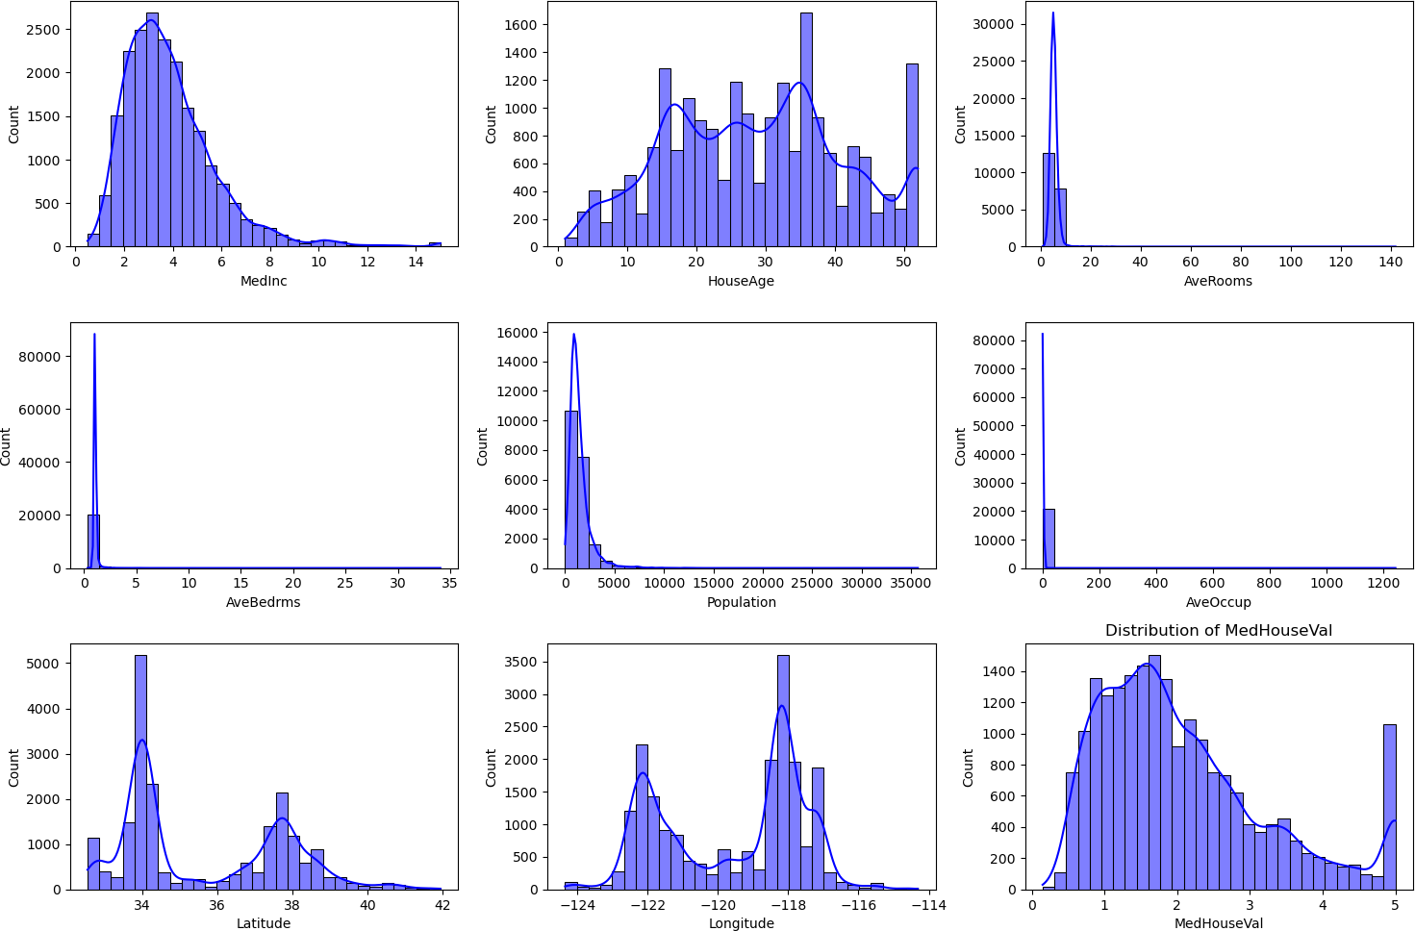
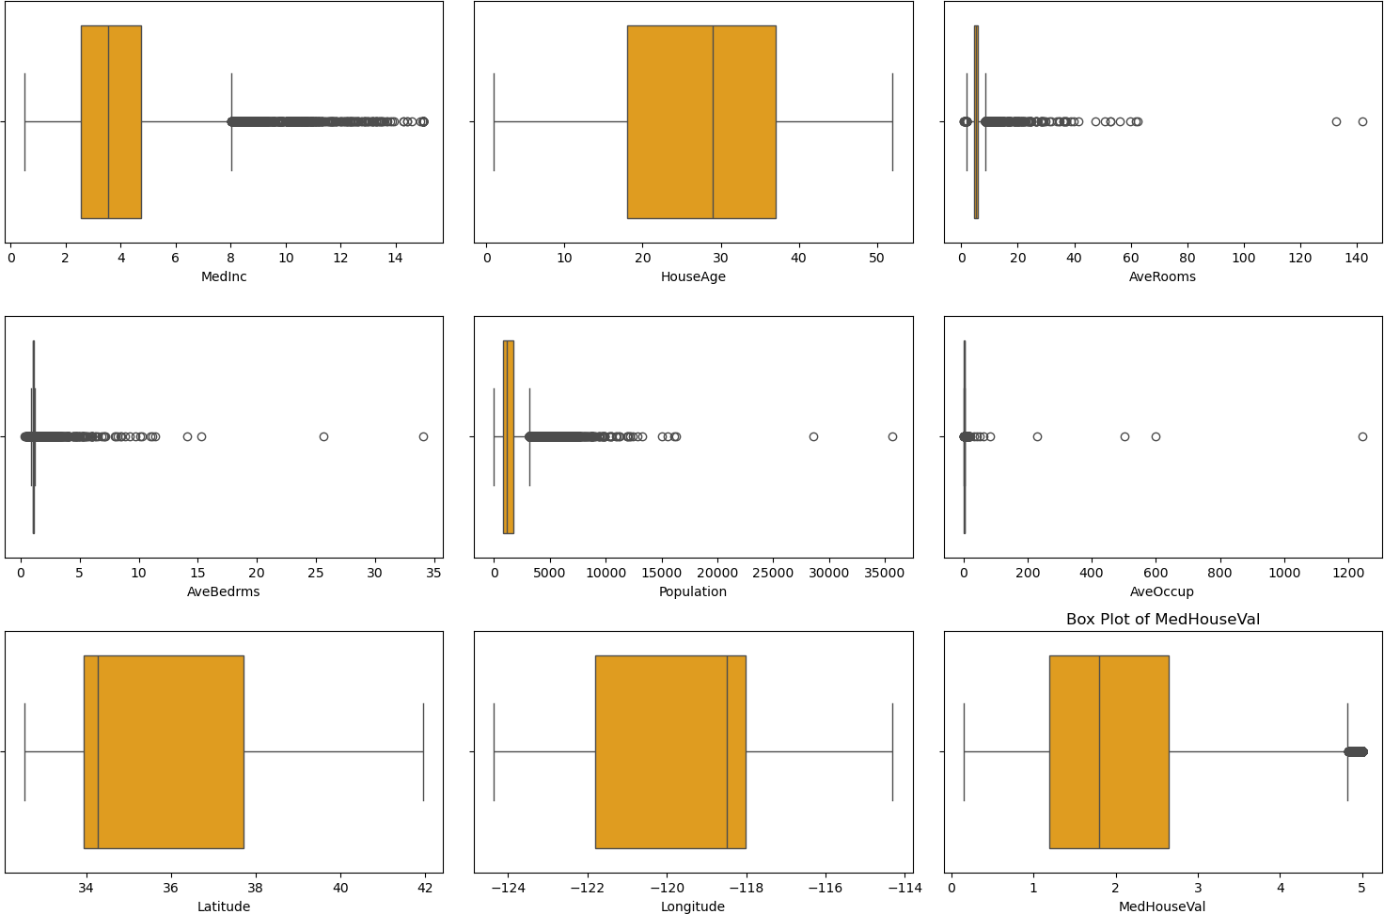

Outliers Detection:
MedHouseVal: 1071 outliers

Dataset Summary:
MedInc HouseAge AveRooms AveBedrms Population \
count 20640.000000 20640.000000 20640.000000 20640.000000 20640.000000
mean 3.870671 28.639486 5.429000 1.096675 1425.476744

std | 1.899822 | 12.585558 | 2.474173 | 0.473911 | 1132.462122
min | 0.499900 | 1.000000 | 0.846154 | 0.333333 | 3.000000
25% | 2.563400 | 18.000000 | 4.440716 | 1.006079 | 787.000000
50% | 3.534800 | 29.000000 | 5.229129 | 1.048780 | 1166.000000
75% | 4.743250 | 37.000000 | 6.052381 | 1.099526 | 1725.000000
max | 15.000100 | 52.000000 | 141.909091 | 34.066667 35682.000000

AveOccup Latitude Longitude MedHouseVal
count 20640.000000 20640.000000 20640.000000 20640.000000
mean 3.070655 35.631861 -119.569704 2.068558
std 10.386050 2.135952 2.003532 1.153956

min | 0.692308 | 32.540000 | -124.350000 | 0.149990
25% | 2.429741 | 33.930000 | -121.800000 | 1.196000
50% | 2.818116 | 34.260000 | -118.490000 | 1.797000
75% | 3.282261 | 37.710000 | -118.010000 | 2.647250
max | 1243.333333 | 41.950000 -114.310000 |  | 5.000010

Develop a program to Compute the correlation matrix to understand the relationships between pairs of features. Visualize the correlation matrix using a heatmap to know which variables have strong positive/negative correlations. Create a pair plot to visualize pairwise relationships between features. Use California Housing dataset.
import pandas as pd import seaborn as sns
import matplotlib.pyplot as plt
from sklearn.datasets import fetch_california_housing # Step 1: Load the California Housing Dataset
california_data = fetch_california_housing(as_frame=True) data = california_data.frame
# Step 2: Compute the correlation matrix correlation_matrix = data.corr()
# Step 3: Visualize the correlation matrix using a heatmap plt.figure(figsize=(10, 8))
sns.heatmap(correlation_matrix, annot=True, cmap='coolwarm', fmt='.2f', linewidths=0.5)
plt.title('Correlation Matrix of California Housing Features') plt.show()
# Step 4: Create a pair plot to visualize pairwise relationships sns.pairplot(data, diag_kind='kde', plot_kws={'alpha': 0.5}) plt.suptitle('Pair Plot of California Housing Features', y=1.02) plt.show()

output:

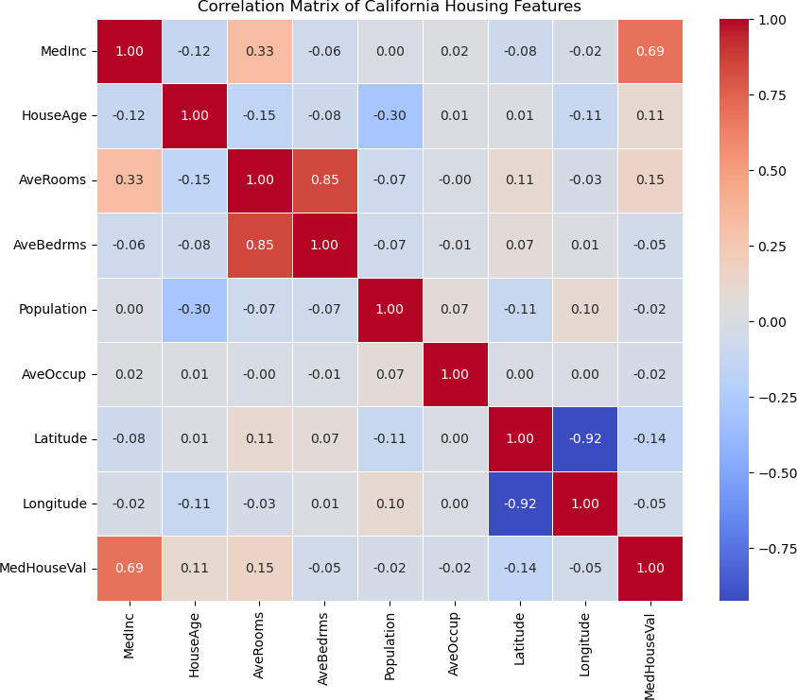

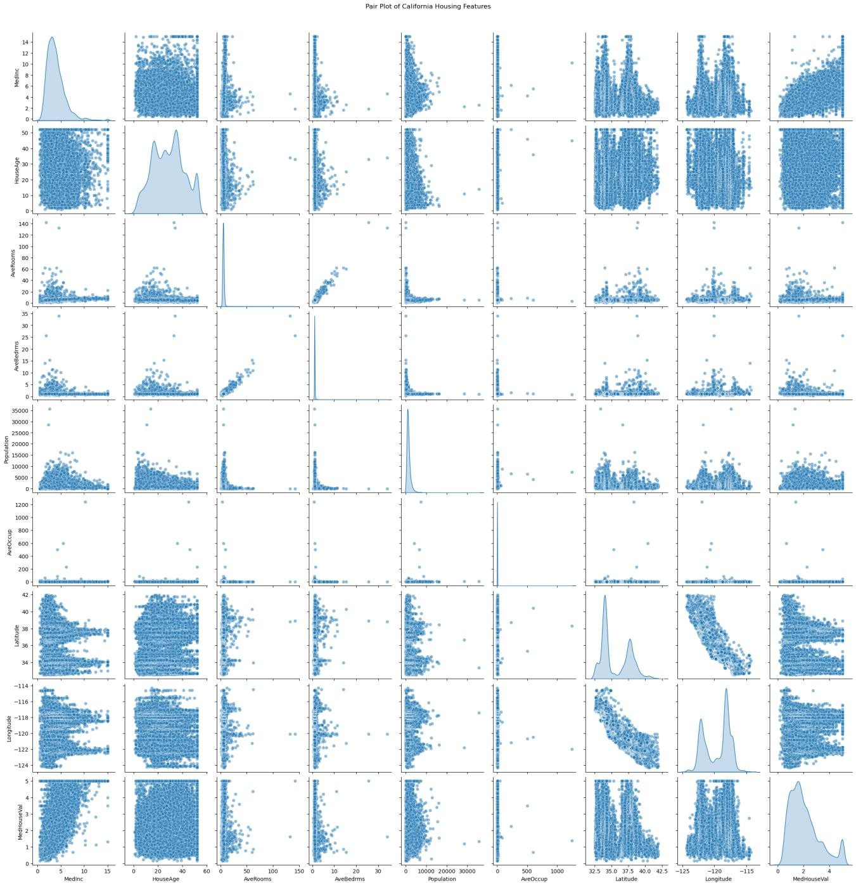

- Develop a program to implement Principal Component Analysis (PCA) for reducing the dimensionality of the Iris dataset from 4 features to 2.
import numpy as np import pandas as pd
from sklearn.datasets import load_iris from sklearn.decomposition import PCA import matplotlib.pyplot as plt
# Load the Iris dataset iris = load_iris()
data = iris.data labels = iris.target
label_names = iris.target_names
# Convert to a DataFrame for better visualization
iris_df = pd.DataFrame(data, columns=iris.feature_names) # Perform PCA to reduce dimensionality to 2
pca = PCA(n_components=2) data_reduced = pca.fit_transform(data)
# Create a DataFrame for the reduced data
reduced_df = pd.DataFrame(data_reduced, columns=['Principal Component 1', 'Principal Component 2'])
reduced_df['Label'] = labels # Plot the reduced data plt.figure(figsize=(8, 6)) colors = ['r', 'g', 'b']
for i, label in enumerate(np.unique(labels)): plt.scatter(
reduced_df[reduced_df['Label'] == label]['Principal Component 1'],

reduced_df[reduced_df['Label'] == label]['Principal Component 2'], label=label_names[label],
color=colors[i]
)
plt.title('PCA on Iris Dataset') plt.xlabel('Principal Component 1')
plt.ylabel('Principal Component 2') plt.legend()
plt.grid() plt.show()

output:
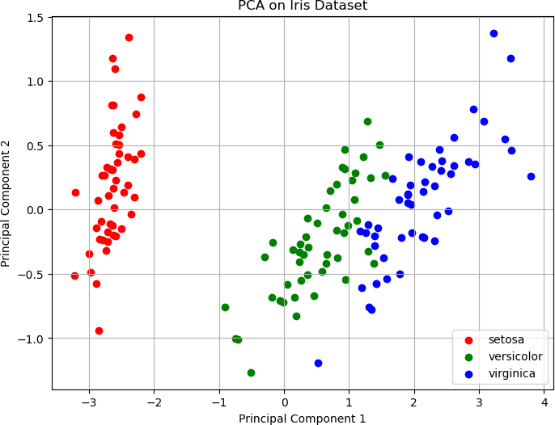

- For a given set of training data examples stored in a .CSV file, implement and demonstrate the Find-S algorithm to output a description of the set of all hypotheses consistent with the training examples.
import pandas as pd
# Function to implement the Find-S Algorithm def find_s_algorithm(file_path):

# Read the dataset
data = pd.read_csv(file_path) print("Training data:") print(data)

# Separate attributes and class label
attributes = data.columns[:-1] # All columns except the last one class_label = data.columns[-1] # Last column is the class label

# Initialize hypothesis with '?' for each attribute hypothesis = ['?' for _ in attributes]

# Iterate through the dataset to find the specific hypothesis for index, row in data.iterrows():
# Only consider positive examples (class label == 'Yes') if row[class_label] == 'Yes':
for i, value in enumerate(row[attributes]):
# If hypothesis is '?' or matches the current value, update hypothesis if hypothesis[i] == '?' or hypothesis[i] == value:
hypothesis[i] = value

else:
# If the value is different, set '?' for that attribute hypothesis[i] = '?'
return hypothesis

# Define file path
file_path = r"C:\Users\atme\Desktop\example ml\training_data.csv"

# Call the Find-S algorithm
hypothesis = find_s_algorithm(file_path)

# Print the final hypothesis
print("\nThe final hypothesis is:", hypothesis)

output:
Training data:Outlook Temperature Humidity Windy PlayTennis

0 Sunny Hot | High False | No
1 Sunny Hot | High True | No
2 Overcast Hot | High False | Yes
3 Rain Cold | High False | Yes
4 Rain Cold | High True | No
5 Overcast Hot | High True | Yes
6 Sunny Hot | High False | No

The final hypothesis is: ['Overcast', 'Hot', 'High', '?']

- Develop a program to implement k-Nearest Neighbour algorithm to classify the randomly generated 100 values of x in the range of [0,1]. Perform the following based on dataset generated. a. Label the first 50 points {x1,……,x50} as follows:
if (xi ≤ 0.5), then xi ∊ Class1, else xi ∊ Class1 b. Classify the remaining points,
x51,……,x100 using KNN. Perform this for k=1,2,3,4,5,20,30
import numpy as np
import matplotlib.pyplot as plt from collections import Counter

# Generate random data data = np.random.rand(100)
labels = ["Class1" if x <= 0.5 else "Class2" for x in data[:50]]

# Function to compute Euclidean distance def euclidean_distance(x1, x2):
return abs(x1 - x2)

# k-NN classifier function
def knn_classifier(train_data, train_labels, test_point, k):
distances = [(euclidean_distance(test_point, train_data[i]), train_labels[i]) for i in range(len(train_data))]
distances.sort(key=lambda x: x[0]) # Sort by distance

k_nearest_neighbors = distances[:k] # Get k nearest neighbors
k_nearest_labels = [label for _, label in k_nearest_neighbors] # Extract the labels return Counter(k_nearest_labels).most_common(1)[0][0] # Return the most
common label

# Prepare the training and test data
train_data = data[:50] # First 50 points for training train_labels = labels # Corresponding labels for training test_data = data[50:] # Remaining 50 points for testing

# Values of k to test
k_values = [1, 2, 3, 4, 5, 20, 30]

print("--- k-Nearest Neighbors Classification ---")
print("Training dataset: First 50 points labeled based on the rule (x <= 0.5 -> Class1, x > 0.5 -> Class2)")
print("Testing dataset: Remaining 50 points to be classified\n")

# Store the results for each k value results = {}

# Loop over different values of k for k in k_values:
print(f"Results for k = {k}:")
classified_labels = [knn_classifier(train_data, train_labels, test_point, k) for test_point in test_data]
results[k] = classified_labels

# Output the classification results
for i, label in enumerate(classified_labels, start=51): # Start index at 51 for test points
print(f"Point x{i} (value: {test_data[i - 51]:.4f}) is classified as {label}") print("\n")

print("Classification complete.\n")

# Visualize the classification results for each k value for k in k_values:
classified_labels = results[k]
class1_points = [test_data[i] for i in range(len(test_data)) if classified_labels[i] == "Class1"]
class2_points = [test_data[i] for i in range(len(test_data)) if classified_labels[i] == "Class2"]

plt.figure(figsize=(10, 6))
plt.scatter(train_data, [0] * len(train_data), c=["blue" if label == "Class1" else "red" for label in train_labels],
label="Training Data", marker="o")
plt.scatter(class1_points, [1] * len(class1_points), c="blue", label="Class1 (Test)", marker="x")
plt.scatter(class2_points, [1] * len(class2_points), c="red", label="Class2 (Test)", marker="x")
plt.title(f"k-NN Classification Results for k = {k}") plt.xlabel("Data Points")
plt.ylabel("Classification Level") plt.legend()
plt.grid(True) plt.show()

output:

--- k-Nearest Neighbors Classification ---
Training dataset: First 50 points labeled based on the rule (x <= 0.5 -> Class1, x > 0.5
-> Class2)
Testing dataset: Remaining 50 points to be classified
Results for k = 1:
Point x51 (value: 0.4701) is classified as Class1 Point x52 (value: 0.2775) is classified as Class1 Point x53 (value: 0.2544) is classified as Class1 Point x54 (value: 0.4693) is classified as Class1 Point x55 (value: 0.6401) is classified as Class2 Point x56 (value: 0.8233) is classified as Class2 Point x57 (value: 0.6015) is classified as Class2 Point x58 (value: 0.7991) is classified as Class2 Point x59 (value: 0.0437) is classified as Class1 Point x60 (value: 0.2407) is classified as Class1 Point x61 (value: 0.5801) is classified as Class2 Point x62 (value: 0.4369) is classified as Class1 Point x63 (value: 0.3841) is classified as Class1 Point x64 (value: 0.3875) is classified as Class1 Point x65 (value: 0.3774) is classified as Class1 Point x66 (value: 0.7355) is classified as Class2 Point x67 (value: 0.9212) is classified as Class2 Point x68 (value: 0.9475) is classified as Class2 Point x69 (value: 0.1168) is classified as Class1 Point x70 (value: 0.1124) is classified as Class1 Point x71 (value: 0.0971) is classified as Class1 Point x72 (value: 0.4307) is classified as Class1 Point x73 (value: 0.9223) is classified as Class2 Point x74 (value: 0.7348) is classified as Class2 Point x75 (value: 0.3533) is classified as Class1 Point x76 (value: 0.8451) is classified as Class2 Point x77 (value: 0.5237) is classified as Class2 Point x78 (value: 0.7778) is classified as Class2 Point x79 (value: 0.4949) is classified as Class1 Point x80 (value: 0.1261) is classified as Class1 Point x81 (value: 0.5396) is classified as Class2 Point x82 (value: 0.2353) is classified as Class1 Point x83 (value: 0.5715) is classified as Class2 Point x84 (value: 0.5105) is classified as Class2 Point x85 (value: 0.5449) is classified as Class2 Point x86 (value: 0.8197) is classified as Class2 Point x87 (value: 0.2319) is classified as Class1 Point x88 (value: 0.5876) is classified as Class2 Point x89 (value: 0.8649) is classified as Class2 Point x90 (value: 0.3587) is classified as Class1 Point x91 (value: 0.0785) is classified as Class1 Point x92 (value: 0.8560) is classified as Class2 Point x93 (value: 0.8341) is classified as Class2 Point x94 (value: 0.0014) is classified as Class1 Point x95 (value: 0.0512) is classified as Class1 Point x96 (value: 0.4411) is classified as Class1 Point x97 (value: 0.7493) is classified as Class2 Point x98 (value: 0.6286) is classified as Class2 Point x99 (value: 0.0223) is classified as Class1 Point x100 (value: 0.3796) is classified as Class1

Results for k = 2:
Point x51 (value: 0.4701) is classified as Class1 Point x52 (value: 0.2775) is classified as Class1 Point x53 (value: 0.2544) is classified as Class1 Point x54 (value: 0.4693) is classified as Class1 Point x55 (value: 0.6401) is classified as Class2 Point x56 (value: 0.8233) is classified as Class2 Point x57 (value: 0.6015) is classified as Class2 Point x58 (value: 0.7991) is classified as Class2 Point x59 (value: 0.0437) is classified as Class1 Point x60 (value: 0.2407) is classified as Class1 Point x61 (value: 0.5801) is classified as Class2 Point x62 (value: 0.4369) is classified as Class1 Point x63 (value: 0.3841) is classified as Class1 Point x64 (value: 0.3875) is classified as Class1 Point x65 (value: 0.3774) is classified as Class1 Point x66 (value: 0.7355) is classified as Class2 Point x67 (value: 0.9212) is classified as Class2 Point x68 (value: 0.9475) is classified as Class2 Point x69 (value: 0.1168) is classified as Class1 Point x70 (value: 0.1124) is classified as Class1 Point x71 (value: 0.0971) is classified as Class1 Point x72 (value: 0.4307) is classified as Class1 Point x73 (value: 0.9223) is classified as Class2 Point x74 (value: 0.7348) is classified as Class2 Point x75 (value: 0.3533) is classified as Class1 Point x76 (value: 0.8451) is classified as Class2 Point x77 (value: 0.5237) is classified as Class2 Point x78 (value: 0.7778) is classified as Class2 Point x79 (value: 0.4949) is classified as Class1 Point x80 (value: 0.1261) is classified as Class1 Point x81 (value: 0.5396) is classified as Class2 Point x82 (value: 0.2353) is classified as Class1 Point x83 (value: 0.5715) is classified as Class2 Point x84 (value: 0.5105) is classified as Class2 Point x85 (value: 0.5449) is classified as Class2 Point x86 (value: 0.8197) is classified as Class2 Point x87 (value: 0.2319) is classified as Class1 Point x88 (value: 0.5876) is classified as Class2 Point x89 (value: 0.8649) is classified as Class2 Point x90 (value: 0.3587) is classified as Class1 Point x91 (value: 0.0785) is classified as Class1 Point x92 (value: 0.8560) is classified as Class2 Point x93 (value: 0.8341) is classified as Class2 Point x94 (value: 0.0014) is classified as Class1 Point x95 (value: 0.0512) is classified as Class1 Point x96 (value: 0.4411) is classified as Class1 Point x97 (value: 0.7493) is classified as Class2 Point x98 (value: 0.6286) is classified as Class2 Point x99 (value: 0.0223) is classified as Class1 Point x100 (value: 0.3796) is classified as Class1

Results for k = 3:
Point x51 (value: 0.4701) is classified as Class1 Point x52 (value: 0.2775) is classified as Class1 Point x53 (value: 0.2544) is classified as Class1

Point x54 (value: 0.4693) is classified as Class1 Point x55 (value: 0.6401) is classified as Class2 Point x56 (value: 0.8233) is classified as Class2 Point x57 (value: 0.6015) is classified as Class2 Point x58 (value: 0.7991) is classified as Class2 Point x59 (value: 0.0437) is classified as Class1 Point x60 (value: 0.2407) is classified as Class1 Point x61 (value: 0.5801) is classified as Class2 Point x62 (value: 0.4369) is classified as Class1 Point x63 (value: 0.3841) is classified as Class1 Point x64 (value: 0.3875) is classified as Class1 Point x65 (value: 0.3774) is classified as Class1 Point x66 (value: 0.7355) is classified as Class2 Point x67 (value: 0.9212) is classified as Class2 Point x68 (value: 0.9475) is classified as Class2 Point x69 (value: 0.1168) is classified as Class1 Point x70 (value: 0.1124) is classified as Class1 Point x71 (value: 0.0971) is classified as Class1 Point x72 (value: 0.4307) is classified as Class1 Point x73 (value: 0.9223) is classified as Class2 Point x74 (value: 0.7348) is classified as Class2 Point x75 (value: 0.3533) is classified as Class1 Point x76 (value: 0.8451) is classified as Class2 Point x77 (value: 0.5237) is classified as Class2 Point x78 (value: 0.7778) is classified as Class2 Point x79 (value: 0.4949) is classified as Class1 Point x80 (value: 0.1261) is classified as Class1 Point x81 (value: 0.5396) is classified as Class2 Point x82 (value: 0.2353) is classified as Class1 Point x83 (value: 0.5715) is classified as Class2 Point x84 (value: 0.5105) is classified as Class1 Point x85 (value: 0.5449) is classified as Class2 Point x86 (value: 0.8197) is classified as Class2 Point x87 (value: 0.2319) is classified as Class1 Point x88 (value: 0.5876) is classified as Class2 Point x89 (value: 0.8649) is classified as Class2 Point x90 (value: 0.3587) is classified as Class1 Point x91 (value: 0.0785) is classified as Class1 Point x92 (value: 0.8560) is classified as Class2 Point x93 (value: 0.8341) is classified as Class2 Point x94 (value: 0.0014) is classified as Class1 Point x95 (value: 0.0512) is classified as Class1 Point x96 (value: 0.4411) is classified as Class1 Point x97 (value: 0.7493) is classified as Class2 Point x98 (value: 0.6286) is classified as Class2 Point x99 (value: 0.0223) is classified as Class1 Point x100 (value: 0.3796) is classified as Class1

Results for k = 4:
Point x51 (value: 0.4701) is classified as Class1 Point x52 (value: 0.2775) is classified as Class1 Point x53 (value: 0.2544) is classified as Class1 Point x54 (value: 0.4693) is classified as Class1 Point x55 (value: 0.6401) is classified as Class2 Point x56 (value: 0.8233) is classified as Class2 Point x57 (value: 0.6015) is classified as Class2 Point x58 (value: 0.7991) is classified as Class2 Point x59 (value: 0.0437) is classified as Class1

Point x60 (value: 0.2407) is classified as Class1 Point x61 (value: 0.5801) is classified as Class2 Point x62 (value: 0.4369) is classified as Class1 Point x63 (value: 0.3841) is classified as Class1 Point x64 (value: 0.3875) is classified as Class1 Point x65 (value: 0.3774) is classified as Class1 Point x66 (value: 0.7355) is classified as Class2 Point x67 (value: 0.9212) is classified as Class2 Point x68 (value: 0.9475) is classified as Class2 Point x69 (value: 0.1168) is classified as Class1 Point x70 (value: 0.1124) is classified as Class1 Point x71 (value: 0.0971) is classified as Class1 Point x72 (value: 0.4307) is classified as Class1 Point x73 (value: 0.9223) is classified as Class2 Point x74 (value: 0.7348) is classified as Class2 Point x75 (value: 0.3533) is classified as Class1 Point x76 (value: 0.8451) is classified as Class2 Point x77 (value: 0.5237) is classified as Class2 Point x78 (value: 0.7778) is classified as Class2 Point x79 (value: 0.4949) is classified as Class1 Point x80 (value: 0.1261) is classified as Class1 Point x81 (value: 0.5396) is classified as Class2 Point x82 (value: 0.2353) is classified as Class1 Point x83 (value: 0.5715) is classified as Class2 Point x84 (value: 0.5105) is classified as Class2 Point x85 (value: 0.5449) is classified as Class2 Point x86 (value: 0.8197) is classified as Class2 Point x87 (value: 0.2319) is classified as Class1 Point x88 (value: 0.5876) is classified as Class2 Point x89 (value: 0.8649) is classified as Class2 Point x90 (value: 0.3587) is classified as Class1 Point x91 (value: 0.0785) is classified as Class1 Point x92 (value: 0.8560) is classified as Class2 Point x93 (value: 0.8341) is classified as Class2 Point x94 (value: 0.0014) is classified as Class1 Point x95 (value: 0.0512) is classified as Class1 Point x96 (value: 0.4411) is classified as Class1 Point x97 (value: 0.7493) is classified as Class2 Point x98 (value: 0.6286) is classified as Class2 Point x99 (value: 0.0223) is classified as Class1 Point x100 (value: 0.3796) is classified as Class1

Results for k = 5:
Point x51 (value: 0.4701) is classified as Class1 Point x52 (value: 0.2775) is classified as Class1 Point x53 (value: 0.2544) is classified as Class1 Point x54 (value: 0.4693) is classified as Class1 Point x55 (value: 0.6401) is classified as Class2 Point x56 (value: 0.8233) is classified as Class2 Point x57 (value: 0.6015) is classified as Class2 Point x58 (value: 0.7991) is classified as Class2 Point x59 (value: 0.0437) is classified as Class1 Point x60 (value: 0.2407) is classified as Class1 Point x61 (value: 0.5801) is classified as Class2 Point x62 (value: 0.4369) is classified as Class1 Point x63 (value: 0.3841) is classified as Class1 Point x64 (value: 0.3875) is classified as Class1 Point x65 (value: 0.3774) is classified as Class1

Point x66 (value: 0.7355) is classified as Class2 Point x67 (value: 0.9212) is classified as Class2 Point x68 (value: 0.9475) is classified as Class2 Point x69 (value: 0.1168) is classified as Class1 Point x70 (value: 0.1124) is classified as Class1 Point x71 (value: 0.0971) is classified as Class1 Point x72 (value: 0.4307) is classified as Class1 Point x73 (value: 0.9223) is classified as Class2 Point x74 (value: 0.7348) is classified as Class2 Point x75 (value: 0.3533) is classified as Class1 Point x76 (value: 0.8451) is classified as Class2 Point x77 (value: 0.5237) is classified as Class2 Point x78 (value: 0.7778) is classified as Class2 Point x79 (value: 0.4949) is classified as Class1 Point x80 (value: 0.1261) is classified as Class1 Point x81 (value: 0.5396) is classified as Class2 Point x82 (value: 0.2353) is classified as Class1 Point x83 (value: 0.5715) is classified as Class2 Point x84 (value: 0.5105) is classified as Class2 Point x85 (value: 0.5449) is classified as Class2 Point x86 (value: 0.8197) is classified as Class2 Point x87 (value: 0.2319) is classified as Class1 Point x88 (value: 0.5876) is classified as Class2 Point x89 (value: 0.8649) is classified as Class2 Point x90 (value: 0.3587) is classified as Class1 Point x91 (value: 0.0785) is classified as Class1 Point x92 (value: 0.8560) is classified as Class2 Point x93 (value: 0.8341) is classified as Class2 Point x94 (value: 0.0014) is classified as Class1 Point x95 (value: 0.0512) is classified as Class1 Point x96 (value: 0.4411) is classified as Class1 Point x97 (value: 0.7493) is classified as Class2 Point x98 (value: 0.6286) is classified as Class2 Point x99 (value: 0.0223) is classified as Class1 Point x100 (value: 0.3796) is classified as Class1

Results for k = 20:
Point x51 (value: 0.4701) is classified as Class1 Point x52 (value: 0.2775) is classified as Class1 Point x53 (value: 0.2544) is classified as Class1 Point x54 (value: 0.4693) is classified as Class1 Point x55 (value: 0.6401) is classified as Class2 Point x56 (value: 0.8233) is classified as Class2 Point x57 (value: 0.6015) is classified as Class2 Point x58 (value: 0.7991) is classified as Class2 Point x59 (value: 0.0437) is classified as Class1 Point x60 (value: 0.2407) is classified as Class1 Point x61 (value: 0.5801) is classified as Class2 Point x62 (value: 0.4369) is classified as Class1 Point x63 (value: 0.3841) is classified as Class1 Point x64 (value: 0.3875) is classified as Class1 Point x65 (value: 0.3774) is classified as Class1 Point x66 (value: 0.7355) is classified as Class2 Point x67 (value: 0.9212) is classified as Class2 Point x68 (value: 0.9475) is classified as Class2 Point x69 (value: 0.1168) is classified as Class1 Point x70 (value: 0.1124) is classified as Class1 Point x71 (value: 0.0971) is classified as Class1

Point x72 (value: 0.4307) is classified as Class1 Point x73 (value: 0.9223) is classified as Class2 Point x74 (value: 0.7348) is classified as Class2 Point x75 (value: 0.3533) is classified as Class1 Point x76 (value: 0.8451) is classified as Class2 Point x77 (value: 0.5237) is classified as Class2 Point x78 (value: 0.7778) is classified as Class2 Point x79 (value: 0.4949) is classified as Class1 Point x80 (value: 0.1261) is classified as Class1 Point x81 (value: 0.5396) is classified as Class2 Point x82 (value: 0.2353) is classified as Class1 Point x83 (value: 0.5715) is classified as Class2 Point x84 (value: 0.5105) is classified as Class2 Point x85 (value: 0.5449) is classified as Class2 Point x86 (value: 0.8197) is classified as Class2 Point x87 (value: 0.2319) is classified as Class1 Point x88 (value: 0.5876) is classified as Class2 Point x89 (value: 0.8649) is classified as Class2 Point x90 (value: 0.3587) is classified as Class1 Point x91 (value: 0.0785) is classified as Class1 Point x92 (value: 0.8560) is classified as Class2 Point x93 (value: 0.8341) is classified as Class2 Point x94 (value: 0.0014) is classified as Class1 Point x95 (value: 0.0512) is classified as Class1 Point x96 (value: 0.4411) is classified as Class1 Point x97 (value: 0.7493) is classified as Class2 Point x98 (value: 0.6286) is classified as Class2 Point x99 (value: 0.0223) is classified as Class1 Point x100 (value: 0.3796) is classified as Class1

Results for k = 30:
Point x51 (value: 0.4701) is classified as Class2 Point x52 (value: 0.2775) is classified as Class1 Point x53 (value: 0.2544) is classified as Class1 Point x54 (value: 0.4693) is classified as Class2 Point x55 (value: 0.6401) is classified as Class2 Point x56 (value: 0.8233) is classified as Class2 Point x57 (value: 0.6015) is classified as Class2 Point x58 (value: 0.7991) is classified as Class2 Point x59 (value: 0.0437) is classified as Class1 Point x60 (value: 0.2407) is classified as Class1 Point x61 (value: 0.5801) is classified as Class2 Point x62 (value: 0.4369) is classified as Class1 Point x63 (value: 0.3841) is classified as Class1 Point x64 (value: 0.3875) is classified as Class1 Point x65 (value: 0.3774) is classified as Class1 Point x66 (value: 0.7355) is classified as Class2 Point x67 (value: 0.9212) is classified as Class2 Point x68 (value: 0.9475) is classified as Class2 Point x69 (value: 0.1168) is classified as Class1 Point x70 (value: 0.1124) is classified as Class1 Point x71 (value: 0.0971) is classified as Class1 Point x72 (value: 0.4307) is classified as Class1 Point x73 (value: 0.9223) is classified as Class2 Point x74 (value: 0.7348) is classified as Class2 Point x75 (value: 0.3533) is classified as Class1 Point x76 (value: 0.8451) is classified as Class2 Point x77 (value: 0.5237) is classified as Class2

Point x78 (value: 0.7778) is classified as Class2 Point x79 (value: 0.4949) is classified as Class2 Point x80 (value: 0.1261) is classified as Class1 Point x81 (value: 0.5396) is classified as Class2 Point x82 (value: 0.2353) is classified as Class1 Point x83 (value: 0.5715) is classified as Class2 Point x84 (value: 0.5105) is classified as Class2 Point x85 (value: 0.5449) is classified as Class2 Point x86 (value: 0.8197) is classified as Class2 Point x87 (value: 0.2319) is classified as Class1 Point x88 (value: 0.5876) is classified as Class2 Point x89 (value: 0.8649) is classified as Class2 Point x90 (value: 0.3587) is classified as Class1 Point x91 (value: 0.0785) is classified as Class1 Point x92 (value: 0.8560) is classified as Class2 Point x93 (value: 0.8341) is classified as Class2 Point x94 (value: 0.0014) is classified as Class1 Point x95 (value: 0.0512) is classified as Class1 Point x96 (value: 0.4411) is classified as Class1 Point x97 (value: 0.7493) is classified as Class2 Point x98 (value: 0.6286) is classified as Class2 Point x99 (value: 0.0223) is classified as Class1 Point x100 (value: 0.3796) is classified as Class1

Classification complete.

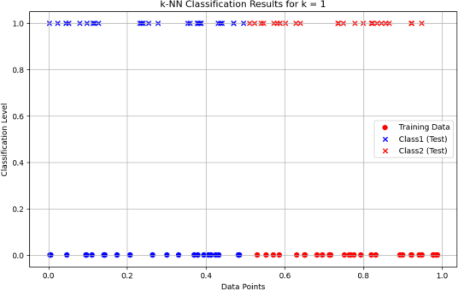
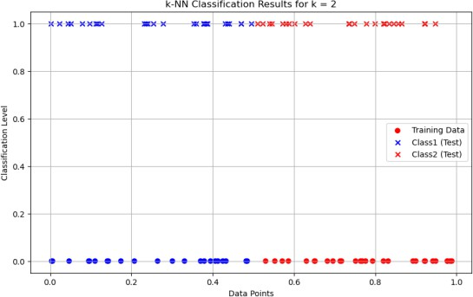

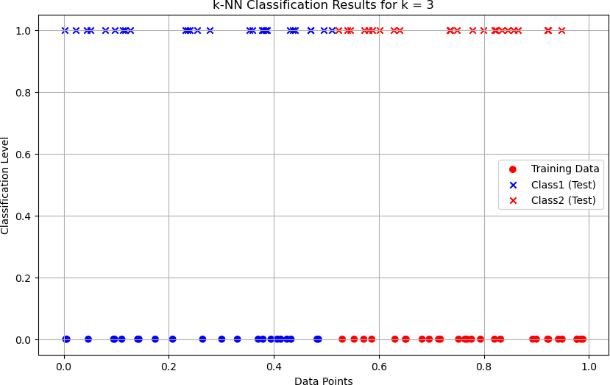

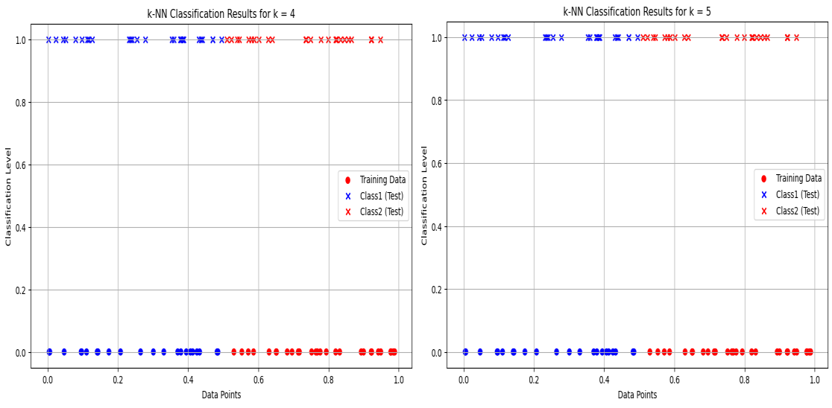

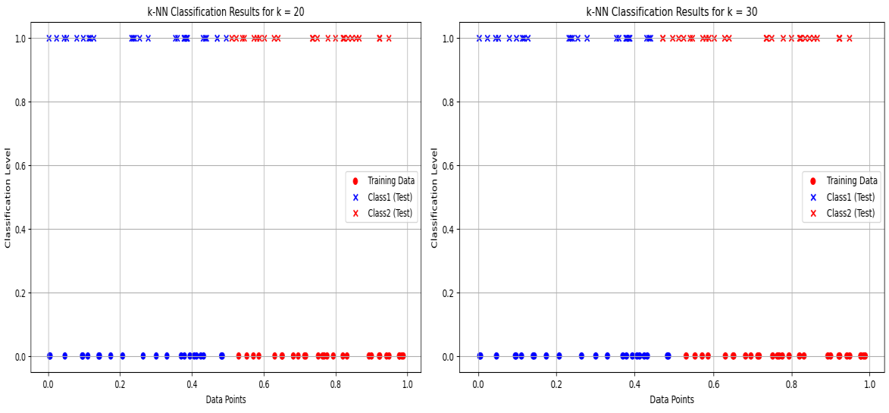

Implement the non-parametric Locally Weighted Regression algorithm in order to fit data points. Select appropriate data set for your experiment and draw graphs
import numpy as np
import matplotlib.pyplot as plt def gaussian_kernel(x, xi, tau):
return np.exp(-np.sum((x - xi) ** 2) / (2 * tau ** 2)) def locally_weighted_regression(x, X, y, tau):
m = X.shape[0]
weights = np.array([gaussian_kernel(x, X[i], tau) for i in range(m)]) W = np.diag(weights)
X_transpose_W = X.T @ W

theta = np.linalg.inv(X_transpose_W @ X) @ X_transpose_W @ y return x @ theta
np.random.seed(42)
X = np.linspace(0, 2 * np.pi, 100)
y = np.sin(X) + 0.1 * np.random.randn(100) X_bias = np.c_[np.ones(X.shape), X]
x_test = np.linspace(0, 2 * np.pi, 200)
x_test_bias = np.c_[np.ones(x_test.shape), x_test] tau = 0.5
y_pred = np.array([locally_weighted_regression(xi, X_bias, y, tau) for xi in x_test_bias])
plt.figure(figsize=(10, 6))
plt.scatter(X, y, color='red', label='Training Data', alpha=0.7)
plt.plot(x_test, y_pred, color='blue', label=f'LWR Fit (tau={tau})', linewidth=2) plt.xlabel('X', fontsize=12)
plt.ylabel('y', fontsize=12)
plt.title('Locally Weighted Regression', fontsize=14) plt.legend(fontsize=10)
plt.grid(alpha=0.3) plt.show()

output:

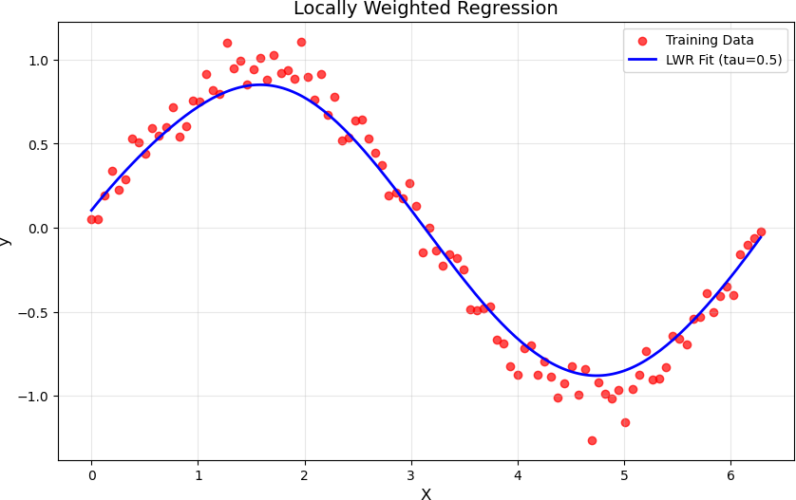

- Develop a program to demonstrate the working of Linear Regression and Polynomial Regression. Use Boston Housing Dataset for Linear Regression and Auto MPG Dataset (for vehicle fuel efficiency prediction) for Polynomial Regression.
import numpy as np import pandas as pd
import matplotlib.pyplot as plt
from sklearn.datasets import fetch_california_housing from sklearn.model_selection import train_test_split from sklearn.linear_model import LinearRegression
from sklearn.preprocessing import PolynomialFeatures, StandardScaler from sklearn.pipeline import make_pipeline
from sklearn.metrics import mean_squared_error, r2_score

# Linear Regression for California Housing Dataset def linear_regression_california():
housing = fetch_california_housing(as_frame=True)
X = housing.data[["AveRooms"]] # Using only AveRooms as feature

y = housing.target # Median value of homes as target
X_train, X_test, y_train, y_test = train_test_split(X, y, test_size=0.2, random_state=42)

# Linear Regression model model = LinearRegression() model.fit(X_train, y_train) y_pred = model.predict(X_test)

# Plotting results
plt.scatter(X_test, y_test, color="blue", label="Actual") plt.plot(X_test, y_pred, color="red", label="Predicted") plt.xlabel("Average number of rooms (AveRooms)") plt.ylabel("Median value of homes ($100,000)") plt.title("Linear Regression - California Housing Dataset") plt.legend()
plt.show()

# Print performance metrics
print("Linear Regression - California Housing Dataset") print("Mean Squared Error:", mean_squared_error(y_test, y_pred)) print("R^2 Score:", r2_score(y_test, y_pred))

# Polynomial Regression for Auto MPG Dataset def polynomial_regression_auto_mpg():
# Load the Auto MPG dataset

url = "https://archive.ics.uci.edu/ml/machine-learning-databases/auto-mpg/auto- mpg.data"
column_names = ["mpg", "cylinders", "displacement", "horsepower", "weight", "acceleration", "model_year", "origin"]
data = pd.read_csv(url, sep='\s+', names=column_names, na_values="?") data = data.dropna() # Drop rows with missing values

X = data["displacement"].values.reshape(-1, 1) # Feature: displacement y = data["mpg"].values # Target: mpg

# Split the data into training and testing sets
X_train, X_test, y_train, y_test = train_test_split(X, y, test_size=0.2, random_state=42)

# Polynomial Regression model (degree 2)
poly_model = make_pipeline(PolynomialFeatures(degree=2), StandardScaler(), LinearRegression())
poly_model.fit(X_train, y_train) y_pred = poly_model.predict(X_test)

# Plotting results
plt.scatter(X_test, y_test, color="blue", label="Actual") plt.scatter(X_test, y_pred, color="red", label="Predicted") plt.xlabel("Displacement")
plt.ylabel("Miles per gallon (mpg)") plt.title("Polynomial Regression - Auto MPG Dataset") plt.legend()
plt.show()

# Print performance metrics
print("Polynomial Regression - Auto MPG Dataset")
print("Mean Squared Error:", mean_squared_error(y_test, y_pred)) print("R^2 Score:", r2_score(y_test, y_pred))
if name == " main ":
print("Demonstrating Linear Regression and Polynomial Regression\n") linear_regression_california() # Call the linear regression function polynomial_regression_auto_mpg() # Call the polynomial regression function

output:
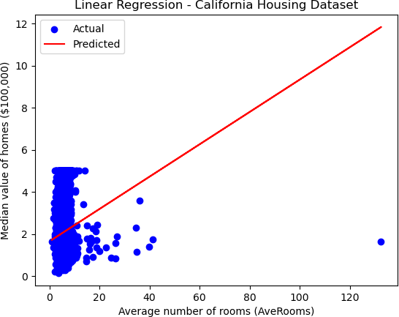
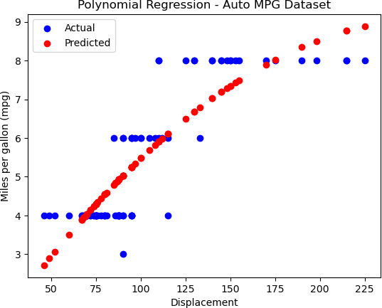

Linear Regression - California Housing Dataset Mean Squared Error: 1.2923314440807299 R^2 Score: 0.013795337532284901
Polynomial Regression - Auto MPG Dataset Mean Squared Error: 0.7431490557205862 R^2 Score: 0.7505650609469626

- Develop a program to demonstrate the working of the decision tree algorithm. Use Breast Cancer Data set for building the decision tree and apply this knowledge to classify a new sample.
# Importing necessary libraries import numpy as np
import matplotlib.pyplot as plt
from sklearn.datasets import load_breast_cancer from sklearn.model_selection import train_test_split from sklearn.tree import DecisionTreeClassifier from sklearn.metrics import accuracy_score
from sklearn import tree data = load_breast_cancer()
X = data.data y = data.target
X_train, X_test, y_train, y_test = train_test_split(X, y, test_size=0.2, random_state=42)
clf = DecisionTreeClassifier(random_state=42) clf.fit(X_train, y_train)
y_pred = clf.predict(X_test)
accuracy = accuracy_score(y_test, y_pred) print(f"Model Accuracy: {accuracy * 100:.2f}%") new_sample = np.array([X_test[0]])
prediction = clf.predict(new_sample)
prediction_class = "Benign" if prediction == 1 else "Malignant" print(f"Predicted Class for the new sample: {prediction_class}") plt.figure(figsize=(12,8))

tree.plot_tree(clf, filled=True, feature_names=data.feature_names, class_names=data.target_names)
plt.title("Decision Tree - Breast Cancer Dataset") plt.show()

output:
Model Accuracy: 94.74%
Predicted Class for the new sample: Benign
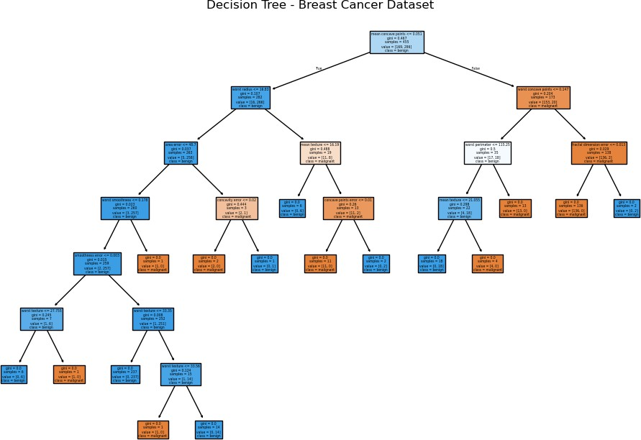

Develop a program to implement the Naive Bayesian classifier considering Olivetti Face Data set for training. Compute the accuracy of the classifier, considering a few test data sets.
import numpy as np
from sklearn.datasets import fetch_olivetti_faces
from sklearn.model_selection import train_test_split, cross_val_score from sklearn.naive_bayes import GaussianNB
from sklearn.metrics import accuracy_score, classification_report, confusion_matrix import matplotlib.pyplot as plt
data = fetch_olivetti_faces(shuffle=True, random_state=42)
X = data.data y = data.target
X_train, X_test, y_train, y_test = train_test_split(X, y, test_size=0.3, random_state=42)
gnb = GaussianNB() gnb.fit(X_train, y_train) y_pred = gnb.predict(X_test)
accuracy = accuracy_score(y_test, y_pred) print(f'Accuracy: {accuracy * 100:.2f}%') print("\nClassification Report:") print(classification_report(y_test, y_pred, zero_division=1)) print("\nConfusion Matrix:") print(confusion_matrix(y_test, y_pred))
cross_val_accuracy = cross_val_score(gnb, X, y, cv=5, scoring='accuracy') print(f'\nCross-validation accuracy: {cross_val_accuracy.mean() * 100:.2f}%') fig, axes = plt.subplots(3, 5, figsize=(12, 8))
for ax, image, label, prediction in zip(axes.ravel(), X_test, y_test, y_pred):

ax.imshow(image.reshape(64, 64), cmap=plt.cm.gray) ax.set_title(f"True: {label}, Pred: {prediction}") ax.axis('off')
plt.show()

output:
Accuracy: 80.83% Classification Report:
precision recall f1-score support
0 0.67 1.00 0.80 2
1 1.00 1.00 1.00 2
2 0.33 0.67 0.44 3
3 1.00 0.00 0.00 5
4 1.00 0.50 0.67 4
5 1.00 1.00 1.00 2
7 1.00 0.75 0.86 4
8 1.00 0.67 0.80 3
9 1.00 0.75 0.86 4
10 1.00 1.00 1.00 3
11 1.00 1.00 1.00 1
12 0.40 1.00 0.57 4
13 1.00 0.80 0.89 5
14 1.00 0.40 0.57 5
15 0.67 1.00 0.80 2
16 1.00 0.67 0.80 3
17 1.00 1.00 1.00 3
18 1.00 1.00 1.00 3
19 0.67 1.00 0.80 2
20 1.00 1.00 1.00 3
...
[0 0 0 ... 0 3 0]
[0 0 0 ... 0 0 5]]
Cross-validation accuracy: 87.25%
Output is truncated. View as a scrollable element or open in a text editor. Adjust cell output settings...

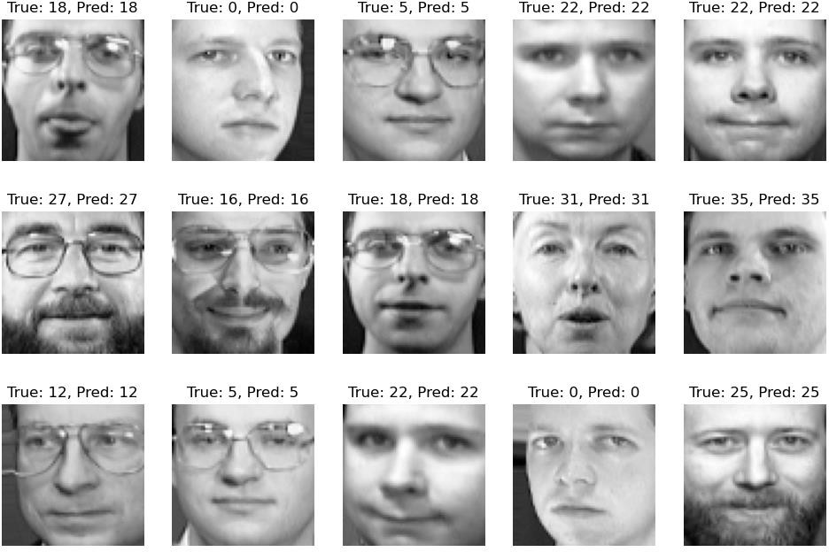

Develop a program to implement k-means clustering using Wisconsin Breast Cancer data set and visualize the clustering result.
import numpy as np import pandas as pd
import matplotlib.pyplot as plt import seaborn as sns
from sklearn.datasets import load_breast_cancer from sklearn.cluster import KMeans
from sklearn.preprocessing import StandardScaler from sklearn.decomposition import PCA
from sklearn.metrics import confusion_matrix, classification_report data = load_breast_cancer()
X = data.data y = data.target
scaler = StandardScaler()
X_scaled = scaler.fit_transform(X)

kmeans = KMeans(n_clusters=2, random_state=42) y_kmeans = kmeans.fit_predict(X_scaled) print("Confusion Matrix:") print(confusion_matrix(y, y_kmeans)) print("\nClassification Report:") print(classification_report(y, y_kmeans))
pca = PCA(n_components=2)
X_pca = pca.fit_transform(X_scaled)
df = pd.DataFrame(X_pca, columns=['PC1', 'PC2']) df['Cluster'] = y_kmeans
df['True Label'] = y plt.figure(figsize=(8, 6))
sns.scatterplot(data=df, x='PC1', y='PC2', hue='Cluster', palette='Set1', s=100, edgecolor='black', alpha=0.7)
plt.title('K-Means Clustering of Breast Cancer Dataset') plt.xlabel('Principal Component 1')
plt.ylabel('Principal Component 2') plt.legend(title="Cluster") plt.show()
plt.figure(figsize=(8, 6))
sns.scatterplot(data=df, x='PC1', y='PC2', hue='True Label', palette='coolwarm', s=100, edgecolor='black', alpha=0.7)
plt.title('True Labels of Breast Cancer Dataset') plt.xlabel('Principal Component 1')
plt.ylabel('Principal Component 2') plt.legend(title="True Label")
plt.show()

plt.figure(figsize=(8, 6))
sns.scatterplot(data=df, x='PC1', y='PC2', hue='Cluster', palette='Set1', s=100, edgecolor='black', alpha=0.7)
centers = pca.transform(kmeans.cluster_centers_)
plt.scatter(centers[:, 0], centers[:, 1], s=200, c='red', marker='X', label='Centroids') plt.title('K-Means Clustering with Centroids')
plt.xlabel('Principal Component 1')
plt.ylabel('Principal Component 2') plt.legend(title="Cluster") plt.show()

output:
Confusion Matrix:
[[175 37]
[ 13 344]]

Classification Report:
precision recall f1-score support

0 | 0.93 | 0.83 | 0.88 | 212
1 | 0.90 | 0.96 | 0.93 | 357
accuracy |  |  | 0.91 | 569
macro avg |  | 0.92 | 0.89 | 0.90 | 569
weighted avg |  | 0.91 | 0.91 | 0.91 | 569
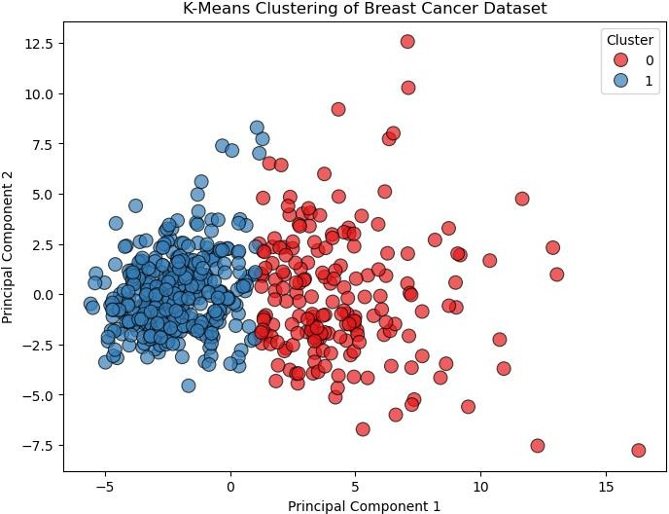

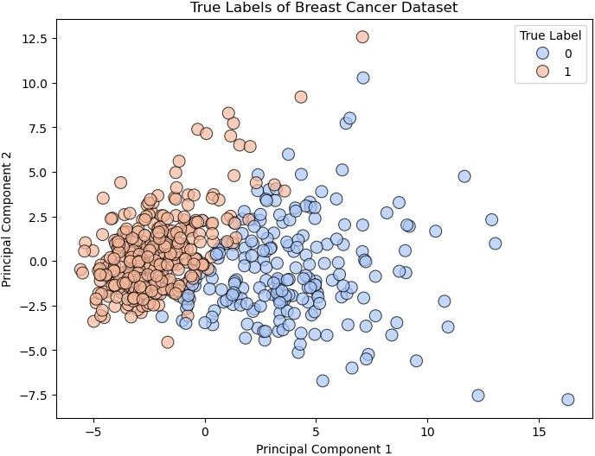

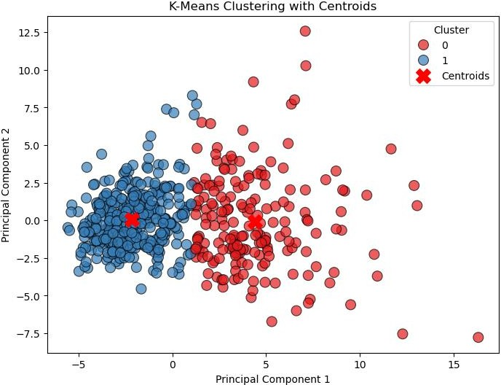

VIVA QUESTIONS

What is the difference between supervised and unsupervised machine learning?
A Supervised learning is a process where it requires training labeled data. When it comes to Unsupervised learning it doesn’t require data labeling.

How is KNN different from K-means clustering?
KNN stands for K- Nearest Neighbours, it is classified as a supervised algorithm.
K-means is an unsupervised cluster algorithm.

How to handle or missing data in a dataset?
An individual can easily find missing or corrupted data in a data set either by dropping the rows or columns. On contrary, they can decide to replace the data with another value. In Pandas they are two ways to identify the missing data, these two methods are very useful. isnull() and dropna().

What is the difference between an array and Linked list?
Deep An array is an ordered fashion of collection of objects. A linked list is a series of objects that are processed in a sequential order.

Explain why Navie Bayes is so Naive?
It is based on an assumption that all of the features in the data set are important, equal and independent.

Please state few popular Machine Learning algorithms?
Nearest Neighbour Neural Networks Decision Trees etc Support vector machines

What are the different types of algorithm techniques available in machine learning?
Some of them are :
Supervised learning Unsupervised learning Semi-supervised learning Transduction
Learning to learn

What are the three stages to build the model in machine learning?
  - Model building
  - Model testing
  - Applying the model

Name a few libraries in Python used for Data Analysis and Scientific computations
NumPy, SciPy, Pandas, SciKit, Matplotlib, Seaborn

Which is the standard data missing marker used in Pandas?
NaN

Write the code to sort an array in NumPy by the nth column?
Using argsort () function this can be achieved. If there is an array X and you would like to sort the nth column then code for this will be x[x [: n-1].argsort ()]

What is pylab?
A package that combines NumPy, SciPy and Matplotlib into a single namespace.

Is all the memory freed when Python exits?
No it is not, because the objects that are referenced from global namespaces of Python modules are not always de-allocated when Python exits.

How can you randomize the items of a list in place in Python?
Shuffle (lst) can be used for randomizing the items of a list in Python

Which tool in Python will be used to find bugs if any?
Pylint and Pychecker. Pylint verifies that a module satisfies all the coding standards or not. Pychecker is a static analysis tool that helps find out bugs in the course code.

What are the supported data types in Python?
Python has five standard data types −
- Numbers
- String
- List
- Tuple
- Dictionary

What are the supported sequence types in Python?
Python supports 7 sequence types. They are str, list, tuple, unicode, byte array, xrange, and buffer. where xrange is deprecated in python 3.5.X.

What is pylab?
A package that combines NumPy, SciPy and Matplotlib into a single namespace.

What are the supported data types in Python?
SciKit-Learn

Is Python a case-sensitive programming language?
Yes, it is a case-sensitive language.

What is the difference between a tuple and a list?
The basic difference between a tuple and a list is that the former is immutable and the latter is mutable.

What is the difference between Xrange() and range()?
Range() returns a list and xrange() returns an xrange object, which is kind of like an iterator and generates the numbers on demand.

Optimize the below python code- word = 'word'
print word. len ()
print ‘word’._len_ ()

What is PEP 8?
PEP 8 is a coding convention that lets us write more readable code. In other words, it is a set of recommendations.

What are Python decorators?
A Python decorator is a specific change that we make in Python syntax to alter functions easily.

What is Dict and List comprehensions are?
They are syntax constructions to ease the creation of a Dictionary or List based on existing iterable.

What is lambda in Python?
It is a single expression anonymous function often used as inline function.

What is pass in Python?
Pass means, no-operation Python statement, or in other words it is a place holder in compound statement, where there should be a blank left and nothing has to be written there.

In Python what are iterators?
In Python, iterators are used to iterate a group of elements, containers like list.

In Python what is slicing?
A mechanism to select a range of items from sequence types like list, tuple, strings etc. is known as slicing.

What is docstring in Python?
A Python documentation string is known as docstring, it is a way of documenting Python functions, modules and classes.

How can you copy an object in Python?
To copy an object in Python, you can try copy.copy () or copy.deepcopy() for the general case. You cannot copy all objects but most of them.

Explain how to delete a file in Python?
By using a command os.remove (filename) or os.unlink(filename)

Is It Mandatory For A Python Function To Return A Value?
It is not at all necessary for a function to return any value. However, if needed, we can use None as a return value.

What Is Whitespace In Python?
Whitespace represents the characters that we use for spacing and separation. They possess an “empty” representation. In Python, it could be a tab or space.

What Is Isalpha() In Python?
Python provides this built-in isalpha() function for the string handling purpose. It returns True if all characters in the string are of alphabet type, else it returns False.

What Does The Join Method Do In Python?
Python provides the join() method which works on strings, lists, and tuples. It combines them and returns a united value.

What Makes The CPython Different From Python?
CPython has its core developed in C. The prefix ‘C’ represents this fact. It runs an interpreter loop used for translating the Python-ish code to C language.

What Is A Tuple In Python?
A tuple is a collection type data structure in Python which is immutable. They are similar to sequences, just like the lists. However, there are some differences between a tuple and list; the former doesn’t allow modifications whereas the list does.

What is Artificial Intelligence?
Artificial Intelligence is an area of computer science that emphasizes the creation of intelligent machine that work and reacts like humans.

What are the various areas where AI (Artificial Intelligence) can be used?
Artificial Intelligence can be used in many areas like Computing, Speech recognition, Bio-informatics, Humanoid robot, Computer software, Space and Aeronautics’ etc.

