COURSE MODULE OF THE SUBJECT TAUGHT FOR THE SESSION 2025-26 (EVEN SEM)
Course Syllabi with CO's

Faculty Name: B S Vanishree |  |  | Academic Year: 2025 – 2026
Department: CSE- Data Science
Course | Course Title | Core / Elective | Prerequisite | Contact |  |  | Total
Code | Course Title | Core / Elective | Prerequisite |  | Hours |  | Hrs/
 | Course Title | Core / Elective | Prerequisite | L | T | P | Sessions
BCSL606 | Machine Learning lab | Core | Python Programming | - | - | 2 | 28P
Course Objectives | CLO1: To become familiar with data and visualize univariate, bivariate, and multivariate data using statistical techniques and dimensionality reduction.  COL2: To understand various machine learning algorithms such as similarity-based learning, regression, decision trees, and clustering.  COL3: To familiarize with learning theories, probability-based models and developing the skills required for decision-making in dynamic environments.
Topics (Experiments) Covered as per Syllabus
- Develop a program to create histograms for all numerical features and analyze the distribution of each feature. Generate box plots for all numerical features and identify any outliers. Use California Housing dataset. Book 1: Chapter 2
- Develop a program to Compute the correlation matrix to understand the relationships between pairs of features. Visualize the correlation matrix using a heatmap to know which variables have strong positive/negative correlations. Create a pair plot to visualize pairwise relationships between features. Use California Housing dataset. Book 1: Chapter 2
- Develop a program to implement Principal Component Analysis (PCA) for reducing the dimensionality of the Iris dataset from 4 features to 2. Book 1: Chapter 2
- For a given set of training data examples stored in a .CSV file, implement and demonstrate the Find- S algorithm to output a description of the set of all hypotheses consistent with the training examples. Book 1: Chapter 3
- Develop a program to implement k-Nearest Neighbour algorithm to classify the randomly generated 100 values of x in the range of [0,1]. Perform the following based on dataset generated. 1. Label the

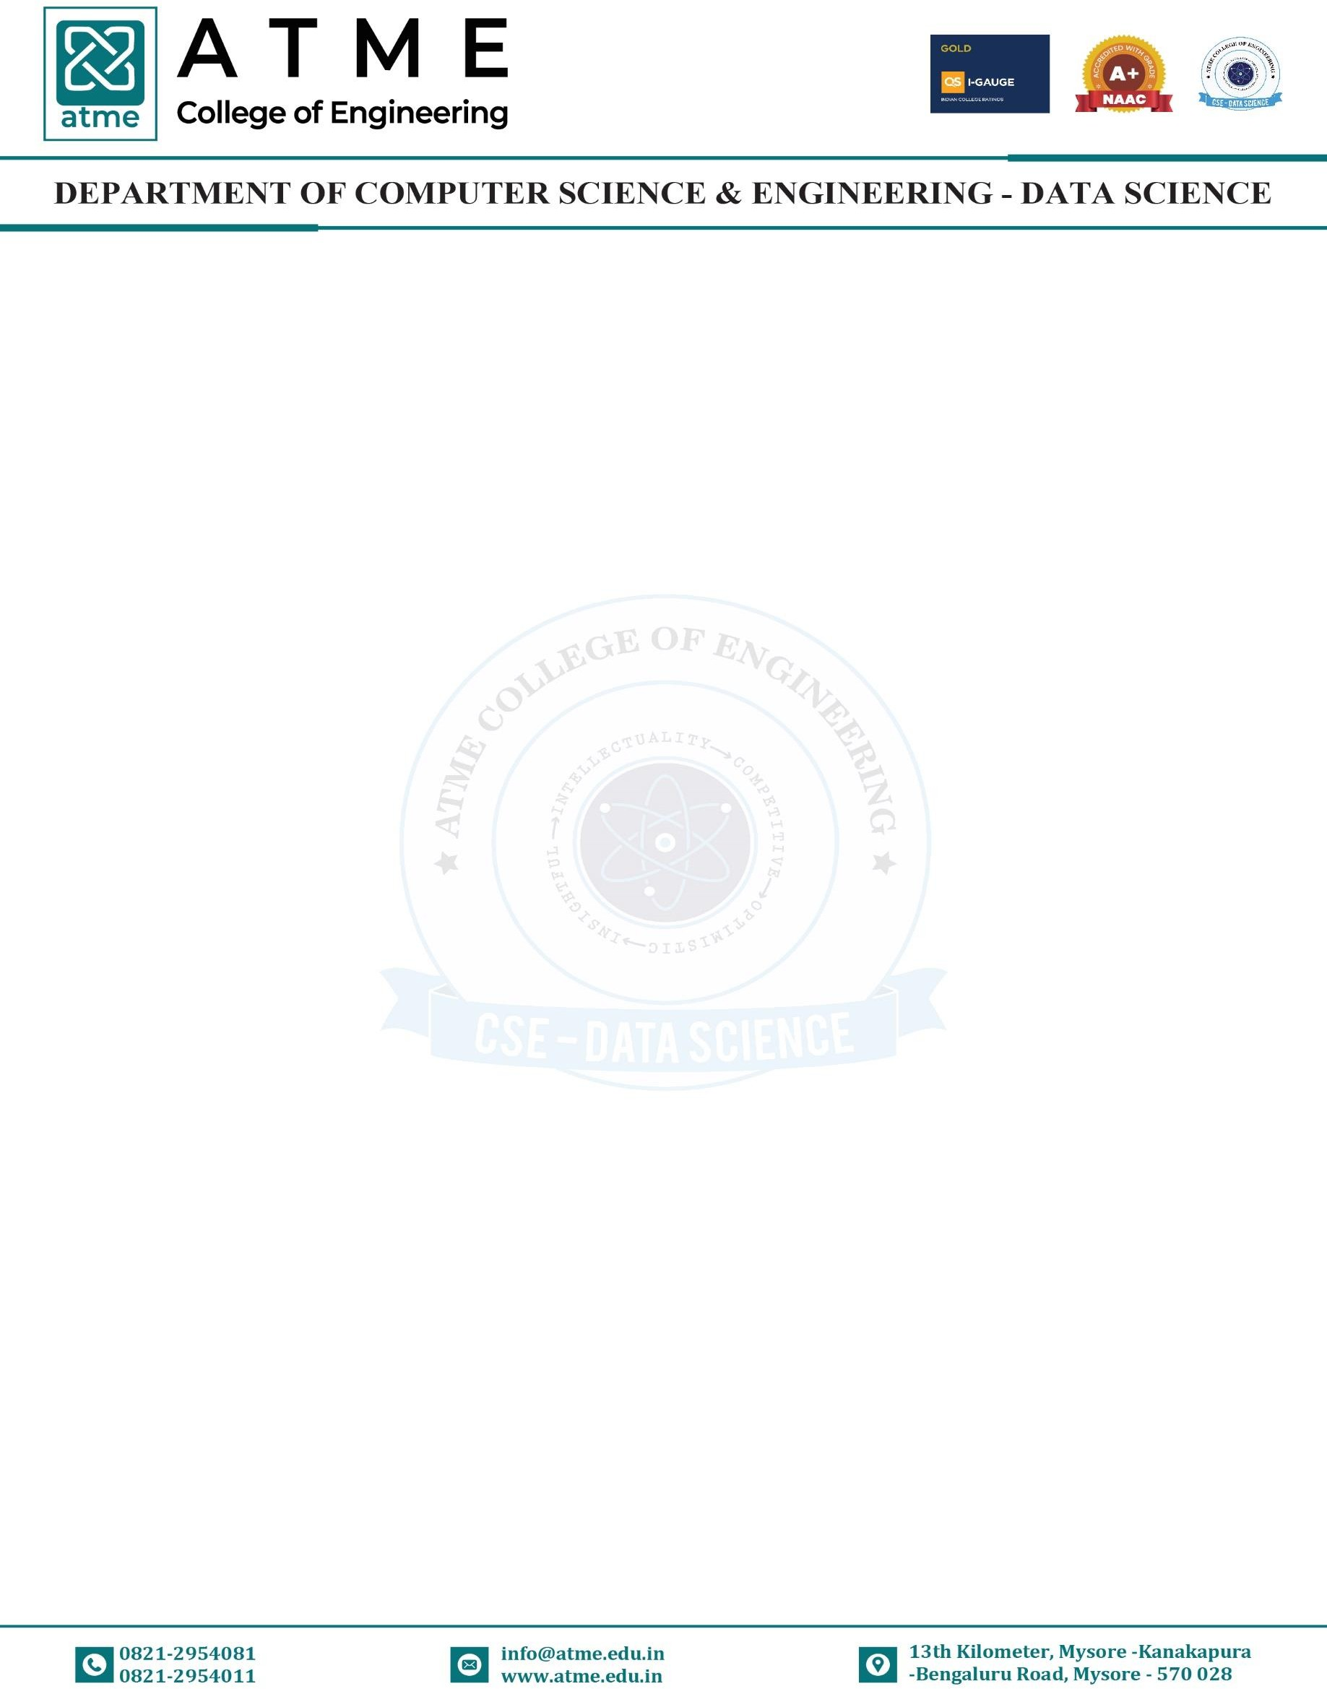

first 50 points {x1,……,x50} as follows: if (xi ≤ 0.5), then xi ∊ Class1, else xi ∊ Class1 2. Classify the remaining points, x51,……,x100 using KNN. Perform this for k=1,2,3,4,5,20,30 Book 2: Chapter – 2
- Implement the non-parametric Locally Weighted Regression algorithm in order to fit data points. Select appropriate data set for your experiment and draw graphs Book 1: Chapter – 4
- Develop a program to demonstrate the working of Linear Regression and Polynomial Regression. Use Boston Housing Dataset for Linear Regression and Auto MPG Dataset (for vehicle fuel efficiency prediction) for Polynomial Regression. Book 1: Chapter – 5
- Develop a program to demonstrate the working of the decision tree algorithm. Use Breast Cancer Data set for building the decision tree and apply this knowledge to classify a new sample. Book 2: Chapter – 3
- Develop a program to implement the Naive Bayesian classifier considering Olivetti Face Data set for training. Compute the accuracy of the classifier, considering a few test data sets. Book 2: Chapter – 4
- Develop a program to implement k-means clustering using Wisconsin Breast Cancer data set and visualize the clustering result. Book 2: Chapter – 4
List of Textbooks
- S Sridhar and M Vijayalakshmi, “Machine Learning”, Oxford University Press, 2021.
- M N Murty and Ananthanarayana V S, “Machine Learning: Theory and Practice”, Universities Press (India) Pvt. Limited, 2024.
Web links and Video Lectures (e-Resources)
- https://www.drssridhar.com/?page_id=1053
- https://www.universitiespress.com/resources?id=9789393330697
- https://onlinecourses.nptel.ac.in/noc23_cs18/preview
Course Outcomes | CO1: Illustrate the principles of multivariate data and apply dimensionality reduction techniques.  CO2: Demonstrate similarity-based learning methods and perform regression analysis.  CO3: Develop decision trees for classification and regression problems, and Bayesian models for probabilistic learning.  CO4: Implement the clustering algorithms to share computing resources..

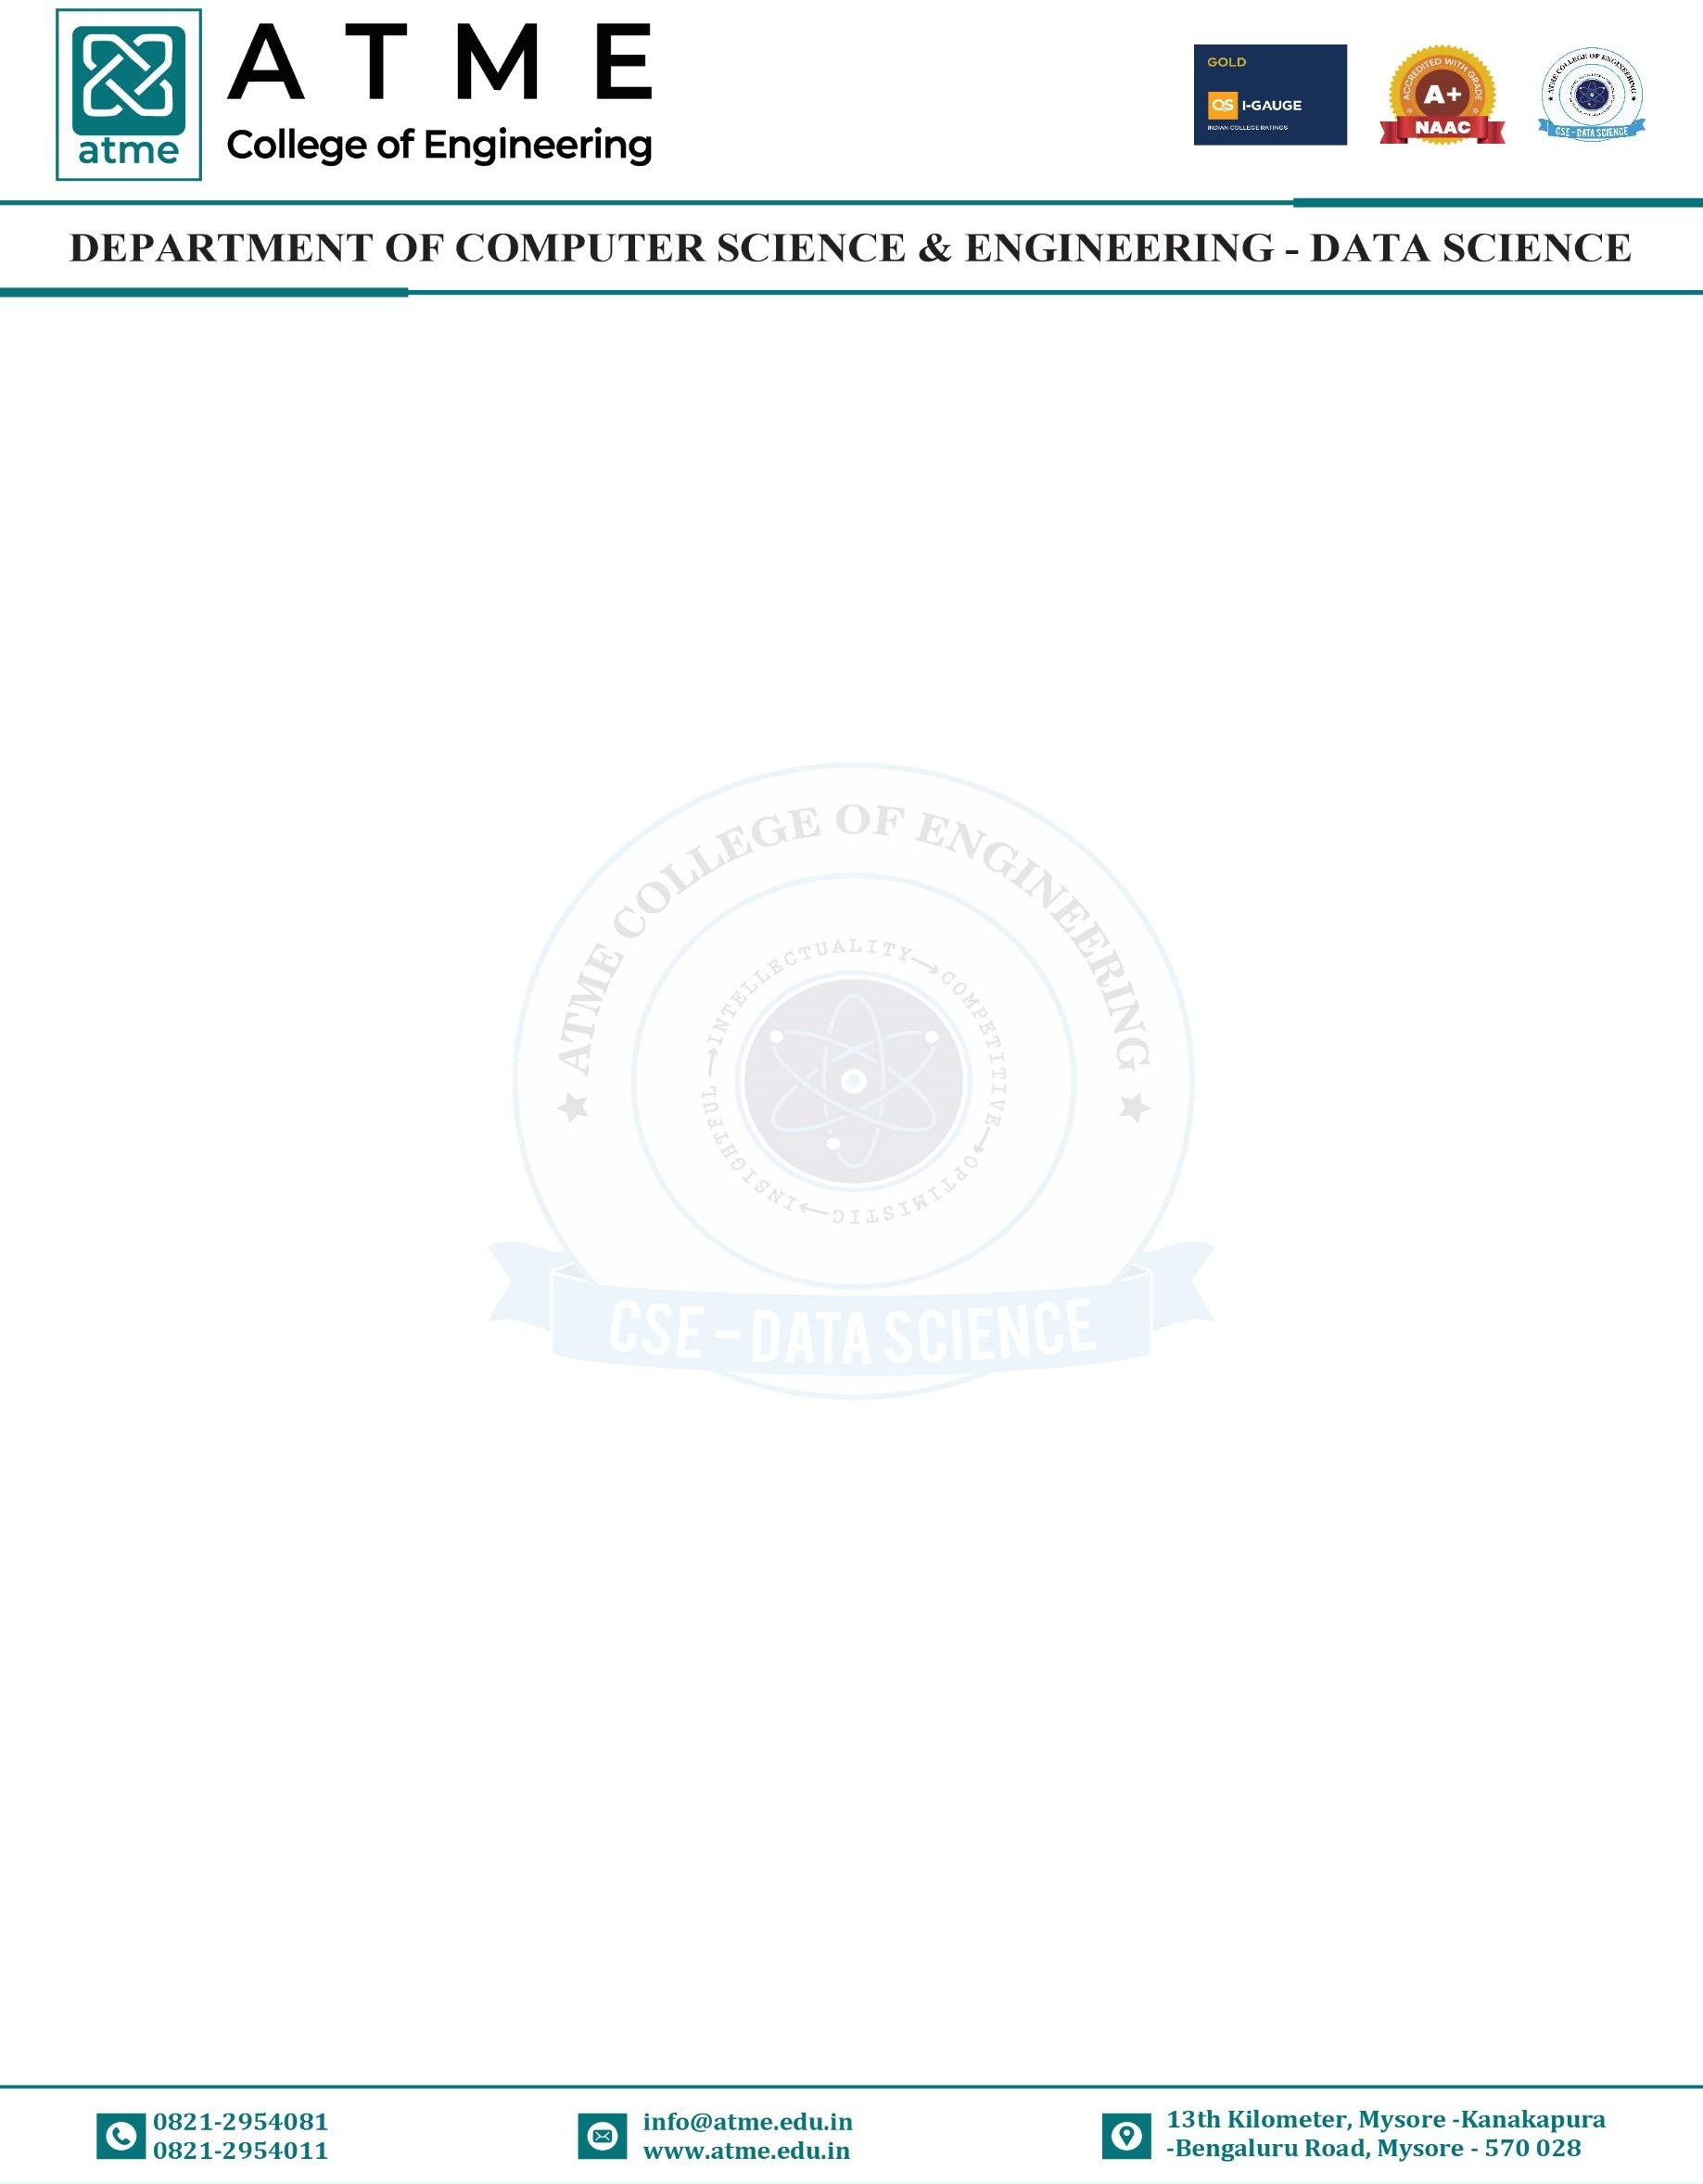

Internal Assessment Marks: CIE marks for the practical course are 50 Marks. The split-up of CIE marks for record/ journal and test are in the ratio 60:40.
- Each experiment is to be evaluated for conduction with an observation sheet and record write-up. Rubrics for the evaluation of the journal/write-up for hardware/software experiments are designed by the faculty who is handling the laboratory session and are made known to students at the beginning of the practical session.
- Record should contain all the specified experiments in the syllabus and each experiment write-up will be evaluated for 10 marks.
- Total marks scored by the students are scaled down to 30 marks (60% of maximum marks).
- Weightage to be given for neatness and submission of record/write-up on time.
- Department shall conduct a test of 100 marks after the completion of all the experiments listed in the syllabus.
- In a test, test write-up, conduction of experiment, acceptable result, and procedural knowledge will carry a weightage of 60% and the rest 40% for viva-voce.
- The suitable rubrics can be designed to evaluate each student’s performance and learning ability.
- The marks scored shall be scaled down to 20 marks (40% of the maximum marks). The Sum of scaled- down marks scored in the report write-up/journal and marks of a test is the total CIE marks scored by the student.

The Correlation of Course Outcomes (CO’s) and Program Outcomes (PO’s)

Subject Code | BCSL606 |  | TITLE: Machine Learning  lab |  |  |  |  |  |  | Faculty Name |  |  | Dr Anitha D B
List of | Program Outcomes |  |  |  |  |  |  |  |  |  |  |  |  |  |  | Total
Course | PO 1 | PO 2 |  | PO 3 | PO 4 | PO 5 | PO 6 | PO 7 | PO 8 |  | PO 9 | PO 10 |  | PO 11 | PO 12 | Total
Outcomes
CO-1 | 2 | - |  | - | - | 3 | - | - | 2 |  | 2 | - |  | - | - | 9
CO-2 | 2 | 2 |  | 2 | - | 3 | - | - | 2 |  | 2 | - |  | - | - | 13
CO-3 | 2 | 2 |  | 2 | - | 3 | - | - | 2 |  | 2 | - |  | - | - | 13
CO-4 | 2 | 2 |  | 2 | - | 3 | - | - | 2 |  | 2 | - |  | - | - | 13
Total | 08 | 06 |  | 06 | - | 12 | - | - | 8 |  | 8 | - |  | - | - | 48

Note: 3 = Strong Contribution, 2 = Average Contribution, 1 = Weak Contribution, - = No Contribution
The Correlation of Course Outcomes (CO’s) and Program Specific Outcomes (PSO’s)

Subject Code | BCSL606 | TITLE: Machine Learning lab |  | Faculty Name |  | Dr Anitha D B
List of  Course Outcomes | Program Specific Outcomes |  |  |  |  |  | Total
List of  Course Outcomes | PSO-1 |  | PSO-2 |  | PSO-3 |  | Total
CO-1 | 2 |  | - |  | - |  | 2
CO-2 | 2 |  | - |  | - |  | 2
CO-3 | 2 |  | - |  | - |  | 2
CO-4 | 2 |  | - |  | - |  | 2
Total | 10 |  | - |  | - |  | 10

